Contents

[datatype=bibtex]citation/citation.bib sczSCZschizophrenia [longplural=Genome Wide Association Studies]GWASGWASGenome Wide Association Study wgsWGSWhole Genome Sequencing SNPSNPSingle Nucleotide Polymorphism LDLDLinkage Disequilibrium PGSPGSPolygenic Risk Score tSVDtSVDTruncated Singular Value Decomposition SVDSVDSingular Value Decomposition shrekSHREKSNP HeRitability Estimation Kit gctaGCTAGenome-wide Complex Trait Analysis ldscLDSCLD SCore regression CEUCEUNorthern Europeans from Utah seSEstandard error mafmafminor allele frequency iscISCInternational Schizophrenia Consortium mgsMGSMolecular Genetic of Schizophrenia sgeneSGENESchizophrenia Genetics Consortium pgcPGCPsychiatric Genomics Consortium rinRINRNA integrity number gdGDGestation Day rpkmRPKMReads Per Kilobase per Million mapped reads wgcnaWGCNAWeighted Gene Co-expression Network Analysis pcPCPrinciple Component GOGOGene Ontology MAGMAMAGMAMulti-marker Analysis of GenoMic Annotation ngsNGSnext generation sequencing dsmDSMDiagnostic and Statistical Manual of Mental Disorders mseMSEmean squared error whoWHOWorld Health Organization yldYLDyears lost due to disability ciCIconfidence interval iqIQintelligence quotient polyicPolyI:Cpolyriboinosinic-polyribocytidilic acid lpsLPSlipopolysaccharide il6IL-6Interleukin-6 mzMZmonozygotic dzDZdizygotic miaMIAmaternal immune activation ncpNCPnon-centrality parameter cnvCNVcopy number variation grmGRMGenetic Relationship Matrix gcGCGenomic Control mhcMHCmajor histocompatibility complex cnsCNScentral nervous system panssPANSSPositive and Negative Symptom Scale fgaFGAFirst Generation Antipsychotic sgaSGASecond Generation Antipsychotic nmdaNMDAN-methyl-D-aspartate epsEPSextrapyramidal motor symptoms tdTDtardive dyskinesia petPETpositron emission tomography catieCATIEClinical Antipsychotic Trials of Intervention Effectiveness pcaPCAprinciple component analysis fdrFDRfalse discovery rate pcgcPCGCPhenotype correlation - genotype correlation regression scidpSCID-PStructured Clinical Interview for DSM-IV-TR Axis I Disorders, Research Version, Patient Edition ibdIBDidentity by descent bpbpbase pair mbmbmegabase kbkbkilobase degDEGdifferentially expressed gene qcQCquality control hkuHKUthe University of Hong Kong pcrPCRpolymerase chain reaction erccERCCExternal RNA Controls Consortium goGOGene Ontology rtpcrrt-PCRreal time PCR ctCTcycle threshold geoGEOGene Expression Omnibus mlmMLMmixed linear model remlREMLrestricted maximum likelihood pufaPUFApolyunsaturated fatty acid lrtLRTlikelihood ratio test msigdbMSigDBMolecular Signatures Database fgfFGFfibroblast growth factor egfEGFepidermal growth factor pi3kPI3Kphosphatidylinositol 3-kinase mapkMAPKmitogen-activated protein kinase gabaGABA-aminobutyric acid ecmECMextracellular matrix mmpMMPmatrix metalloproteinase qqplotQQ-plotquantile-quantile Plots cmcMcentiMorgan mrnamRNAmessenger RNA [LE,RO] [LE] [RO]

top=1in, inner=1in, outer=3.5cm, bottom=3.5cm, headheight=3ex, headsep=2ex,

**Understanding How Genetics and Environments Shape the Development of Schizophrenia**

**mailto:choishingwan@gmail.comChoi Shing Wan**

A thesis submitted in partial fulfillment of the requirements for

the Degree of Doctor of Philosophy



Department of Psychiatry

University of Hong Kong

Hong Kong

Mon Dec 28 19:01:05 2015

# Abstract

scz is a detrimental disorder affecting approximately 1% of the population worldwide. To fully understand the disease mechanism for the development of proper treatments, it is important not only to examine how certain genetic polymorphisms can predispose individuals to the disease development, but also how environmental factors triggers the disorder in apparently healthy individuals.

GWAS is now a standard approach for investigating associations of common genetic variations (mainly the SNP) with scz. A recent meta-analysis of GWAS of scz has identified 108 loci significantly associated with scz. However, due to the limitation of sample size and the moderate-to-small effect size of an unknown number of causal loci, many SNP associated with scz may be left undetected and a much larger sample size of GWAS may be required. However, it is also possible that these 108 loci have already contained all or near most of the SNP associated with the disease. So estimating the contribution of these common SNP to scz (and other complex diseases) has important implications for future research strategy.

In this thesis, we proposed an alternative approach for estimating the contribution of SNP to scz (SNP-heritability) from GWAS summary statistics, called the shrek. Our simulation results suggested that when compared to the existing method (ldsc), shrek provided a more robust estimate for oligogentic traits and in case-control designs in which no confounding variables was present. Using the summary statistics from the latest meta-analysis of GWAS of scz, we estimated that scz has a SNP-heritability of 0.174 (SD=0.00453), which is similar to the estimate of 0.197 (SD=0.0058) by our competitor ldsc. The result indicated that common SNP have relatively less contribution to the genetic predisposition of individuals to scz as measured by the heritability estimated. Also, it suggested that alternative strategies like whole genome sequencing would be more efficient for identifying additional scz genes, compared to GWAS.

On the other hand, prenatal infection has been identified as the single largest environmental risk factor of scz. It was estimated that prenatal infection may account for one-third of the cases of scz and a wide variety of infections are associated with the increased scz risk in the offspring. This suggests that mia during prenatal development may have a negative impact on fetal brain functions as well as behaviors. So it is important to understand how mia triggers the disorder by examining the molecular events that take place in the cerebellum using established animal models, such as those involving the viral RNA mimic polyic.

As a result, we also performed a RNA-sequencing study for the mia on the change in global gene expressions in the fetal cerebellum in polyic-treated pregnant mice. We found that several pathways related to neural functioning and calcium ion signaling were likely to be disrupted by mia in the cerebellum. In addition, we investigated how a n-3 pufa rich diet can help to reduce the scz-like phenotype in mice exposed to early mia insults. We found that *Sgk1*, a gene that regulates the glutamatergic system, is potentially affected by the n-3 pufa rich diet in the polyic exposed mice. In conclusion, our results suggested that genes related to neural function or calcium ion signaling, as well as glutamate-related genes such as *Sgk1*, are potential targets for future scz research.

(550 words)

inner=2in, outer=2in

# Declaration

I declare that this thesis represents my own work, except where due acknowledgments is made, and that it has not been previously included in a thesis, dissertation or report submitted to this University or to any other institution for a degree, diploma or other qualification.

Signed.................................................................... Choi Shing Wan

# Acknowledgements

I would like to express my deepest gratitude to Professor Pak Sham. I am eternally grateful for his trust, supervision, patience and support in the course of my study. I would also like to thanks Dr Stacey Cherny and Dr Wanling Yeung for giving me valuable advice for my projects. My special thanks go to Dr Johnny Kwan. He has provided critical advices on my projects and has taught me a great deal in the field of statistic.

The past 4 years has been a blast and I really enjoy my time in this department. This is only possible because of all the great people here. Thank you Beatrice Wu, Dr Li Qi, Tomy Hui, Vicki Lin, Nick Lin, John Wong, Dr Clara Tang, Dr Amy Butler, Dr Emily Wong, Dr Allen Gui, Dr Sylvia Lam, Yung Tse Choi, Oi Chi Chan, Pui King Wong and Dr Miaoxin Li, without you everything will be much different. I will forever cherish the time I spent with you.

Words alone cannot express my gratitude to Beatrice Wu and my family. Their support and encouragement have been my greatest source of energy and have helped me to continue on with my study.

THANK YOU!

[title=Abbreviations,toctitle=Abbreviations,style=long,nonumberlist]

**Contents**

**Abstract ??**

**Declaration ??**

**Acknowledgments ??**

**Contents ??**

**1 Introduction ??**

**1 Schizophrenia ??**

**2 Understanding the Disease Mechanism ??**

2.1 Broad Sense Heritability ??

2.2 Narrow Sense Heritability ??

2.3 Liability Threshold ??

2.4 Adoption Study ??

2.5 Twin Studies ??

**3 Schizophrenia Genetics ??**

3.1 The Human Genome Project and HapMap Project ??

3.2 Genome Wide Association Study ??

3.2.1 The Success of Psychiatric Genomic Consortium ??

3.3 Contribution of Common SNPs ??

3.3.1 Genome-wide Complex Trait Analysis ??

3.3.2 ldsc ??

3.3.3 Partitioning of Heritability ??

3.4 Rare Variants in Schizophrenia ??

3.4.1 Copy Number Variation ??

3.4.2 Rare Single Nucleotide Mutation ??

**4 Environmental Risk Factors of Schizophrenia ??**

4.1 Prenatal Infection ??

4.2 RNA Sequencing ??

**5 Summary ??**

**2 Heritability Estimation ??**

**1 Introduction ??**

**2 Methodology ??**

2.1 Heritability Estimation ??

2.2 Calculating the se ??

2.3 Case Control Studies ??

2.4 Extreme Phenotype Sampling ??

2.5 Inverse of the LD matrix ??

2.6 Implementation ??

2.7 Comparing with ldsc ??

**3 Comparing Different LD correction Algorithms ??**

**4 Comparison with Other Algorithms ??**

4.1 Sample Size ??

4.2 Number of SNPs in Simulation ??

4.3 Genetic Architecture ??

4.4 Extreme Effect Size ??

4.5 Case Control Studies ??

4.6 Extreme Phenotype Sampling ??

**5 Application to Real Data ??**

**6 Result ??**

6.1 LD Correction ??

6.2 Comparing with Other Algorithms ??

6.2.1 Quantitative Trait Simulation ??

6.2.2 Quantitative Trait Simulation with Extreme Effect Size ??

6.2.3 Case Control Simulation ??

6.3 Extreme Phenotype Simulation ??

6.4 Application to Real Data ??

**7 Discussion ??**

7.1 LD Correction ??

7.2 Simulation Results ??

7.2.1 Quantitative Trait Simulation ??

7.2.2 Case Control Simulation ??

7.2.3 Extreme Phenotype Sampling ??

7.3 Application to Real Data ??

7.4 Limitations and Improvements ??

**8 Supplementary ??**

**3 n-3 Polyunsaturated Fatty Acid Rich Diet in Schizophrenia ??**

**1 Introduction ??**

**2 Methodology ??**

2.1 Sample Preparation ??

2.2 RNA Extraction, Quality Control and Sequencing ??

2.3 Sequencing Quality Control ??

2.4 Alignment ??

2.5 Differential Expression Analysis ??

2.6 Functional Annotation ??

2.7 Partitioning of Heritability ??

2.8 Designing the Replication Study ??

**3 Results ??**

3.1 Sample Quality ??

3.2 Differential Expression Analysis ??

3.3 Functional Annotation ??

3.4 Partitioning of Heritability ??

3.5 Designing the Replication Study ??

**4 Discussion ??**

4.1 Limitation ??

**5 Supplementary ??**

**4 Conclusion ??**

**1 Challenge in SNP-Heritability Estimation ??**

**2 Schizophrenia: Future Perspectives ??**

# 1 Introduction

## 1 Schizophrenia

scz is a devastating psychiatric disorder affecting approximately  of the population worldwide [?]. According to the dsm- 5 , which is one of the standard diagnostic tools, a diagnosis of scz (F20.9) can only be reached if the patient suffered from 2 or more of the following symptoms for a significant portion of time during a 1-month period: [label=)] delusion; hallucinations; disorganized speech; grossly disorganized or catatonic behaviour; and negative symptoms such as diminished emotional expression, where one of the symptom must be either (1, (1 or (1. Signs of disturbance also need to persist for at least 6-month before the patient can be diagnosed with scz.

Due to detrimental symptoms and the lack of effective treatments, scz imposes a long lasting health, social and financial burden to the patients and their families [?]. scz patient also have a higher tendency to commit suicide [?], leading to a higher mortality, based on the who report, scz is one of the top 20 leading cause of yld in 2012, ranking 16 among all possible causes (tab:whoYLD), demonstrating the extent of impact from scz to patients.

Table 1: Top 20 leading cause of yld calculated by who in year 2012. scz was considered as one of the top 20 leading cause of yld[?]

|  |  |  |  |  |
| --- | --- | --- | --- | --- |
| Rank | Cause | yld (000s) | % yld |  |
| yld per | |
| k population | |
|  | |
|  | |
| 0 | All Causes | 740,545 | 100 | 10466 |
|  | Unipolar depressive disorders | 76,419 | 10.3 | 1080 |
|  | Back and neck pain | 53,855 | 7.3 | 761 |
|  | Iron-deficiency anaemia | 43,615 | 5.9 | 616 |
|  | Chronic obstructive pulmonary disease | 30,749 | 4.2 | 435 |
|  | Alcohol use disorders | 27,905 | 3.8 | 394 |
|  | Anxiety disorders | 27,549 | 3.7 | 389 |
|  | Diabetes mellitus | 22,492 | 3 | 318 |
|  | Other hearing loss | 22,076 | 3 | 312 |
|  | Falls | 20,409 | 2.8 | 288 |
|  | Migraine | 18,538 | 2.5 | 262 |
|  | Osteoarthritis | 18,096 | 2.4 | 256 |
|  | Skin diseases | 15,744 | 2.1 | 223 |
|  | Asthma | 14,134 | 1.9 | 200 |
|  | Road injury | 13,902 | 1.9 | 196 |
|  | Refractive errors | 13,498 | 1.8 | 191 |
|  | Schizophrenia | 13,408 | 1.8 | 189 |
|  | Bipolar disorder | 13,271 | 1.8 | 188 |
|  | Drug use disorders | 10,620 | 1.4 | 150 |
|  | Endocrine, blood, immune disorders | 10,495 | 1.4 | 148 |
|  | Gynecological diseases | 10,227 | 1.4 | 145 |
|  | |

Due to the severity of scz, it has drawn much attention from the research community, hoping to delineate the disease mechanics and to identify risk factors associate with scz. Ultimately, the goal of scz research is to identify effective treatment(s) to improve the quality of life of the patients.

## 2 Understanding the Disease Mechanism

An important first step in scz research is to understand whether if variation in genetic or environment contribute more to the disease etiology. In order to study the relative contribution of genetic and environmental influence to individual differences in scz, one will need to calculate the *heritability* of scz. There are two definition of heritability: the broad sense heritability and the narrow sense heritability. The broad sense heritability is defined as the *proportion* of total variance of a trait in a population explained by the *total* variation of genetic factors in the population whereas the narrow sense heritability only take into account of the variation of *additive* genetic factors in the population instead of the total variation of genetic factors.

First, we need to understand the broad sense heritability.

### 2.1 Broad Sense Heritability

For any phenotype, one can partition it into a combination of genetic and environmental components [?]



where the variance of the observed phenotype () can be expressed as variance of genotype () and variance of environment ()



The ratio between the variance of the observed phenotype and the variance of the genetic effects is then defined as the broad sense heritability:



One key feature of heritability is that it is a *ratio* of *population* measurement at a specific time point. As a result of that, the heritability estimation might differ from one population to another due to difference in maf. One might also obtain a different heritability estimate if the method or the time of measurement of the trait differs as a result of different environmental factors coming into play. A classic example is iq where its heritability increases with age [?]. It was hypothesize that the shared environment has a larger effect on individuals when they were young, and as they become more independent, the effect of shared environment diminishes, leading to an *increased portion* of variance in iq explained by the variance in genetic [?].

The problem of heritability gets more complicated when we take into account of different forms of genetic effects and this is when we consider the narrow sense heritability.

### 2.2 Narrow Sense Heritability

There are different forms of genetic effects including and therefore one can partition the genetic variance into variance of additive genetic effects (), variance of dominant genetic effects () and other epistatic genetic effects () such that



where additive genetic variance is the variance explained by the average effects of all loci involved in the determination of the trait, whereas dominant genetic effects and epistatic genetic effects are the interaction between alleles at the *same* locus or *different* loci respectively.

As individuals only transmit one copy of each allele to their offspring, relatives other than full siblings and identical twins will only share a maximum of one copy of the allele. Considering that dominance and non-additive genetic effects are the interactive effect, which usually involve more than one copy of the alleles, these effects are unlikely to contribute to the resemblance between relatives [?]. On the other hand, the additive genetic effects are usually transmitted from parent to offspring, thus it is more useful to consider the narrow sense heritability () which only consider the additive genetic effects:



 (1)

To obtain the additive genetic effect, we can first consider the genetic effect of a parent to be . As only half of the additive effect were transmitted to their offspring, the child will have a genetic effect of  where  is the additive genetic effect obtained from another parent by random and  is the non-additive genetic effect in the offspring. If we then consider the parent offspring covariance, we will get





 (2)

Under the assumption of random mating,  should be independent from  and . Moreover, as  was specific to the child, it should be independent from  and , with the covariance between the additive genetics and non-additive genetics being zero [?]. Thus, eq:halfCompletedCovOP becomes



 (3)

Now if we assume the variance of phenotype of the parent and offspring were the same, then using eq:covOP, we can obtain the narrow-sense heritability as

 (4)

In the simple linear regression equation , the regression slope can be calculated as

 (5)

which resemble eq:narrowHerit. Therefore, we can calculate the narrow sense heritability as

 (6)

where  is the slope of the simple linear regression regressing the phenotype of an offspring to the phenotype of *one* of its parents. We can further generalize eq:narrowSenseHerit to all possible relativeness

 (7)

where  is the relativeness of  and .

A key assumption in this calculation is that only additive genetic factors are shared among relatives. However, this is not completely true as relatives does tends to be in the same cultural group and might have similar socio-economic status. These might all contribute to the variance of the trait, thus lead to bias in eq:finalNarrow and we shall discuss the partitioning of variance in the later sections.

Nonetheless, eq:finalNarrow provide a simple example to the calculation of the narrow sense heritability. However, in the case of discontinuous trait (e.g. disease status) the calculation becomes more complicated because the variance of the phenotype was dependent on the population prevalence. As eq:finalNarrow does not account for the trait prevalence, it cannot be directly applied to discontinuous traits. In order to perform heritability estimation on discontinuous trait, the concept of liability threshold model proposed by [?] is necessary with the calculation.

### 2.3 Liability Threshold

According to the central limit theorem, if a phenotype is determined by a multitude of genetics and environmental factors with relatively small effect, then its distribution will likely follow a normal distribution as is the case of many quantitative traits [?]. The variance of phenotype can therefore be calculated as the variance under the normal distribution. However, such is not the case for disease like scz where only a dichotomous disease status (“affected” and “normal”) are obtained. The variance of these phenotypes are therefore more difficult to obtain.

[?] proposed the liability threshold model, which suggests that these discontinuous traits also follow a continuous distribution with an additional parameter called the “liability threshold”. Under the liability threshold model, the discontinuous traits are assumed to be affected by combination of multitude of genetics and environmental factors, each with small effects. The main difference is that the phenotype of an individual is determined by whether if the combined effects of these factors (“liability”) are above a particular threshold (“liability threshold”) (fig:liability), e.g. only when an individual has a liability above the liability threshold will he/she be affected.

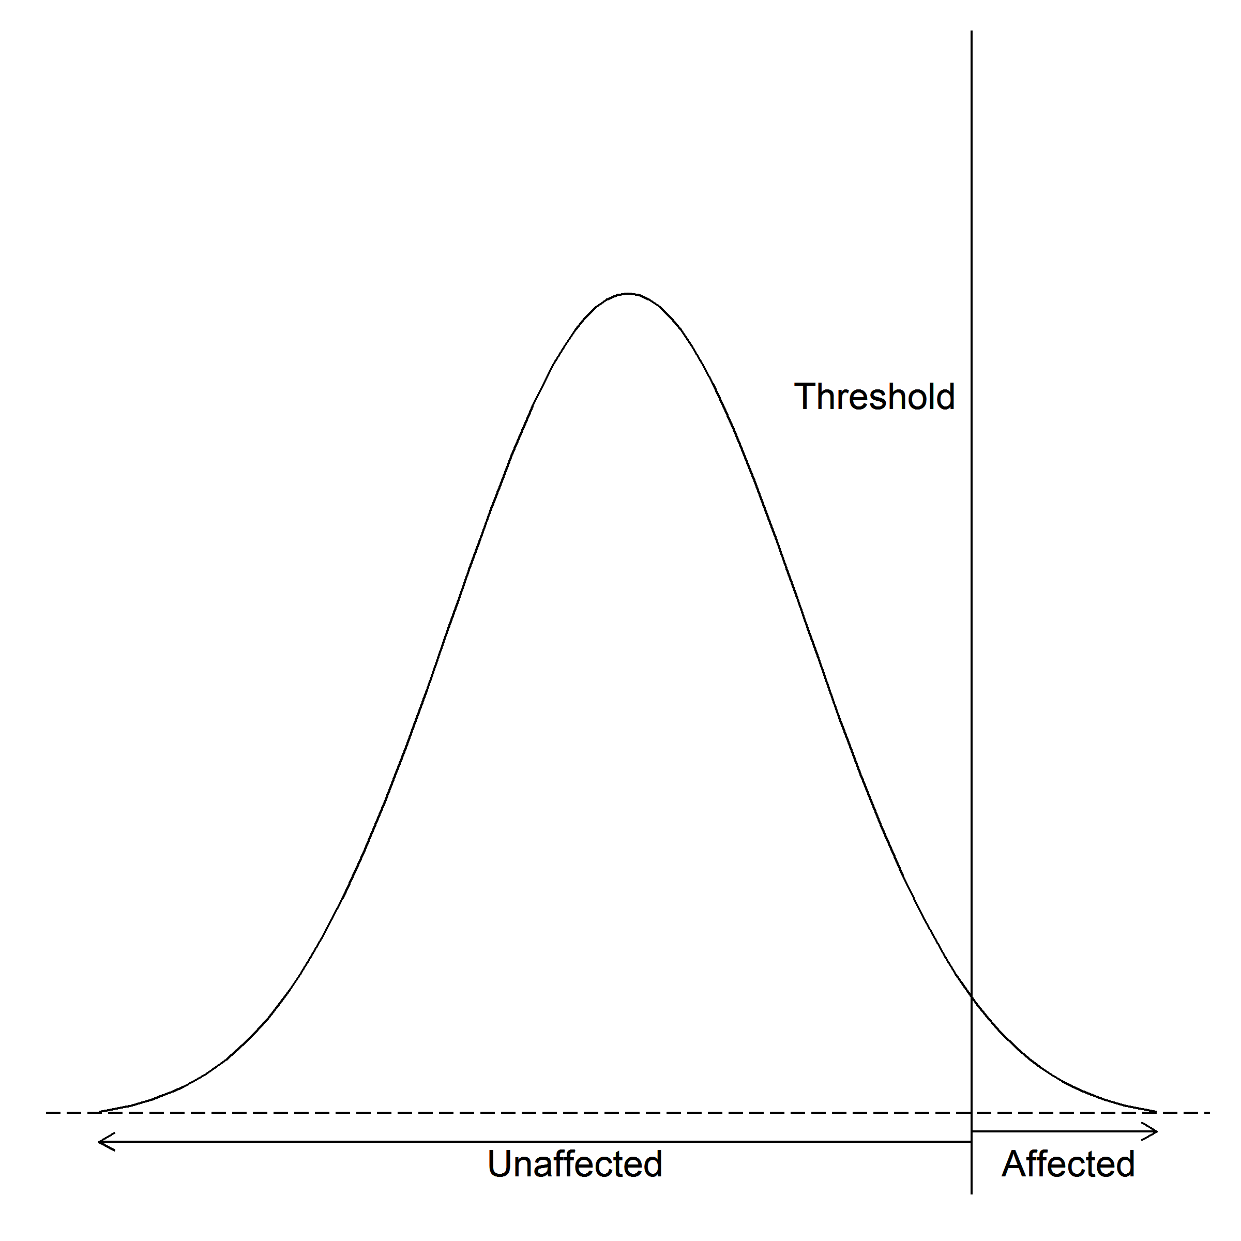

Figure 1: The liability threshold model. Only when an individual has a liability above the liability threshold will he/she be affected.

One can then estimate the heritability of the discontinuous trait by comparing the mean liability of the general population when compared to the relatives of the affected individuals. For example, if we consider a single threshold model of a dichotomous trait, where











by assuming both the liability distribution of the general population and the relative of the index case both follows the standard normal distribution, we can align the two distributions with respect to  and . We can then calculate the mean liability of the index case  as  where  is the density of the normal distribution at the liability threshold . Then we can express the regression of relatives’ liability on the liability of the index case as

 (8)

Thus, by applying eq:liability to eq:finalNarrow, we get

 (9)

### 2.4 Adoption Study

One key limitation of eq:finalNarrow is its inability to discriminate the genetic factors from the shared environmental factors. Such problem arises as family not only share some of their alleles, but they also tends to share some of the environmental factors such as diet and socio-economic status. In fact, this was the main reason for researchers to discord the argument that scz is a genetic disorder.

A classical adoption study carried out by [?] in 1966 investigated whether if the increased risk of scz in relatives of scz was caused by the shared environmental factors or the shared genetic factors. An advantage of adoption studies is that if the child was separated from their family early after birth, then the shared environmental factors should be minimized, thus any resemblance between the parent and child should be driven mainly by the shared genetic factors. [?] collected data of 47 individuals who were born to schizophrenic mothers during the period from 1915 to 1947. They were separated from their mother within three days of birth and sent to a foster family. 50 matched controls were also recruited in this study. It was observed that there was an increased risk of scz in individuals born to schizophrenic mothers when compared to the control groups even-though they were brought up in a different environment as that of their mother. This result suggested that scz is likely driven by the shared genetic factors instead of the shared environmental factors.

### 2.5 Twin Studies

Despite the usefulness of adoption studies in delineating the effect of shared environment from the genetic factors, collection of adoption data are extremely difficult. Moreover, any prenatal influence such as alcohol abuse and malnutrition during pregnancy might confound the results. Therefore, an alternative method would be the twin studies which utilize the relationship between the mz and dz twins.

Theoretically, mz twins share all their genetic components (both additive () and non-additive () genetic factors) and also their common environmental factors () where the only difference between a twin pair is the non-shared environmental factors (). As for the dz twins, they also share the same common environmental factors yet they only share  of their additive genetic factors and  of their non-additive genetic factors. The non-shared environment is also, by definition, not shared among the twins [?]. Based on these assumptions, [?] derived the heritability as

 (10)

where  and  are the phenotype correlation between the mz twins and dz twins respectively.

By combining Falconer’s formula and the concept of liability threshold model, [?] estimated that the heritability of scz to be  based on previously collected twin data, provide strong evidence that the genetic variation contributes more to the variance of scz. The result was further supported by one of the landmark meta-analysis study conducted by [?]. Based on data obtained from 12 published scz twin studies, [?] found that although there is a non-zero contribution of environmental influence on liability of scz (, ci=), there is a much larger contribution from genetics (, ci=), further supporting that scz is largely mediated by the genetic factors.

Such findings are not only limited to twin-studies but were also reported in large scale population based studies. A recent large scale population based study in Sweden population [?] also found that there is a large genetic contribution in scz (). Although the estimated heritability (64% [?] vs 81% [?]) differs between the two studies, there is no doubt that scz is highly heritable.

## 3 Schizophrenia Genetics

Although population-based, adoption and twin studies suggest that scz is highly heritable, little was known about the disease mechanism of scz nor the genetic architecture of the disorder. All data from adoption studies, twin studies and family studies shown that scz does not follow the Mendelian framework [?, ?]. Specifically, shall scz be a Mendelian disorder, then we would expect all mz siblings of the proband to also suffer from scz. However, the life time morbid risk of monozyogitc twins were only  (fig:lifeMRscz) [?], making it unlikely for scz to follow a Mendelian pattern.

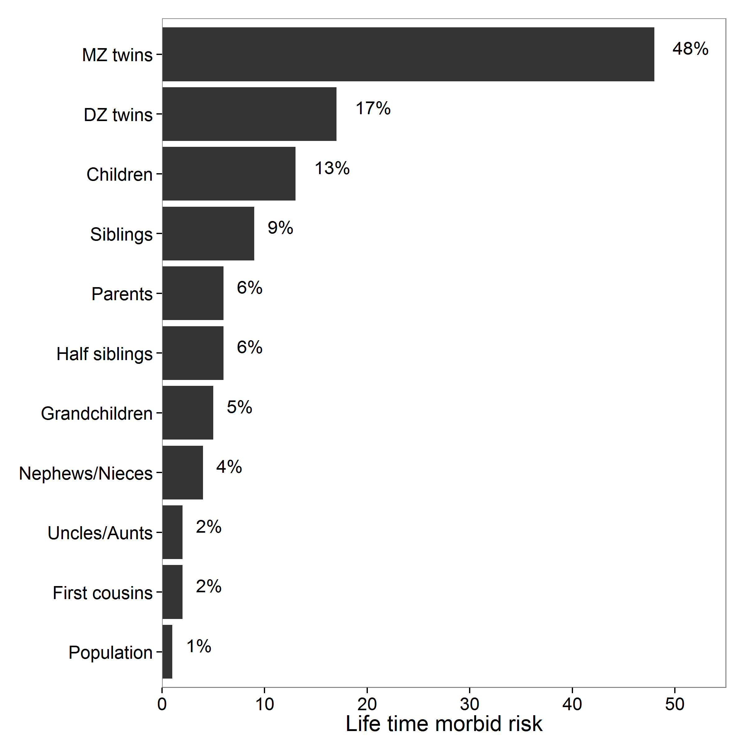

Figure 2: Lifetime morbid risks of scz in various classes of relatives of a proband. It was noted that the morbid risk of monozygotic (MZ) twins were only , much lower than one would expect if scz follows a Mendelian pattern. Reproduced with permission from journal [?].

Based on these observations, [?] proposed that scz follows a polygenic model where disease phenotype were determined by the additive effects from multiple genes. Thus, scz is likely to be a complex genetic disorder with complicated pattern of inheritance.

By comparing the observed life time morbid risk and the expected risk from different models, [?] proposed that the cause variants of scz are more likely to have a risk less than 2 with no loci with risk larger than 3, suggesting a relatively small effect size. Very large samples are therefore required to detect these susceptibility loci through linkage studies [?].

This might explain the early inconsistent findings of linkage studies in scz [?]. As linkage studies were aimed to identify genetic variation of large effect size and usually have a relatively small sample size, it lacks detection power to identify the susceptibility loci with small effect size. The early failure of linkage studies in scz were disappointing and not until the initiation of Human Genome Project, and technological advance resulted from that does genetic research of scz began to enter an era of success.

### 3.1 The Human Genome Project and HapMap Project

SNP LD In 1990, the Human genome project was initiated, aiming at constructing the first physical map of the human genome at per nucleotide resolution [?]. The completion of the human genome project has opened up a new era of genetic research, allowing researchers to identify SNP, which is one of the major source of genetic variation in the human genome.

Soon after the completion of the human genome project, the HapMap Project was initiated [?], aiming to provide a genome-wide database of common human sequence variation such as SNP with maf .

More importantly, the HapMap Project provided a detailed LD map of the human genome. LD is of particular importance to genetic research for it is the non-random correlation of genotypes between 2 genetic loci. SNP in high LD are usually observed together in the human genome. When a large amount of SNP are in high LD together, they form what is known as a LD block. By performing association testing on SNP representing a LD block (“tagging”), one can avoid the need of performing association on the whole genome, therefore reducing the cost of the experiment. This was the fundamental concept of GWAS which is now extensively used in the genetic research.

### 3.2 Genome Wide Association Study

In GWAS, genome-wide genotyping array are commonly used to systematically detect common genetic variants such as SNP and cnv in genome-wide scale. For quantitative traits, the association between the trait and frequency of the variants are calculated using methods such as linear regression. On the other hand, for dichotomous traits such as scz, the frequency of the variants are compared between the case and control samples using methods such as chi-square test or logistic regression. Because of the problem of multiple testing, only variants with a p-value passing a genome wide threshold (p-value ) are considered to be significant in GWAS. Another possible method to decide the significant threshold is to consider the “effective number” of tests [?], which reduced the genome-wide threshold according to the LD structure. When designing a GWAS, one need to take into account of the magnitude of effect, sample size, and required level of statistical significance (the false-positive, or type I, error rate) in order to have a powerful study [?].

#### 3.2.1 The Success of Psychiatric Genomic Consortium

Despite the great promise from GWAS, early GWAS in scz remain largely disappointing and were unable to identify any robust genetic markers associated with scz. The failure of early GWAS in scz were mainly due to the relative small sample size of the studies, which result in low statistical power.

To overcome the problem of small sample size, large consortium were formed such that genetic data from different research groups from different countries were combined and analyzed. By 2014, the scz Working group of the pgc has conducted a multi-stage scz GWAS of up to 36,989 scz samples and 113,075 controls. In their study [?], 128 linkage-disequilibrium-independent SNP were found to exceeded the genome-wide significance (p-value ), corresponding to 108 independent genetic loci. 75% of these loci contain protein coding genes and a further 8% of these loci were within 20kb of a gene. It was found that genes involved in glutamatergic neurotransmission (e.g. *GRM3*, *GRIN2A* and *GRIA1*), synaptic plasticity and genes encoding the voltage-gated calcium channel subunits (e.g. *CACNA1C*, *CACNB2* and *CACNA1I*) were among the genes associated within these loci. Moreover, *DRD2*, the target of all effective anti-psychotic drug were also found to be associated with scz. This result converges with existing knowledge of *DRD2* being involved in the pathology of scz, supported by multiple lines of research [?].

Figure 3: Enrichment of enhancers of SNPs associated with scz. It was observed that the largest enrichment were in cell lines related to the brain and in tissues with important immune functions. Graphs reproduced with permission from the journal [?].

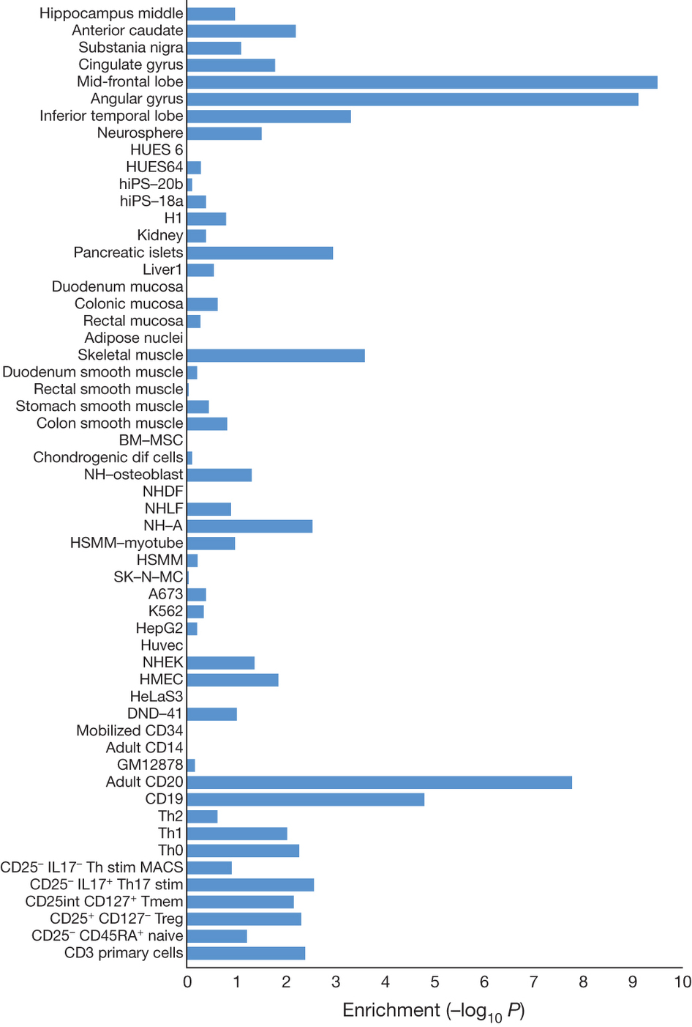 It was further demonstrated that scz association were significantly enriched at enhancers active in brain and enriched at enhancers active in tissues with important immune functions (fig:pgcEnrich)[?].

Additionally, the enrichment of immune related enhancers remains significant even after the removal of mhc region from the analysis, providing further genetic support of the involvement of the immune system in the etiology of scz. Because of its role in neural development [?, ?], it is likely that the perturbation in the immune system might disrupt the brain development, therefore increasing the risk of scz.

Although the pgc scz GWAS is very successful, it is uncertain whether if all common variants associated with scz has been captured. With the unknown number of causal loci with moderate-to-small effect size, many SNP associated with scz may be left undetected given the current sample size. However, it is also possible that the pgc scz GWAS has already captured all or near most of the SNP associated with the disease. Therefore, estimating the contribution of these common SNP to scz has important implications for future research strategy.

### 3.3 Contribution of Common SNPs

In a typical GWAS, a stringent genome wide significant threshold were usually employed to avoid false positive findings. However, if individual SNP have a small effect on the trait, the real association might be missed. Therefore, to estimate the true contribution of common SNP to a disease (SNP-heritability), one should try to consider all SNP in the estimation.

#### 3.3.1 Genome-wide Complex Trait Analysis

Currently, the most popular algorithm for the estimation of SNP-heritability is gcta, which uses information from the grm [?]. The grm represents the “genetic distance” between all individuals within the GWAS. Genetic relationship between individual  and  is estimated as

 (11)

where  is the number of copies of the reference allele for the  SNP of the  individual and  is the frequency of the reference allele. This is based on the fact that genotypes are usually code as 0, 1 or 2 (homozygous reference, heterozygous and homozygous alternative respectively) and should follow the binomial distribution where the expected mean and variance of the genotype  will be  and  respectively. Thus  where  is the standardized genotype for the  SNP of the  individual.

Using the information from the grm, [?] then fit the effects of all the SNP as random effects by a mlm

 (12)

 (13)

where  is an  vector of phenotypes with  samples,  is a vector of fixed effects such as sex and age,  is an  vector of the total genetic effects of the individuals,  is the variance explained by all the SNP and finally,  is the variance explained by residual effects.

The main concept of gcta is that instead of testing the associations for individual SNP, one fit the effects of all SNP as random effects in a mlm and estimate a single parameter, i.e. the variance explained by all SNP or SNP-heritability. Given the information of the grm, [?] implemented the reml using the average information algorithm to estimate the  and  where the reml is a form of maximum likelihood estimation that allows unbiased estimates of variance and covariance parameters. The SNP-heritability of the trait is then defined as .

Based on the above concept, [?] were able to estimate the variance in height explained by SNP from the height GWAS to be around 45%, much larger than previously reported 5%. The main difference in the estimates was because the mlm reml were able to consider all SNP simultaneously without thresholding the significant SNP. Although the estimates was still less than 80% which is the expected heritability of height, [?] was able to demonstrated that one possible source of “missing heritability” might be due to incomplete LD. By taking into consideration of incomplete LD, it was estimated that the proportion of variance explained by causal variants can be as high as 0.84 with se of 0.16 [?], close to the expected heritability. Together, [?] provide a possible method for the estimation of the variance explained by SNP in GWAS data and the method is now implemented in gcta which is wildly adopted.

One limitation of gcta is that genotype data are required to calculate the grm. For complex disease like scz, the data were usually obtained from multiple data source where the raw genotypes are unavailable. Instead, summary statistics are usually provided. Therefore estimation of variance explained by SNP in these GWAS can only rely on the summary statistics.

#### 3.3.2 ldsc

In large scale GWAS studies, a general inflation of summary statistics can sometimes be observed. It was usually considered to be contributed by the presence of confounding factors such as population stratification, under the assumption that most of the SNP should have no association to the disease. It was therefore a common practice for one to perform the gc on the GWAS results [?].

The problem of gc was that the basic assumption of a small number of causal SNP might not be true, especially in complex disease like scz. Through careful simulation, [?] demonstrated that in the absence of population stratification and other form of technical artifacts, the presence of polygenic inheritance can inflate the summary statistic [?]. More importantly, they observed that the magnitude of inflation was determined by the *heritability*, the LD structure, sample size and the number of causal SNP of the trait.

The observation of [?] provide important foundation for the estimation of SNP heritability based on summary statistics where a possible method will be to elucidate the heritability based on the magnitude of inflation of the summary statistics. However, when confounding factors such as population stratification and cryptic relatedness are presented, they can also inflate the summary statistics. Therefore, in order to estimate the SNP-heritability, one must delineate the confounding factors from the polygenicity of the trait.

Based on the work of [?], [?] hypothesized that strength of “tagging” of a SNP should be correlated with the probability of it to “tag” the causal SNP and should be independent to confounding factors such as population stratification and cryptic relatedness. [?] then defined the strength of “tagging” of a SNP as the LD score, which is the sum of  of  SNP within a 1cm window of SNP:

 (14)

Based on their hypothesis, the expected  of association of SNP with the trait can be defined as a function of the LD score (), the number of samples (), the number of SNP in the analysis() and most importantly, the SNP heritability ():

 (15)

When confounding factors presents in the study (e.g. population stratification), eq:fixedLDSC can instead be defined as

 (16)

where  is the contribution of confounding bias.

By considering eq:fullLDSC as a regression model, [?] observed that the contribution of common variants (the SNP heritability ) will be the slope of the regression and the intercept minus one will represent the mean contribution of the confounding bias such as those of population stratification. The ldsc was implemented by [?], using eq:fullLDSC to delineate the contribution from confounding factors and common genetic variants.

To test their hypothesis, [?] simulated multiple GWAS where the trait can have a polygenic architecture or where confounding factors can present. When the simulated trait is polygenic and no confounding factors were presented, the average ldsc intercept was close to one and the estimates were unbiased in all situation. Only when the number of causal variants was small will the standard error of the estimates become very large. On the other hand, when the GWAS was simulated with only the confounding factors such as population stratification, the intercept estimated was approximately equal to the gc inflation factor with only a small positive bias in the regression slope.

Moreover, when a polygenic trait was simulated with confounding factors, the intercept of ldsc was approximately equal to the mean  statistic among the null SNP, providing strong evidence that ldsc can partition the inflation in test statistic even in the presence of both bias and polygenicity.

Given the success of the simulation, [?] estimated the SNP heritability of scz using the summary statistics from the pgc scz GWAS [?] to be 0.555 with se of 0.008 after adjusting for ascertainment bias. The estimated SNP heritability was lower than the heritability estimated from population based study (64% [?]) and twin studies (81% [?]) suggesting that it is possible for variants other than common SNP also account for variations in scz.

#### 3.3.3 Partitioning of Heritability

Another implication of ldsc is that it allows the partitioning of heritability, which helps to identify pathways that are associated with a trait.

Traditionally, functional enrichment analysis in GWAS only take into account of SNP that passed the genome wide significance threshold. However, for complex traits such as scz, much of the heritability might lies in SNP that do not reach genome wide significance threshold at the current sample size. For example, in 2013, only 13 risk loci were detected using 13,833 scz samples and 18,310 controls [?]. When the sample size increased to 34,241 scz samples and 45,604 controls in 2014, 108 risk loci were identified [?]. Thus, if one only consider the significant loci, risk loci that have not reach genome wide significance threshold might be ignored from the analysis, decreasing the power of the functional enrichment analysis.

In order to estimate whether if a functional categories is associated with the trait, ldsc takes into consideration of the summary statistic of all the SNP including in the GWAS. The partitioning of the heritability is then calculated as

 (17)

The main difference between eq:partitionH and eq:fullLDSC is that  is substituted by  where  is the LD Score of SNP  with respect to category  and  is the per-SNP heritability in category .

Using data from [?] and functional categories derived from the ENCODE annotation [?], the NIH Roadmap Epigenomics Mapping Consortium annotation [?] and other studies, [?] attempted to identify functional categories that were most enriched in scz. In their study, it was found that brain cell types and immune related cell types were most enriched in scz. Among the functional categories, the most enriched category in scz was the H3K4me3 mark in the fetal brain(tab:cellTypeScz). As H3K4me3 is mostly linked to active promoters, this suggests that genes that are activated in fetal brain (e.g. genes related to brain development) are associated with scz, supporting the idea of scz as a neuro-developmental disorder. Undoubtedly, the cns and the immune system have an important role in the disease etiology of scz.

|  |  |  |  |
| --- | --- | --- | --- |
| Cell type | cell-type group | Mark | P-value |
| Fetal brain** | CNS | H3K4me3 |  |
| Mid frontal lobe** | CNS | H3K4me3 |  |
| Germinal matrix** | CNS | H3K4me3 |  |
| Mid frontal lobe** | CNS | H3K9ac |  |
| Angular gyrus** | CNS | H3K4me3 |  |
| Inferior temporal lobe** | CNS | H3K4me3 |  |
| Cingulate gyrus** | CNS | H3K9ac |  |
| Fetal brain** | CNS | H3K9ac |  |
| Anterior caudate** | CNS | H3K4me3 |  |
| Cingulate gyrus** | CNS | H3K4me3 |  |
| Pancreatic islets** | Adrenal/Pancreas | H3K4me3 |  |
| Anterior caudate** | CNS | H3K9ac |  |
| Angular gyrus** | CNS | H3K9ac |  |
| Mid frontal lobe** | CNS | H3K27ac |  |
| Anterior caudate** | CNS | H3K4me1 |  |
| Inferior temporal lobe** | CNS | H3K4me1 |  |
| Psoas muscle** | Skeletal Muscle | H3K4me3 |  |
| Fetal brain** | CNS | H3K4me1 |  |
| Inferior temporal lobe** | CNS | H3K9ac |  |
| Hippocampus middle** | CNS | H3K9ac |  |
| Pancreatic islets** | Adrenal/Pancreas | H3K9ac |  |
| Penis foreskin melanocyte primary** | Other | H3K4me3 |  |
| Angular gyrus** | CNS | H3K27ac |  |
| Cingulate gyrus** | CNS | H3K4me1 |  |
| Hippocampus middle** | CNS | H3K4me3 |  |
| CD34 primary** | Immune | H3K4me3 |  |
| Sigmoid colon** | GI | H3K4me3 |  |
| Fetal adrenal** | Adrenal/Pancreas | H3K4me3 |  |
| Inferior temporal lobe** | CNS | H3K27ac |  |
| Peripheralblood mononuclear primary** | Immune | H3K4me3 |  |
| Gastric** | GI | H3K4me3 |  |
| Substantia nigra* | CNS | H3K4me3 |  |
| Fetal brain* | CNS | H3K4me3 |  |
| Hippocampus middle* | CNS | H3K4me1 |  |
| Ovary* | Other | H3K4me3 |  |
| CD19 primary (UW)* | Immune | H3K4me3 |  |
| Small intestine* | GI | H3K4me3 |  |
| Lung* | Cardiovascular | H3K4me3 |  |
| Fetal stomach* | GI | H3K4me3 |  |
| Fetal leg muscle* | Skeletal Muscle | H3K4me3 |  |
| Spleen* | Immune | H3K4me3 |  |
| Breast fibroblast primary* | Connective/Bone | H3K4me3 |  |
| Right ventricle* | Cardiovascular | H3K4me3 |  |
| CD4+ CD25- Th primary* | Immune | H3K4me3 |  |
| CD4+ CD25- IL17- PMA Ionomycin stim MACS Th sprimary* | Immune | H3K4me1 |  |
| CD8 naive primary (UCSF-UBC)* | Immune | H3K4me3 |  |
| Pancreas* | Adrenal/Pancreas | H3K4me3 |  |
| CD4+ CD25- Th primary* | Immune | H3K4me1 |  |
| CD4+ CD25- CD45RA+ naive primary* | Immune | H3K4me1 |  |
| Colonic mucosa* | GI | H3K4me3 |  |
| Right atrium* | Cardiovascular | H3K4me3 |  |
| Fetal trunk muscle* | Skeletal Muscle | H3K4me3 |  |
| CD4+ CD25int CD127+ Tmem primary* | Immune | H3K4me3 |  |
| Substantia nigra* | CNS | H3K9ac |  |
| Placenta amnion* | Other | H3K4me3 |  |
| Breast myoepithelial* | Other | H3K9ac |  |
| CD8 naive primary (BI)* | Immune | H3K4me1 |  |
| Substantia nigra* | CNS | H3K4me1 |  |
| Cingulate gyrus* | CNS | H3K27ac |  |
| CD4+ CD25- CD45RA+ naive primary* | Immune | H3K4me3 |  |
|  | |

Table 2: Enrichment of Top Cell type of Schizophrenia. * = significant at False Discovery Rate  0.05. ** = significant at p  0.05 after correcting for multiple hypothesis. Reproduce with permission from Journal.[?]

### 3.4 Rare Variants in Schizophrenia

cnv The estimated SNP-heritability using the common variants captured by the pgc scz GWAS suggest that variants other than common SNP are accounting for the variation in scz. Based on the “common disease-rare variant” hypothesis, another interesting direction of scz research will be to identify rare variants associated with scz.

#### 3.4.1 Copy Number Variation

A possible source of rare variants can be cnv. cnv are classified as segment of DNA that is 1kb or larger and that is present at a different copy number when compared to the reference genome, usually in the form of insertion, deletion or duplication [?]. Due to the length of these variants, the cnv might contain the entire genes and their regulatory regions which might in turn contribute to significant phenotypic differences [?].

Recently, [?] conducted a GWAS for cnv association with scz using the Swedish national sample (4,719 scz samples and 5,917 controls). In their study, they were able to identify association between scz and cnv such as 16p11.2 duplications, 22q11.2 deletions, 3q29 deletions and 17q12 duplications. Through the gene set association analysis, calcium channel signaling and binding partners of the fragile X mental retardation protein were found to be associated with these cnv [?]. Interestingly, the calcium channel signaling were also enriched in the pgc GWAS on SNP association, suggesting that the variants were converging the same set of pathways or gene sets.

Similarly, [?] also found that genes disrupted by structure variants in their cases were significantly overrepresented in pathways important for brain development, including neuregulin signaling, extracellular signal-regulated kinase/mapk signaling, synaptic long-term potentiation, axonal guidance signaling, integrin signaling, and glutamate receptor signaling [?].

An important observation in these cnv studies was that the cnv were generally rare ( in 4,719 samples [?]) and has a relative large effect (e.g. odd ratio  [?, ?]), following the “common disease-rare variant” model.

#### 3.4.2 Rare Single Nucleotide Mutation

Unlike cnv which affects a large region, rare SNP cannot be captured using current genotyping chips. Therefore, large scale association of rare SNP was unavailable until the development of the ngs technology. The ngs generates high-throughput sequencing data with per base resolution, allow one to investigate the whole human genome or the human exome without relying on “tagging”.

Using exome sequencing, [?] sequenced the exome of 2,536 scz cases and 2,543 normal controls. They were able to identify a common missense allele in *CCHCR1* in the mhc that were associated with scz. Although none of the genes showed a significant burden of rare mutation in cases, a significant increased burden of rare nonsense and disruptive variants was observed in cases in gene sets such as voltage-gated calcium ion channel, genes affected by *de novo* mutations in scz [?] and the postsynaptic density, all of which have been reported to be associated with scz in previous genetic studies [?]

The overlaps between the rare variant studies and the common variant studies suggest that both rare and common variants are likely to be acting upon the same pathway and are complementary to each other.

## 4 Environmental Risk Factors of Schizophrenia

Apart from genetic variants, another possible source of “missing” heritability can come from interaction between the genetic and environmental risk factors. Although previous studies [?] suggested that the non-additive genetic factors were unlikely to contribute to scz, the possibility of involvement of gene-environmental interaction () were not ruled out. Indeed, in the adoption study conducted by [?], it was found that individuals with higher genetic risk were significantly more sensitive to “adverse” vs “healthy” rearing patterns in adoptive families than are adoptees at low genetic risk [?]. Moreover, using the national registers in Finland, [?] found that the effect of prenatal infection was five times greater in those who had a family history of psychosis when compared to those who did not. Together, these findings support a mechanism of gene-environment interaction in the causation of scz.

Many environmental factors have been associated with scz, including prenatal infection [?], winter birth [?], tobacco consumption [?] and socio economic status [?]. They are therefore potential targets for the study of  interaction. However, by and large, the prenatal infection is the largest environmental risk factor of scz and existing evidence suggest that there are indeed an interaction between prenatal infection and genetic variations [?]. It is therefore interesting to investigate how prenatal infection trigger scz and how it interacts with genetic variations in the development of scz.

### 4.1 Prenatal Infection

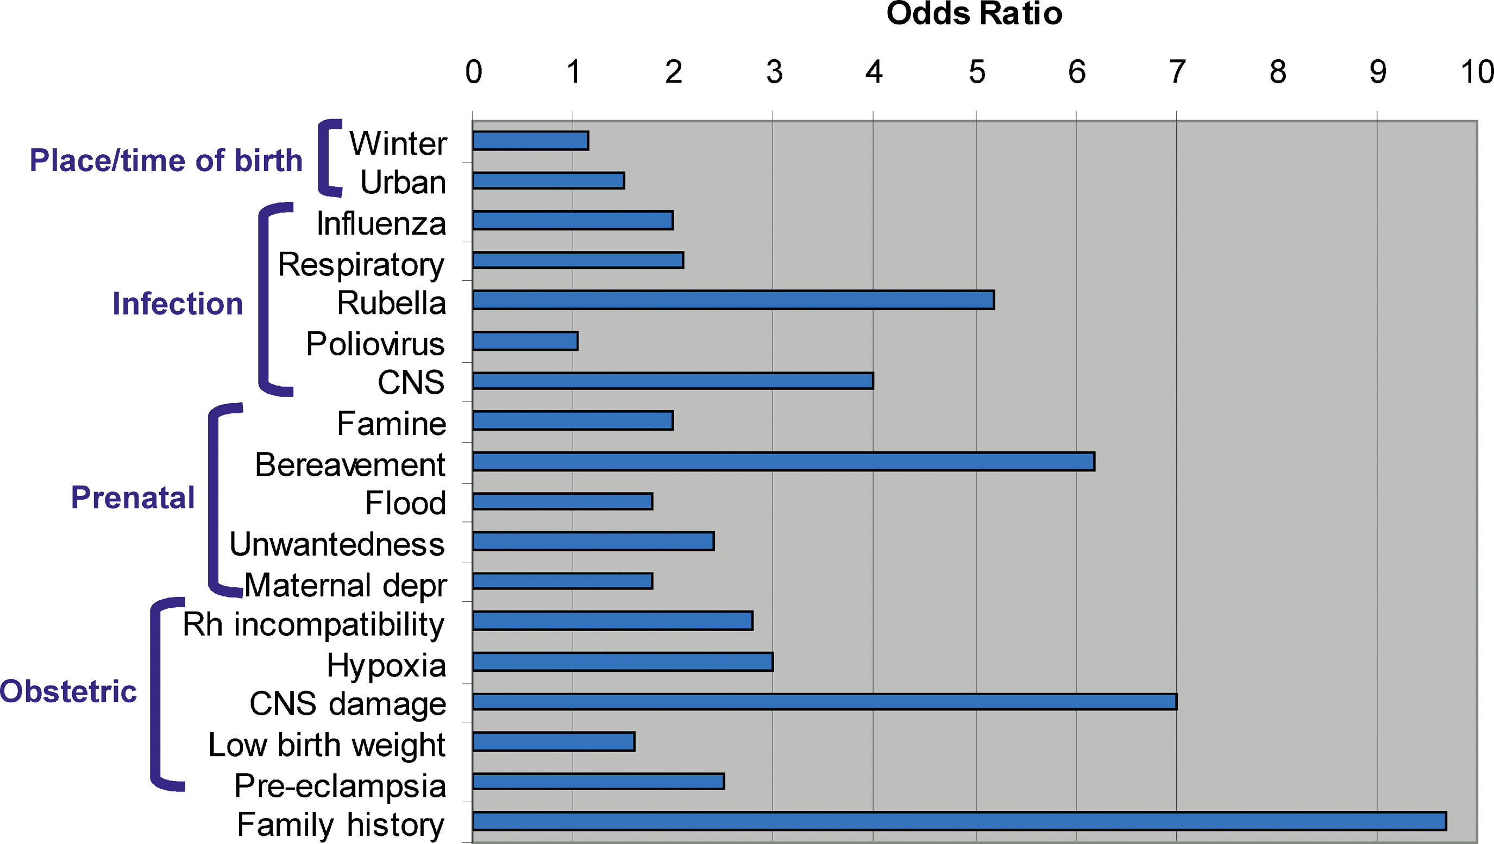

Figure 4: Risk factors of scz. It was observed that family history of scz was the largest risk factors. Risk of scz can be more than 9 times higher than the general population for individual with a family history of scz

Among all the environmental factors, prenatal infection has been considered to be an important risk factor of scz, being the single largest non-genetic risk factor of scz (fig:riskfactors)[?]. Initial clues indicated that births during the winter and spring months and in urban areas were related to an increased risk of the disorder [?]. It was also observed that there was an increased risk of scz in individuals who were fetuses during the 1957 influenza epidemic [?]. As the chance of getting infectious disease varies by season and infectious disease can spread more quickly in urban regions due to higher population density, these evidences suggest that prenatal infection might be associated with scz.

Early studies of prenatal infection in scz mainly relies on ecological data such as influenza epidemics in the population to define the exposure status [?]. The problem of these studies was that the exposure status was based solely on whether an individual was in gestation at the time of the epidemic without any confirmation of maternal infection during pregnancy, leads to difficulties in replication of the findings. Subsequently, researchers uses birth cohorts where infection was documented using different biomarkers during pregnancies to provide a better labeling of the exposure status [?]. Through these rigorous studies, it was found that the risk of scz increases as long as an individual’s mother was infected by any form of infectious agents such as influenza, HSV-2 and *T.gondii* during gestation [?]. As various infectious agents increase the risk of scz, it leads to the hypothesis that mia [?] rather than a particular infectious agents, is the source of risk factor. It was suggested that the maternal immune response disrupt the brain development in the fetus, thus leading to an elevated risk of scz [?].

A great challenge in the study of mia is that one cannot carry out empirical experiment in human samples due to ethical concerns. Thus a popular alternative is to employ rodent models. However, unlike physiological traits, psychiatric disorder such as scz are characterized by symptoms related to higher level functioning such as hallucinations, delusion, disorganized speech etc [?], these traits are not readily detectable in rodents. This raises challenge in diagnosing whether if the rodent has demonstrated the symptoms of scz for not only it was difficult to check whether if the high level functioning of the rodent is disrupted, there were no available biomarkers for scz. Therefore instead of labeling whether if the rodent is “schizophrenic” or “normal”, one would rather consider whether if the rodent demonstrate any “schizophrenia-like” behaviours such as impaired prepulse inhibition, impaired working memory and reduced social interaction [?]. An important point to note here is that as autism and scz shares most of these behavioral abnormality, and that risk of autism is also increased by mia [?], studies using these rodent models were usually non-specific to scz or autism. Rather, autism and scz are usually considered together in these rodent models. However, the discussion of the etiology of autism and the similarity and difference between autism and szc is beyond the scope of the current thesis. Therefore, for the simplicity and focus of the current thesis, we will limit our discussion to scz.

A common rodent model in the study of effect of mia is to use the viral analogue polyic to induce the maternal immune response during pregnancy in rodents. It was found that offspring exposed to polyic displays phenotypes mirrors that observed in schizophrenia [?, ?, ?] such as deficiency in prepulse inhibition [?]. Because polyic only induce the mia without infecting the fetuses, the polyic model provide strong evidence that mia, instead of the specific infection, contributes to the increased risk of scz.

[?] were able to demonstrate that a single injection of il6 to the pregnant mouse can induce scz-like behaviour in the adult offspring. What was most interesting was by eliminating the il6 from the maternal immune response using either genetic methods (il6 knock out) or with blocking antibodies, the behaviour deficits associated with mia were not present in the adult offspring, suggesting that il6 is central to the process by which mia causes long-term behavioral changes.

Further studies of global gene expression patterns in mia-exposed rodent fetal brains [?, ?] suggest that the post-pubertal onset of schizophrenic and other psychosis-related phenotypes might stem from attempts of the brain to counteract the environmental stress induced by mia during its early development [?]. For example, genes with neuroprotective function such as crystallins might also have additional roles in neuronal differentiation and axonal growth [?]. By over-expressing these genes to counteract the environmental stress, the balance between neurogenesis and differentiation in the embryonic brain maybe disrupted. Based on these observations, [?] propose that once the immune activation disappears, the normal brain development programme resumes with a time lag, result in permanent changes in connectivity and neurochemistry that might ultimately leads to scz-like behaviours.

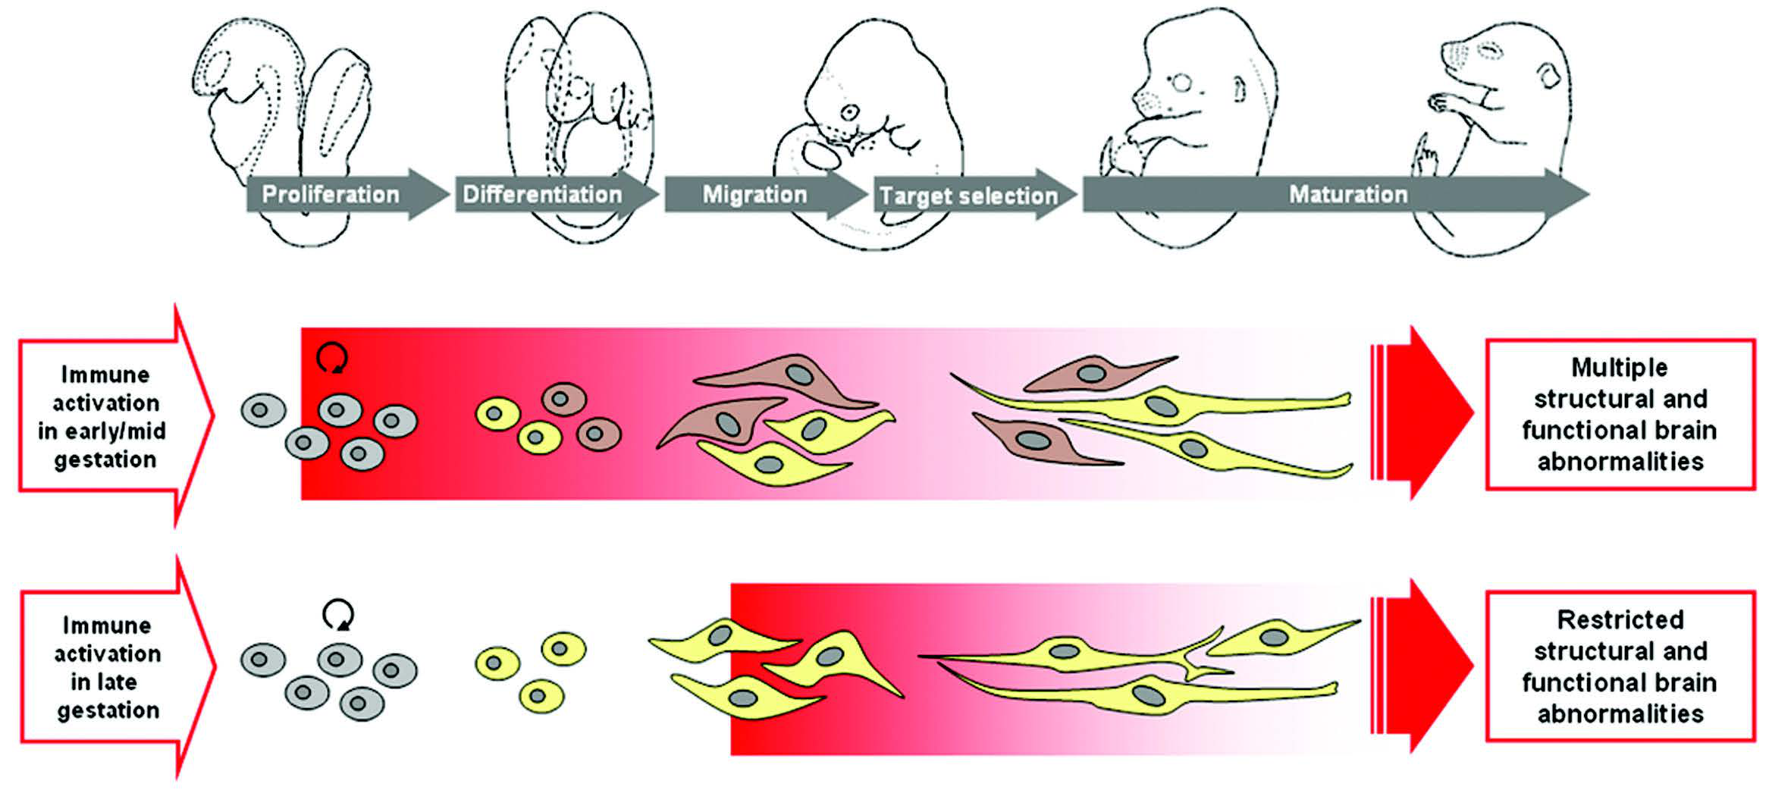

Figure 5: Hypothesized model of the impact of prenatal immune challenge on fetal brain development. Maternal infection in early/mid pregnancy may affect early neurodevelopmental events in the fetal brain, thereby influencing the differentiation of neural precursor cells (grey) into particular neuronal phenotype (yellow or brown). This may predispose the developing fetal nervous system to additional failures leading to multiple structural and functional brain abnormalities in later life. Figure used with permission from Journal [?]

On the other hand, an age dependent structural abnormalities in the mesoaccumbal and nigrostriatal dopamine systems were also found to be induced by mia [?]. Specifically, mia induces an early abnormality in specific dopaminergic systems such as those in the striatum and midbrian region [?]. Based on these observations, [?] hypothesized that inflammation in the fetal brain during early gestation not only can disrupt neurodavelopmental processes such as cell proliferation and differentiation, it also predispose the developing nervous system to additional failures in subsequent cell migration, target selection, and synapse maturation (fig:miaEffect) [?].

In a separate study by [?], mice were exposed to a lower dosage of polyic during early gestation. Offspring born were then left undisturbed or exposed to unpredictable stress during peripubertal development. It was observed that offspring exposed to polyic has an increased level of dopamine in the nucleus accumbens independent to whether if they were exposed to postnatal stress whereas serotonin (5-HT) were decreased in the medial prefrontal cortex when exposed to postnatal stress regardless of prenatal exposure. Only when the offspring were exposed to both polyic and postnatal stress will they have an increased dopamine levels in the hippocampus or will sensorimotor gating and psychotomimetic drug sensitivity be affected [?]. [?] therefore suggest that the prenatal insult serves as a “disease primer” that increase offspring’s vulnerability to subsequent insults.

Together, these results supports the involvement of mia in the development of scz. It was even estimated that one third of all scz cases could have been prevented shall all infection were prevented from the entire pregnant population [?].

One of the critical consideration in the study of mia is the specific gestation period of vulnerability to infection-mediated disturbance [?]. Early epidemiological studies have suggested that the second trimester of human pregnancy might have been the vulnerability period. However, in the birth cohorts such as the Prenatal Determinants of scz, it was found that the time window with maximal risk for infection-mediated disturbance in brain development is earlier than the second trimester of human pregnancy and can be as early as the first trimester [?]. Through the review of existing mia studies on rodent models, [?] suggests that effect of mia during late pregnancy can be restricted to the late developmental programmes, thus have a more restricted pathological phenotype in the grown offspring compared to mia during early pregnancy [?]. Subsequent mia studies using the polyic mouse model also support the hypothesis proposed by [?], where it was observed that mia early in gestation event might exert a more extensive impact on the phenotype of offspring [?, ?].

Despite the more severe impact of mia during early gestation, most mia studies have been focusing on the mid-gestation period and the understanding of the full molecular implication of early mia events in adult brain were lacking. As technology advances, we can now employ the RNA Sequencing technique to examine the global mrna expression changes in the brain of the adult offspring exposed to mia during early gestation.

### 4.2 RNA Sequencing

Before the development of the ngs, one can only inspect the global expression changes using the microarray which is based on probe hybridization. As ngs developed, one can now use poly-T probes to “extract” the mrna fragments and sequence them. The depth of coverage of each gene then provide a general representation of the concentration of the mrna in the cell. When compared to microarray, the RNA Sequencing has a number of advantages, most notably, because RNA Sequencing does not rely on specific probe hybridization, it does not suffer from bias introduced by probe performances such as signal saturation, cross-hybridization, background noises and non-specific hybridization [?]. Moreover, RNA Sequencing has the additional advantage that one can perform not only the differential expression analysis, but also detect alternative splicing events and de novo transcripts.

However, the analysis of RNA Sequencing is more complicated when compared to microarray. The first hurdle in the analysis of RNA Sequencing data is the sequence alignment. RNA sequencing will typically generate sequence reads from the mrna transcripts and one will need to align these reads to either the genome or the transcriptome in order to be able to calculate the depth of coverage for each genes, thus allowing the differential expression analysis. The different alignment strategies have their own pros and cons.

Alignment to transcriptomes are most straightforward as the reads were originated from the transcripts and should have sequence composition similar to the transcriptome. The problem of transcriptome alignment is that multiple isoform can share the same exon, leading to read mapping uncertainties [?]. Without taking into consideration of the uncertainties, the downstream analysis might be biased and inaccurate. When one is only interested in analyzing the gene level expression difference, this complication might be unnecessary.

On the other hand, alignment to the genome should help to reduce the problem of multiple mapping yet it will require a splice aware aligner such as TopHat2 [?], STAR [?] and MapSplice [?]. The reason behind is that as the reads were originated from the mrna where alternative splicing might have occurred, the reads might span multiple exons which are separated by intronic regions. The splicing algorithm will be able to “split” the reads and correctly align them onto the exons. With the accurate alignment, one can then quantify the “expression” of each individual genes.

The expression of a gene is usually represented in terms of number of reads aligned to the gene. Given this information, statistic analysis can then be performed on the count data. Unlike microarray, where the signal usually follows a normal distribution [?, ?], the distribution of the RNA Sequencing count data are more complicated. Early RNA Sequencing experiment assumes the gene expression counts follows the Poisson distribution [?] where the variance is equal to the mean of the expression. However, it was found that the assumption of Poisson distribution is too restrictive where an over-dispersion was typically observed in RNA Sequencing data [?]. Therefore, to overcome the problem of over-dispersion, modern RNA Sequencing statistical package usually models the RNA Sequencing counts using the negative binomial distribution [?, ?] or the beta negative binomial distribution [?] instead of the Poisson distribution.

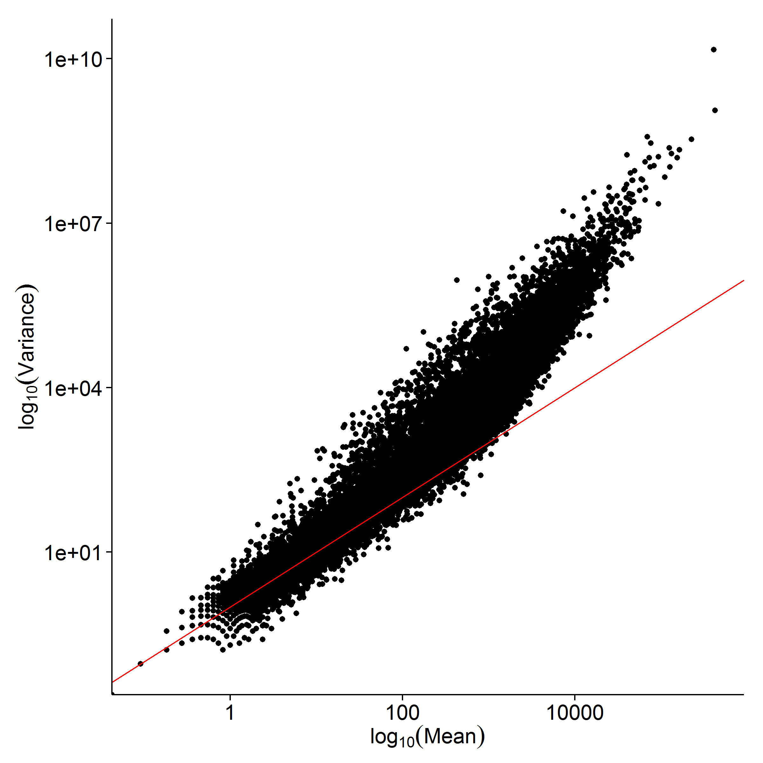

Figure 6: Over-dispersion observed in RNA Sequencing Count Data. If the RNA Sequencing count data follows the Poisson distribution, then the mean and variance of the data should be equal (follow the diagonal). However, it was observed that as the mean increases, the variance increases even more, suggesting that there is an over-dispersion in the data.

Nonetheless, as our knowledge with RNA Sequencing advances, we are getting better in utilizing the information provided by RNA Sequencing and it should serves as an important tool for the analysis of gene expression changes induced by mia event.

## 5 Summary

In this thesis, we would like to first perform a series of empirical simulations to the effect of different genetic architectures and sampling strategies in GWAS to the performance of ldsc, for example, the effect of extreme phenotype samplings. On the other hand, as suggested by [?], under certain conditions such as when the trait is oligogenic, the performance of ldsc might be subpar. Thus we would also like to develop an alternative algorithm for the estimation of SNP heritability that is robust to different genetic architecture. Ultimately, we would like to repeat the analysis by [?] to estimate the true contribution of common SNP to the variance in scz.

Currently, there are evidences suggesting that there might be interaction between prenatal infection and genetic variations in the development of scz [?, ?]. We therefore hypothesize that the differential gene expression induced by mia and genetic mutation might have act upon the same functional pathway. To test this hypothesis, we performed a hypothesis generation RNA Sequencing study to capture gene expression changes induced by early mia events (gd9) in the cerebellum of mouse using the polyic mouse model. Based on the gene expression changes, we hope to identify functional pathways perturbed by early mia events. Most importantly, we would like to test whether if these pathways contribute disproportionately to the heritability of scz. As a result of that, we would also perform the partitioning of heritability using ldsc on the pathways affected by mia.

Moreover, recent study from our lab suggested that n-3 pufa rich diet might help to reduce the scz-like behaviour in mice exposed to early mia insults [?]. Therefore we would also like to take this opportunity to assess the effect of n-3 pufa rich diet on the gene expression pattern in the brain of the adult offspring.

This thesis will be divided into three parts. First, in heritabilityChapter, we performed a series of empirical simulations to assess the performance of ldsc in the estimation of SNP heritability. We also proposed an alternative approach for the estimation of SNP-heritability from GWAS summary statistics that is robust to different genetic architectures.

In omegaProject, a hypothesis generation study was performed to study the effect of mia on the gene expression pattern of mouse cerebellum. On top of that, as recent study suggested that n-3 pufa rich diet can help to reduce the scz-like behaviour observed mouse exposed to early mia [?], we also investigated the effect of n-3 pufa rich diet on the gene expression pattern of mouse cerebellum.

Lastly, we summarize and conclude all findings in conclusionChapter and give future perspectives on the szc research.

# 2 Heritability Estimation

## 1 Introduction

The development of ldsc [?] has allow researchers to estimate the true contribution of common SNP to the variance in different diseases. Its ability in delineating the contributions from confounding factors such as population stratification and common SNP are vital to its success. However, limited simulations were performed by [?] and it is unclear how different sampling strategies (e.g. extreme phenotype sampling) or genetic architectures (e.g. different population prevalence) affect the performance of ldsc.

Moreover, as scz is usually defined as “affected” or “normal”, the estimation of SNP heritability might have to be adjusted for the ascertainment bias introduced by the case control sampling. The ascertainment bias correction is usually performed based on the liability threshold model. However, this adjustment might not be as straightforward as it seems. For example, it has been suggested that gcta, the most popular SNP heritability estimation tools for GWAS, will provide highly biased estimates for case control studies [?]. As [?] did not perform any empirical simulation of the effect of the case control sampling to their estimates, it is therefore important for us to perform empirical simulations to investigate whether if the case control sampling has any impact to the estimates of ldsc.

Finally, as noted by [?], the performance of ldsc can be subpar under certain condition, for example when the trait is oligogenic. We are therefore interested to see if there is a robust algorithm for the estimation of SNP heritability without being affected by the genetic architecture of the trait.

In this chapter, we first introduce shrek, an alternative algorithm to ldsc for the robust estimation of SNP heritability based on GWAS summary statistics. We then perform a series of empirical simulation to test the performance of ldsc and shrek when the trait has different genetic architectures. Most importantly, we would like to repeat the analysis of [?] to estimate the true contribution of SNP to scz using the pgc scz GWAS summary statistics. This would provide us insights into possible direction of future researches in scz.

The work in this chapter were done in collaboration with my colleagues who have kindly provided their support and knowledges to make this piece of work possible. Dr Johnny Kwan, Dr Miaxin Li and Professor Sham have helped to lay the foundation of this study. Dr Timothy Mak has derived the mathematical proof for our heritability estimation method. Miss Yiming Li, Dr Johnny Kwan, Dr Miaxin Li, Dr Desmond Campbell, Dr Timothy Mak and Professor Sham have helped with the derivation of the standard error of the heritability estimation. Dr Henry Leung has provided critical suggestions on the implementation of the algorithm.

## 2 Methodology

It was noted that in GWAS, the summary statistic of a particular SNP should increases with its own effect size and the effect size from all the other SNP in LD with it. Based on this property, we may use the information from the LD matrix and the summary statistic of the GWAS SNP to estimate the SNP heritability.

### 2.1 Heritability Estimation

Remember that the SNP heritability is defined as



where  is the variance of the genotype and  is the variance of the phenotype. In a GWAS, regression were performed between the SNP and the phenotypes, giving

 (18)

where  and  are the standardized phenotype and genotype respectively.  is then the error term, accounting for the non-genetic elements contributing to the phenotype (e.g. environment factors). Based on eq:standardRegress, and by assuming that  to be independent of , one can then have





 (19)

 is then considered as the portion of phenotype variance explained by the variance of genotype, which can also be considered as the SNP heritability of the phenotype.

A challenge in calculating the heritability from GWAS data is that usually only the summary statistic or p-value are provided and one will not be able to directly calculate the heritability based on eq:betaHeri. In order to estimate the heritability of a trait from the GWAS summary statistic, we exploit the fact that when both  and  are standardized,  will be equal to the coefficient of determination (). Thus, based on properties of the Pearson product-moment correlation coefficient:

 (20)

where  follows the student-t distribution under the null and  is the number of samples, one can then obtain the  by taking the square of eq:pearsonProduct

 (21)

Although  follows the F-distribution under the null, it will converge into  distribution when  is large.

Furthermore, when the effect size is small and  is large,  will be approximately  distributed with mean . We can then approximate eq:oriRSquared as

 (22)

and define the *observed* effect size of each SNP to be

 (23)

When there are LD between each individual SNP, the situation will become more complicated as each SNP’ observed effect will be influenced by other SNP in LD with it:

 (24)

To account for the LD structure, we first assume our phenotype  and genotype  are standardized and that





Where  denote a general distribution with mean  and variance  and  is the LD matrix between SNP.

We can then express eq:standardRegress in matrix form:

 (25)

Because the phenotype is standardized with variance of 1, the SNP heritability can then be expressed as



 (26)

If we then assume that  has distribution







where  is the variance of the “true” effect. It is shown that heritability can be expressed as









 (27)

Now if we consider the covariance between SNP () and , we have







 (28)

As both  and  are standardized, the covariance will equal to the correlation and we can define the correlation between SNP and  as

 (29)

In reality, the *observed* correlation usually contains error. Therefore we define the *observed* correlation between SNP and the phenotype to be:

 (30)

for some error . The distribution of the correlation coefficient about the true correlation  is approximately



By making the assumption that  is close to 0 for all , we have





We then define our -statistic and -statistic as







From eq:obsPheno and eq:corPhenoTrue,  can then be expressed as





We have





To derive least square estimates of , we need to find  which minimizes



If we define

 (31)

we got



 (32)

where  and  denotes the element-wise product (Hadamard product). By differentiating eq:leastSquareH with respect to  and set to 0, we get



 (33)

the heritability is then defined as

 (34)

where the  are multiplied to  to get the sum of the vector .

### 2.2 Calculating the se

From eq:fullShrek, we can derive the variance of heritability as

 (35)

Therefore, to obtain the variance of , we first need to calculate the variance covariance matrix of .

If we consider the standardized genotype  with a standard normal mean  and non-centrality parameter , we have



















As the genotypes are standardized, , we can obtain



where  is the LD between SNP and SNP. Given these information, we can then calculate  as:





Remember that , we then have



By definition,



We can then calculate  as















As a result, the variance covariance matrix of the  variances represented as

 (36)

After some tedious algebra, we can get

 (37)

where  from eq:defineF, with the direction of effect as its sign and  is the element-wise product (Hadamard product).

The problem with eq:covH is that it requires the direction of effect. Without the direction of effect, the estimation of se will be inaccurate. If we consider that  is approximately  distributed, we might view eq:shrekEq as a decomposition of a vector of  distributions with degree of freedom of 1. Replacing the vector  with a vector of 1, we will be able to calculate the “effective number”() of the association [?]. Substituting  into the variance equation of non-central  distribution will yield

 (38)

eq:effectiveChi should in theory gives us an heuristic estimation of the se. Moreover, the direction of effect was not required for eq:effectiveChi, reducing the number of input required from the user.

### 2.3 Case Control Studies

When dealing with case control data, we cannot directly use eq:fullShrek to estimate the heritability. Instead, we will need to employ the concept of liability threshold model from sec:liability.

Based on the derivation of [?], the approximate ratio between the ncp obtained from case control studies () and quantitative trait studies() are

 (39)

where











Using this approximation, we can directly transform the ncp between the case control studies and quantitative trait studies. As we are not interested in transforming the ncp between two different studies, the sample size of the case control study () and sample size of the quantitative trait study () will be the same in eq:originNCPTransform, therefore eq:originNCPTransform becomes

 (40)

By combining eq:transform and eq:defineF, we can then have

 (41)

where  is the test statistic from the case control association test. As eq:ccConvert is only eq:defineF multiply with the constant , the heritability estimation of case control studies can be simplified to

 (42)

### 2.4 Extreme Phenotype Sampling

The development of GWAS now provide unprecedented power to perform hypothesis free association throughout the whole genome. However, a challenge for the studies of complex traits is to obtain sufficient sample size with a limited budgets. It is therefore important to design the experiment in a way where sample size can be reduced without affecting the power of the study. A common technique is to perform extreme phenotype sampling in the detection stage of the study. The extreme phenotype sampling will inflate the frequency distortion between samples from the two extreme end of phenotype, thus increase the statistical power [?]. It was estimated that for a 0.5% variant with a fivefold effect in the general population, a discovery studies using extreme phenotype sampling requires four times less samples in the replication to achieve 80% power when compared to studies using random samples [?]. This allows studies to be conducted using a smaller amount of samples with the same degree of power, therefore reducing the cost of the study.

A problem of extreme phenotype sampling was that the variance of the selected phenotype will not be representative of that in the population. The effect size are generally overestimated [?]. Thus, to adjust for this bias, one can multiple the effect size by the ratio between the variance before  and after  the selection process [?], which is equivalent to the multiplication of  to  in eq:defineF.

 (43)

### 2.5 Inverse of the LD matrix

In order to obtain the heritability estimation, we will require to solve eq:fullShrek. If  is of full rank and positive definite, it will be straight-forward to solve the matrix equation. However, more often than not, the LD matrix are rank-deficient and suffer from multicollinearity, making it ill-conditioned, therefore highly sensitive to changes or errors in the input. To be exact, we can view eq:fullShrek as calculating the sum of  from eq:shrekEq. This will involve solving for

 (44)

which requires the inverse of .

In normal circumstances (e.g. when  is full rank and positive semi-definite), one can easily solve eq:shrekInverse using the QR decomposition or LU decomposition. However, when  is ill-conditioned, the traditional decomposition method will fail. Even if the decomposition can be performed, the result tends to be a meaningless approximation to the true .

Therefore, to obtain an unique solution, regularization techniques such as the Tikhonov Regularization (also known as Ridge Regression) and tSVD has to be performed[?]. There are a large variety of regularization techniques, yet the discussion of which is beyond the scope of this study. In this study, we will focus on the use of tSVD in the regularization of the LD matrix. This is because the SVD routine has been implemented in the EIGEN C++ library [?], allowing us to implement the tSVD method without much concern with regard to the detail of the algorithm.

To understand the problem of the ill-conditioned matrix and regularization method, we consider the matrix equation  where  is ill-conditioned or singular with  dimension. The SVD of  can be expressed as

 (45)

where  and  are both orthogonal matrix and  is the diagonal matrix of the *singular values* () of matrix . Based on eq:svd, we can get the inverse of  as

 (46)

Where . we can then represent  as





 (47)

The condition number () of a matrix  can be calculated as . When the condition number is large,  is considered to be ill-conditioned; when the condition number is infinite,  is considered to be singular. Therefore it can be observed that when  is tiny,  is likely to be ill-conditioned and when ,  will be singular.

One can also observe from eq:solveBwithError that when the singular value  is small, the error  in  will be drastically magnified by a factor of . Making the system of equation highly sensitive to errors in the input.

To obtain a meaningful solution from this ill-conditioned/singular matrix , we may perform the tSVD method to obtain a pseudo inverse of . Similar to eq:svd, the tSVD of  can be represented as

 (48)

where  equals to replacing the smallest  singular value by 0 [?]. Alternatively, we can define

 (49)

where  is the tolerance threshold. Any singular value  less than the threshold will be replaced by 0 during the inversion.

By selecting an appropriate , tSVD can effectively regularize the ill-conditioned matrix and help to find a reasonable approximation to . A problem with tSVD however is that it only work when matrix  has a well determined numeric rank [?]. That is, tSVD work best when there is a large gap between  and . If a matrix has ill-conditioned rank, then  will be small. For any threshold , a small error can change whether if  and subsequent singular values should be truncated, leading to unstable results.

According to [?], matrix where its rank has meaning will have well defined rank. The LD matrix is the correlation matrix between each individual SNP, thus the rank of the LD matrix is the maximum number of linear independent SNP in the region. Because the rank has a meaning, the LD matrix is likely to have well-defined rank.

The easiest way to test whether if the threshold  and if the matrix  has well-defined rank is to calculate the “gap” in the singular value:

 (50)

a large gap usually indicate a well-defined gap.

Figure 7: Cumulative Distribution of “gap” of the LD matrix, the vertical line indicate the full rank. It can be observed that there is a huge increase in “gap” before full rank is achieved. Suggesting that the rank of the LD matrix is well defined

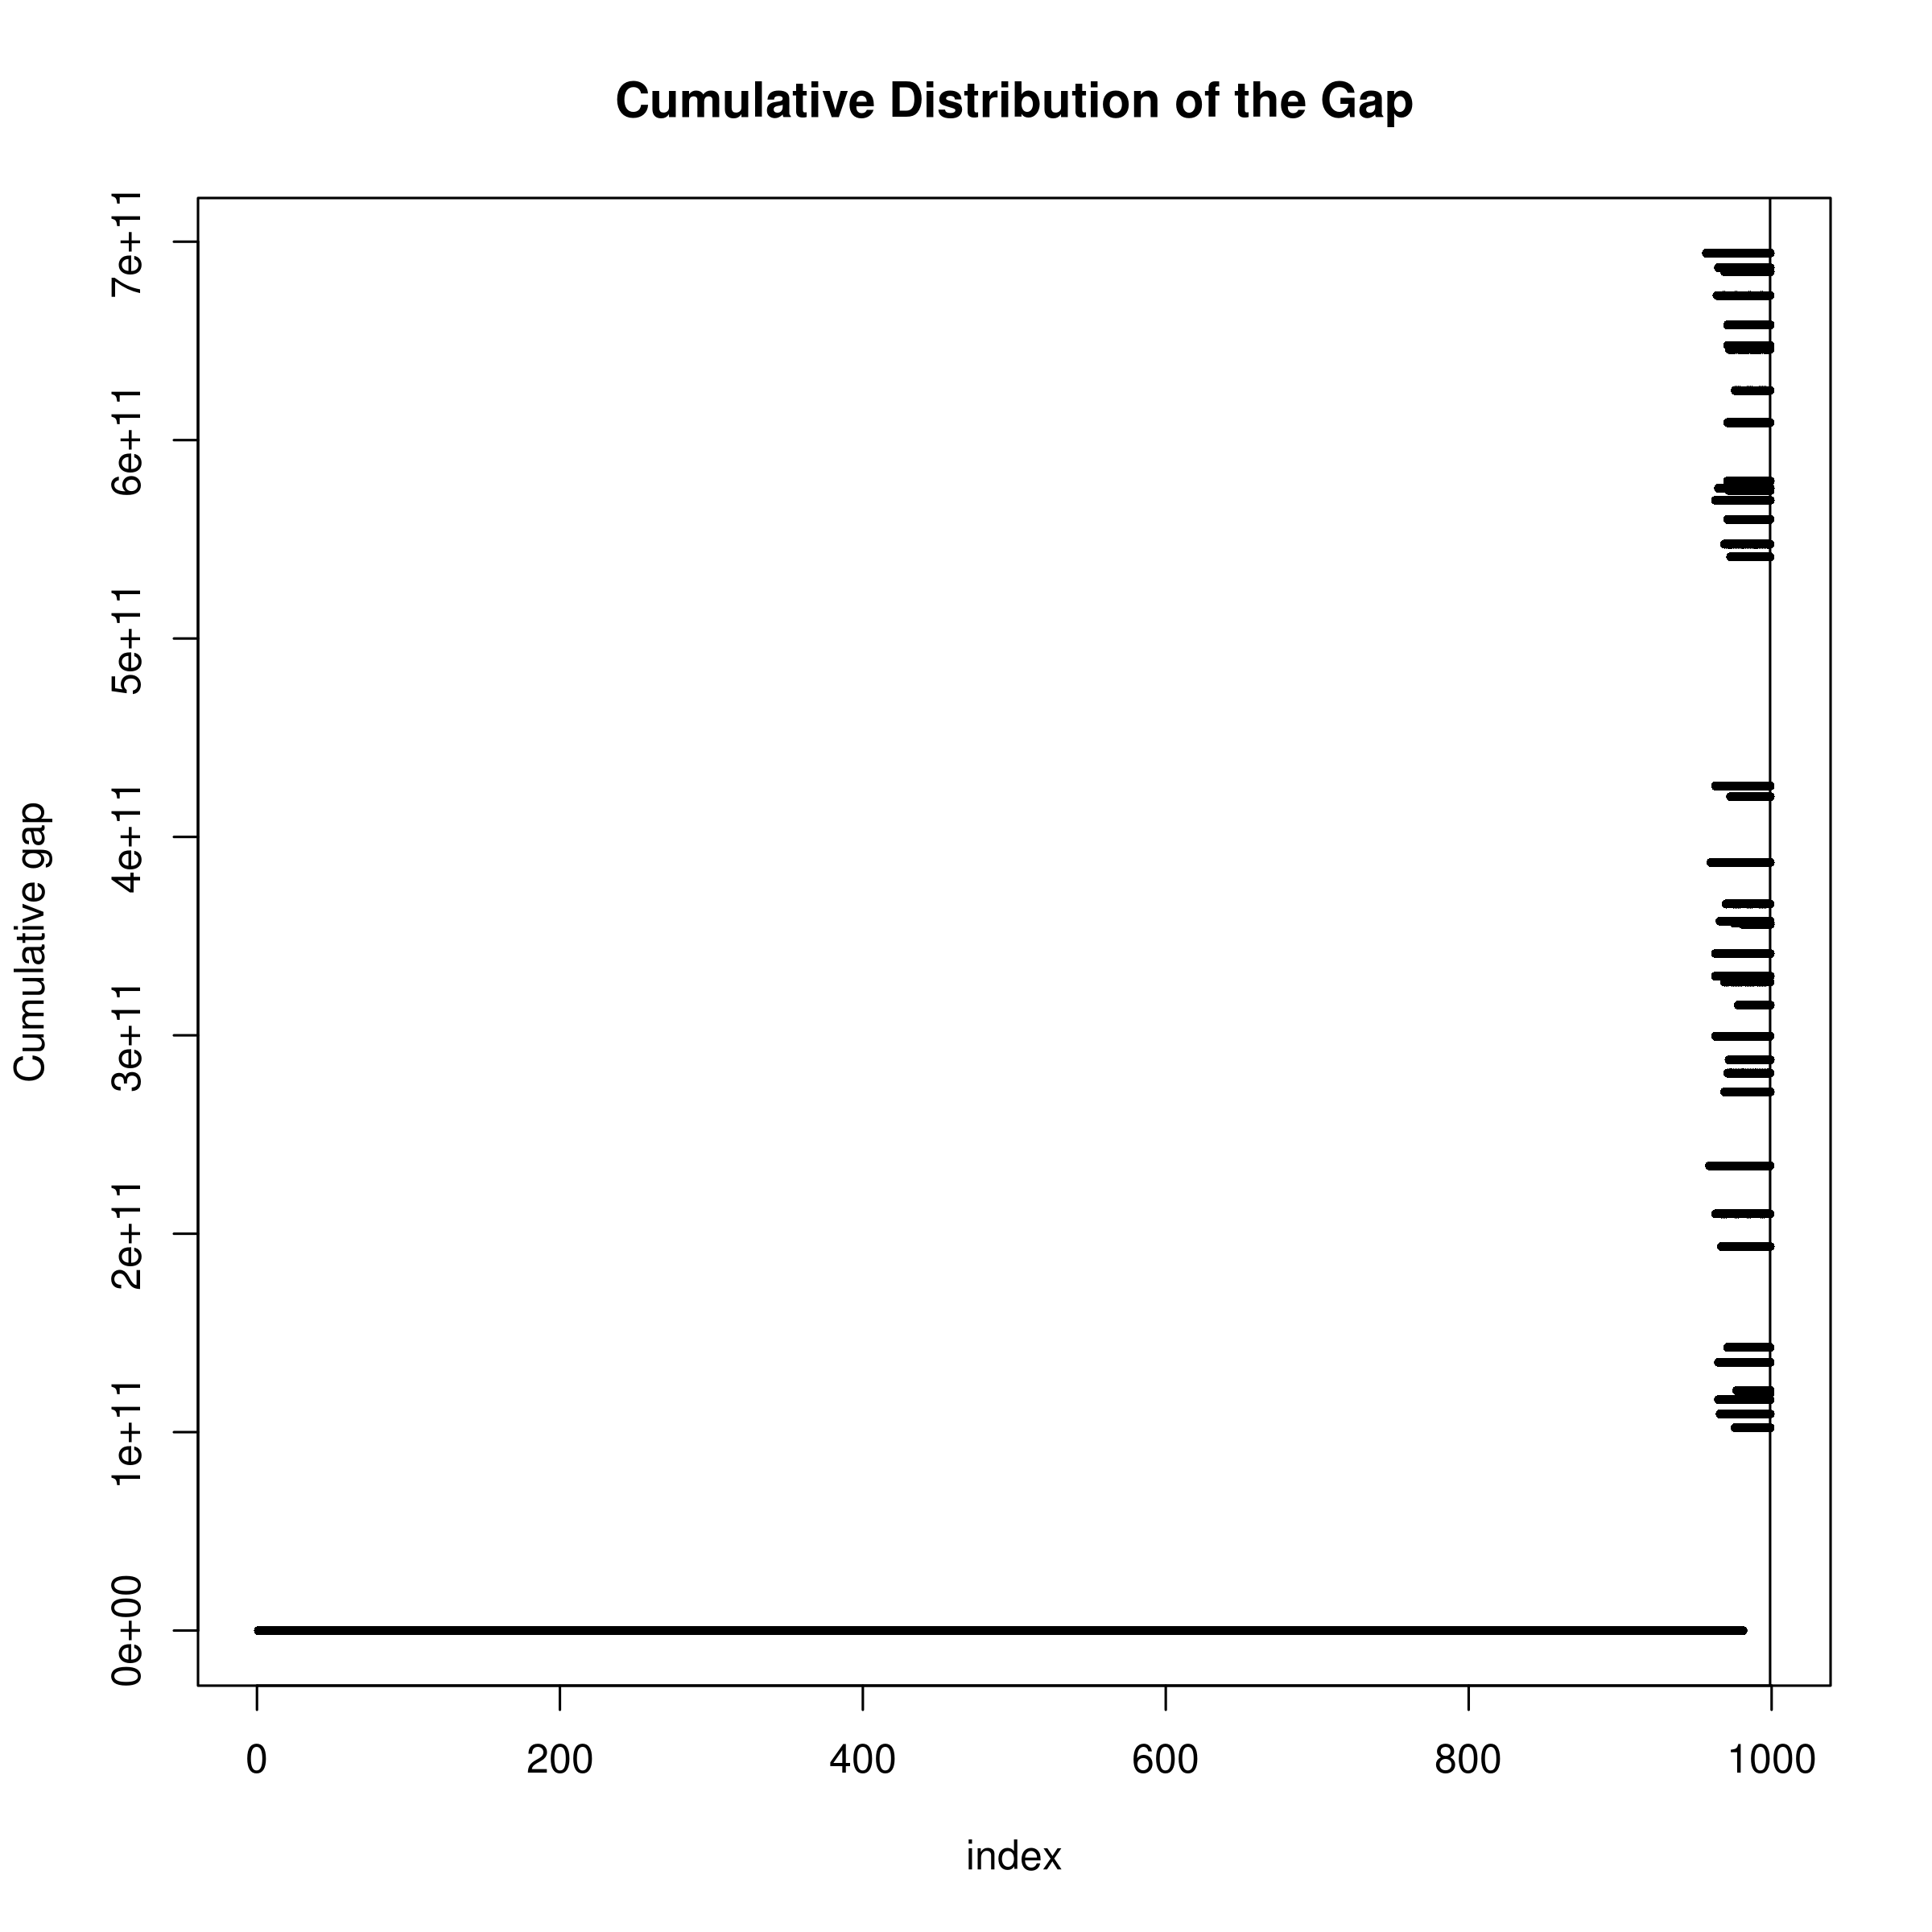

In this study, we adopt the threshold as defined in MATLAB, NumPy and GNU Octave:  where  is the machine epsilon (the smallest number a machine can define as non-zero). And we performed a simulation study to investigate the performance of tSVD under the selected threshold. Ideally, if the “gap” is large under the selected threshold, then tSVD will provide a good regularization to the equation.

1,000 samples were randomly simulated from the HapMap [?] CEU population with 1,000 SNP randomly select from chromosome 22 using HAPGEN2 [?]. HAPGEN2 allow us to simulate samples with LD structure similar to that observed in the reference panel. The LD matrix and its corresponding singular value were calculated. The whole process were repeated 50 times and the cumulative distribution of the “gap” of singular values were plotted (fig:singularValueDist). It is clearly show that the LD matrix has a well-defined rank with a mean maximum “gap” of 466,198,939,298. Therefore the choice of tSVD for the regularization is appropriate.

By employing the tSVD as a method for regularization, we are able to solve the ill-posed eq:shrekEq, and obtain the estimated heritability.

### 2.6 Implementation

Our algorithm was implemented using C++ programming languages (version C++11) and the matrix algebra was performed using the EIGEN C++ header library [?]. In spite of the fact that the Armadillo library [?] is much faster in the calculation of SVD when compared to EIGEN [?], the speed can obly be achieved when addition libraries such as OpenBLAS were installed. The use of EIGEN therefore simplify the programme installation, making it more user friendly.

Although tSVD allow one to approximate the ill-posed eq:shrekEq, it is an  algorithm, making the computation run time prohibitive when the number of SNP is large. Unfortunately, the number of SNP in a GWAS is generally large, making it impossible for one to calculate the tSVD of the whole genome at once.

If we consider eq:svd, the matrix  and  are the eigenvectors of  and  respectively. So for any symmetric matrix such as that of the LD matrix,  and  should be the same. Thus eq:svd reduce into the problem of eigenvalue decomposition where the singular values are the magnitude of the eigenvalues. Although the eigenvalue decomposition is still an  algorithm, it has a smaller constant, therefore has a faster run time when compared to the computation of SVD.

However, even with the use of eigenvalue decomposition in place of SVD, the size of the LD matrix is still too big for a feasible computation. Given that it is unlikely for inter chromosomal LD to exists or for SNP 1mb apart to be in LD with each other, one can safely assume SNP more than 1mb apart or SNP on different chromosomes are independent of each other. We therefore separate SNP into 1mb bins where start of each bin are at least 1 mb away from each other. Three bins are then combined to form one window, and we perform the decomposition on each windows using eq:shrekEq and only update the  for the bin forming the center of the window. We then transverse the genome with step size of 1 bin until  for all bins were computed. By breaking down the genome into windows, we were able to reduce the matrix dimension which makes the analysis feasible. Users can also choose distance other than 1mb as the distance between bins, allowing for a more flexible usage of the algorithm.

### 2.7 Comparing with ldsc

Conceptually, the fundamental hypothesis of ldsc and our algorithm were quite different. ldsc were based on the “global” inflation of test statistic and its relationship to the LD pattern. ldsc hypothesize that the larger the LD score, the more likely will the SNP be able to “tag” the causal SNP and the heritability can then be estimated through the regression between the LD score and the summary statistic.

On the other hand, our algorithm focuses more on the per-SNP level. Our main idea was that the individual test statistic of each SNP is a combination of its own effect and effect from SNP in LD with it. Thus, based on this concept, our algorithm aimed to “remove” the inflation of test statistic introduced through the LD between SNP and the heritability can be calculated by adding the test statistic of all SNP after “removing” the inflation.

Mathematically, the calculation of ldsc and our algorithm were also very different. ldsc take the sum of all  within a 1cM region as the LD score and regress it against the test statistic to obtain the slope and intercept which represent the heritability and amount of confounding factors respectively. In their model, ldsc assume that each SNP will explain the same portion of heritability

 (51)









As for our algorithm, the whole LD matrix were used and inverted to decompose the LD from the test statistic. There were no assumption of the amount of heritability explained by each SNP. However, our algorithm does assumed that the mean of the  test statistic to be one (e.g. no inflation in the summary statistics), thus our estimation might inflates shall there be any confounding factors in the GWAS summary statistics.

## 3 Comparing Different LD correction Algorithms

Another important consideration in our algorithm is the bias in LD. In reality, one does not have the population LD matrix, instead we have to estimate the LD based on various reference panels such as those from the 1000 genome project [?] or the HapMap project [?]. These reference panels were a subsamples from the whole population and therefore LD estimated from the reference panels usually contains sampling bias. Under normal circumstances, because the symmetric nature of sampling error, one would expect there to be little to no bias in the estimated LD. However, in our algorithm, the  is required for the estimation of heritability (eq:fullShrek). Because we were using the squared LD, the sampling error will also be squared, generating a positive bias.

On average, there were around 500 samples for each super population from the 1000 genome project reference panel. Given the relatively small sample size, the sampling bias might be large, therefore lead to systematic bias in the heritability estimation in our algorithm.

To correct for the bias, we would like to apply a LD correction algorithm to correct for the bias in the sample LD. Different authors [?, ?] have proposed methods for the correction of sample  and can be applied for the correction of sample bias in LD. Therefore we considered the following  correction algorithms:

 (52)

 (53)

 (54)

 (55)

 (56)

where  is the number of samples used to calculate the ,  is the sample  and  is the corrected .

In order to assess the performance of each individual correction methods, we perform simulations to compare the performance of our algorithm using different LD bias correction algorithms. Most importantly, we would like to assess the performance of different algorithms not only under one specific LD range, but also under the complex LD structure observed in real life scenarios. First, 5,000 SNP with maf  were randomly selected from chromosome 22 from the 1000 genome CEU haplotypes and were used as an input to HAPGEN2 [?] to simulate 1,000 individuals. HAPGEN2 is a simulation tools which simulates new haplotypes as an imperfect mosaic of haplotpyes from a reference panel and the haplotypes that have already been simulated using the *Li and Stephens* (LS) model of LD [?]. This allow us to simulate genotypes with LD structures comparable to those observed in CEU population. Of those 5,000 SNP, 100 of them were randomly selected as the causal variant. [?] suggested that the exponential distribution can be used to approximate the genetic architecture of adaptation. As a result of that, we used the exponential distribution with  as an approximation to the effect size distribution:



 (57)

with a random direction of effect. The simulated effects were then randomly distributed to each causal SNP.

Using the normalized genotype matrix of the causal SNP of all individuals () and the vector of effect size (), we can simulate a phenotype with target heritability of  as





 (58)

To simulate the whole spectrum of heritability, we varies the target  from 0 to 0.9 with increment of 0.1.

The summary statistics of association between the genotype and phenotype were then calculated using PLINK [?]. Resulting summary statistic were then input to our algorithm to estimate the heritability, using different LD correction algorithms. An independent 500 samples, a size roughly correspond to the average sample size of each super population form the 1,000 genome project, were simulated as a reference panel for the calculation of LD matrix. This is because in reality, one usually does not have assess to the sample genotype and has to rely on an independent reference panel for the calculation of LD matrix. Thus this simulation procedure should provide a realistic representation of how the algorithm will be commonly used in real life scenario.

The whole process were repeated 50 times such that a distribution of the estimate can be obtained. In summary, we simulate a large population of samples (e.g. ) where 500 samples were randomly selected as a reference panel. In the subsequent iteration of simulation, 1,000 samples were randomly selected from the population *without replacement* and estimation were performed.

1. Randomly select 5,000 SNP with maf from chromosome 22

2. Simulate 500 samples using HAPGEN2 and used as a reference panel

3. Randomly generate 100 effect size with following eq:randomEffect

4. Randomly assign the effect size to 100 SNP with heritability from 0 to 0.9 (increment of 0.1)

5. Simulate 1,000 samples using HAPGEN2 and calculate their phenotype according to eq:simulationOfPhenotype

6. Perform heritability estimation using our algorithm with different ways of LD correction

7. Repeat step 5-6 50 times

## 4 Comparison with Other Algorithms

After identifying the optimal LD correction algorithm, we would like to compare our algorithm to existing methods for the performance in estimating the SNP-heritability. It is important for us to consider most if not all conditions in our simulation. Therefore, we would like to simulate quantitative traits and case control studies with different number of causal SNP; quantitative traits with extreme effect sizes; and last but not least, quantitative traits with extreme phenotype sampling.

Currently, the only other algorithm that is capable to estimate the SNP-heritability using only summary statistic from GWAS is the ldsc [?] whereas gcta [?] is the most commonly used programme for the estimation of SNP-heritability from GWAS data. Therefore, we choose to compare the performance of our algorithm to that of ldsc and gcta. It is important to note that we did not simulate any confounding factors. However, for ldsc, the default intercept estimation function allows it to estimate and correct for confounding factors with an increase in se. The simulation will therefore be unfair to ldsc with intercept estimation, as the se is increased yet there are little confounding factors for it to correct. Thus, we also compared results from ldsc with a fixed intercept (--no-intercept) parameters to avoid bias against ldsc.

### 4.1 Sample Size

One important consideration in our simulation was the sample size of the simulated GWAS study. The sample size is the most important parameter in determining the standard error of the estimate. As sample size increases, study will be more representative of the true population. The increased number of information also means a better estimation of parameters, therefore a smaller se. Based on the information from GWAS catalog [?], we calculate the sample size distribution using simple text mining and exclude studies with conflicting sample size information in multiple entries. The average sample size for all GWAS recorded on the GWAS catalog was 7,874, with a median count of 2,506 and a lower quartile at 940 (fig:gwasCata). We argue that if the algorithm works for studies with a small sample size (e.g lower quartile sample size), then it should perform even better when the sample size is larger. Thus, we only simulate 1,000 samples in our simulation, which roughly represent the lower quartile sample size range.

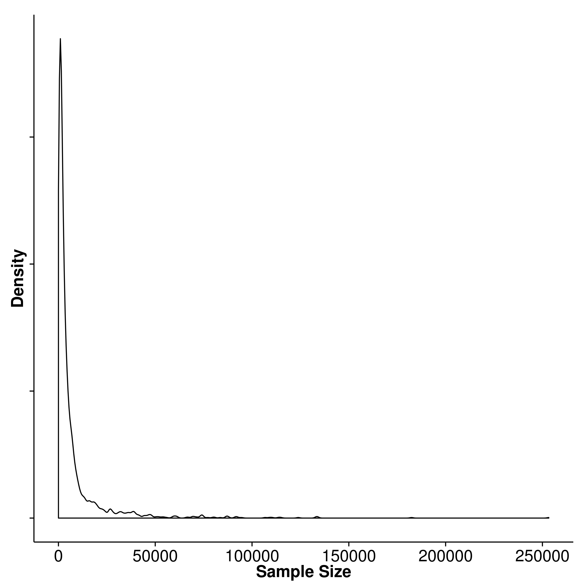

GWAS sample size distribution.

### 4.2 Number of SNPs in Simulation

Another consideration in the simulation was the number of SNP included. In a typical GWAS study, there are usually a larger number of SNP when compared to the sample size. For example, in the pgc scz GWAS, more than 9 million SNP were included, with around 700,000 SNP on chromosome 1. In reality, the estimation of SNP heritability based on 700,000 SNP can be done quickly. However, in our simulation, we will repeat the calculation  times for *each* condition tested. The time required to finish all the simulation becomes infeasible given the large amount of SNP. To compromise, we simulate a total of 50,000 SNP from chromosome 1 as a balance between run time of simulation and the total SNP simulated. With 50,000 SNP, there are roughly 200 SNP within a 1 mb region.

### 4.3 Genetic Architecture

Of all simulation parameter, the genetic architecture was the most complicated and important parameter. The LD pattern, the number of causal SNP, the effect size of the causal SNP and the heritability of the trait are all important factors contributing to the genetic architecture of a trait.

First and foremost, because the aim of the algorithm is to estimating the heritability of the trait, it is important that the algorithm works for traits from different heritability spectrum. We therefore simulated traits with heritability ranging from 0 to 0.9, with increment of 0.1.

Secondly, in real life scenario, the “causal” variant might not be readily included on the GWAS chip and are only “tagged” by SNP included on the GWAS chip. However, to simplify our simulation, all “causal” variants were included in our simulation (e.g. perfectly “tagged”).

Thirdly, to obtain a realistic LD pattern, we simulate the genotypes using the HAPGEN2 programme [?], giving the 1000 genome CEU haplotypes as an input. In a typical GWAS , one usually only have power in detecting “common variants”, defined as variants with maf . We therefore only consider scenario with “common” variants and only use SNP with maf  in the CEU haplotypes as an input to HAPGEN2 to simulate 1,000 samples.

Finally, we would like to simulate traits with different inheritance model such as oligogenic traits and polygenic traits. We therefore varied the number of causal SNP () with . The effect size were then simulated using eq:randomEffect and the phenotype were simulated using eq:simulationOfPhenotype.

For gcta, the sample genotypes were provided to calculate the genetic relationship matrix and the sample phenotypes were used in combination with the genetic relationship matrix to estimate the heritability.

On the other hand, for ldsc and our algorithm, an independent 500 samples were simulated as the reference panel for the calculation of LD scores and LD matrix, mimicking real life scenario where an independent reference panel were used. The genotype association test statistics calculated from PLINK and the LD score / LD matrix were then used for the estimation of SNP heritability for ldsc and our algorithm respectively.

The whole process were be repeated 50 times such that a distribution of the estimate can be obtained. 10 independent population were simulated and the whole processed were repeated. In summary, the simulation follows the following procedures:

1. Randomly select 50,000 SNP with maf from chromosome 1

2. Simulate 500 samples using HAPGEN2 to be served as a reference panel

3. Randomly generate  effect size with  following eq:randomEffect, with heritability ranging from 0 to 0.9 (increment of 0.1)

4. Randomly assign the effect size to  SNP

5. Simulate 1,000 samples using HAPGEN2 and calculate their phenotype according to eq:simulationOfPhenotype

6. Perform heritability estimation using our algorithm, gcta, ldsc with fixed intercept and ldsc with intercept estimation.

7. Repeat step 5-6 50 times

8. Repeat step 1-7 10 times

### 4.4 Extreme Effect Size

On top of the original quantitative trait simulation, another condition we were interested in was the performance of the algorithms when there is a small amount of SNP with a much larger effect size. This can be observed in disease such as Hirschsprung’s disease. The Hirschsprung’s disease is a congenital disorder where deleterious mutations on *RET* account for  of the familial cases yet there is still missing heritability, suggesting that there might be more variants with small effects that have not been identified [?].

To simulate extreme effect size, we considered scenarios where  SNP accounts 50% of all the effect size with . The effect size was then calculated as





 (59)

The effect size were then randomly assigned to 100 causal SNP and phenotype will be calculated as in eq:simulationOfPhenotype. The simulation procedure then becomes

1. Randomly select 50,000 SNP with maf  from chromosome 1

2. Simulate 500 samples using HAPGEN2 and used as a reference panel

3. Randomly generate 100 effect size where  has extreme effect, following eq:extremEffect, with 

4. Randomly assign the effect size to 100 SNP

5. Simulate 1,000 samples using HAPGEN2 and calculate their phenotype according to eq:simulationOfPhenotype

6. Perform heritability estimation using our algorithm, ldsc with fixed intercept, ldsc with intercept estimation and gcta

7. Repeat step 5-6 50 times

8. Repeat step 1-7 10 times

### 4.5 Case Control Studies

The simulation of case control studies was similar to the simulation of quantitative trait. However, there were two additional parameters to consider: the population prevalence and the observed prevalence. These parameters were required to simulate the samples under a liability model for case control studies.

Although there were only two additional parameter, it is significantly more challenging for to simulate when compared to the simulation of quantitative traits. It is mainly because of the number of samples required to simulate under the liability threshold model. Take for example, if one would like to simulate a trait with population prevalence of  and observed prevalence of  and would like to have  cases in total, one will have to simulate  samples. Considering the scenario where the observed prevalence is , the population prevalence is , if we want to simulate 1,000 cases, a minimum of 100,000 samples will be required.

Given limited computer resources, it will be infeasible for us to simulate 1,000 cases with 50,000 SNP when the population prevalence is small (e.g. 1%). To simplify the simulation and reduce the burden of computation, we limited the observed prevalence to 50% and varies the population prevalence  such that . Most importantly, we reduce the number of SNP simulated to 5,000 on chromosome 22 instead of 50,000 SNP on chromosome 1. The change from chromosome 1 to chromosome 22 allow us to reduce the number of SNP without significantly changing the SNP density. We acknowledged that the current simulation was relatively brief, however, it should serves as a proof of concept simulation to study the performance of the algorithms under the case control scenario.

In the case control simulation, we randomly selected 5,000 SNP from chromosome 22 with maf  in the CEU haplotypes as an input to HAPGEN2. We then randomly selected  SNP where , each with effect size simulated based on eq:randomEffect. In order to simulate a case control samples with 1,000 cases, we then simulated  samples and calculate their phenotype using eq:simulationOfPhenotype. The phenotype was then standardized and cases were defined as sample with phenotype passing the liability threshold with respect to . An equal amount of samples were then randomly selected from samples with phenotype lower than the liability threshold and defined as controls.

Finally, the case control simulation were performed as:

1. Randomly select 5,000 SNP with maf from chromosome 22

2. Simulate 500 samples using HAPGEN2 and used as a reference panel

3. Randomly generate  effect size following eq:randomEffect where 

4. Randomly assign the effect size to  SNP

5. Simulate  samples using HAPGEN2 and calculate their phenotype according to eq:simulationOfPhenotype

6. Define case control status using the liability threshold and randomly select the same number of case and controls for statistic analysis

7. Perform heritability estimation using our algorithm, ldsc with fixed intercept, ldsc with intercept estimation and gcta

8. Repeat step 5-7 50 times

9. Repeat step 1-8 10 times

### 4.6 Extreme Phenotype Sampling

With a limited budget, it is usually difficult to obtain adequate sample size for a GWAS, leading to studies with insufficient power. A possible approach was to perform the extreme phenotype sampling that only select samples with phenotypes on the extreme end of the distribution. The extreme phenotype sampling may allow one to obtain the same degree of power using a smaller sample size. It is therefore interesting to see how the selection of extreme phenotype will affect the performance of the SNP heritability estimation.

Herein, we performed simulations on extreme phenotype sampling. 50,000 SNP with maf  were selected from chromosome 1 and were used as an input for HAPGEN2 similar to that in the quantitative trait simulation. 500 samples were first simulated to serves as the reference panel.

From the 50,000 SNP we randomly select 100 as the causal SNP and their effect was simulated based on eq:randomEffect. We then simulated  samples where  is the portion of extreme samples selected (e.g. 0.1 or 0.2). Phenotype of the individuals were then simulated using eq:simulationOfPhenotype and were standardized. 500 samples were selected at both end of the phenotype distribution (500 top and 500 bottom, total of 1,000) and were used for the statistical analysis. To compare the performance of extreme phenotype sampling and the general random sampling strategies, we also drawn 1,000 samples from the  samples at random and perform statistic analysis on them. At the end, we compared the heritability estimated from samples using the two different strategies and the whole procedure was repeated 50 times.

It was noted that the extreme phenotype sampling were not supported by the ldsc and gcta. To allow comparison in such scenario, we applied the extreme phenotype adjustment from [?] to the estimates obtained from ldsc and gcta. In summary, the following simulation procedures were used:

1. Randomly select 50,000 SNP with maf from chromosome 1

2. Simulate 500 samples using HAPGEN2 and used as a reference panel

3. Randomly generate 100 effect size following eq:randomEffect, with heritability ranging from 0 to 0.9 (increment of 0.1)

4. Randomly assign the effect size to 100 SNP

5. Simulate  samples using HAPGEN2 where  is the portion of extreme samples selected and 

6. Phenotype of the samples were calculated according to eq:simulationOfPhenotype and were standardized

7. Top 500 and bottom 500 samples (ranked by phenotype) were selected, representing the extreme phenotype sample selection strategy

8. 1,000 samples were also randomly selected to represent the general random sampling strategy

9. Perform heritability estimation using our algorithm, gcta, ldsc with fixed intercept and ldsc with intercept estimation.

10. Adjust the estimation from ldsc and gcta by the extreme phenotype adjustment factor as proposed by [?]

11. Repeat step 5-10 50 times

12. Repeat step 1-11 10 times

## 5 Application to Real Data

To test the performance of our algorithm under real life scenario, we applied our algorithm to the pgc data, including Bipolar [?], Major depression disorder [?], and scz [?]. We also performed ldsc alongside our algorithm to compare the results from the two algorithm. Unfortunately, as the sample genotypes were not provided, we cannot perform gcta analysis. For the bipolar and major depression data, we performed liftover [?] to convert the genomic coordinates to genome version hg19 such that it is compatible with the data from 1000 genome.

The reference genome were downloaded from 1000 genome [?] and were converted to plink binaries using plink --vcf function. We used the European super population as the reference panel which contains a total of 503 samples. Singleton and non-biallelic SNP were filtered out from the reference panel. To filter related samples, genotypes were first pruned before the ibd were calculated. Sample pairs with pi hat larger than 0.125 were considered related, which roughly correspond to third degree relativeness. Samples were removed on a stepwise fashion where samples related to most samples were removed first, until none of the samples were related. In total, 57 samples were removed, leaving us with 446 reference samples. For ldsc, we calculated the LD score based on the 446 samples using a 1mb window size and filtered out SNP with maf . To allow for the adjustment of confounding factors, we performed the intercept estimation with ldsc.

As only summary statistics were available, there is no way for us to determine the male to female ratio in the samples. This makes the analysis on the sex chromosome problematic, thus we only performed the SNP heritability estimation on the autosomal chromosomes.

All the studies were case control GWAS, thus the population prevalence of the trait has to be provided in order to adjust for the attenuation bias. Therefore we used prevalence of 0.15 for major depression disorder and 0.01 for scz and bipolar disorder following [?].

Unfortunately, the density of the SNP in the pgc scz samples were too high, making it impossible for shrek to finish the analysis with the current available computation resources using the default window size, even if we separate the analysis to individual chromosome. To facilitates the analysis, we reduced the distance between each bin to 50,000 bp instead of the original 1mb distance. This might leads to inflation in the estimates and therefore the heritability estimates from shrek should only be considered as an upper bound of the true SNP heritability.

## 6 Result

The heritability estimation were implemented in shrek and is available on https://github.com/choishingwan/shrek.

### 6.1 LD Correction

First, we would like to assess the effect of LD correction on the heritability estimation and the impact of different bias correction algorithms. By performing the simulation using HAPGEN2, we were able to simulate samples with LD structure comparable to the LD of the 1000 genome CEU samples.

Different bias correction algorithms were applied and their performance was compared (fig:meanLDCor). From the graph, it was observed that when no bias correction was applied, the mean estimation were in general downwardly biased. This was consistent with our expectation of a general upward bias in sample  which will downwardly penalize the resulting heritability estimation.

[Mean Estimation] 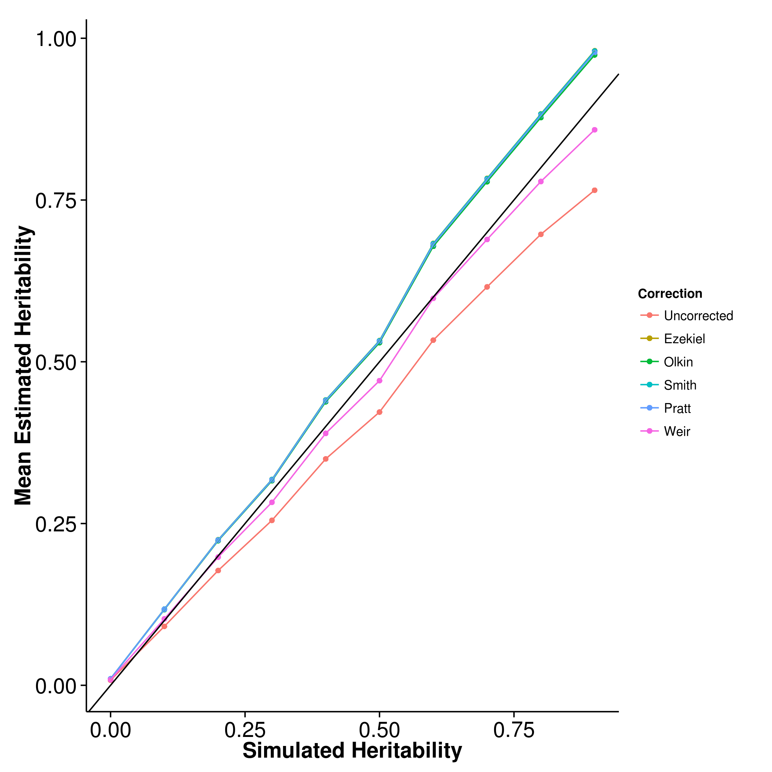 [Empirical Variance] 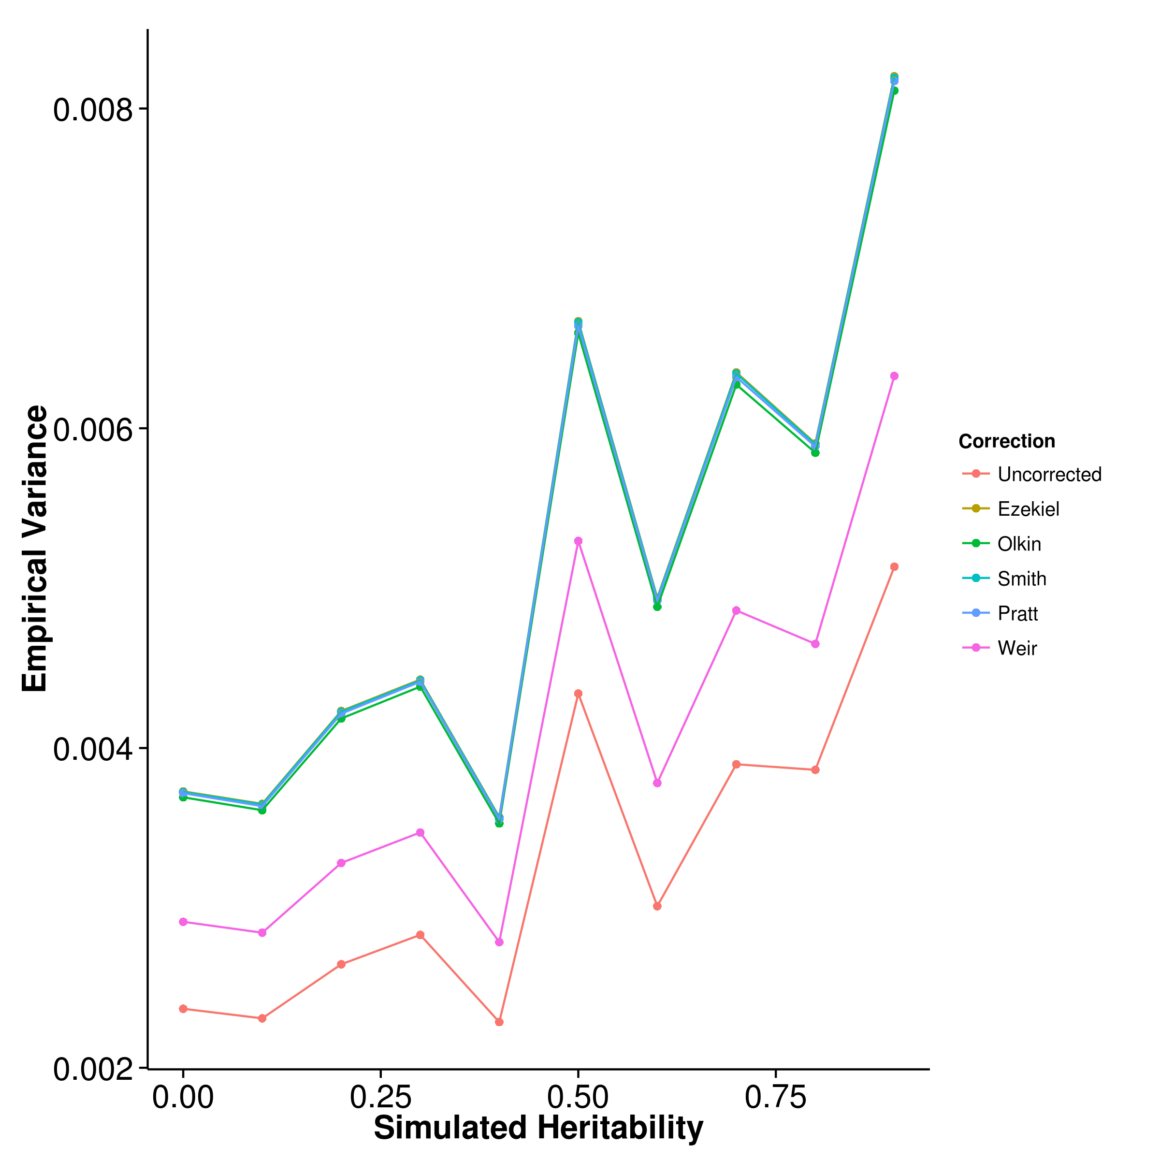

Figure 8: Effect of LD correction to Heritability Estimation. We compared the performance of our algorithm when different  bias correction algorithm was used. When no bias correction was carried out, a downward bias was observed. After the application of the bias correction algorithms, the mean estimations of all except in the case of Weir eq:weir algorithms leads to an overestimation of heritability. On the other hand, the corrections all lead to increase in variance of the estimation.

On the other hand, the bias correction algorithms all worked as expected where they increases the mean estimation of heritability because removal of the upward bias in the sample  should increase the heritability estimation. However for most algorithms except for Weir’s formula (eq:weir) an over adjustment were observed, leading to a general upward bias in the estimation. Taking into account of the variance of estimation (fig:varLDCor), Weir’s formula was the most suitable for shrek where not only it reduces the bias in the final heritability estimation, it introduced the smallest amount of additional variance to the estimates. As a result of that, we selected the Weir’s formula as our default LD correction algorithm.

### 6.2 Comparing with Other Algorithms

Having selected the optimal LD correction algorithm, we then compared the performance of shrek with existing algorithms to understand the relative performance of these algorithms under different conditions. First, we examined the performance of the algorithms under the quantitative trait scenario where the trait heritability and the number of causal SNP were varied.

#### 6.2.1 Quantitative Trait Simulation

[SHREK] 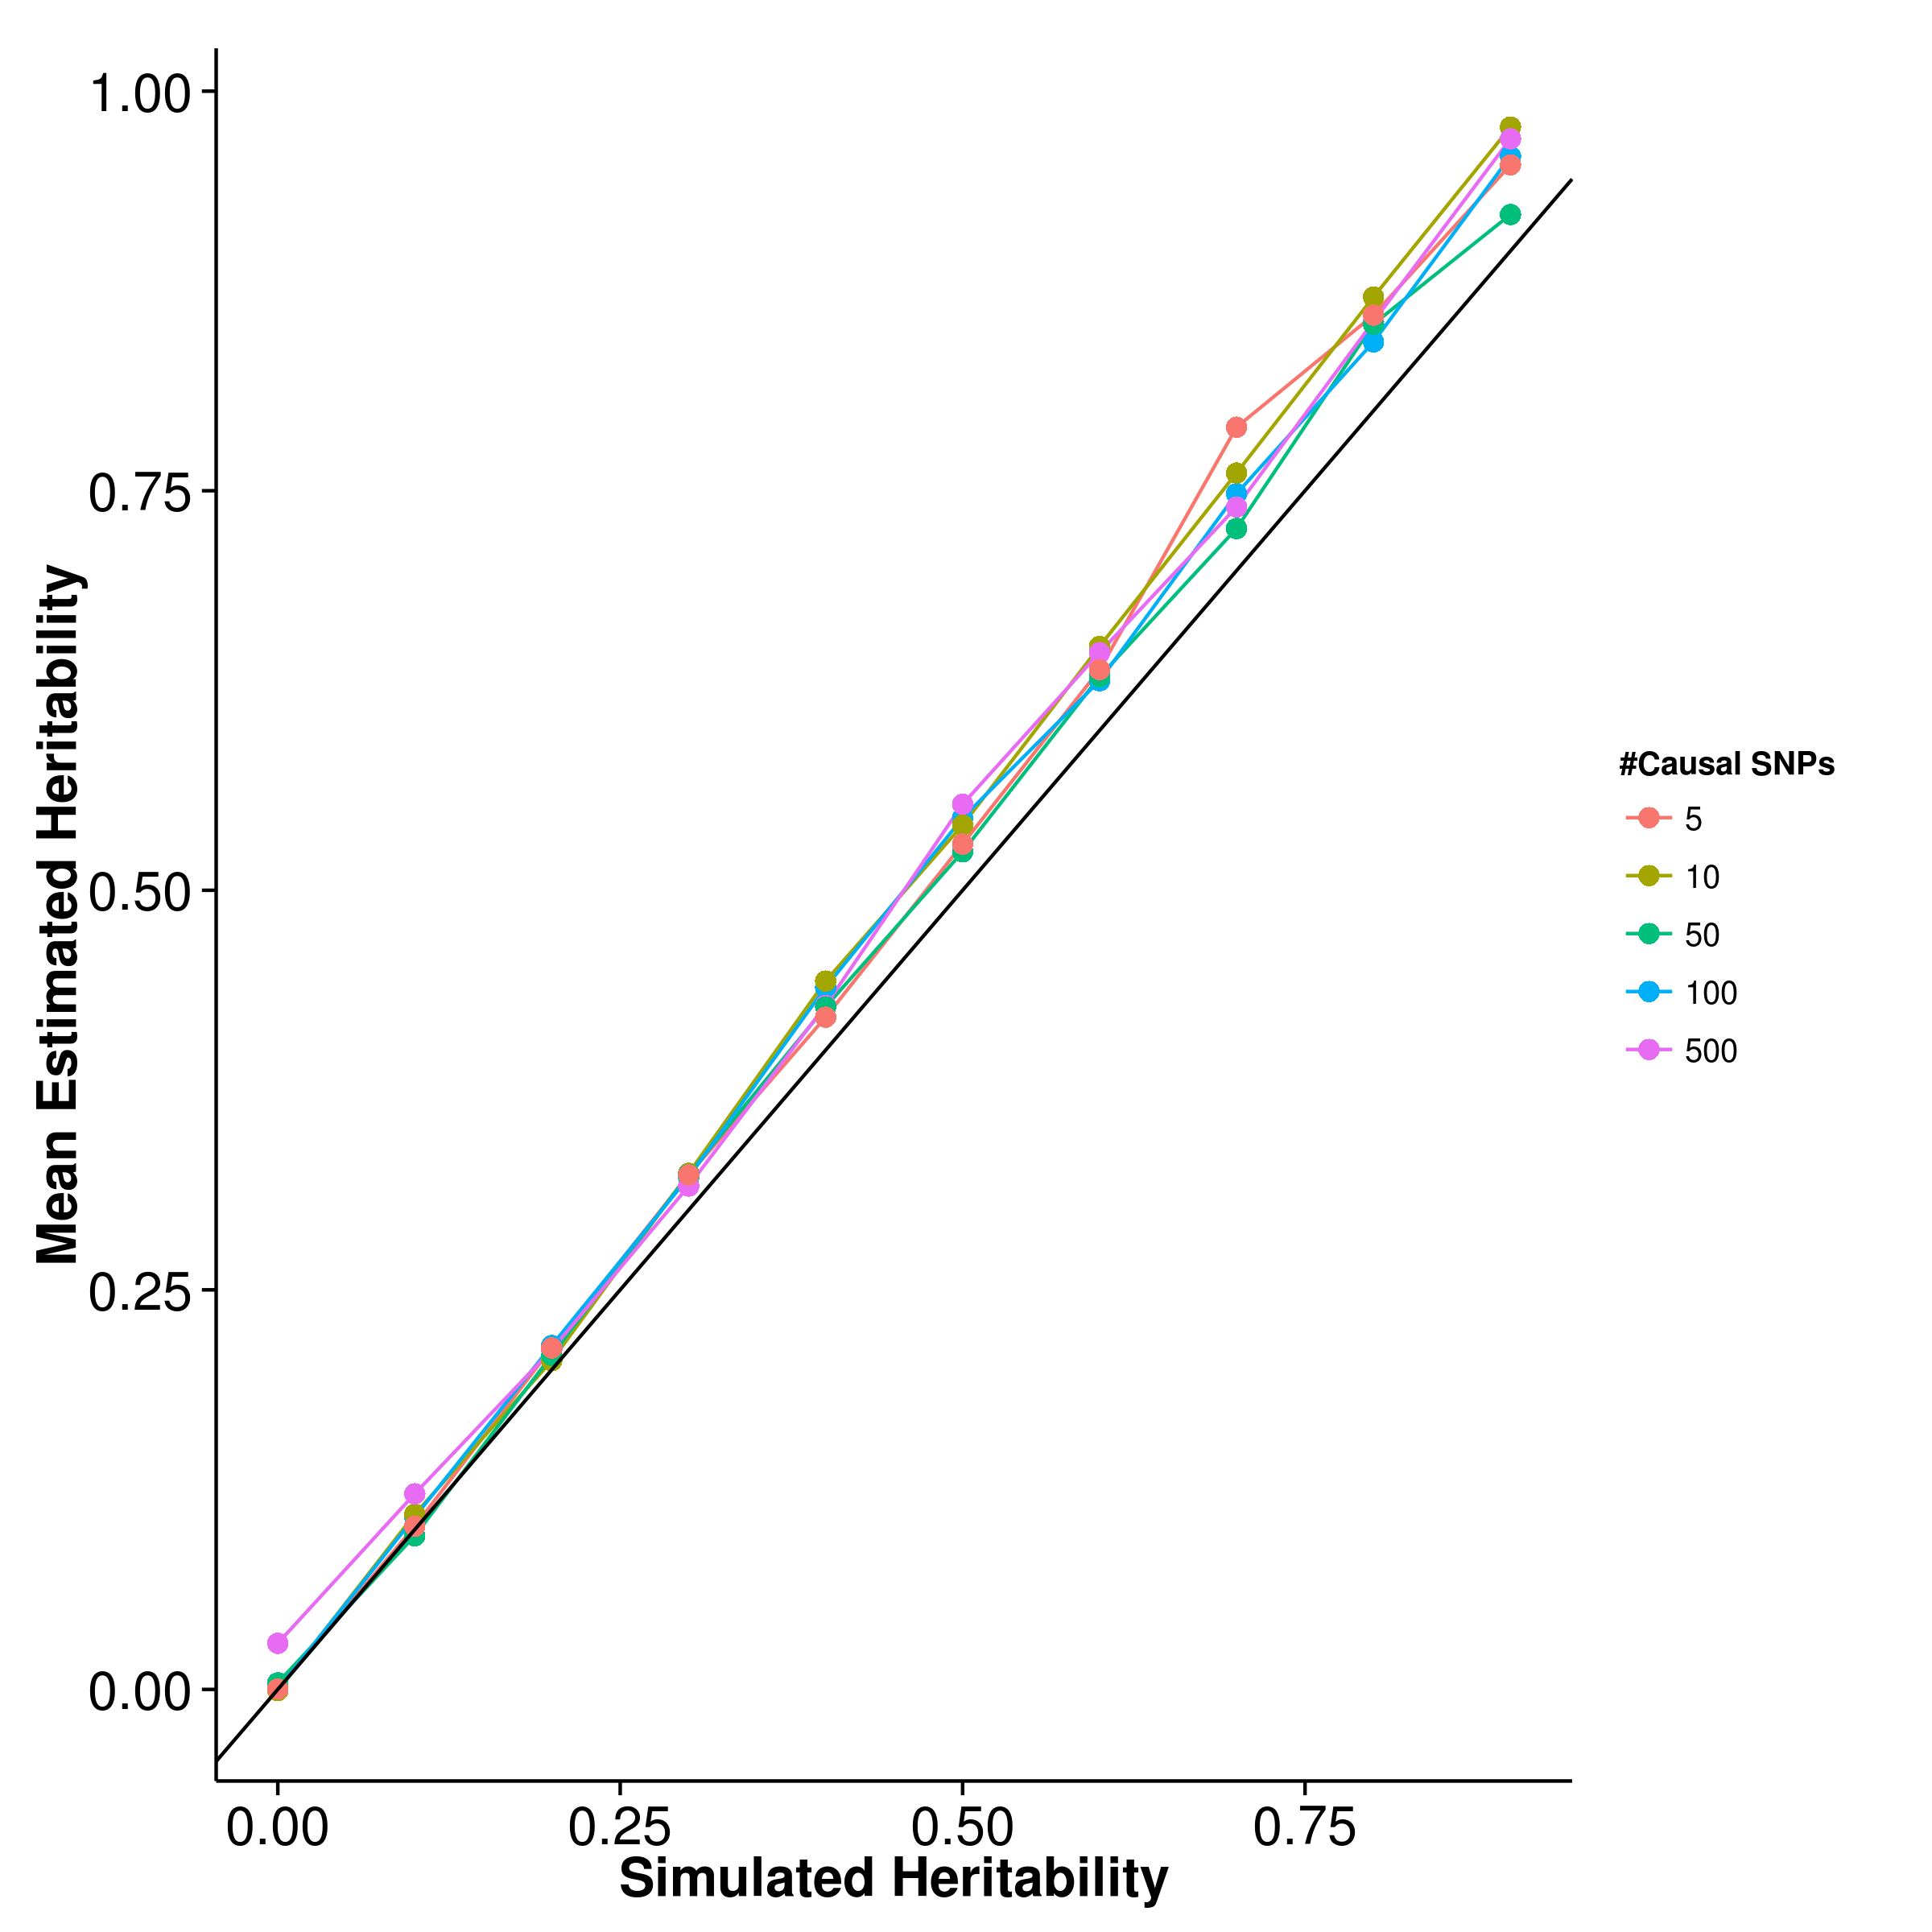 [GCTA] 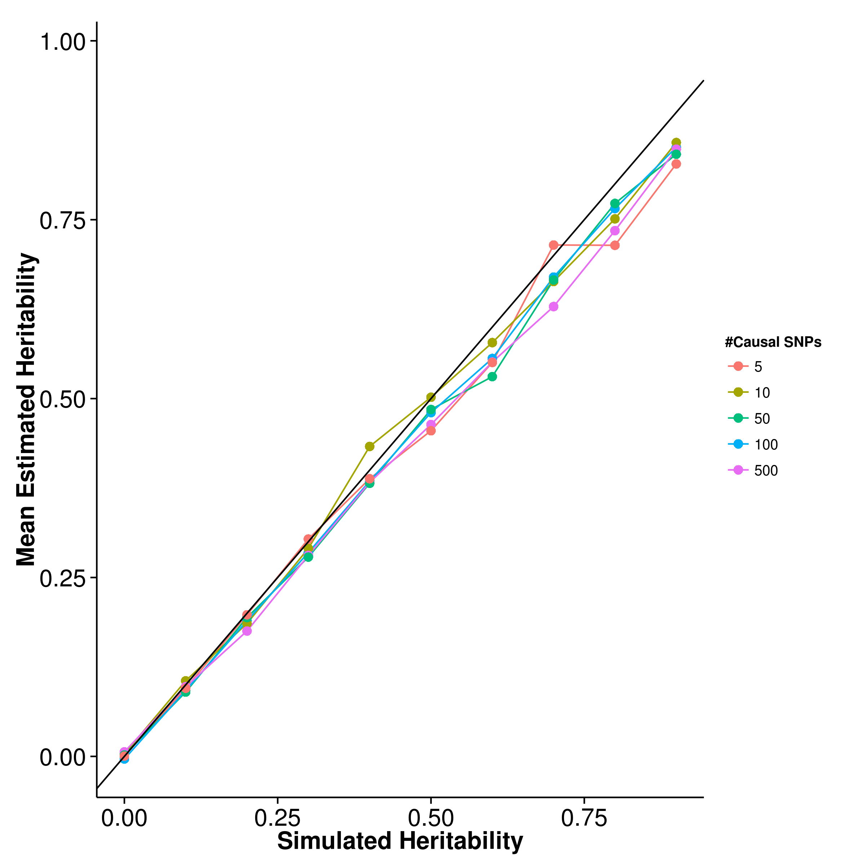

[LDSC with fix intercept] 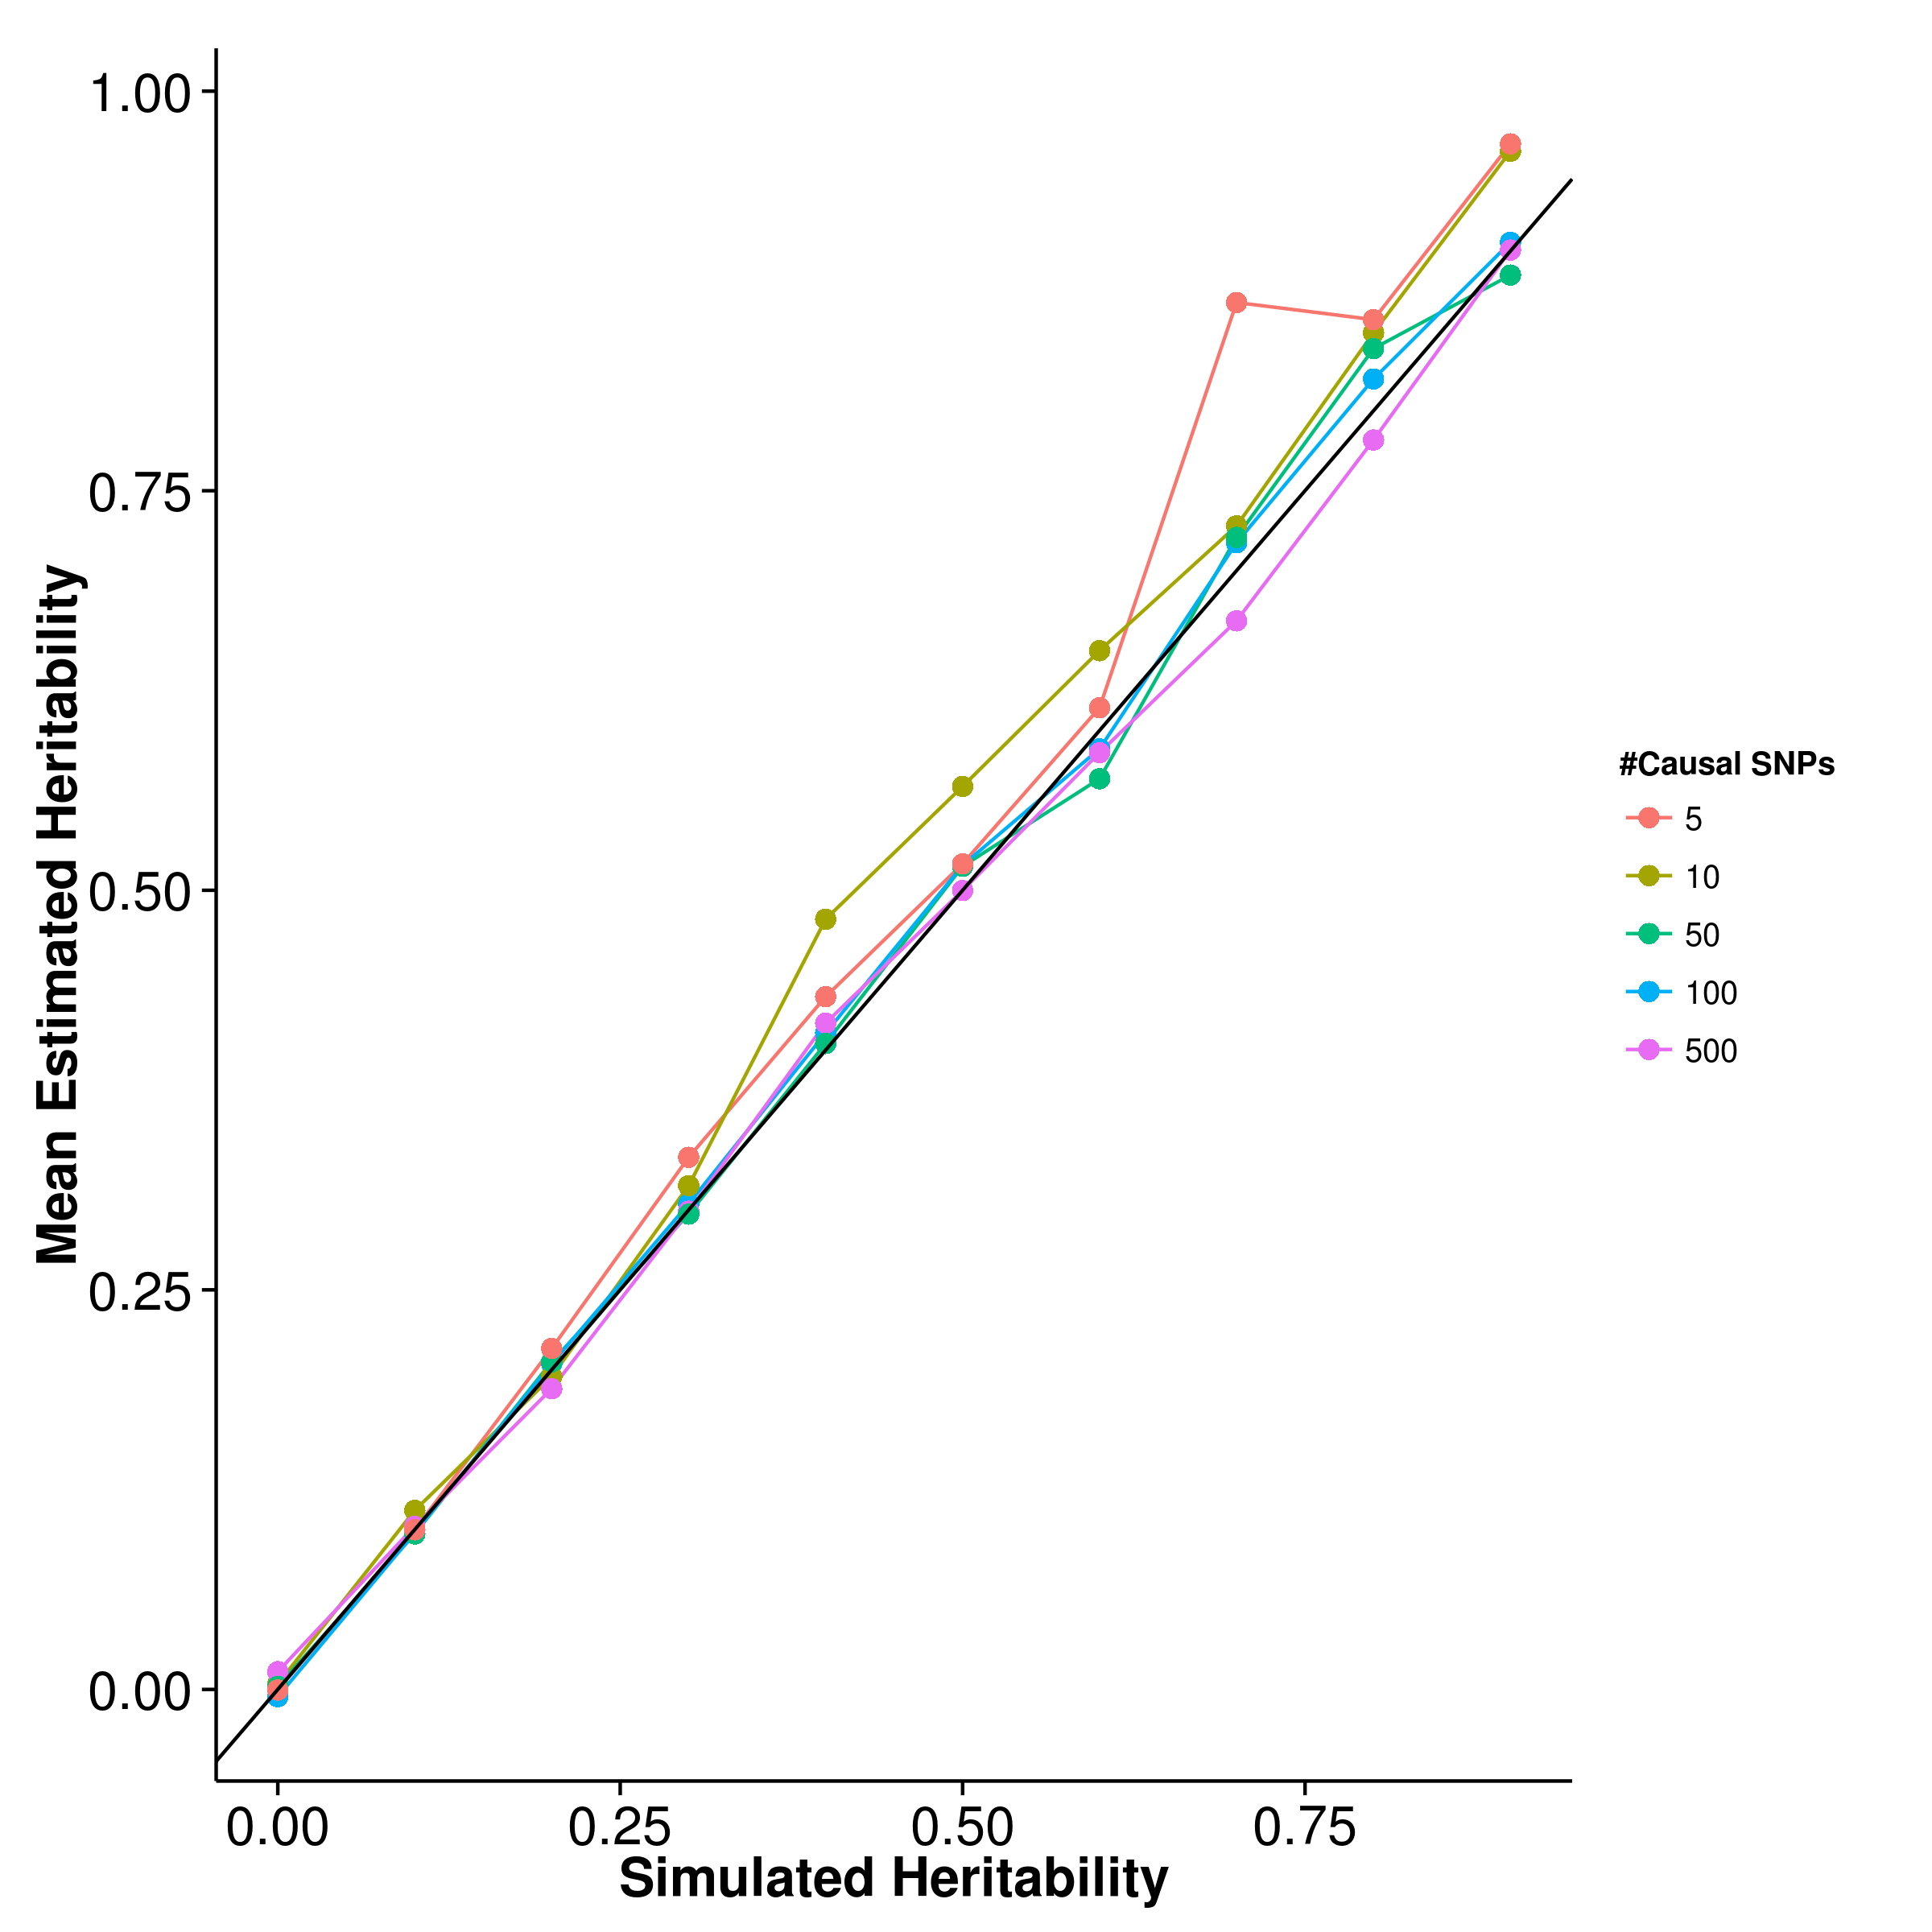 [LDSC with intercept estimation]

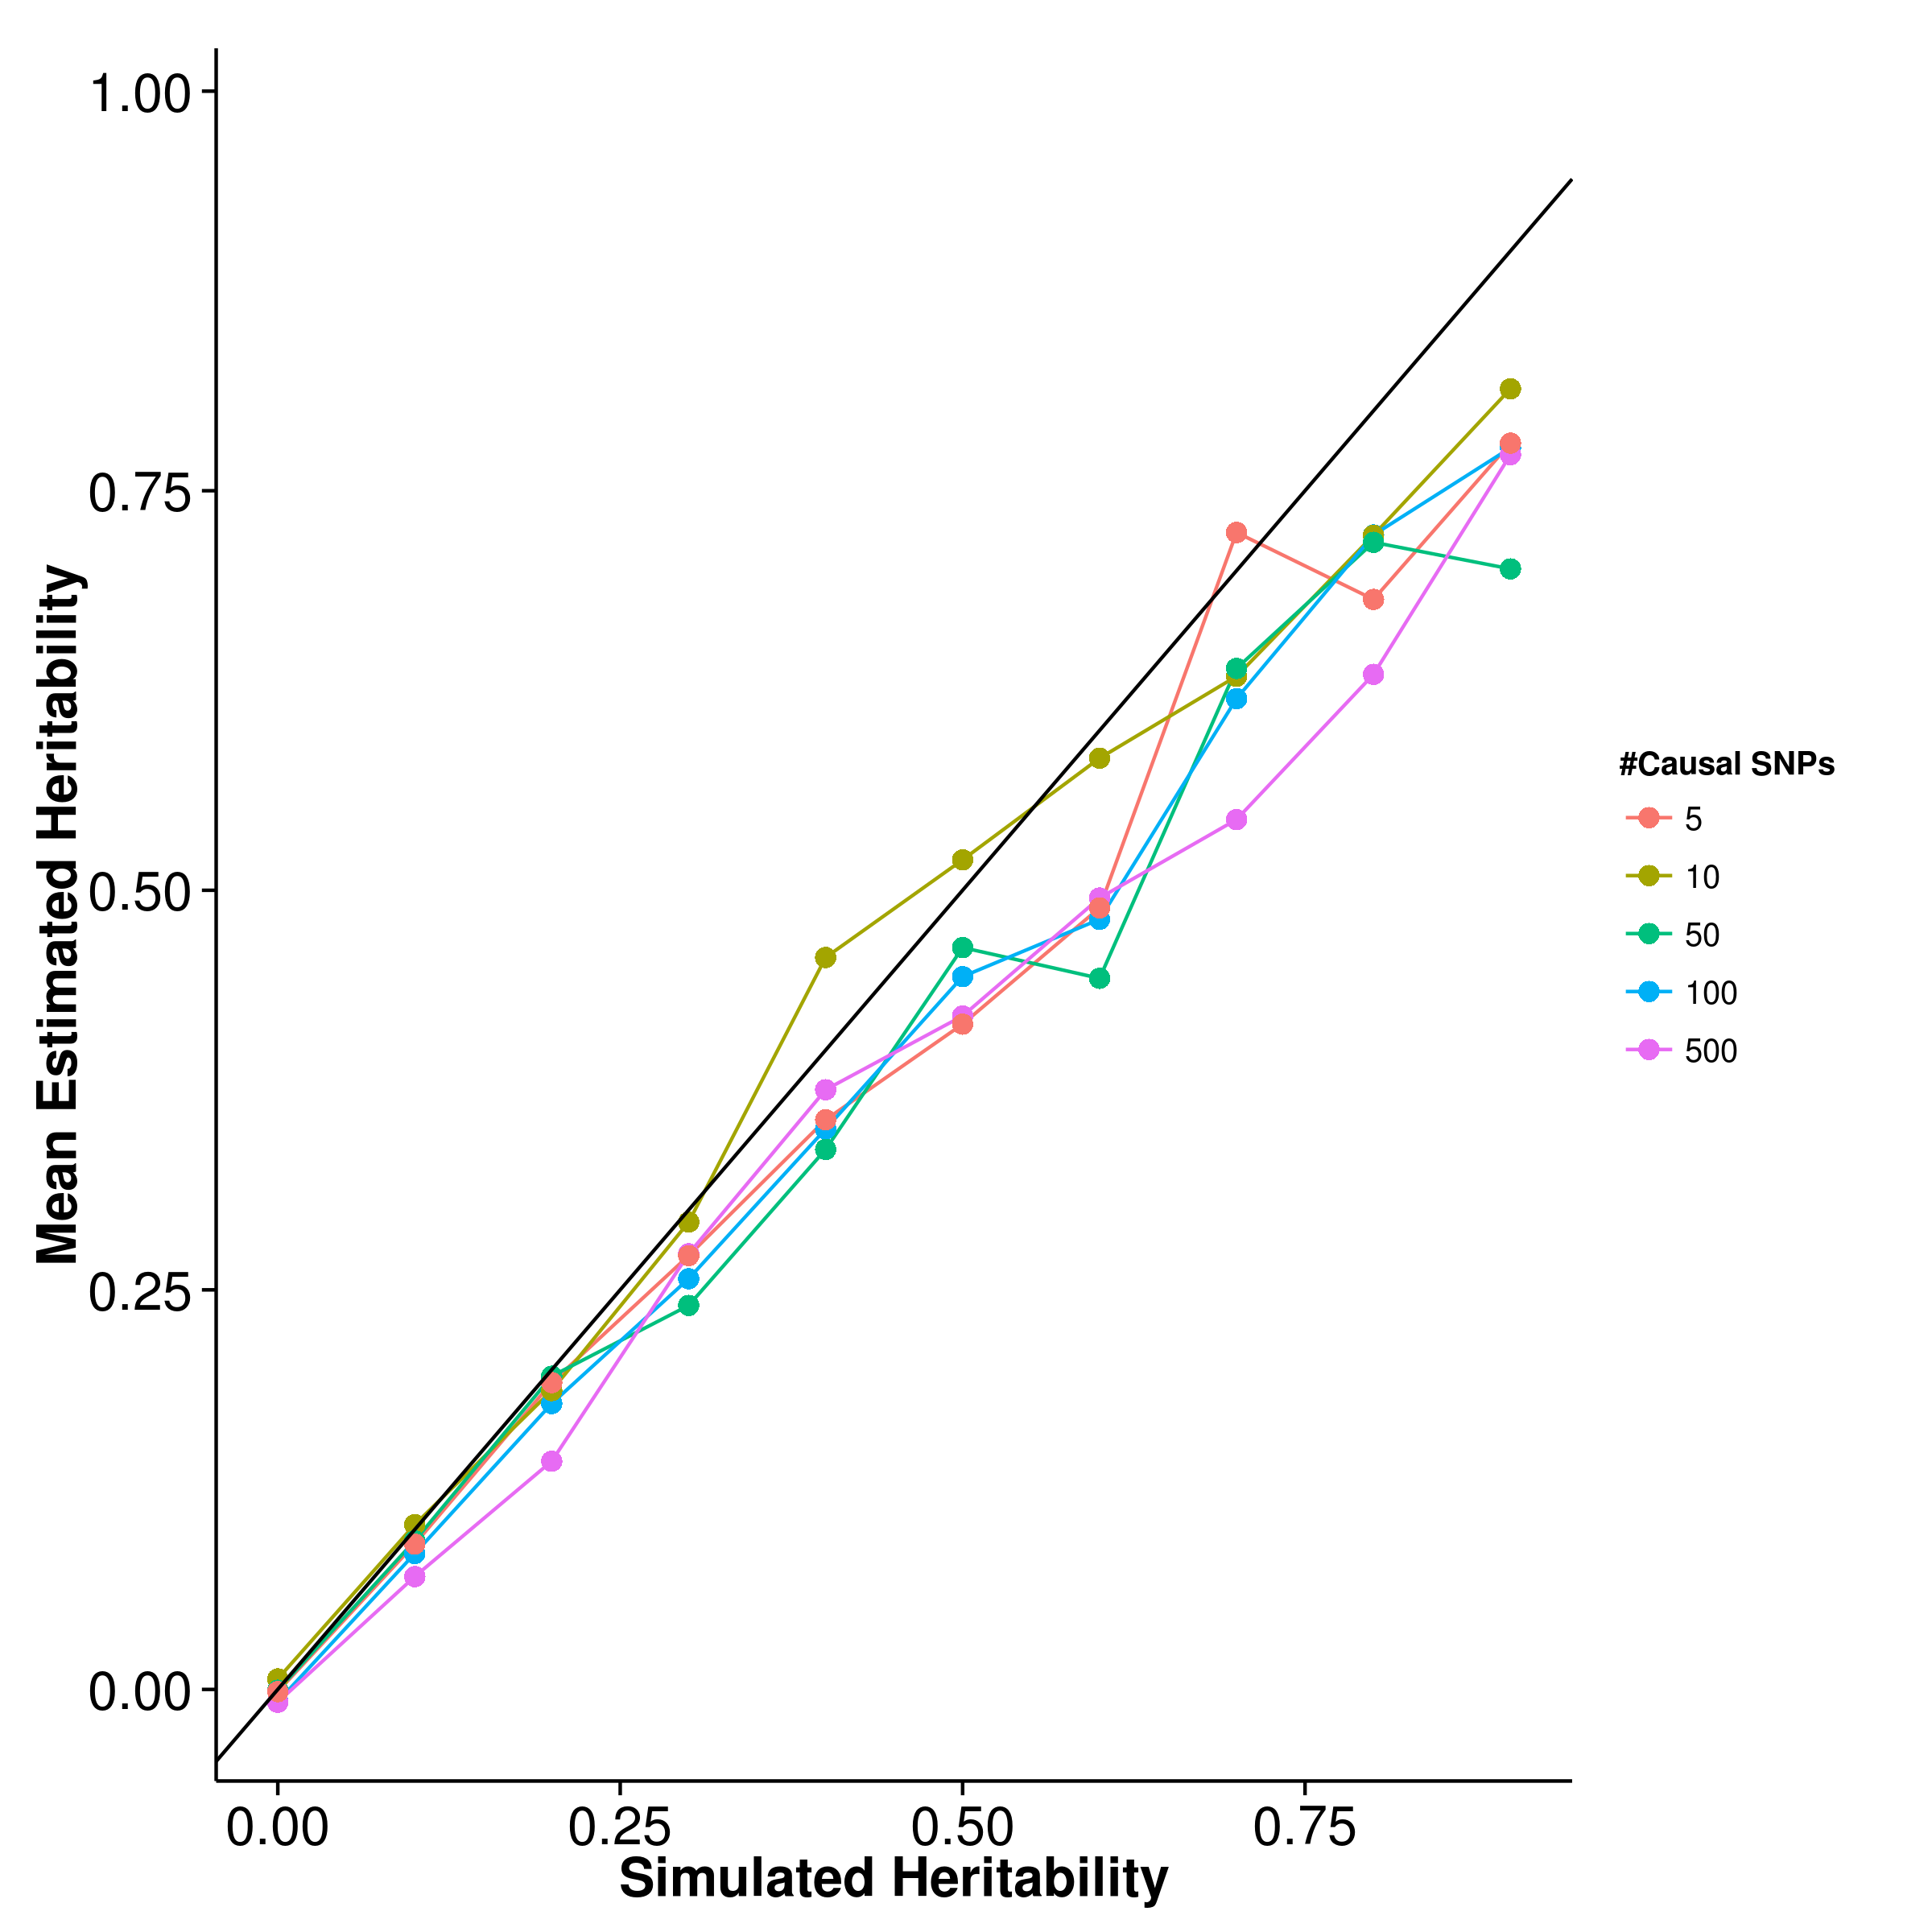

Figure 9: Mean of results from quantitative trait simulation with random effect size simulation. Estimations form shrek were slightly biased upwards whereas gcta and ldsc with intercept estimations both biased downwards. On the other hand, ldsc with fixed intercept provides least biased estimates under polygenic conditions. However, when the number of causal SNP is small (e.g. 5 or 10), an upward bias was observed.

[SHREK] 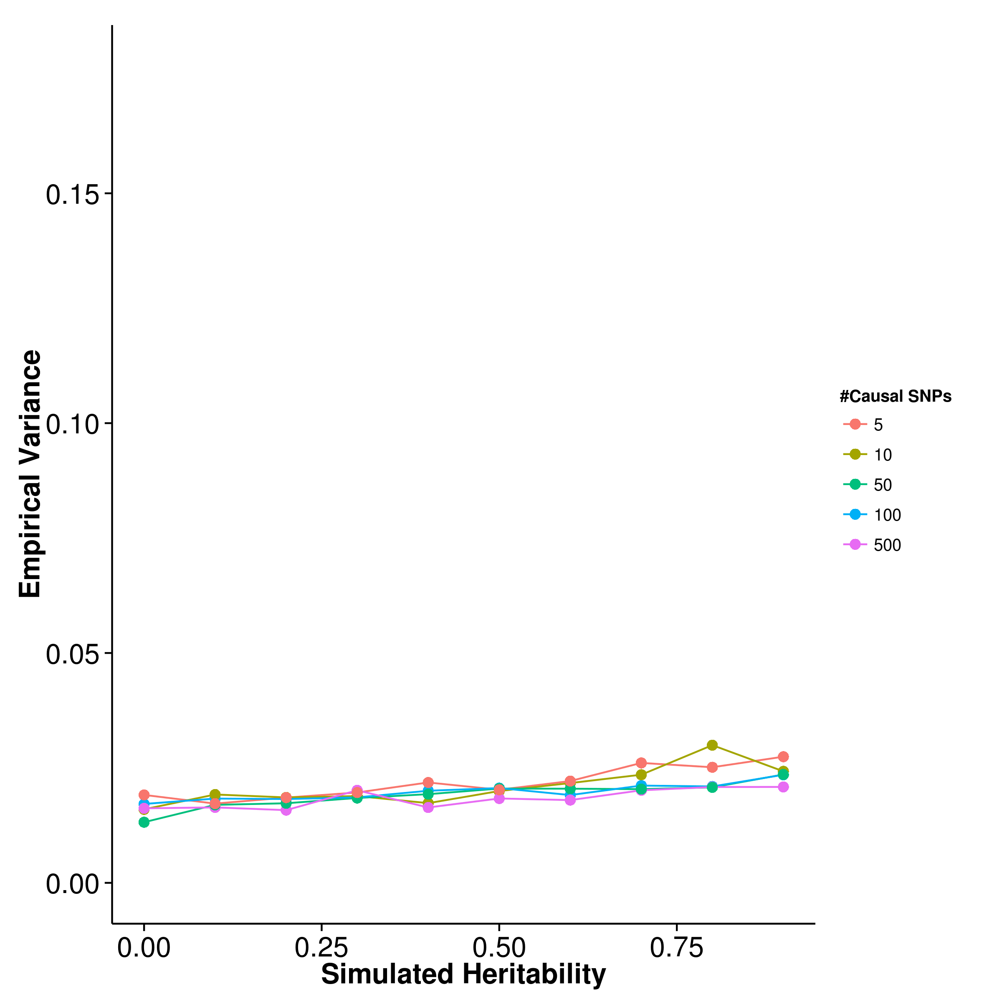 [GCTA] 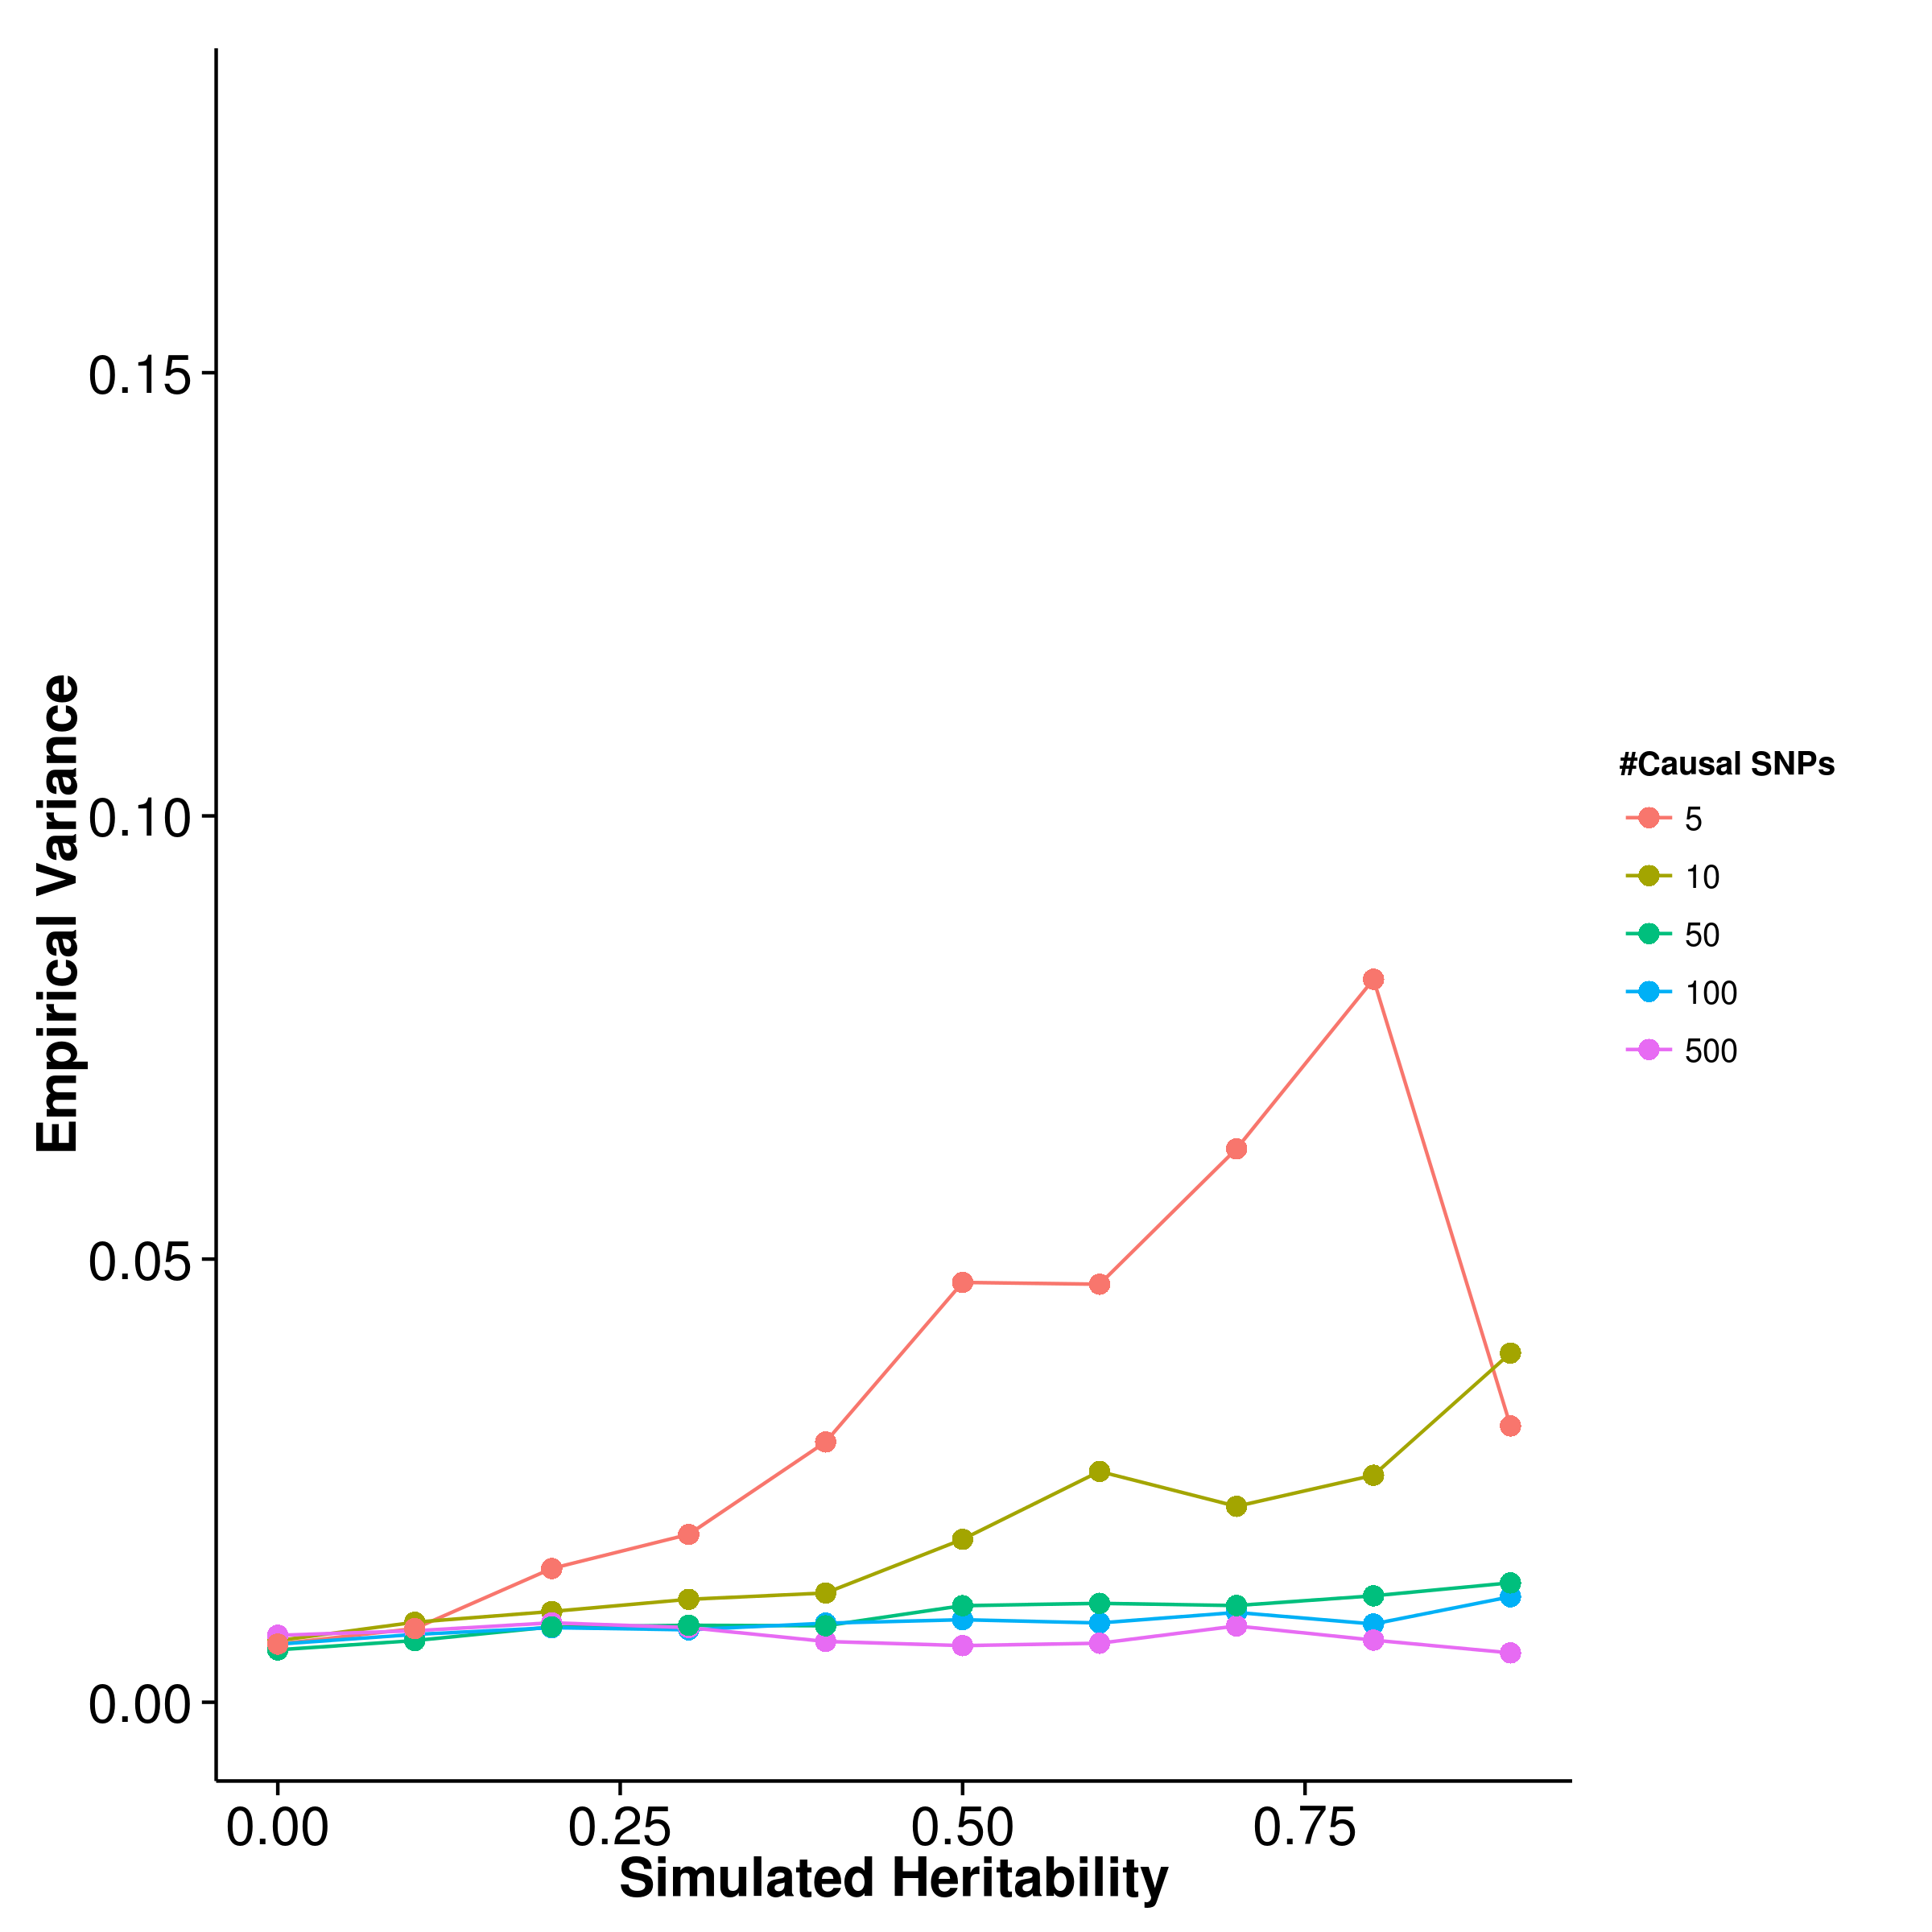

[LDSC with fix intercept] 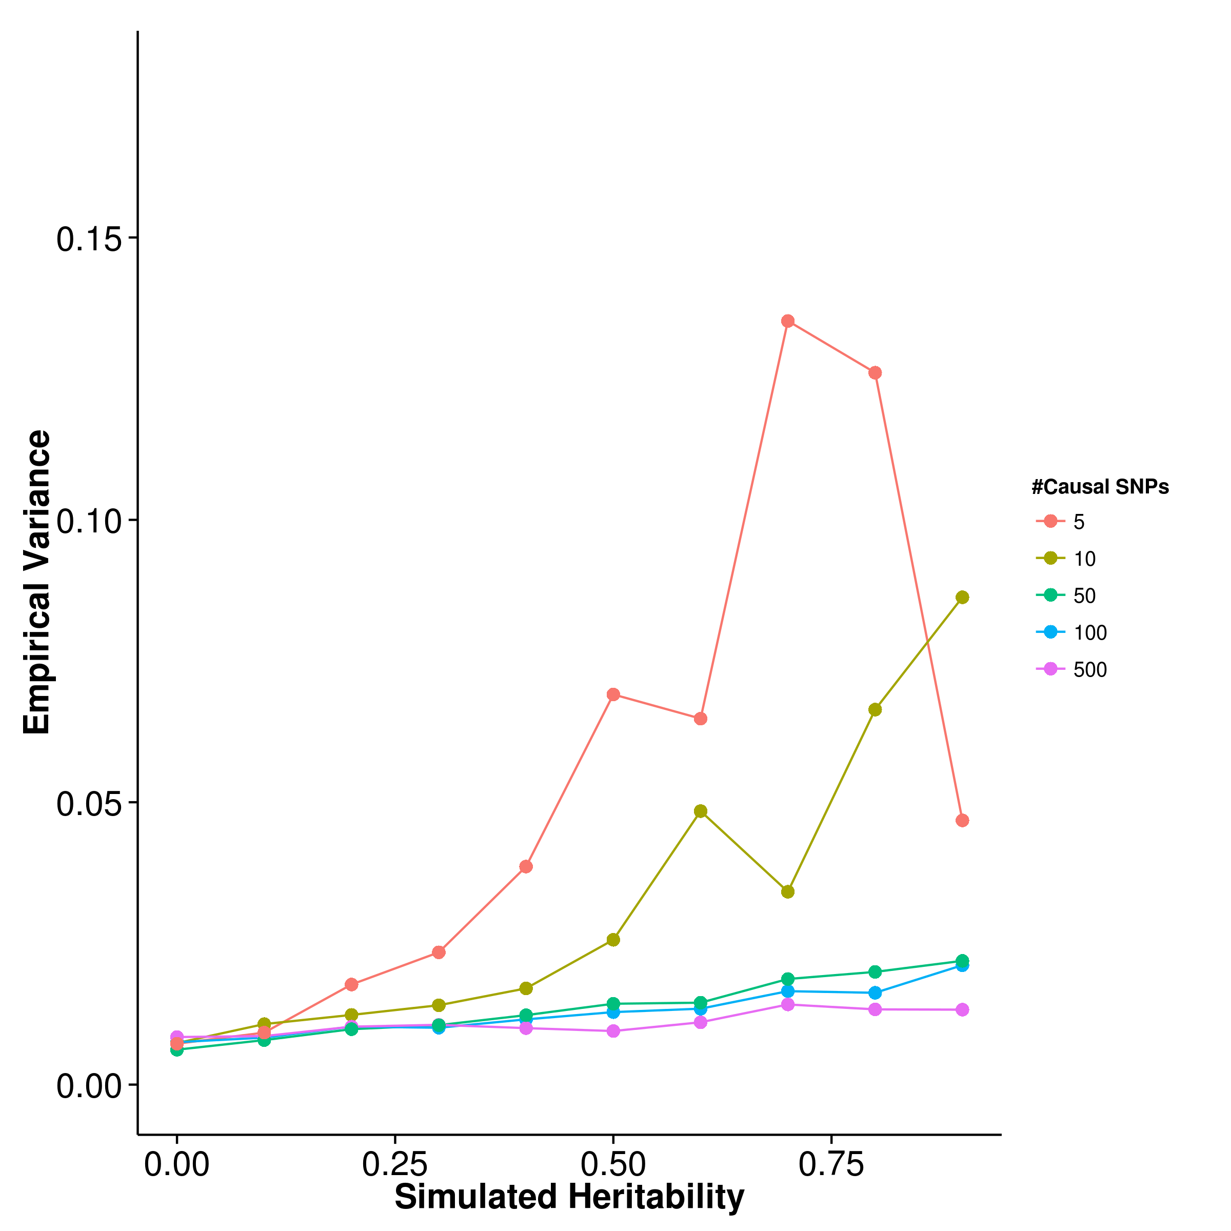 [LDSC with intercept estimation]

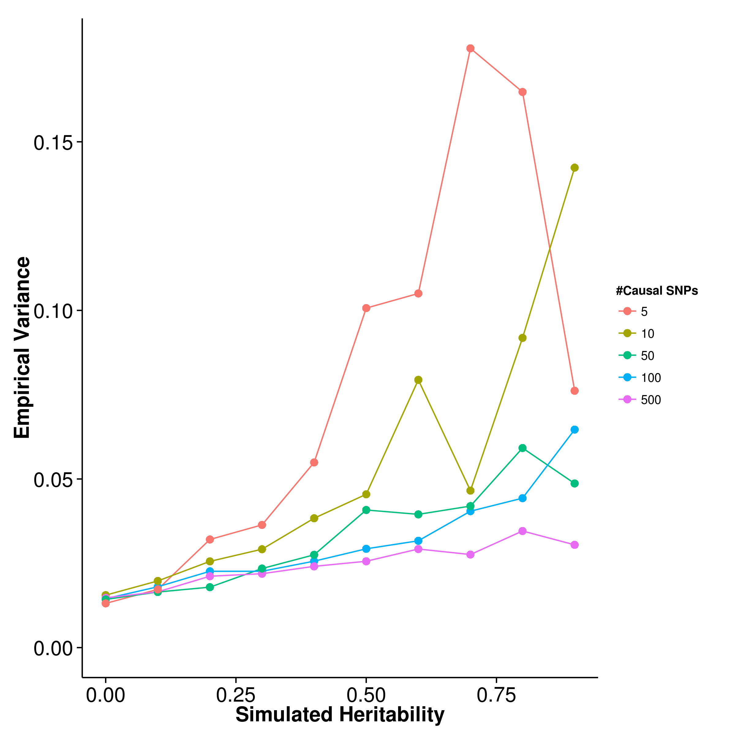

Figure 10: Variance of results from quantitative trait simulation with random effect size simulation. Under the polygenic conditions, gcta has the smallest variance, follow by ldsc. However, it was observed when the number of causal SNP decreases, the variance of the estimation increases for all algorithm, with variance of the shrek estimate being the least affected. In fact, under oligogenic conditions, shrek has a lower empirical variance when compared to ldsc.

[SHREK] 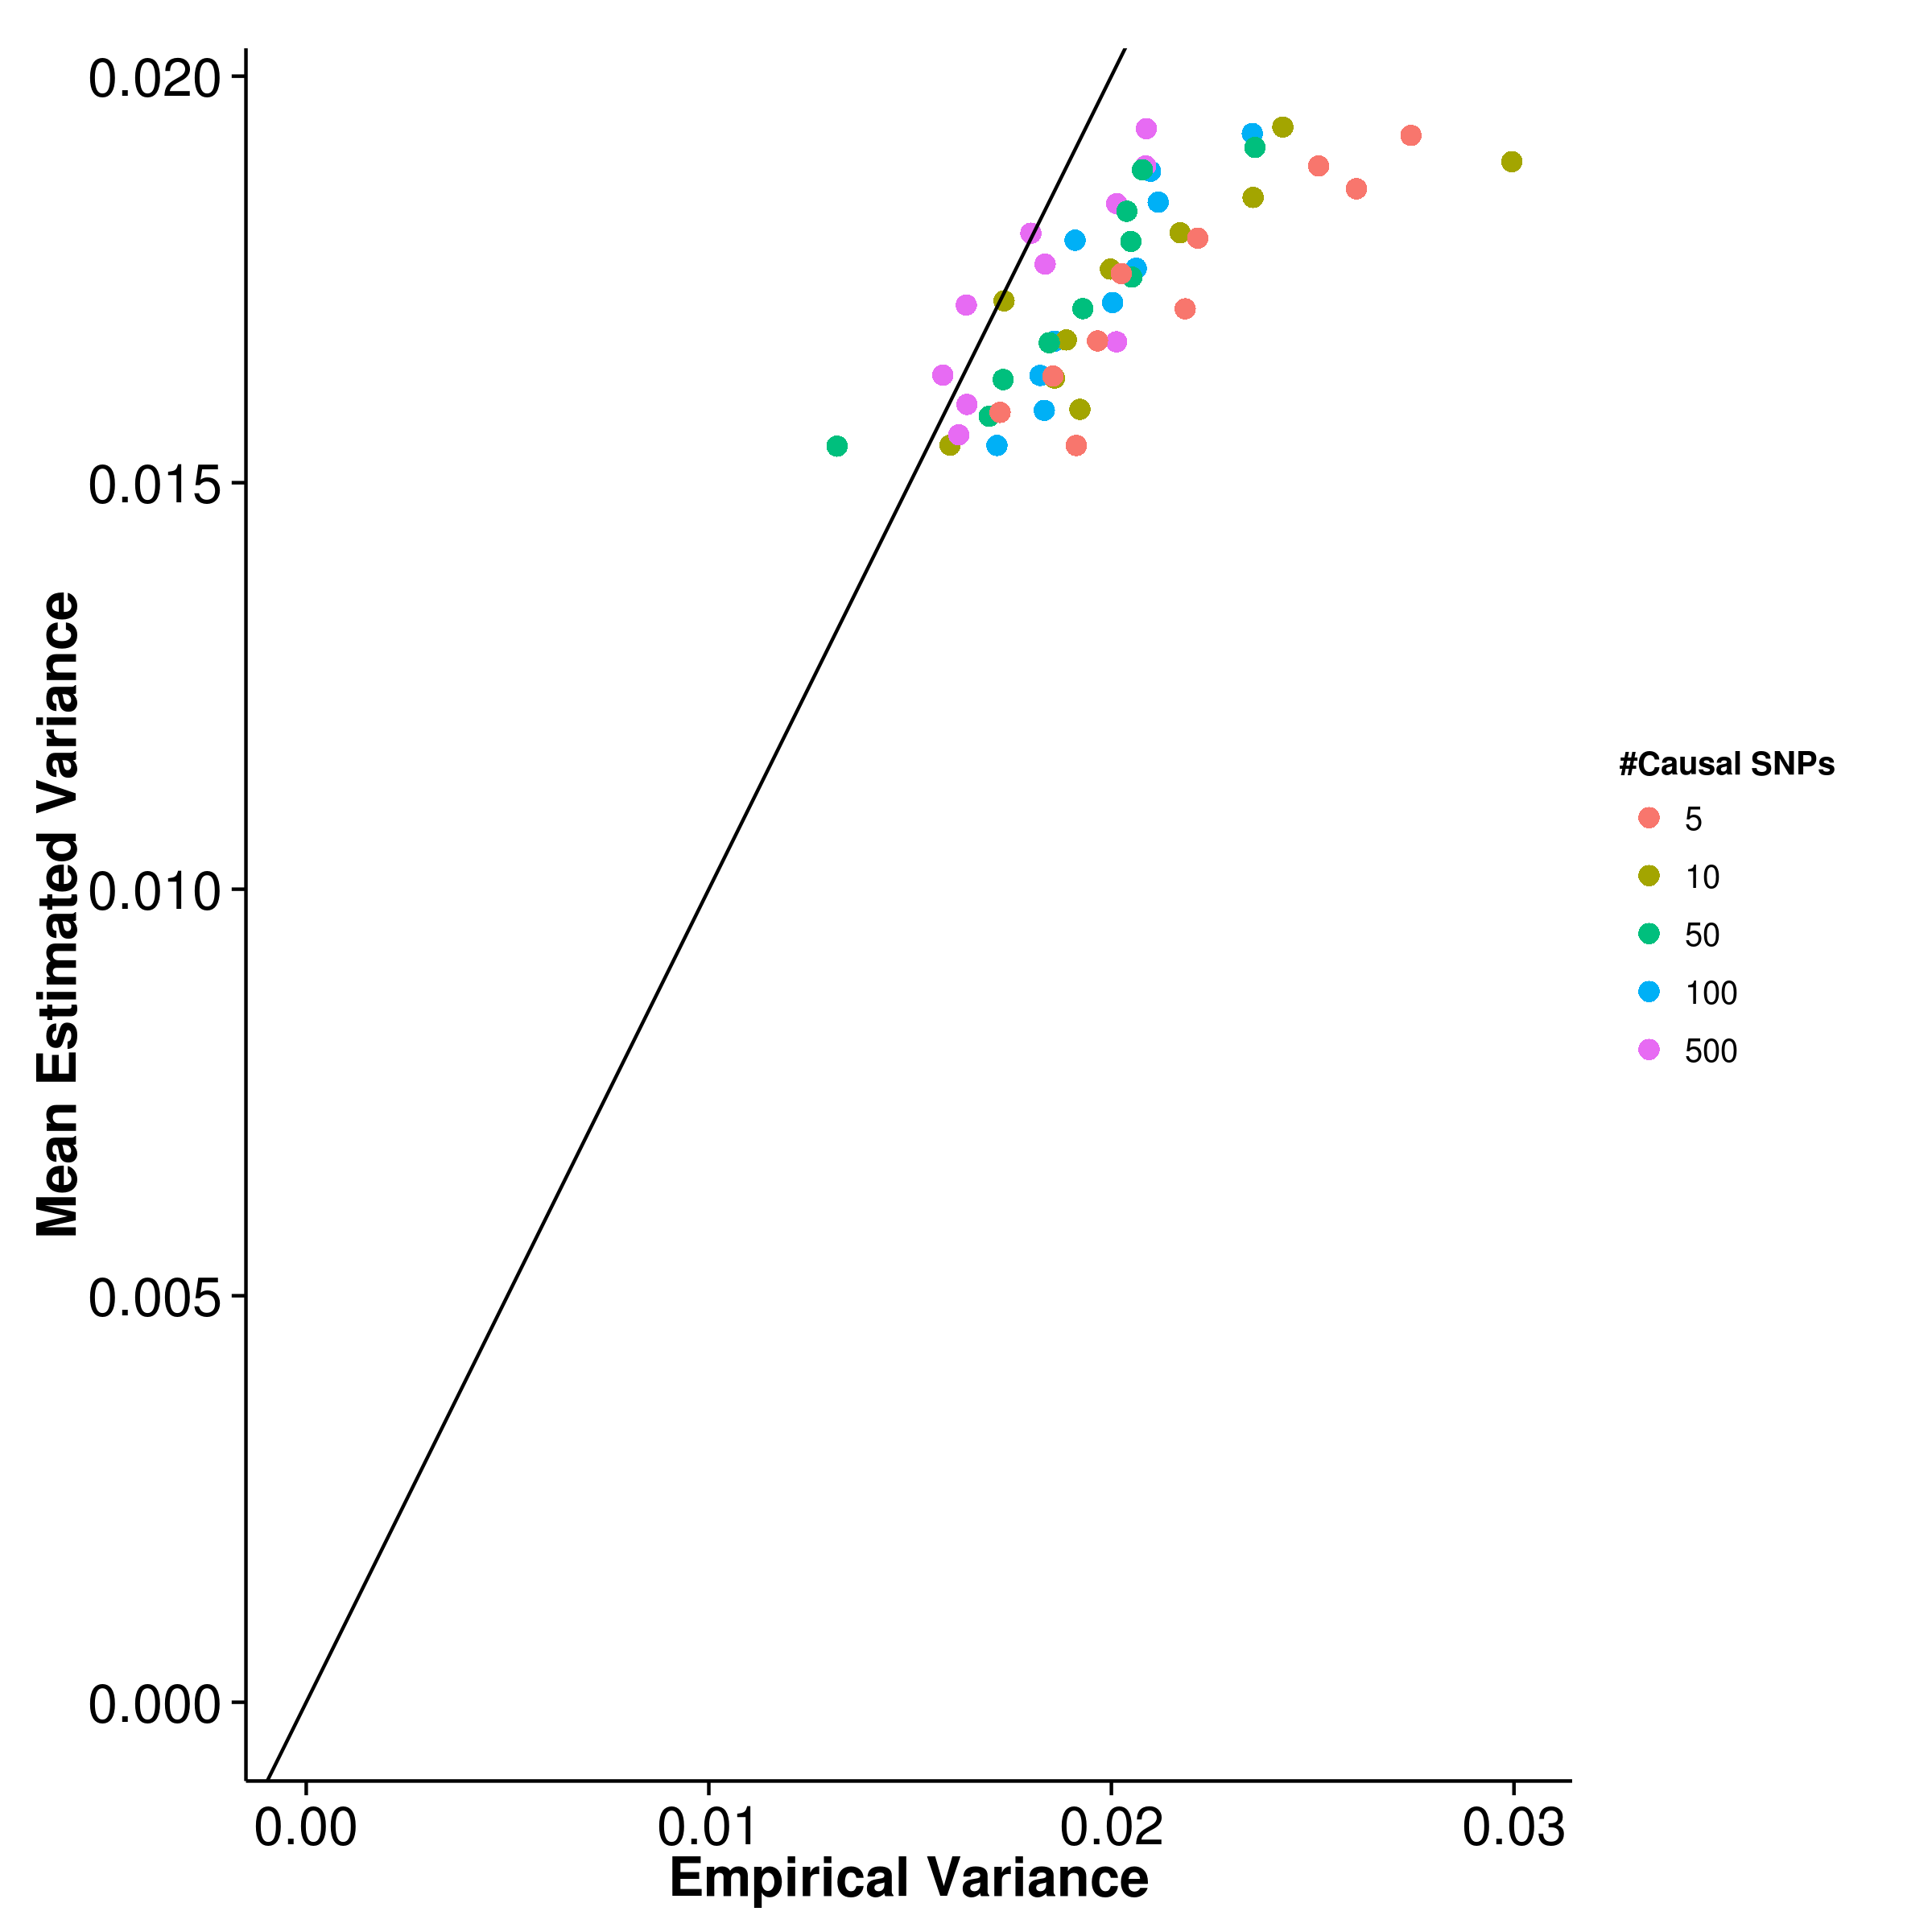 [GCTA] 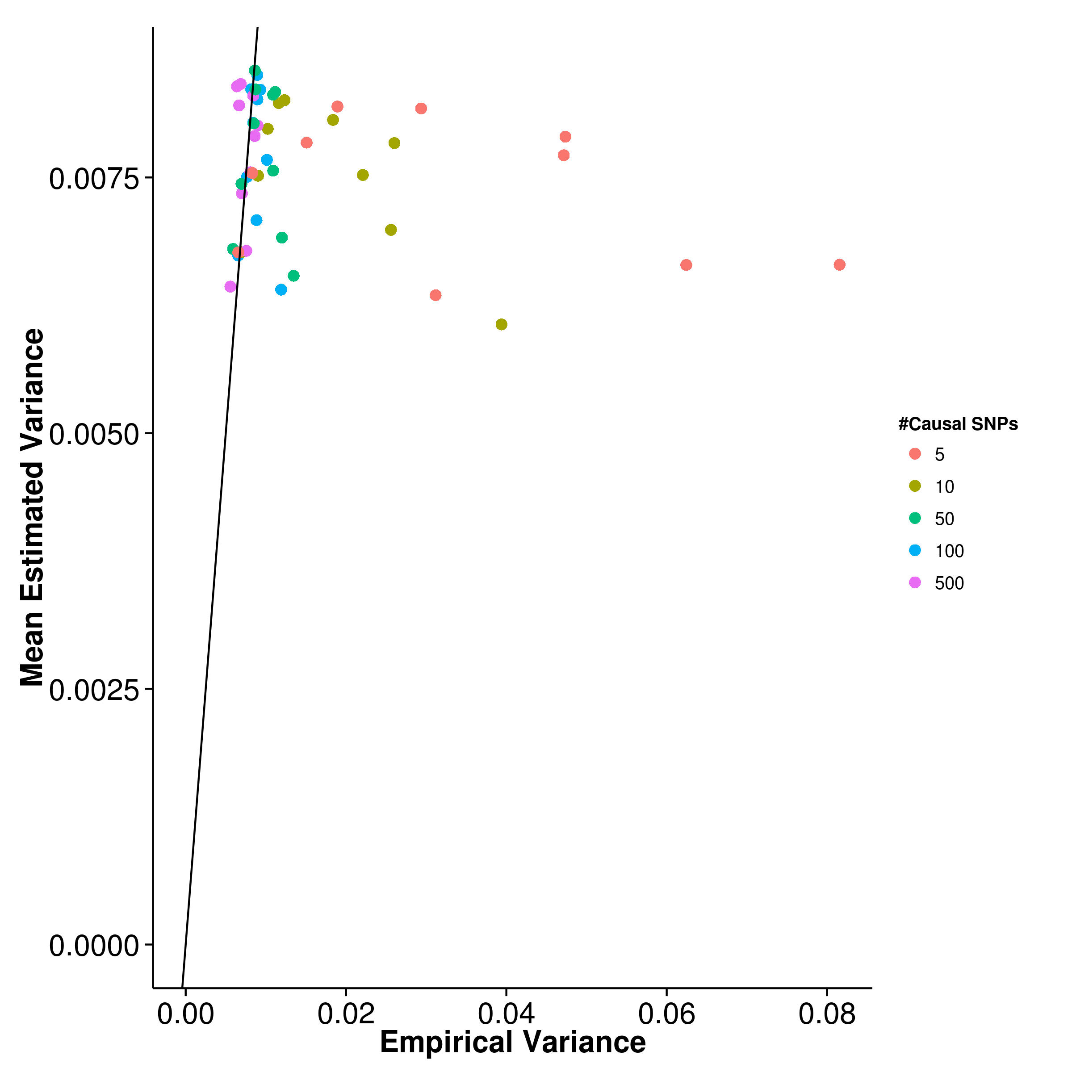

[LDSC with fix intercept] 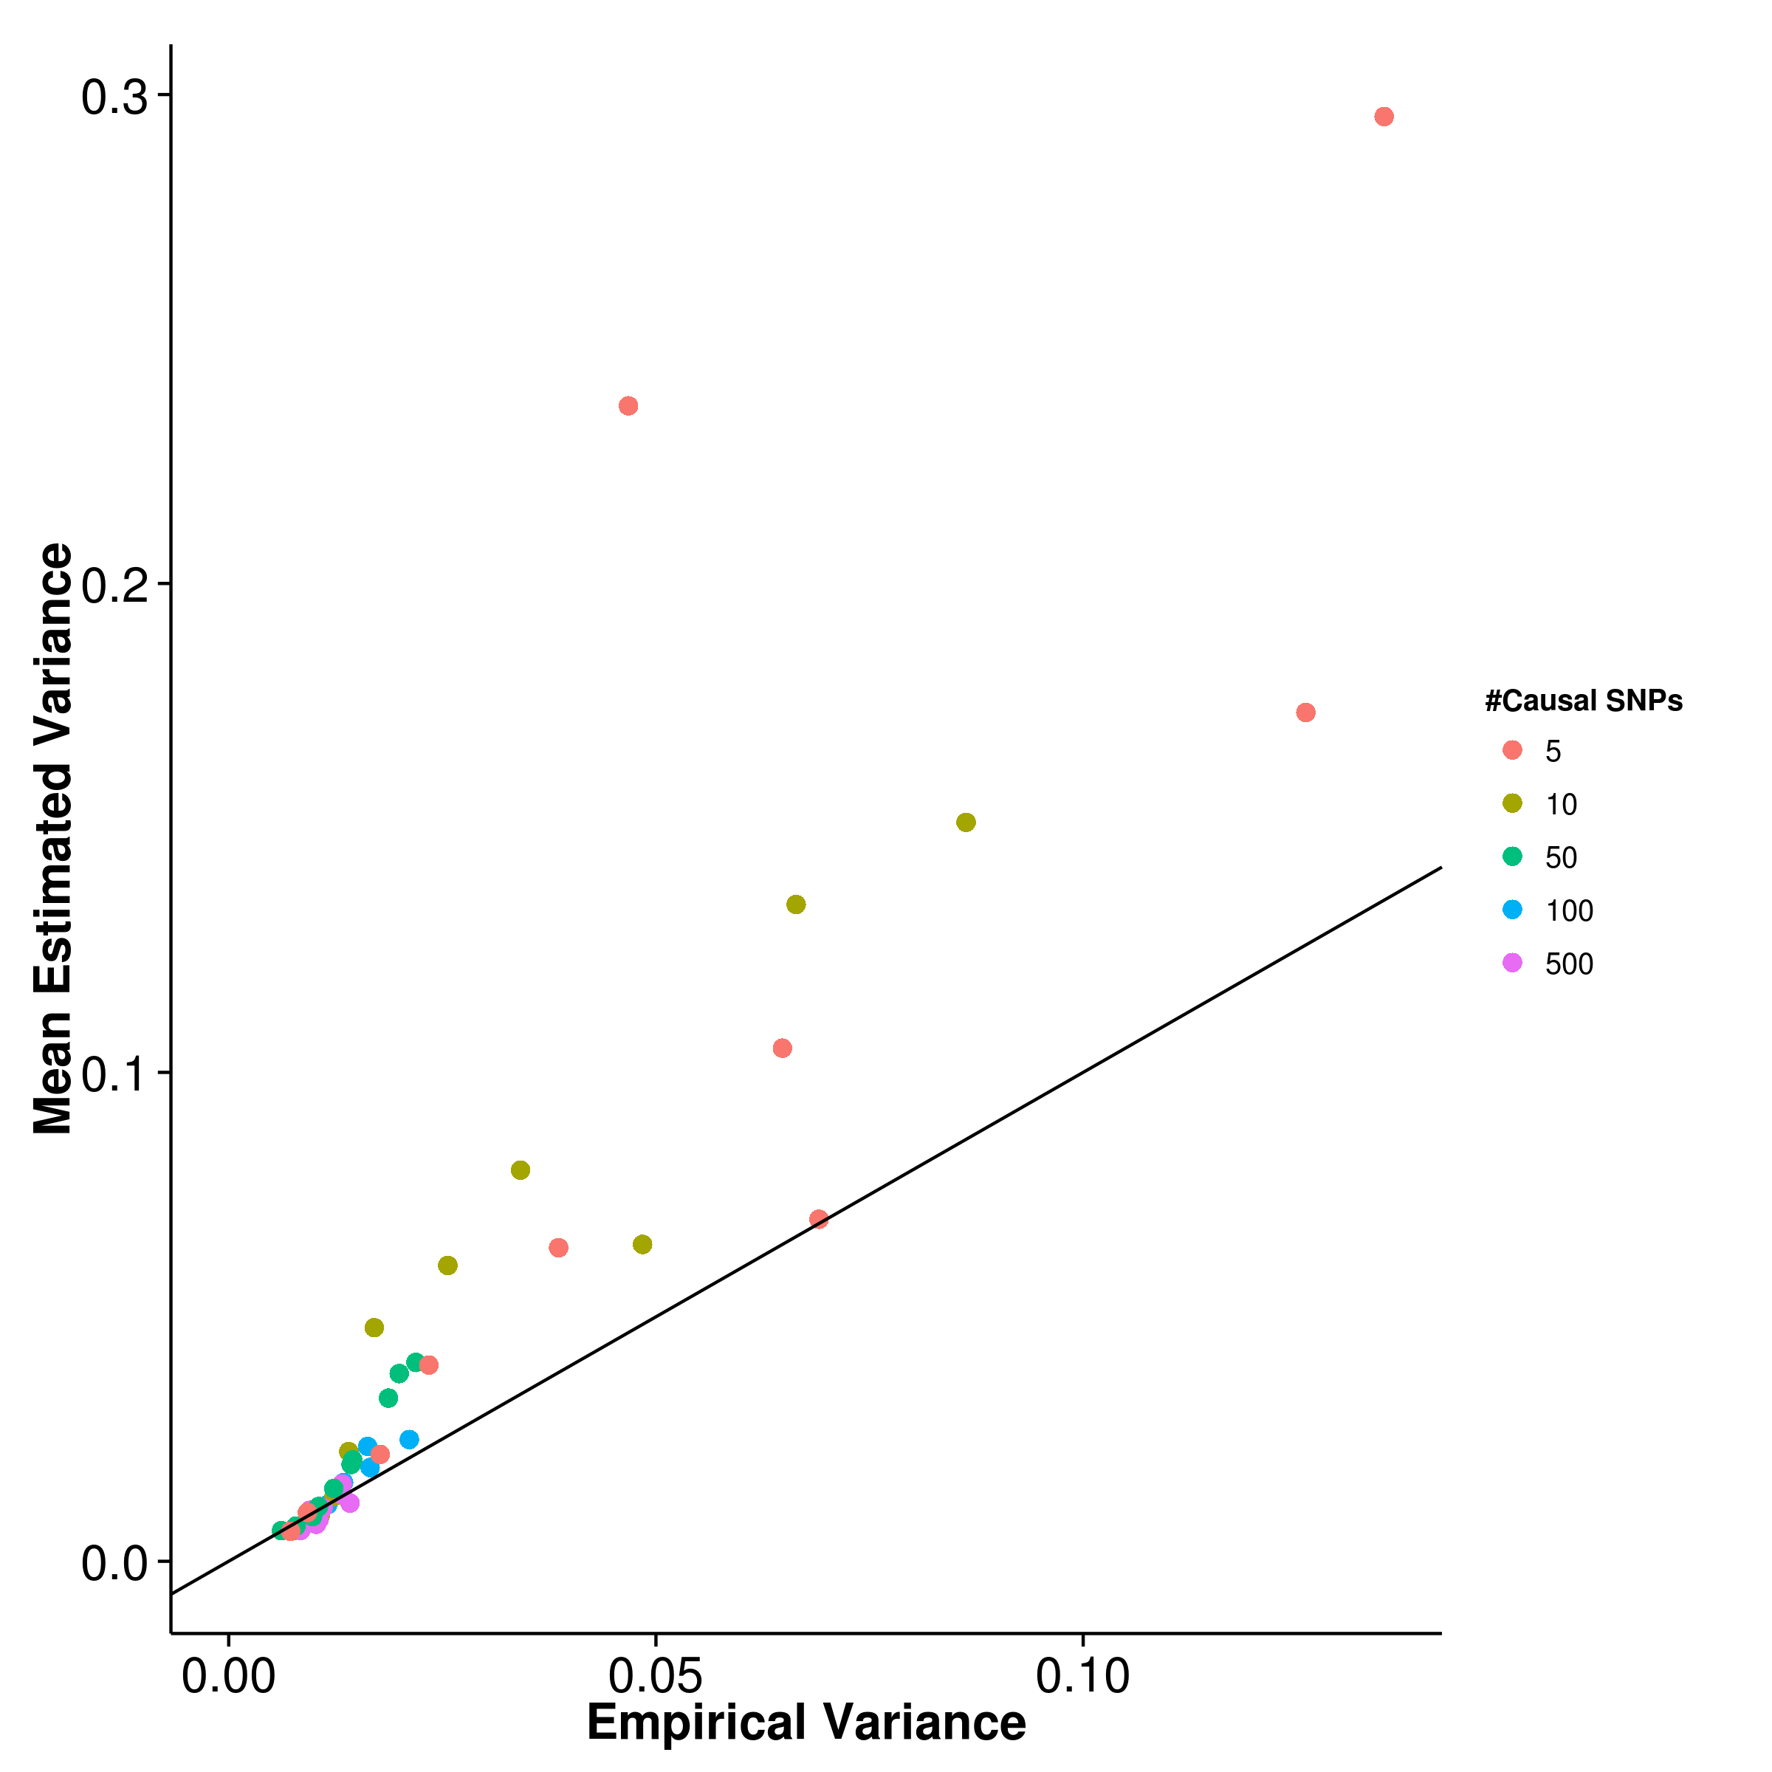 [LDSC with intercept estimation]

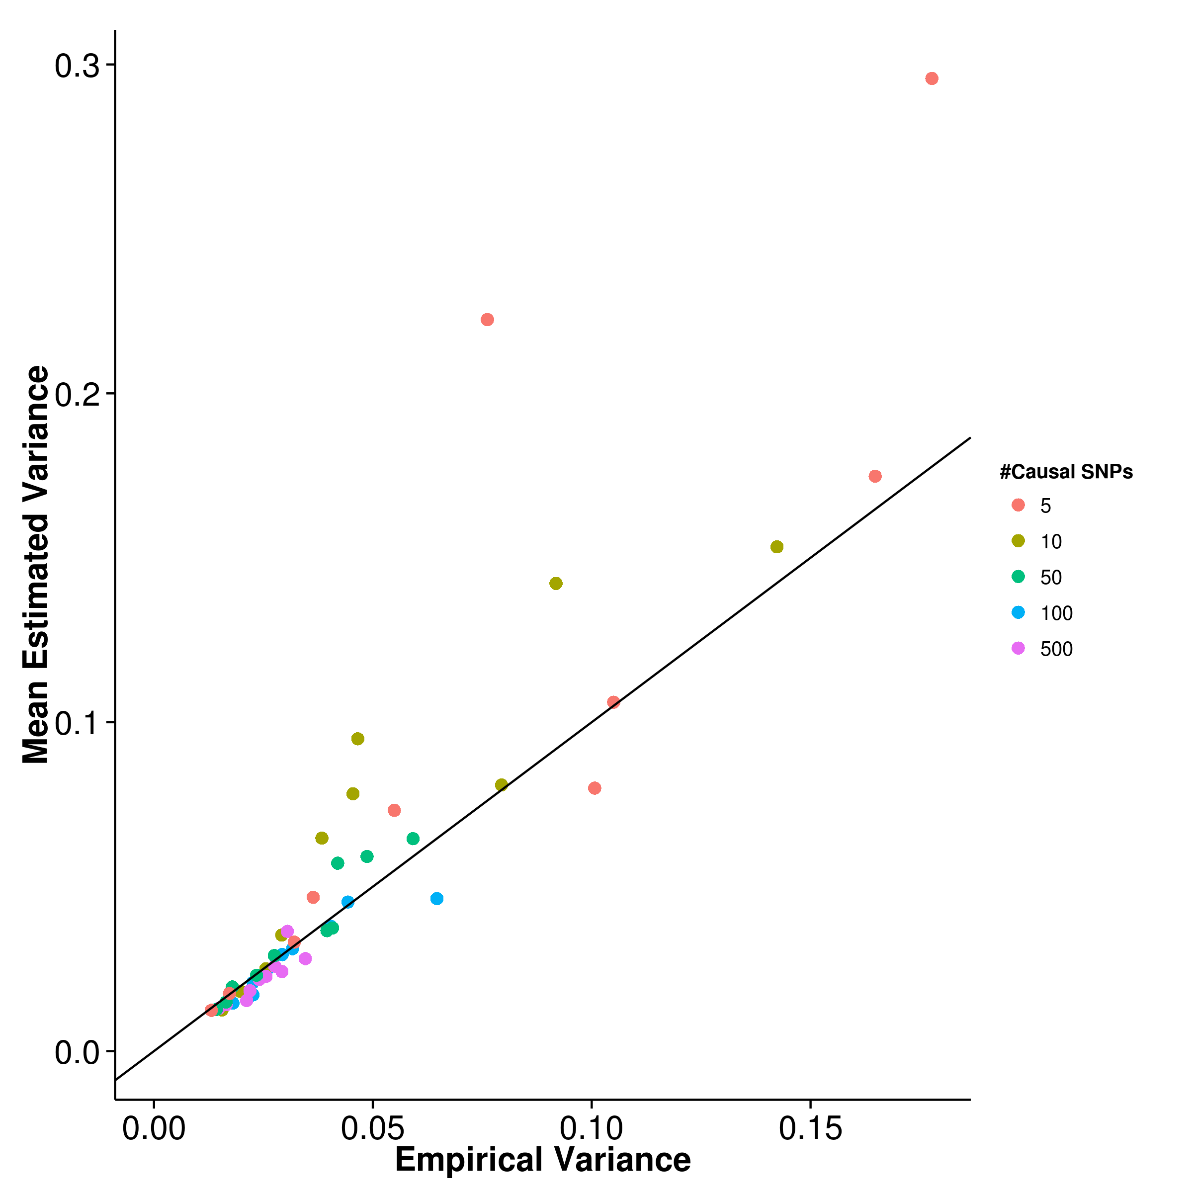

Figure 11: Estimated variance of results from quantitative trait simulation with random effect size simulation when compared to the empirical variance. gcta has the best estimate of its empirical variance under the polygenic conditions whereas shrek tends to under-estimate its empirical variance. On the other hand, ldsc to over-estimate the variance especially when the number of causal SNP is small.

In the simulation of quantitative trait scenario, the effect size were randomly drawn from the exponential distribution with  and traits with different number of causal SNP and different heritability were simulated. The main aim of this simulation was to assess the effect of number of causal SNP and trait heritability on the power of estimation of different algorithms.

First, the mean heritability estimation were compared to the simulated heritability in order to identify the bias in estimation for each algorithms. From the graph (fig:QtRandMean), it was observed that the mean estimations of shrek has a small upward bias (fig:shrekQtRandMean). However, the bias was insensitive to the change in number of causal SNP suggesting that shrek is relatively robust to trait complexity. On the other hand, estimations form gcta were moderately biased downward (fig:gctaQtRandMean), similar to the estimations from ldsc with intercept estimation (fig:ldscInQtRandMean), but with a smaller variability. Finally, when the intercept is fixed, ldsc has the smallest bias when the trait is polygenic but an upward bias is also observed when the number of causal SNP is small.

Furthermore, while comparing the empirical variance of the estimates (fig:QtRandVar), variance of the estimates from ldsc are sensitive to the number of causal SNP. As the number of causal SNP decreases (fig:ldscQtRandVar,fig:ldscInQtRandVar), the variance of ldsc estimates increases, similar to what was reported by [?]. The variance are also higher when intercept estimation was performed. On the other hand, although the variance of shrek is relatively higher when compared to ldsc when the intercept was fixed, the variation of its estimates is insensitive to the number of causal SNP. When the number of causal SNP was small, the variance of estimates from shrek can even be lower than ldsc (fig:shrekQtRandVar). Finally, of all the algorithms, the estimates from gcta has the lowest variation when compared to other algorithm (fig:gctaQtRandVar), except when only 5 causal SNP were simulated where it has a slightly higher variance in comparison to shrek when the simulated heritability was high (e.g. ).

|  |  |  |  |  |
| --- | --- | --- | --- | --- |
| Number of Causal SNPs | SHREK | LDSC | LDSC-In | GCTA |
| 5 | 0.0235 | 0.0576 | 0.0828 | 0.0365 |
|  | 0.0231 | 0.0343 | 0.0555 | 0.0189 |
|  | 0.0196 | 0.0157 | 0.0494 | 0.0114 |
|  | 0.0210 | 0.0129 | 0.0363 | 0.00961 |
|  | 0.0205 | 0.0115 | 0.0308 | 0.00887 |
|  | |

Table 3: mse of quantitative trait simulation with random effect size. Of all the algorithms, gcta has the lowest mse except when there is only 5 causal SNP. When comparing the performance of shrek and ldsc with fixed intercept, the performance of shrek is better under the oligogenic condition whereas ldsc with fixed intercept excels under the polygenic condition. On the other hand, when intercept estimation were performed, the mse of ldsc increases, mainly due to the increased se. Therefore shrek out perform ldsc with intercept estimation when there are minimal confounding variables.

Another important factor to consider was the estimation of the se. Of all the algorithms, gcta (fig:gctaQtRandVarCom) has the best estimate, follow by shrek (fig:shrekQtRandVarCom). However, it was noted that a consistent underestimation of variance is observed with shrek whereas gcta only underestimate the variance when the number of causal SNP is small. On the other hand, when the intercept was fixed (fig:ldscQtRandVarCom), ldsc cannot accurately estimate its variance and tends to overestimate, especially when the number of causal SNP simulated were small. When intercept estimations was performed (fig:ldscInQtRandVarCom), the estimation of variance is relatively better yet the overestimation are still observed when the number of causal SNP is small.

By taking into consideration of both the bias and variance of the estimates, gcta has the best overall performance. Under the oligogenic condition (e.g. number of causal SNP ), shrek has relatively better performance when compared to ldsc. Whereas under the polygenic condition, ldsc has better performance.

#### 6.2.2 Quantitative Trait Simulation with Extreme Effect Size

[SHREK] 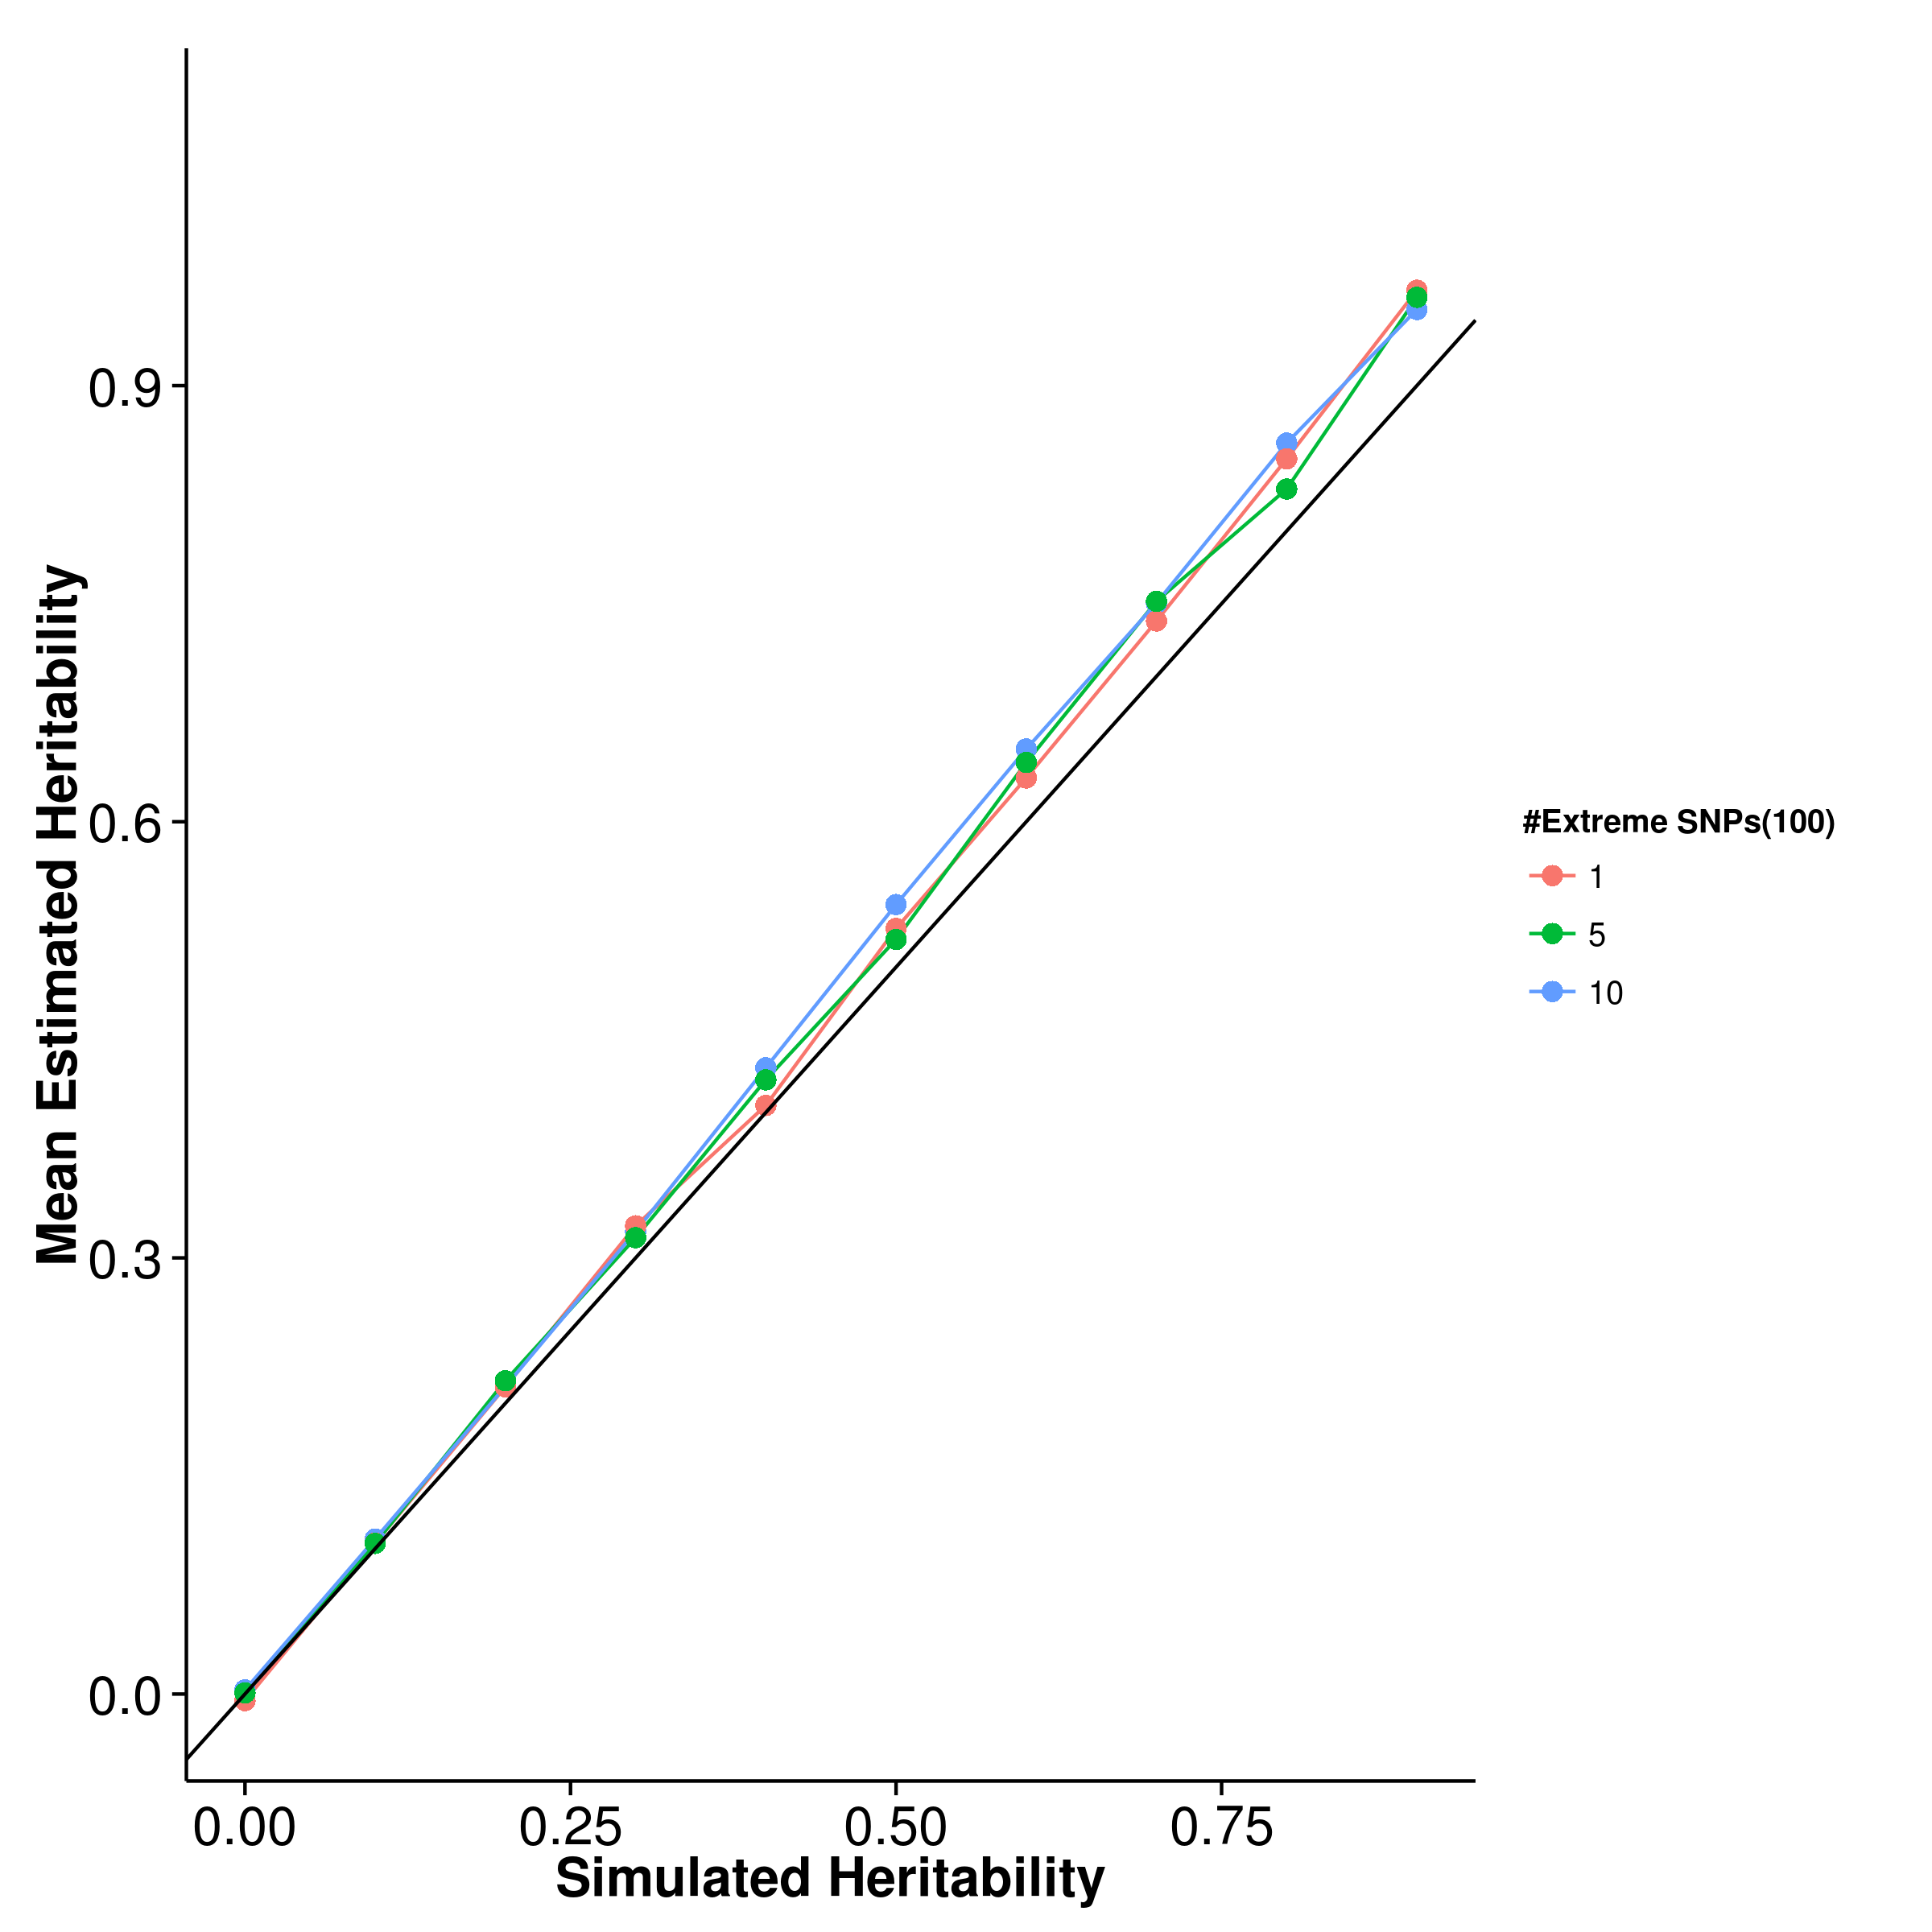 [GCTA] 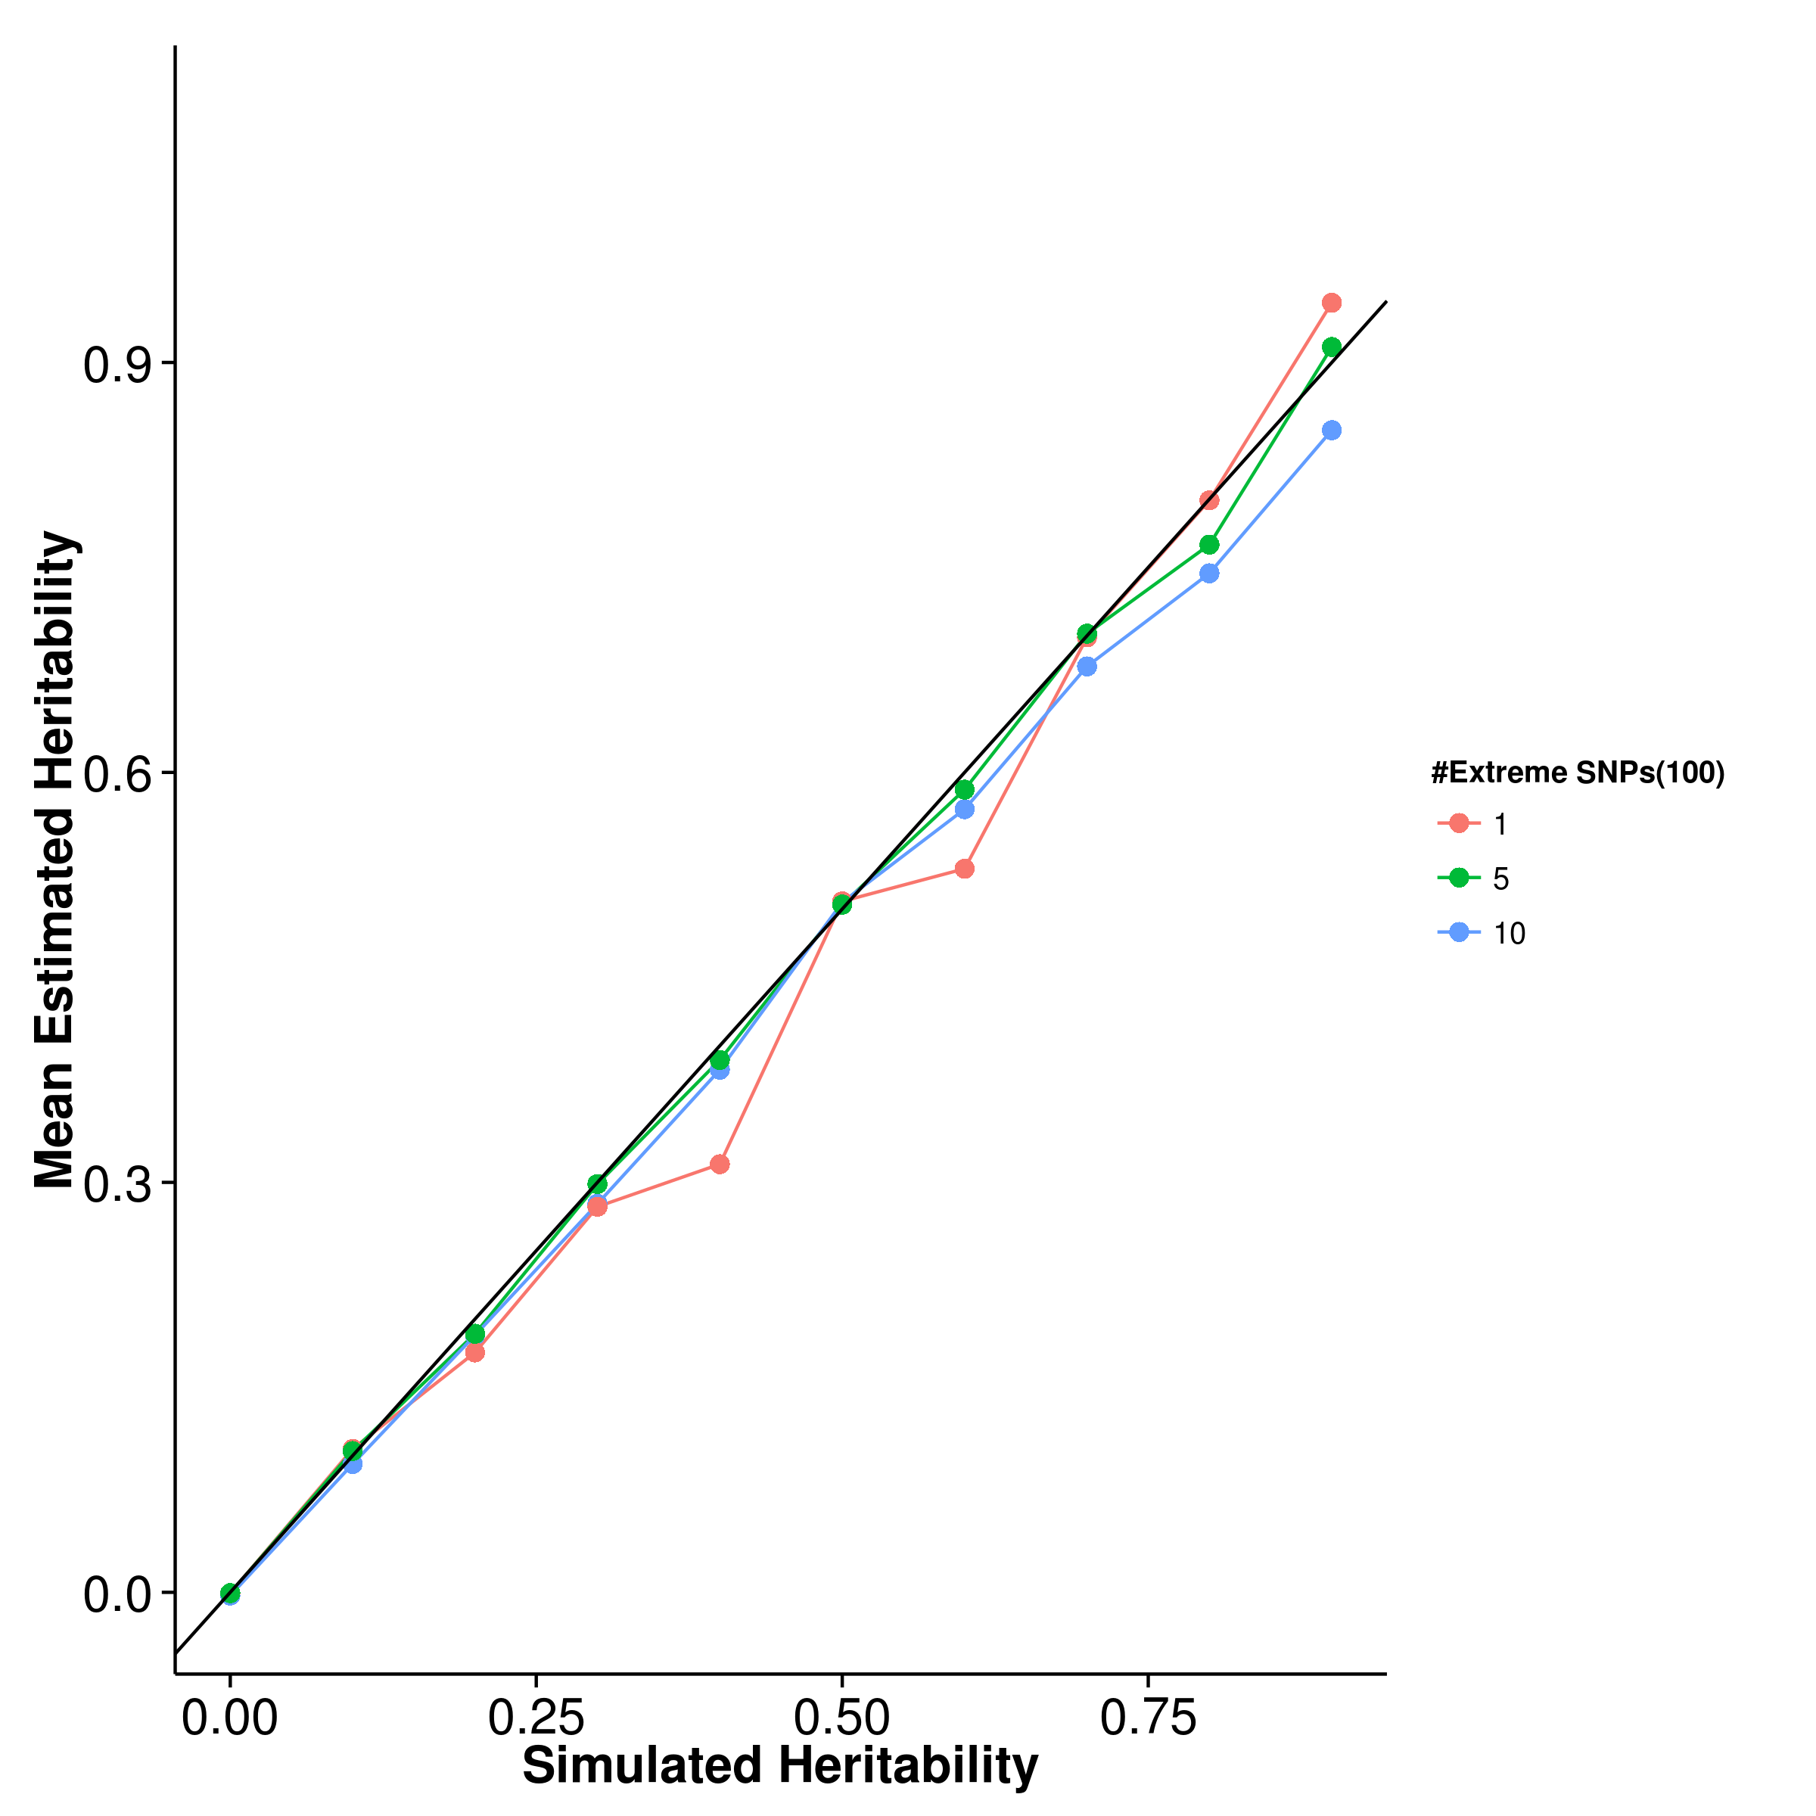

[LDSC with fix intercept] 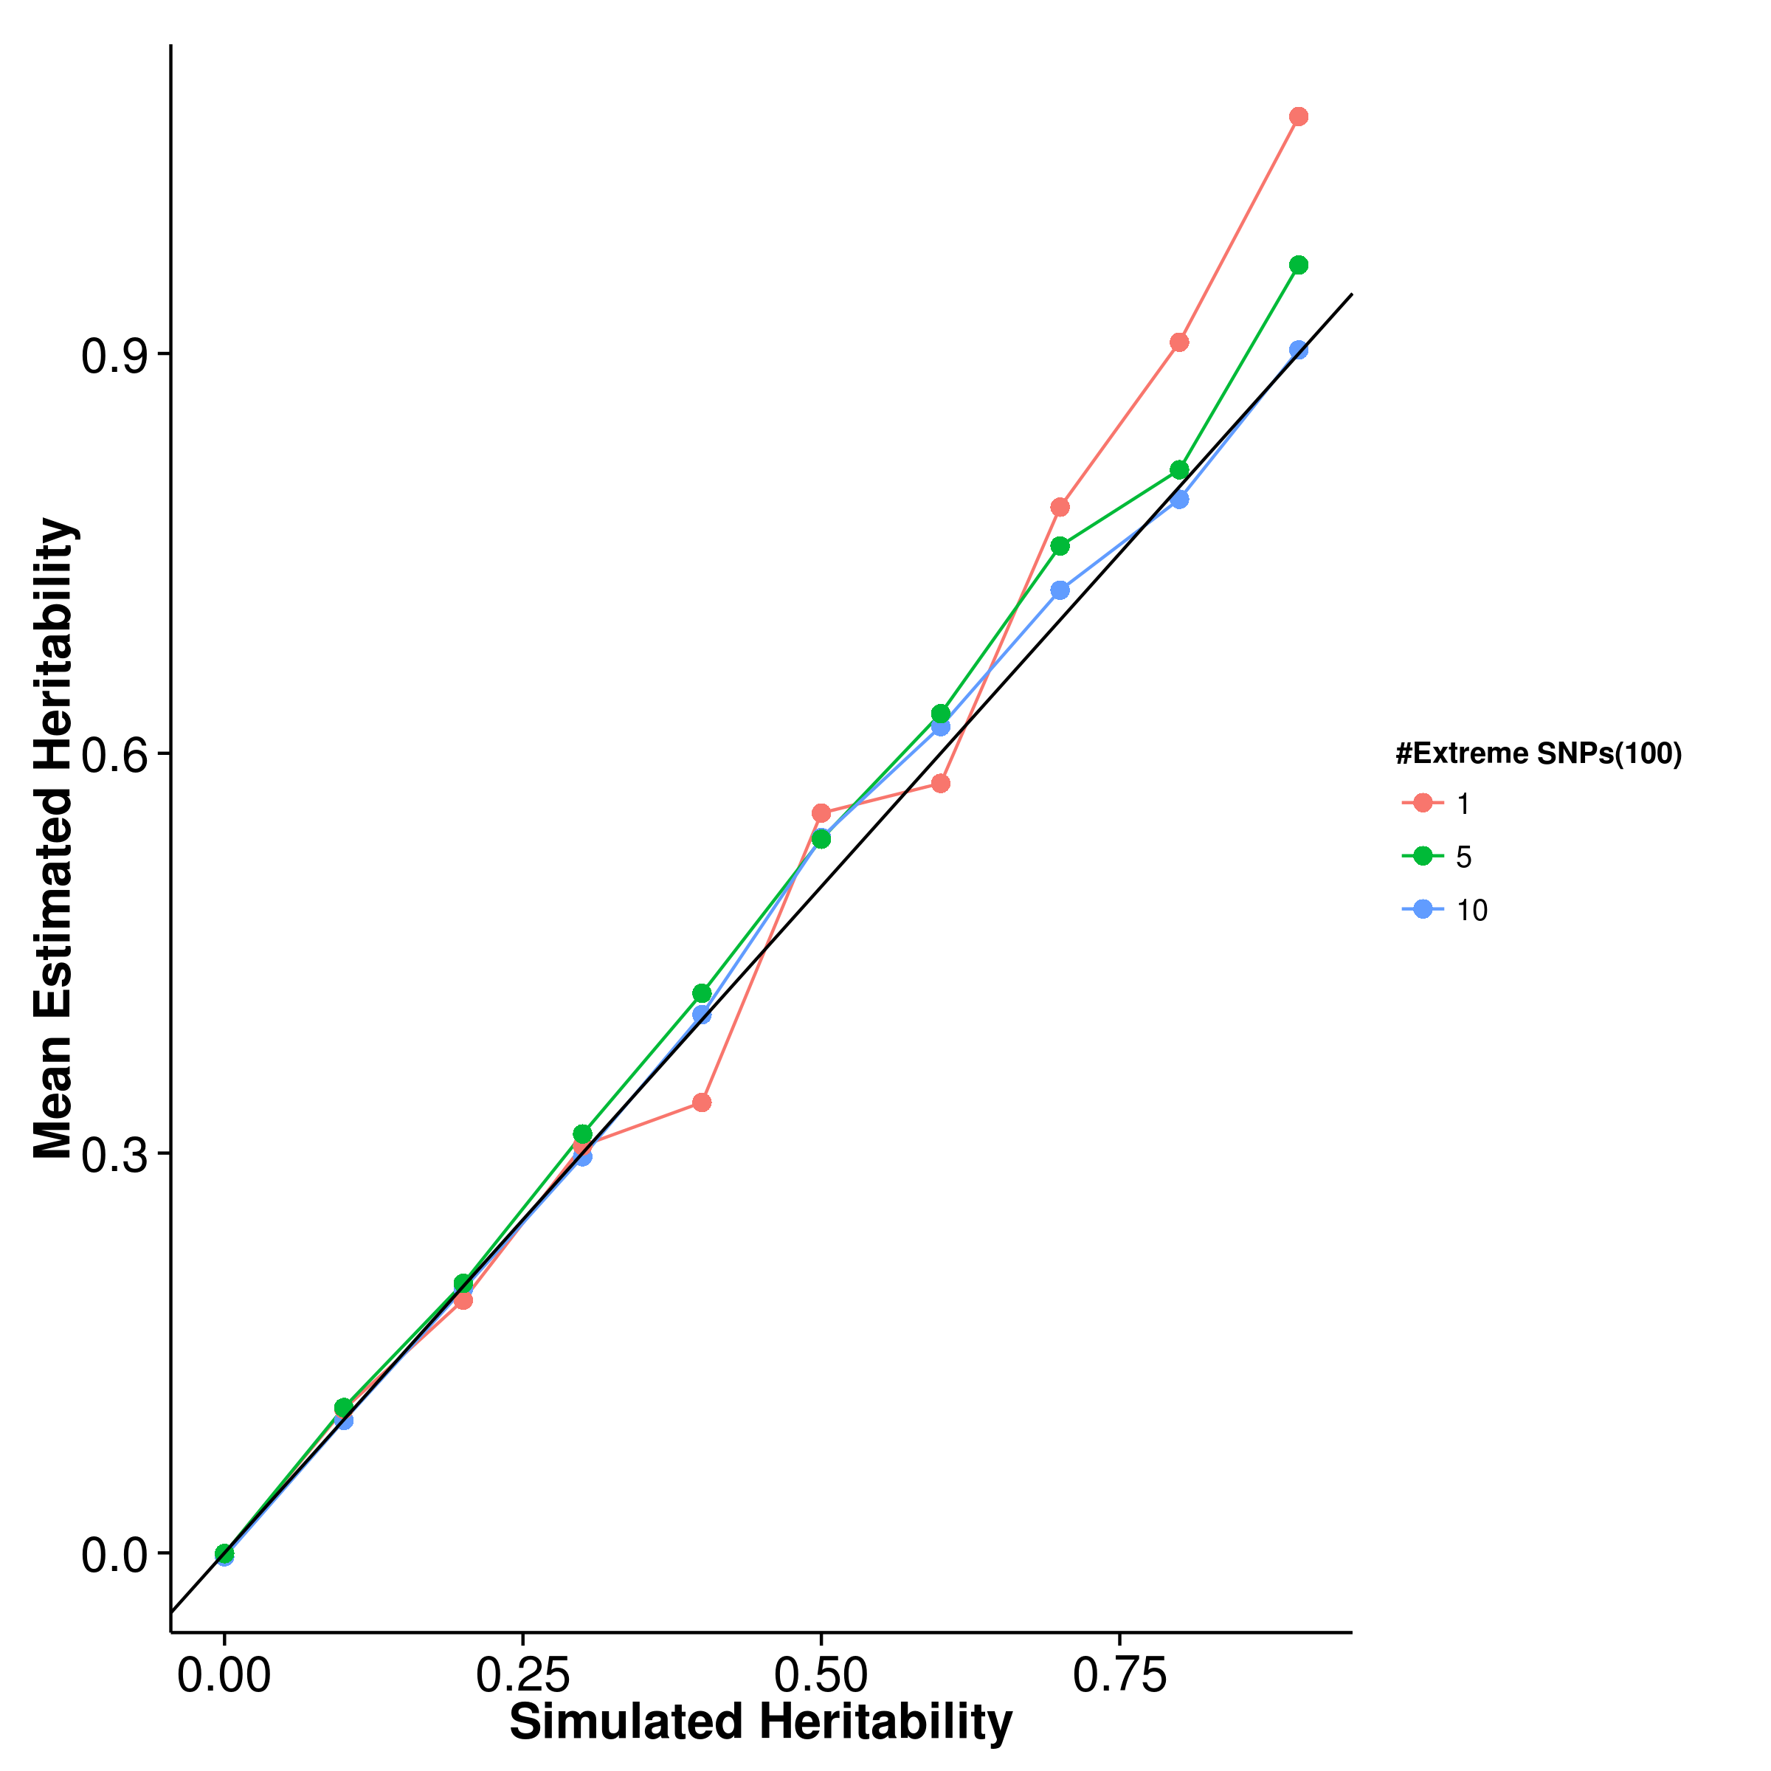 [LDSC with intercept estimation]

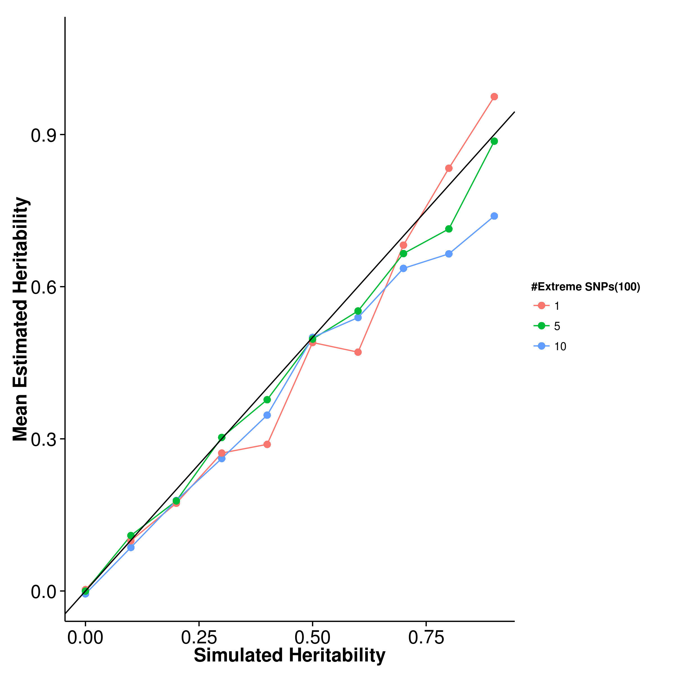

Figure 12: Mean of results from quantitative trait simulation with extreme effect size simulation. It was observed that the mean estimation of heritability of shrek is not affected by the number of SNP(s) with large effect but with slight upward bias. On the other hand, the mean estimation of ldsc and gcta seems to fluctuate with respect to the simulated heritability.

[SHREK] 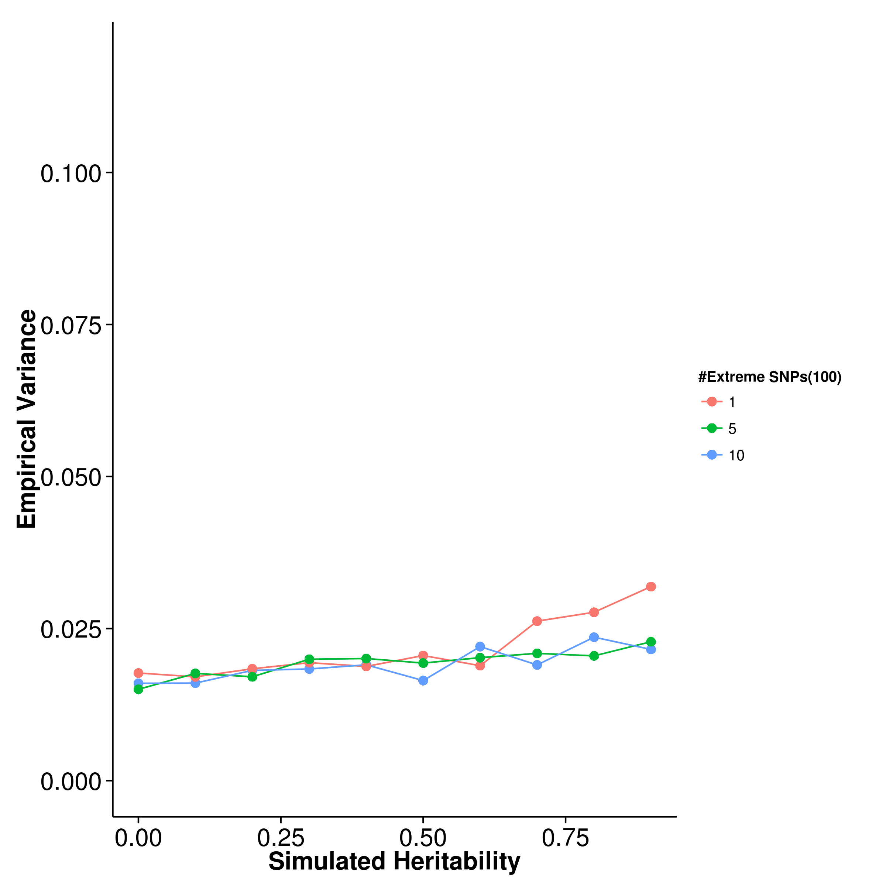 [GCTA] 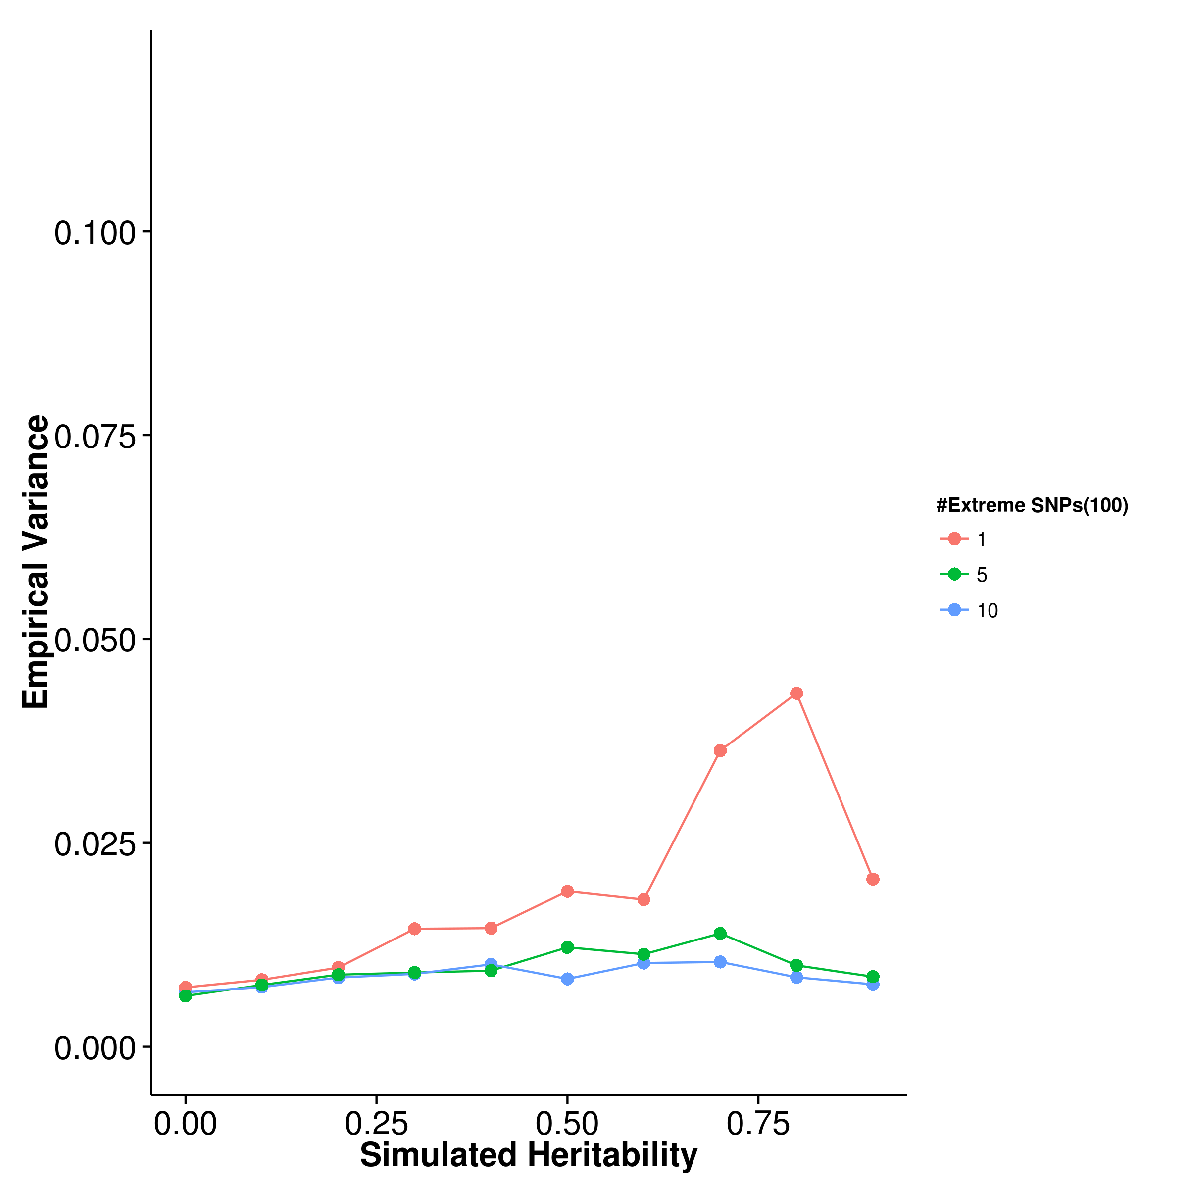

[LDSC with fix intercept] 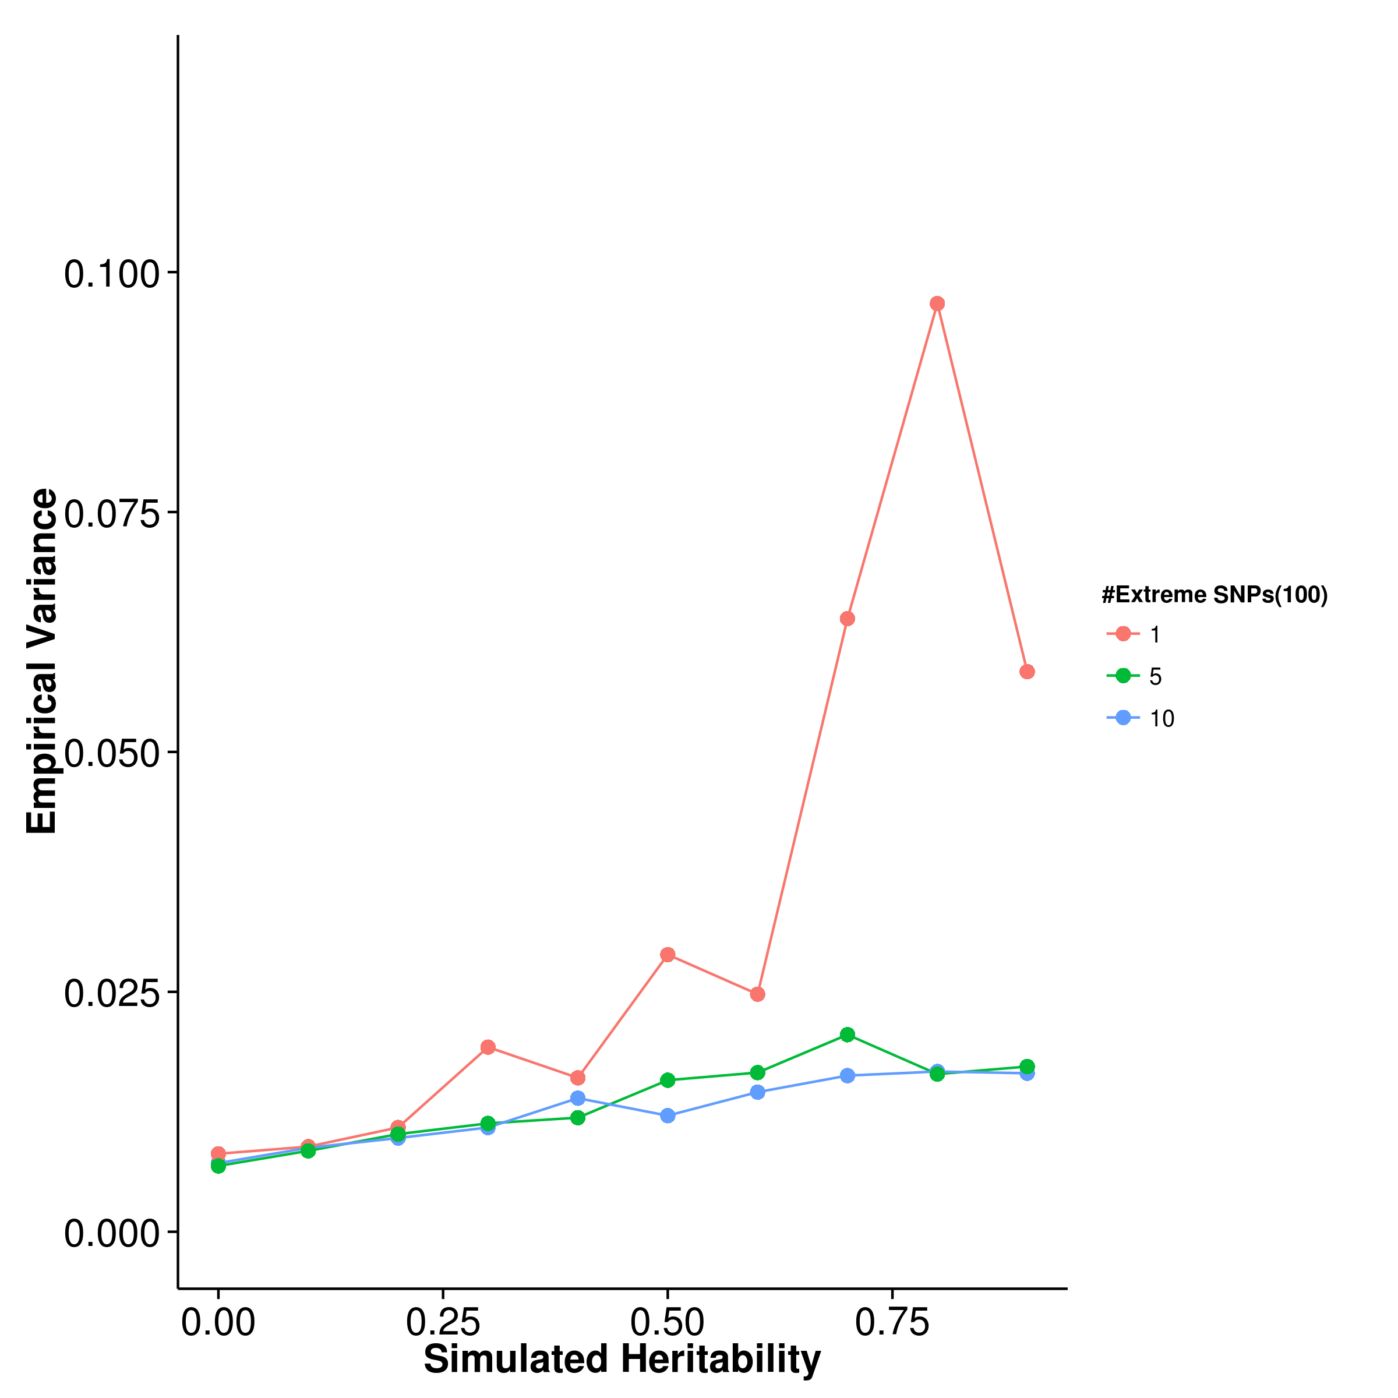 [LDSC with intercept estimation]

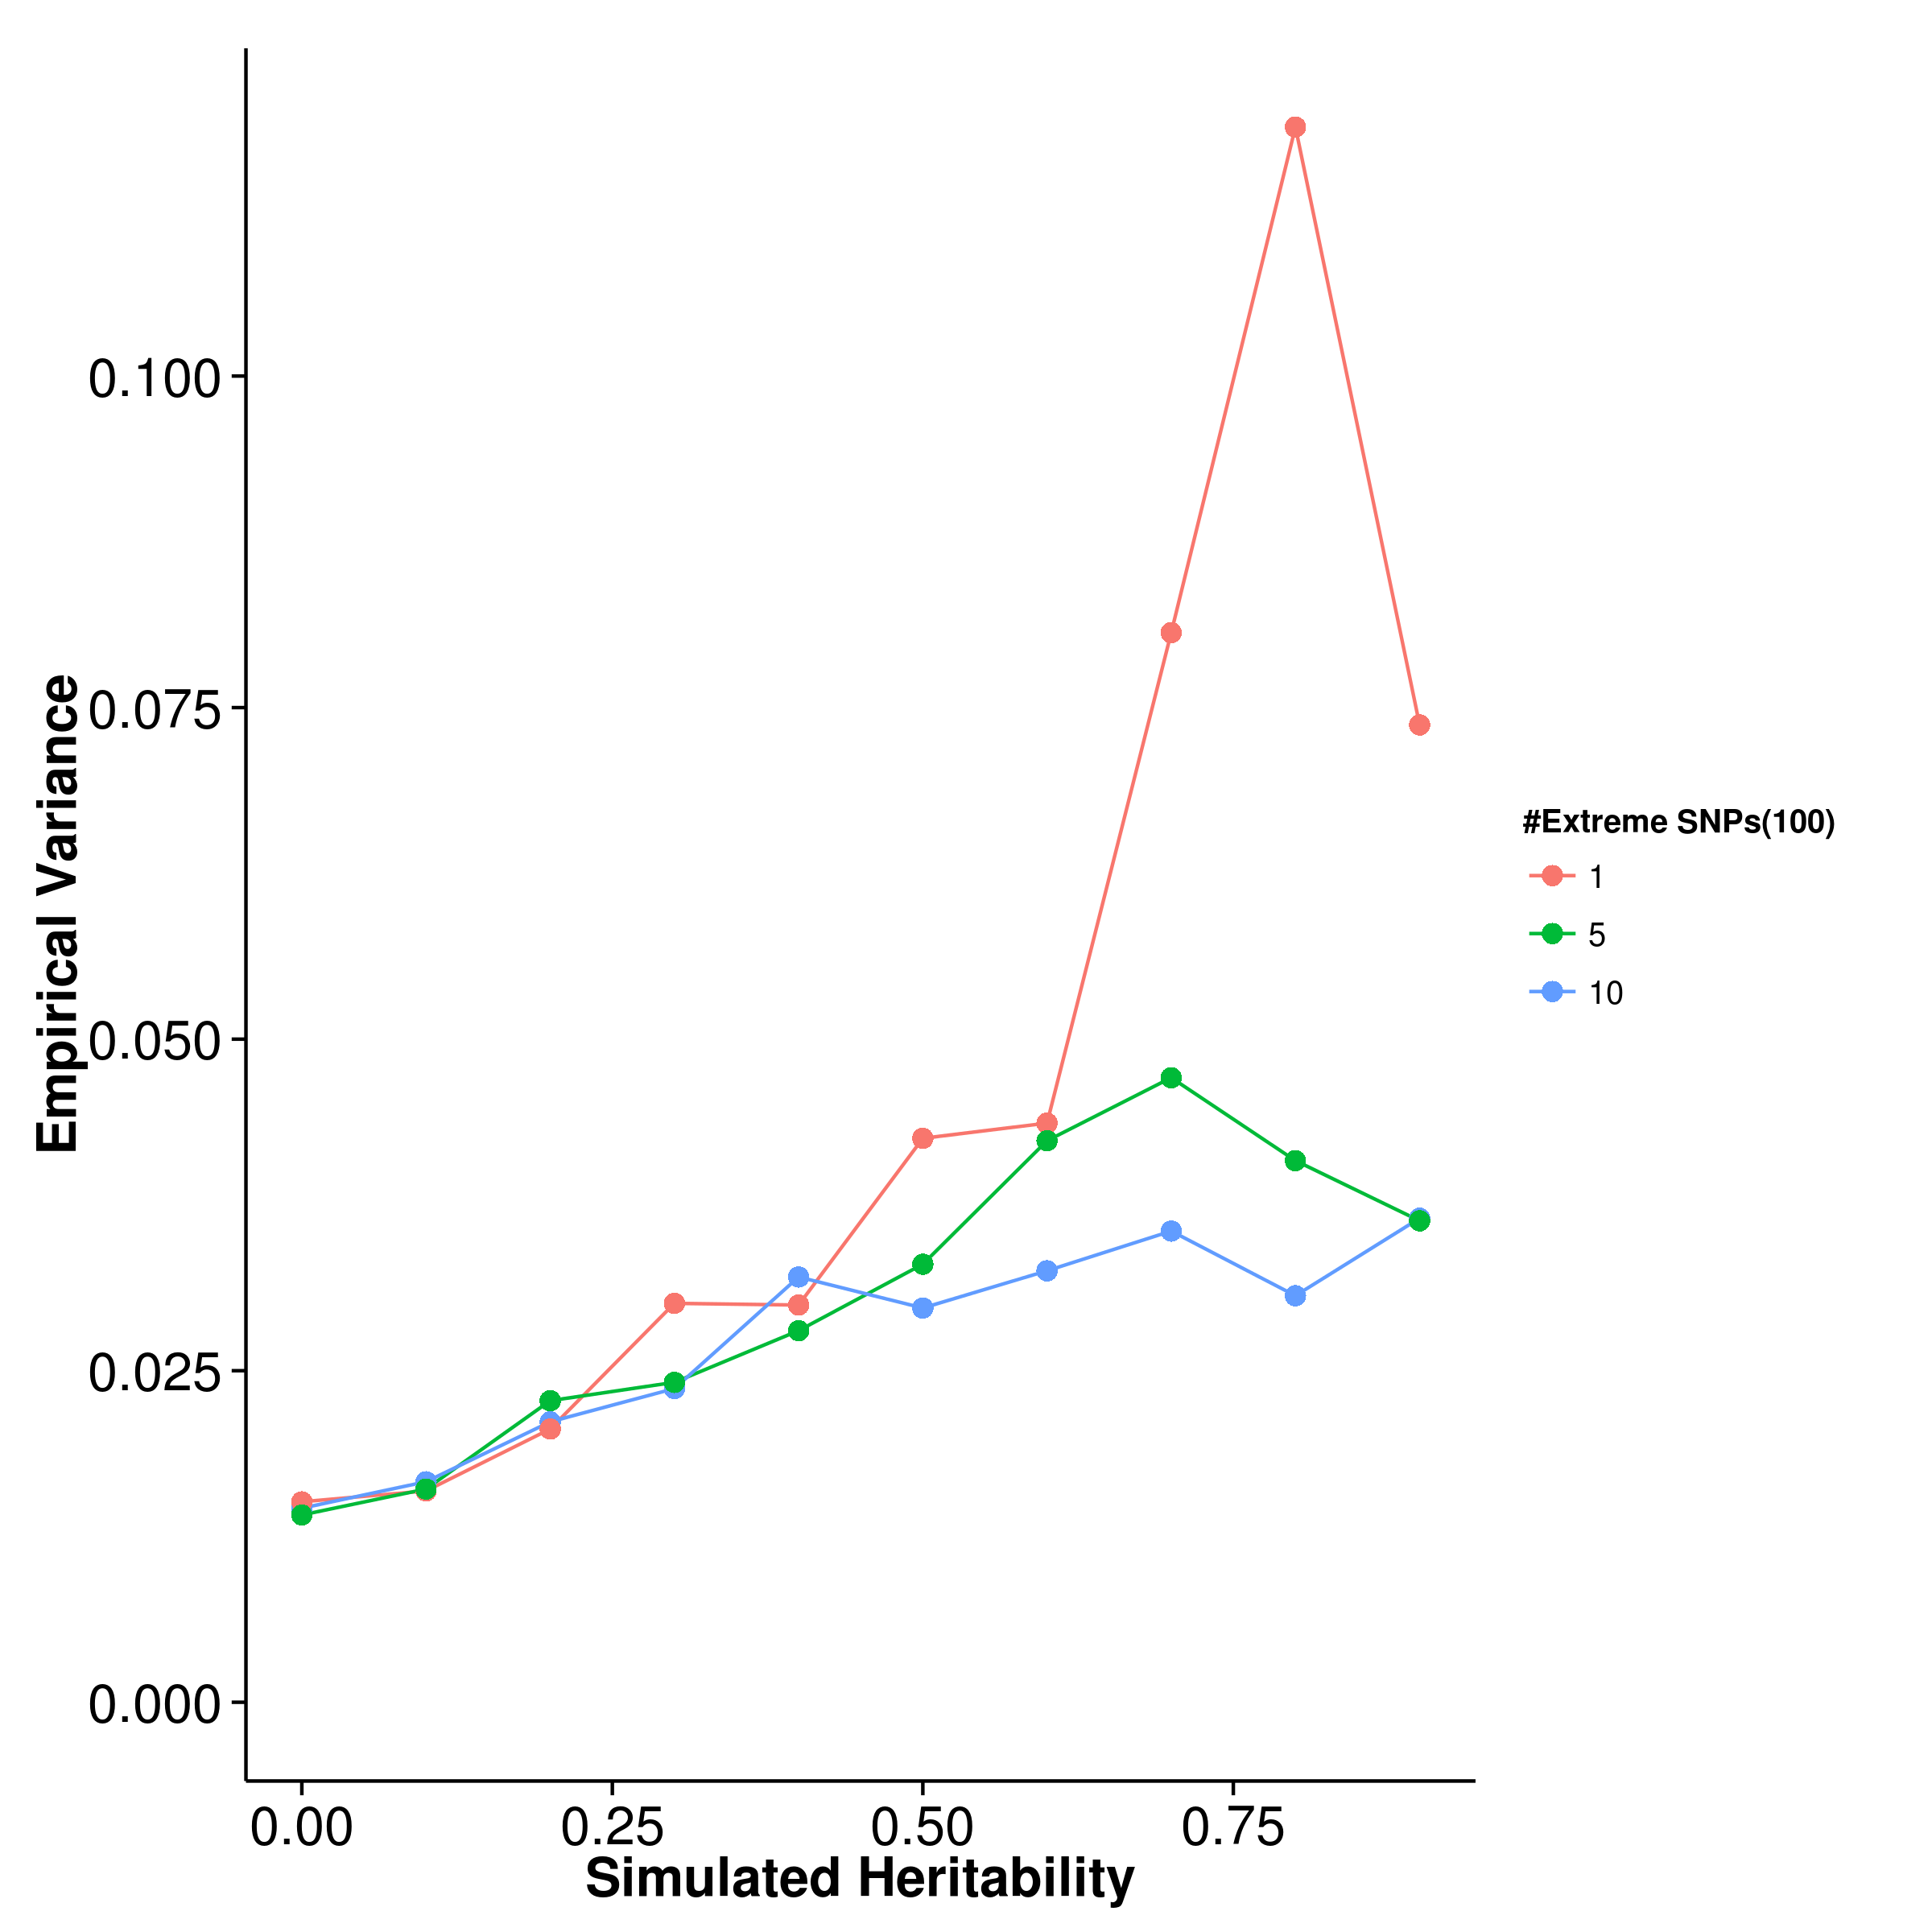

Figure 13: Variance of results from quantitative trait simulation with extreme effect size simulation. 100 causal SNP were simulated. When only 1 SNP with extreme effect was simulated, the empirical variance of gcta and ldsc increases and a large fluctuation was observed. Whereas the empirical variance of shrek only increase slightly when the simulated heritability is large and with only 1 SNP with extreme effect. Suggesting that it is more robust to the change in number of extreme SNP(s).

[SHREK] 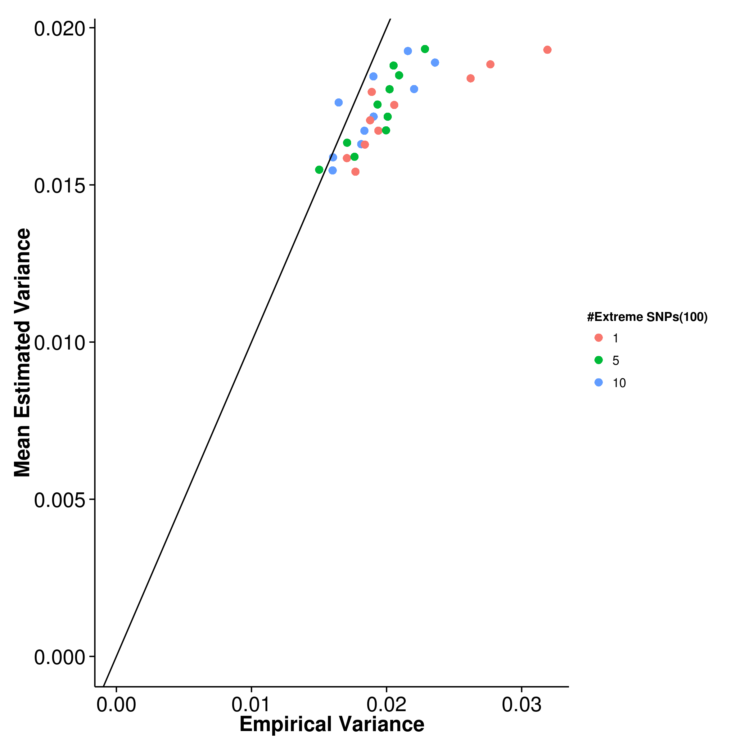 [GCTA] 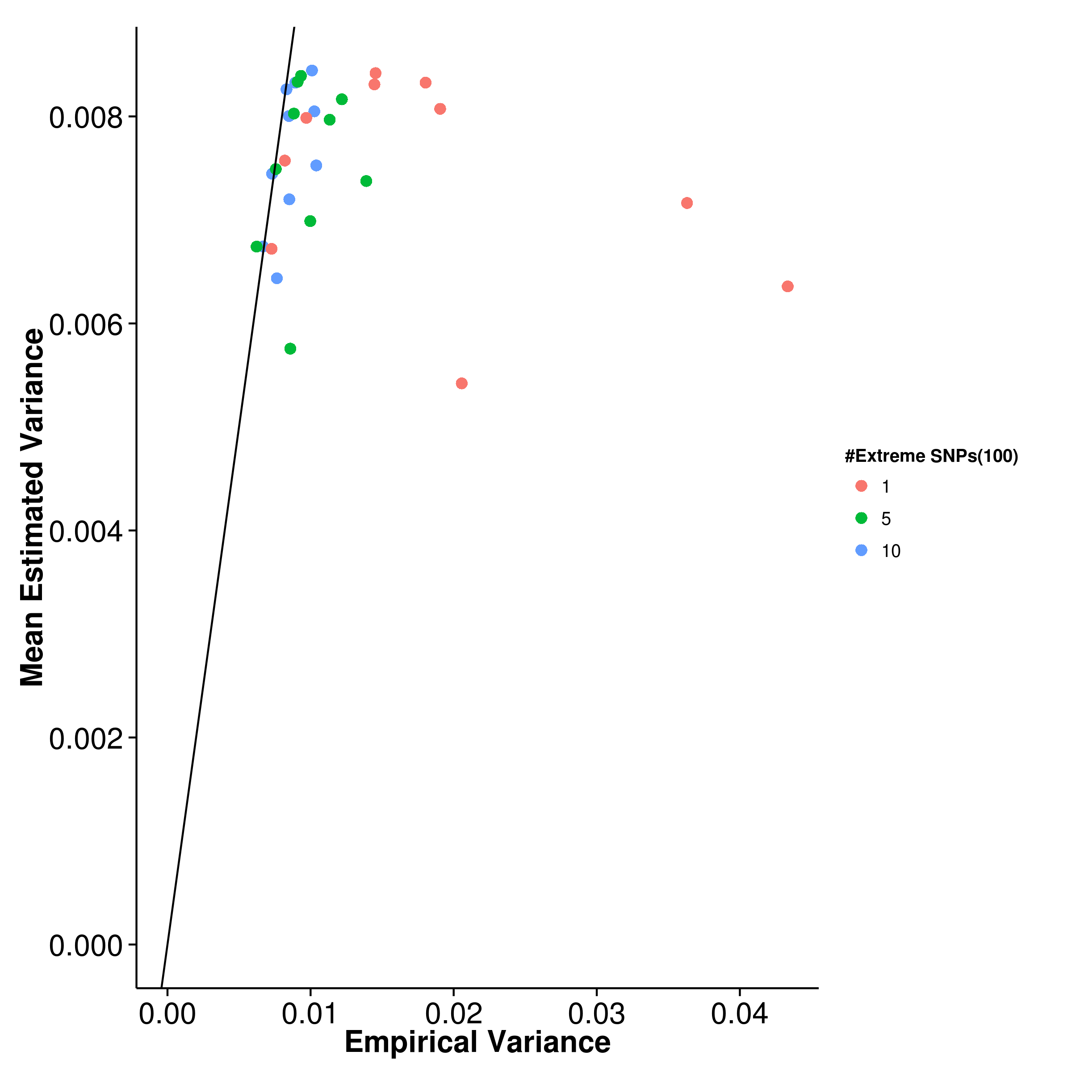

[LDSC with fix intercept] 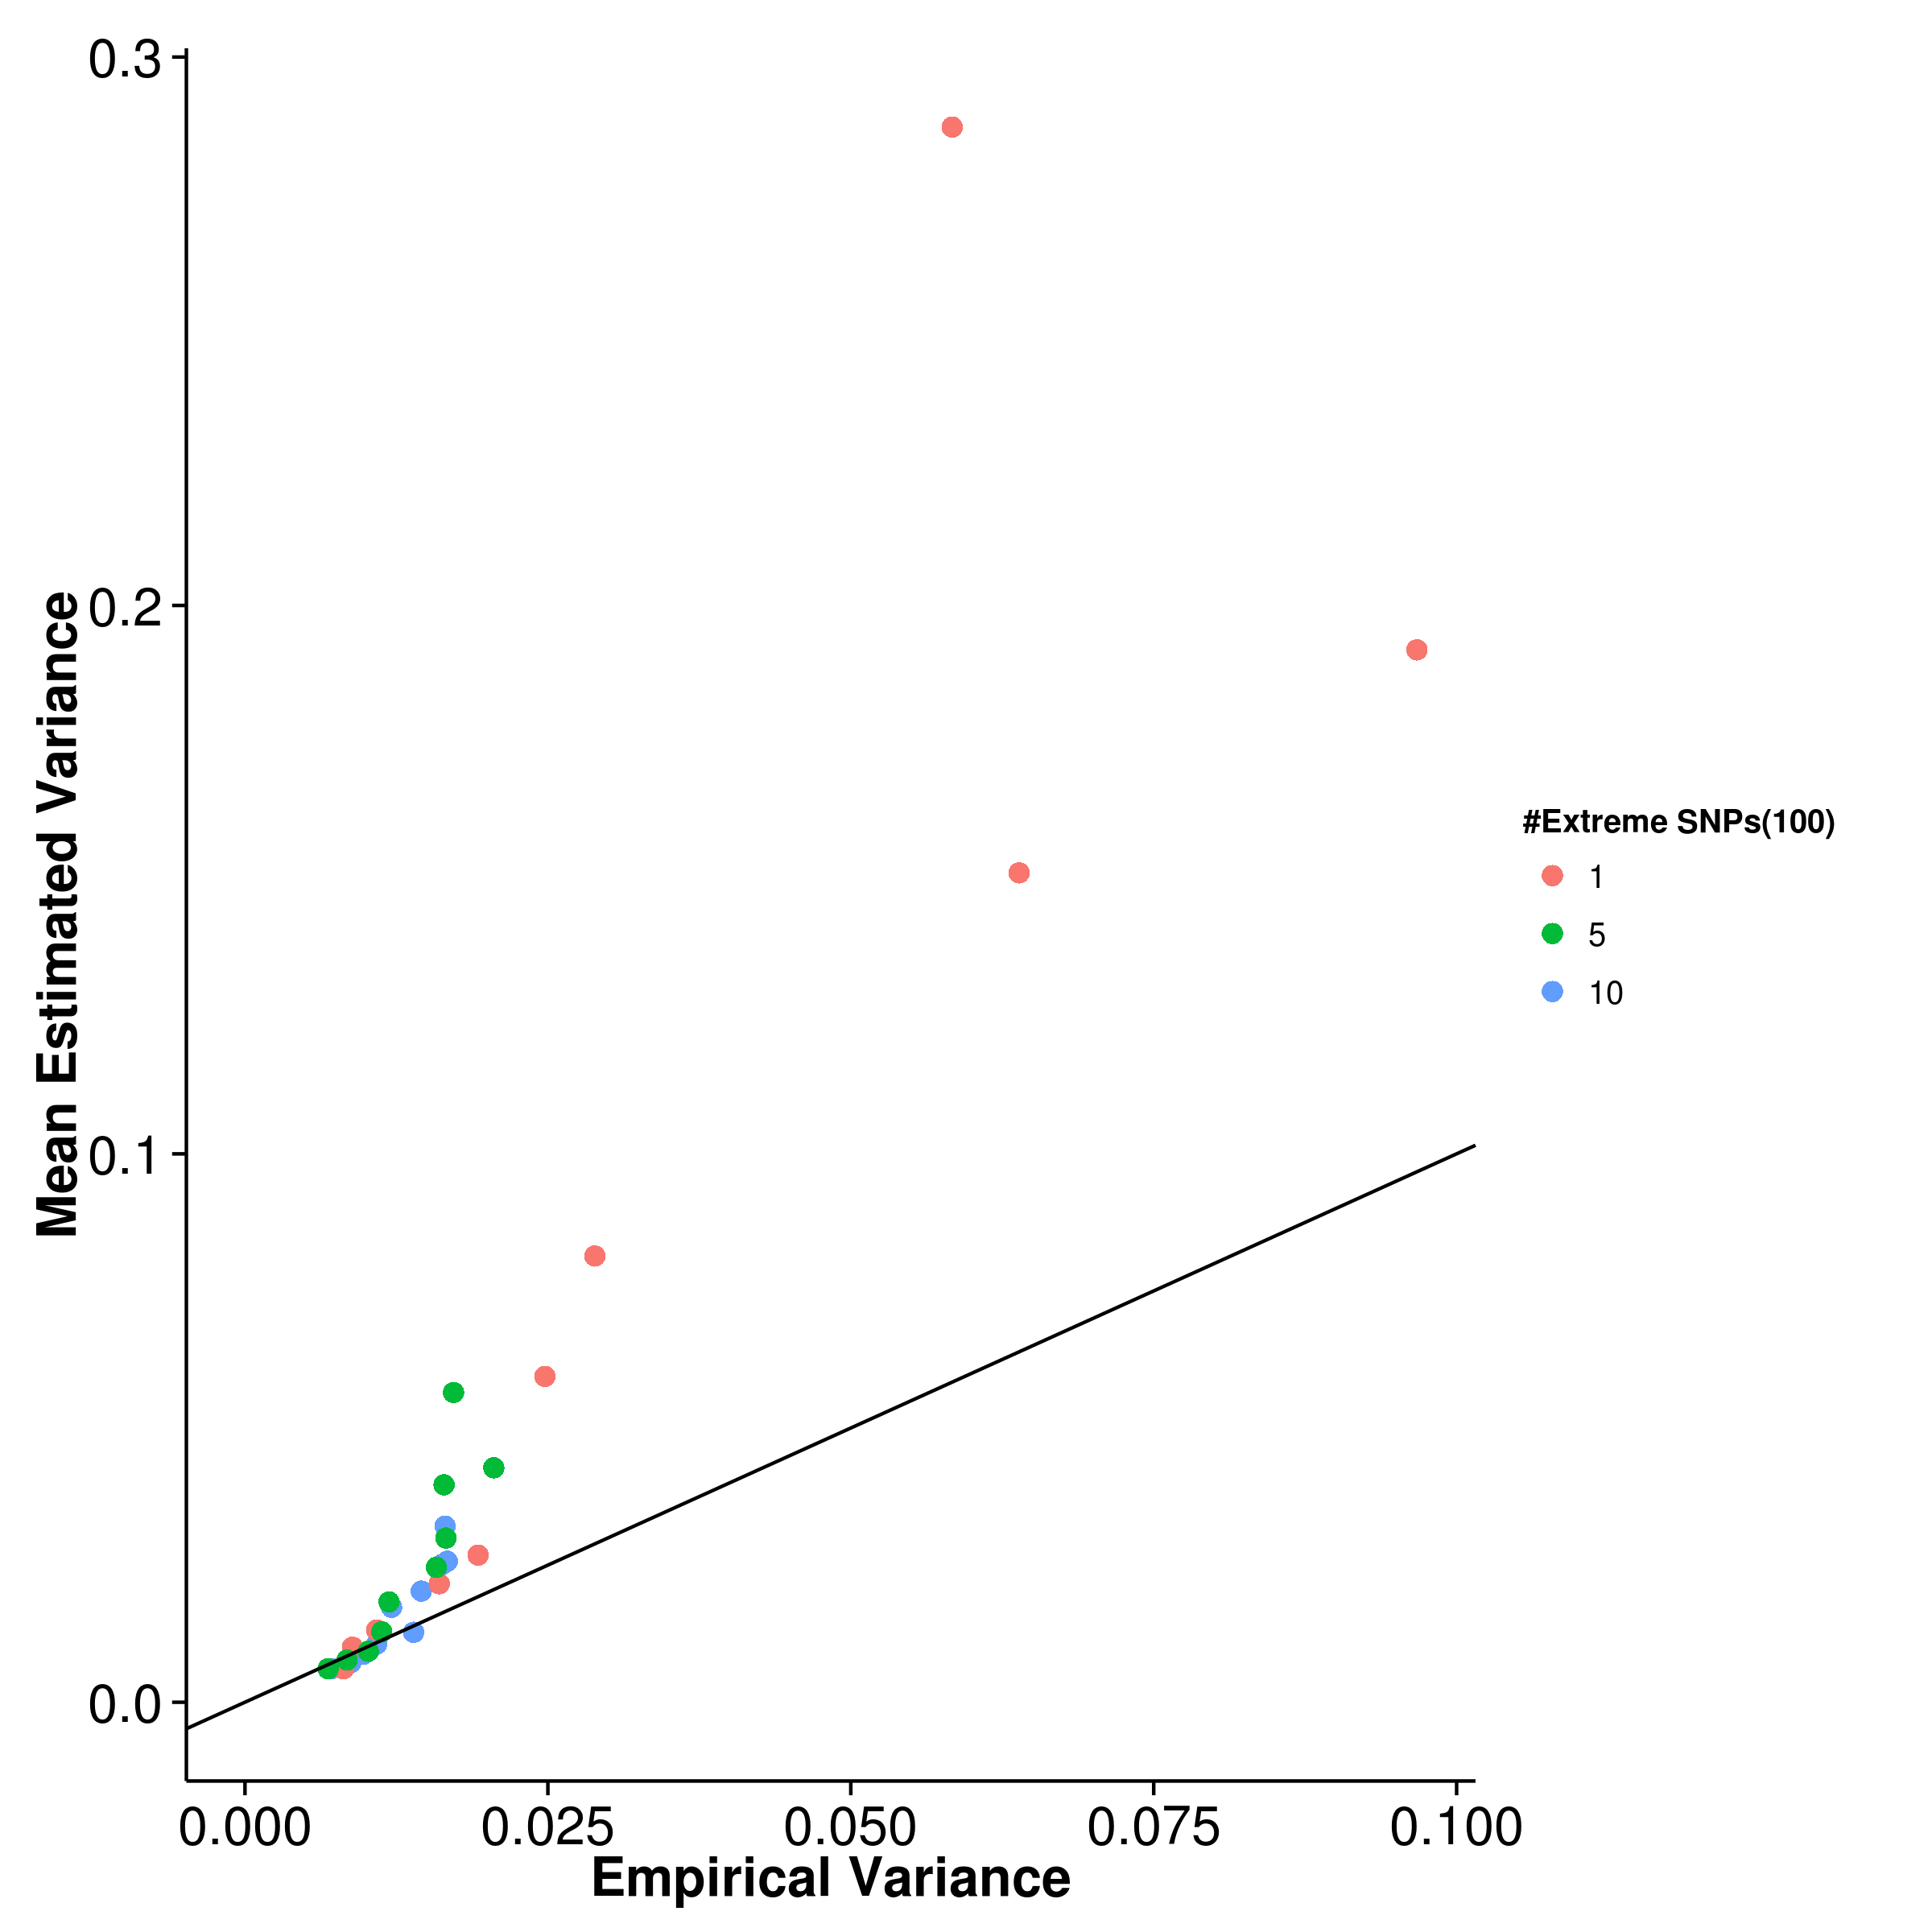 [LDSC with intercept estimation]

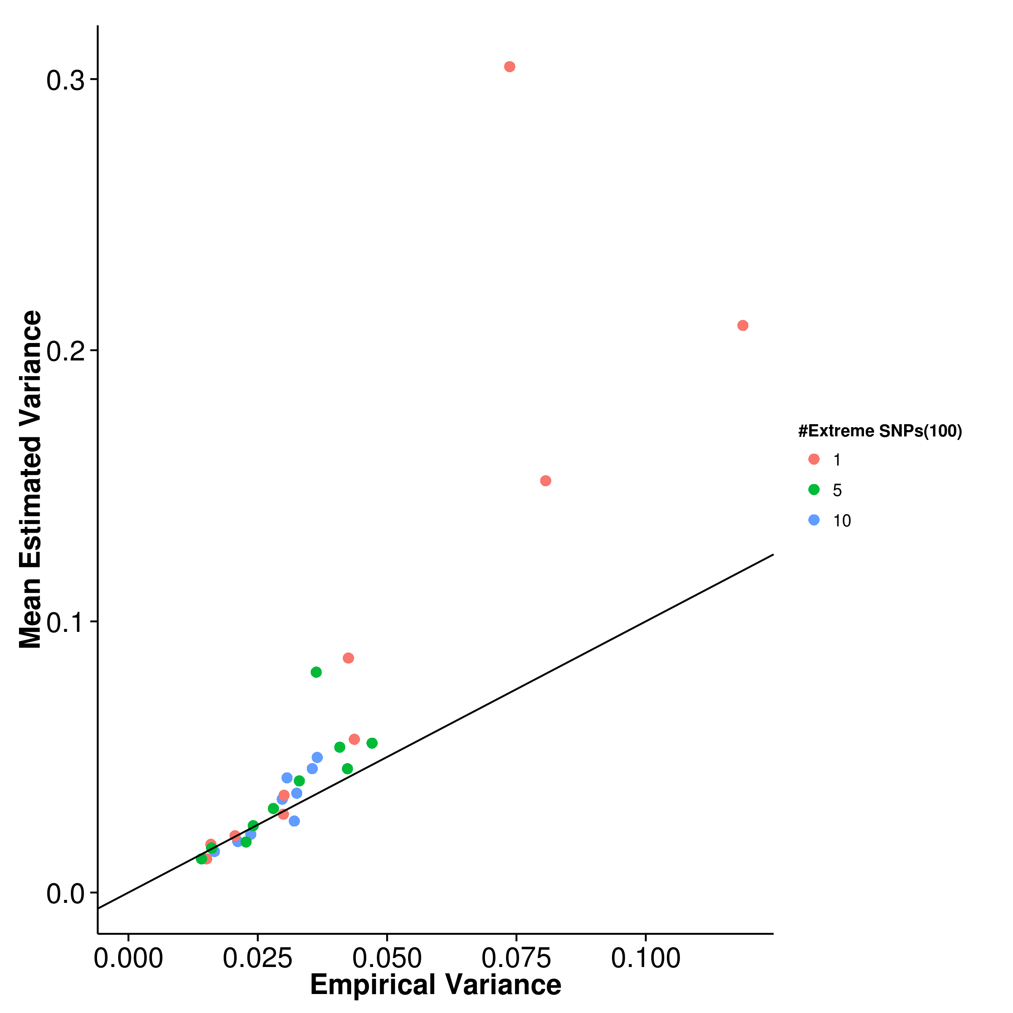

Figure 14: Estimated variance of results from quantitative trait simulation with extreme effect size simulation when compared to the empirical variance. 100 causal SNP were simulated. shrek and gcta generally under-estimate the variance with the magnitude of bias being the highest when there is only 1 SNP with extreme effect. On the other hand, ldsc tends to over-estimate the variance and it can overestimate the variance by more than 3 folds when there is only 1 SNP with extreme effect.

For some diseases such as Hirschsprung’s disease, a small number of SNP can account for majority of the effect with a large number of SNP with small effect size. Therefore we were interested to test the performance of SNP heritability estimation in such scenario. We performaned the quantitative trait simulation with 100 causal SNP where 1,5 or 10 of those SNP(s) has a large effect.

When assessing the mean estimation of heritability (fig:QtEx100cMean), the performance of the algorithms are similar to that in the quantitative trait simulation. The only exception is when 1 SNP with large effect was simulated, the mean estimation of ldsc and gcta fluctuates (fig:gctaQtEx100cMean,fig:ldscQtEx100cMean,fig:ldscInQtEx100cMean). The same fluctuation is not observed in shrek (fig:shrekQtEx100cMean). Similarly, the empirical variance of the estimation (fig:QtEx100cVar) from gcta and ldsc increases and fluctuates when only 1 SNP with large effect was simulated. It is most obvious in the case of ldsc where the variance increased drastically as the heritability is high (fig:ldscQtEx100cVar). However, shrek does not seems to be affected and are robust to the number of SNP with large effect.

The estimated variance are also affected by the number of SNP with large effect where the larges discrepancy between the estimated and empirical variance is observed when only 1 SNP with large effect was simulated. It is observed that both shrek and gcta tends to underestimates their empirical variance whereas ldsc tends to overestimates the empirical variance. The difference between the estimated and empirical variance for ldsc with fixed effect can be as much as 3 fold.

To conclude, the performance of gcta is superior to other algorithm(tab:mseEx100c). However, if we only consider the algorithms using summary statistic for heritability estimation, the performance of ldsc is better than shrek when there are more than 1 SNP with large effect. Again, as no confounding factors were simulated, ldsc with fixed intercept outperforms ldsc with intercept estimation. It is interesting to note that the mse of shrek was least affected by the number of SNP(s) with large effect.

|  |  |  |  |  |
| --- | --- | --- | --- | --- |
| Number of Extreme SNPs | SHREK | LDSC | LDSC-In | GCTA |
| 1 | 0.0227 | 0.0393 | 0.0508 | 0.0206 |
|  | 0.0203 | 0.0145 | 0.0316 | 0.00985 |
|  | 0.0205 | 0.0129 | 0.0329 | 0.00939 |
|  | |

Table 4: mse of quantitative trait simulation with extreme effect size. Of all the algorithms, gcta has the lowest mse in all situations. When comparing the performance of shrek and ldsc, shrek only has a better performance when there is one SNP with large effect. For other scenarios, ldsc with fixed intercept has better performance. However, we can observe that the performance of shrek is very consistent and robust to the change in number of SNP with extreme effect size.

#### 6.2.3 Case Control Simulation

[SHREK] 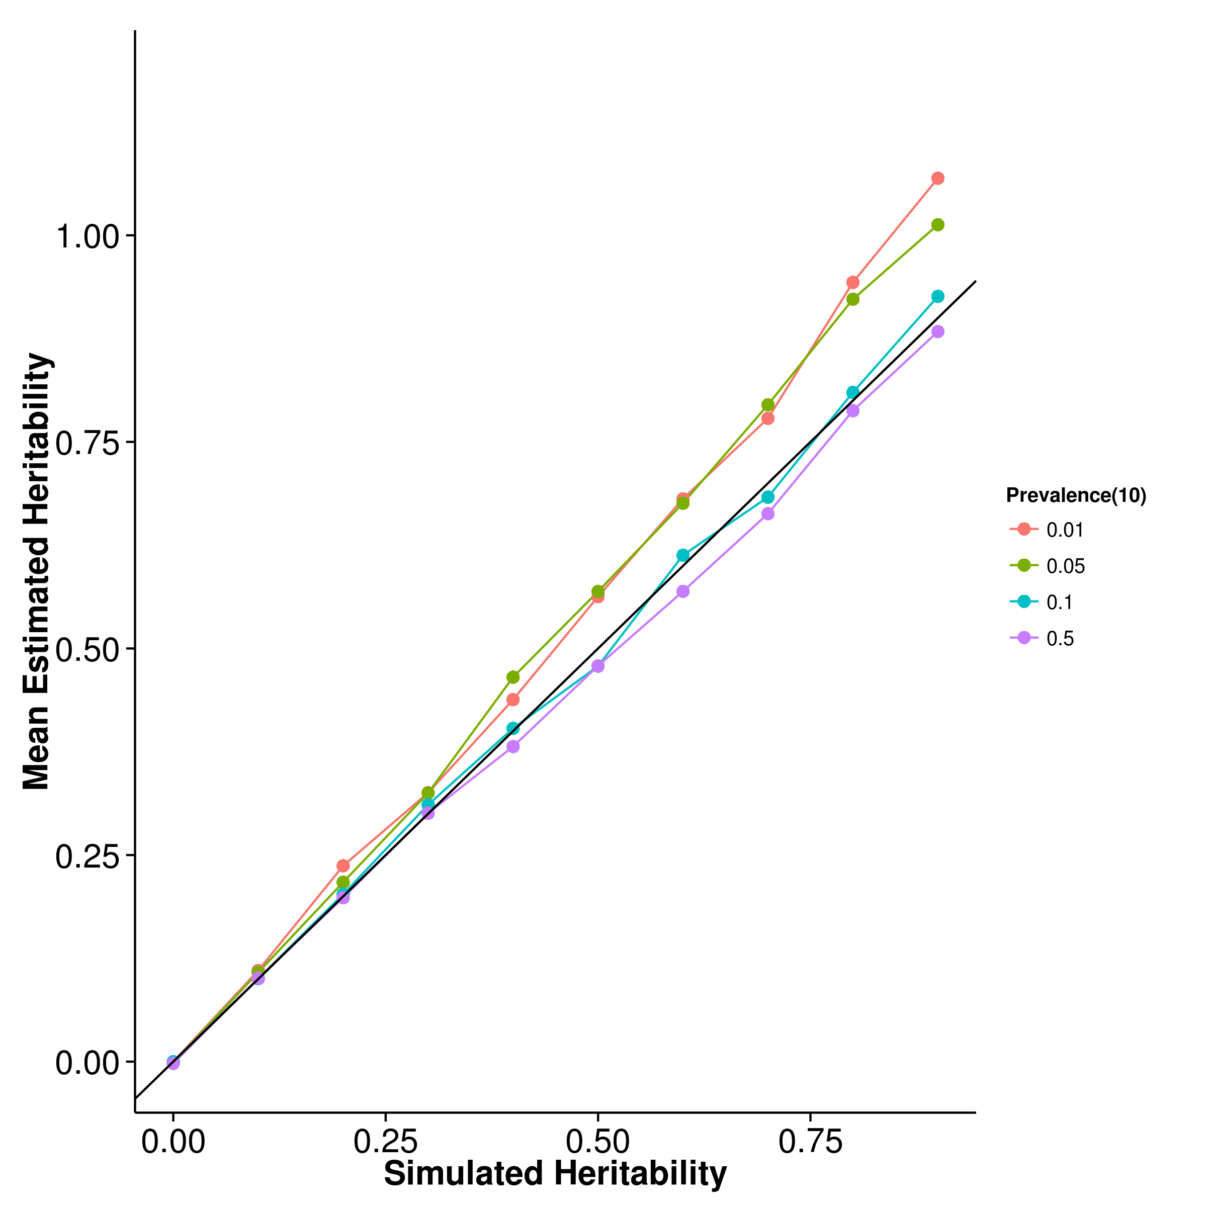 [GCTA] 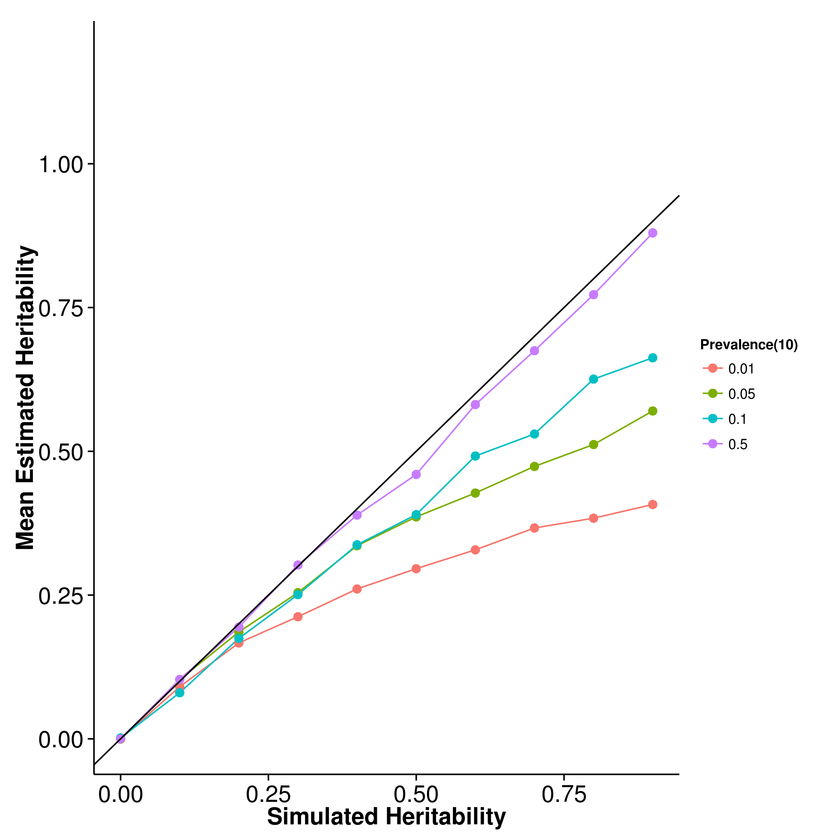

[LDSC with fix intercept] 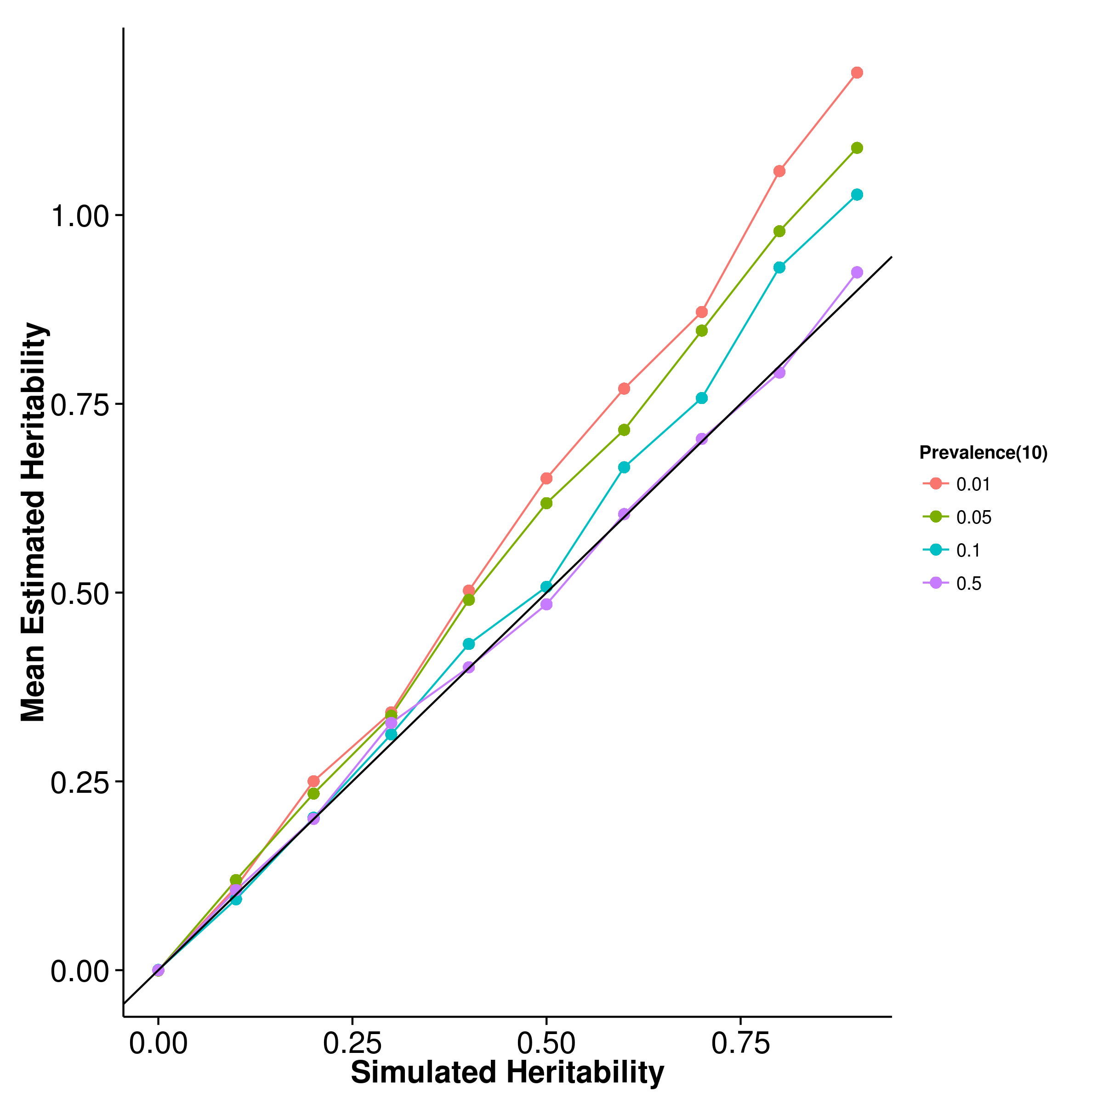 [LDSC with intercept estimation]

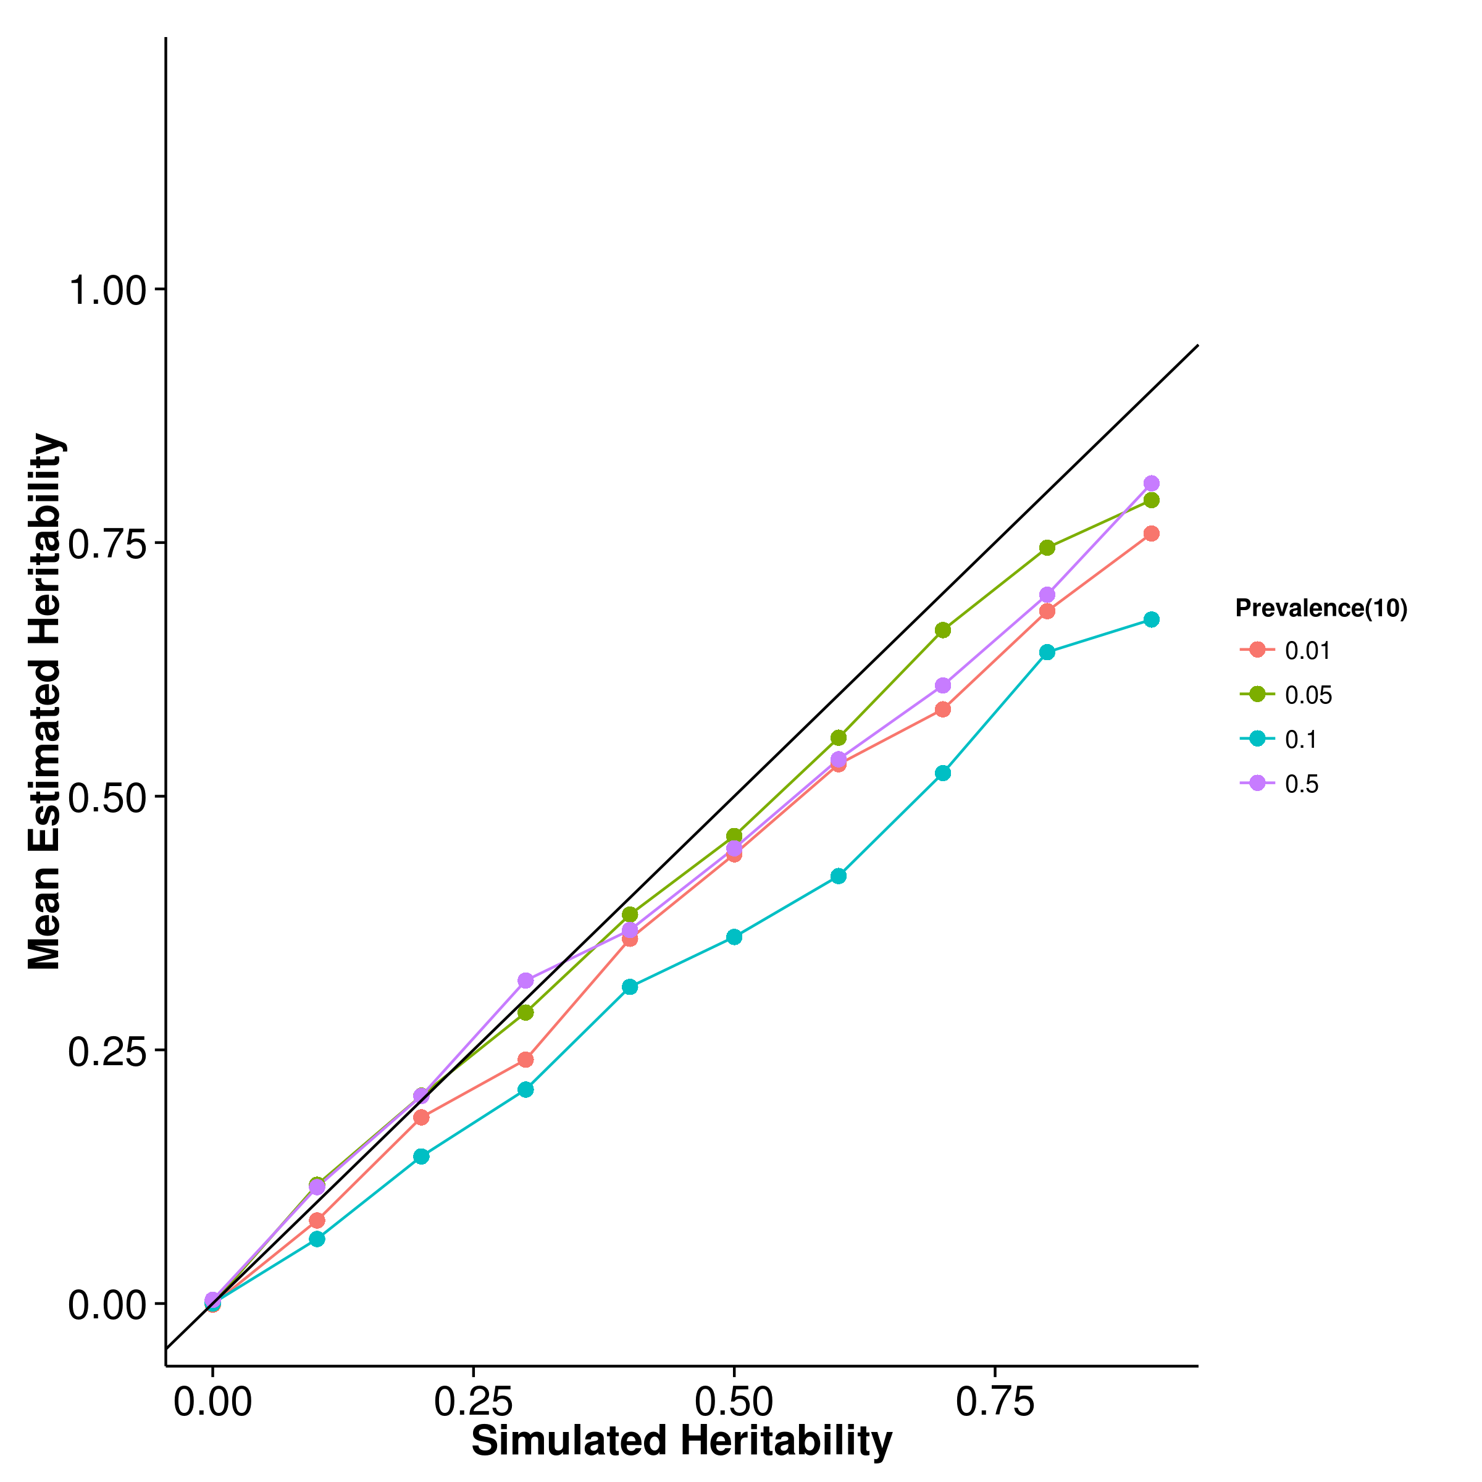

Figure 15: Mean of results from case control simulation with random effect size simulation with 10 causal SNP. The performance of gcta was as suggested by [?] where there was an underestimation as prevalence decreases. On the other hand, the upward bias of both ldsc with fixed intercept and shrek increases as the prevalence decreases whereas ldsc with intercept estimation seems relatively robust to the change in prevalence.

[SHREK] 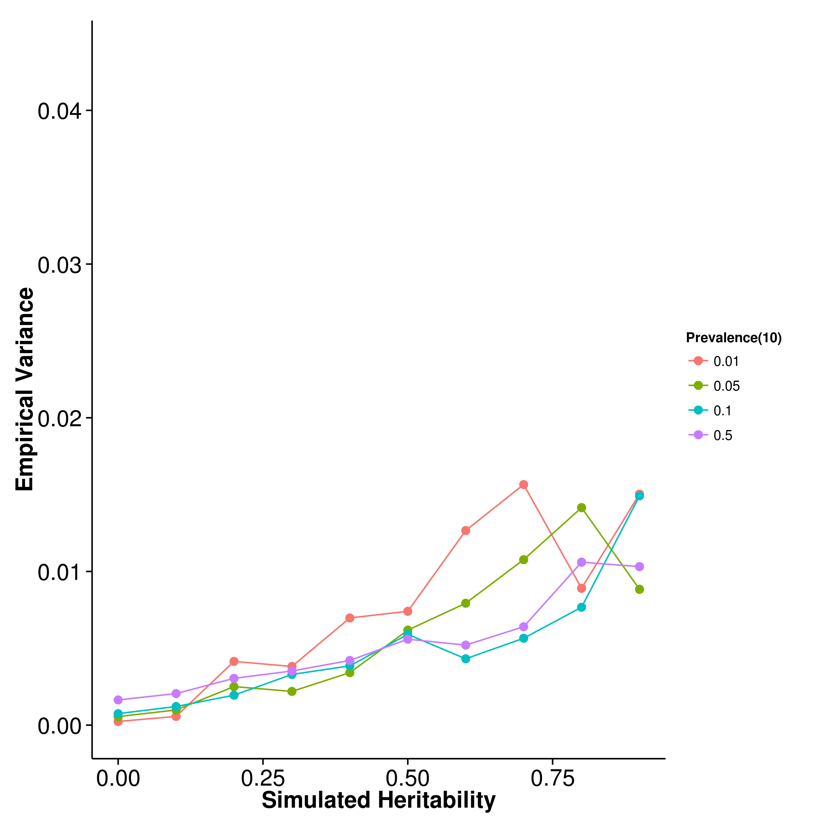 [GCTA] 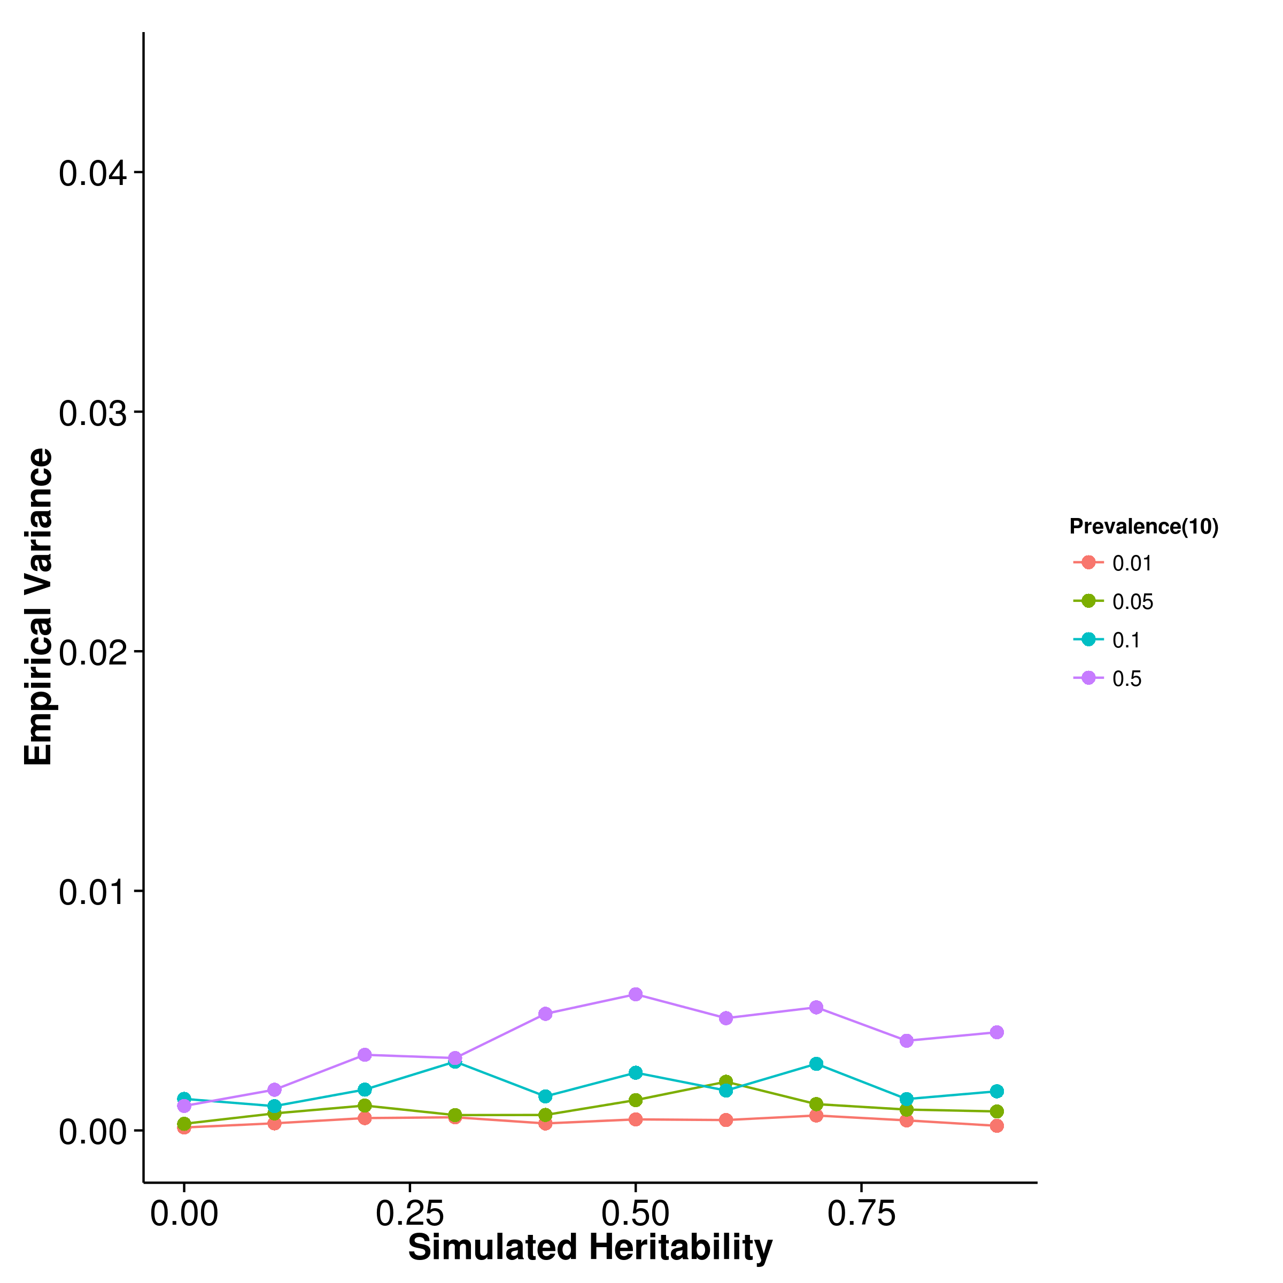

[LDSC with fix intercept] 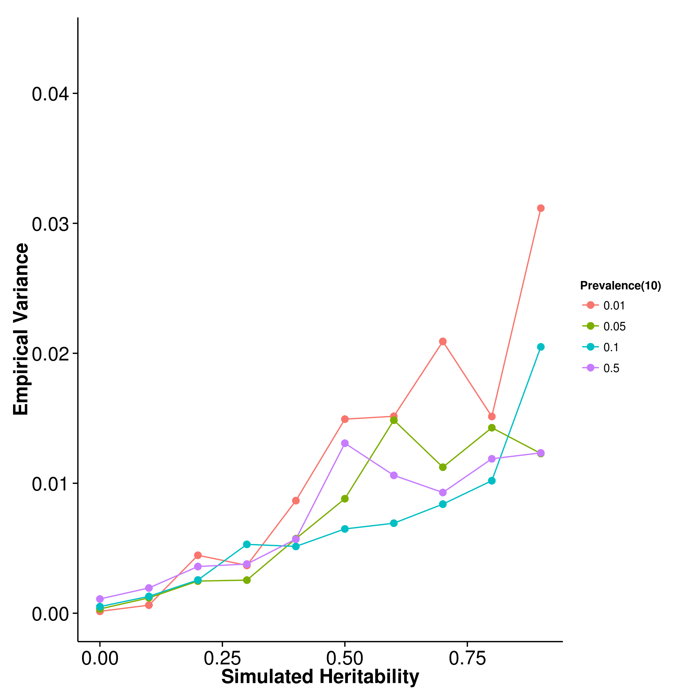 [LDSC with intercept estimation]

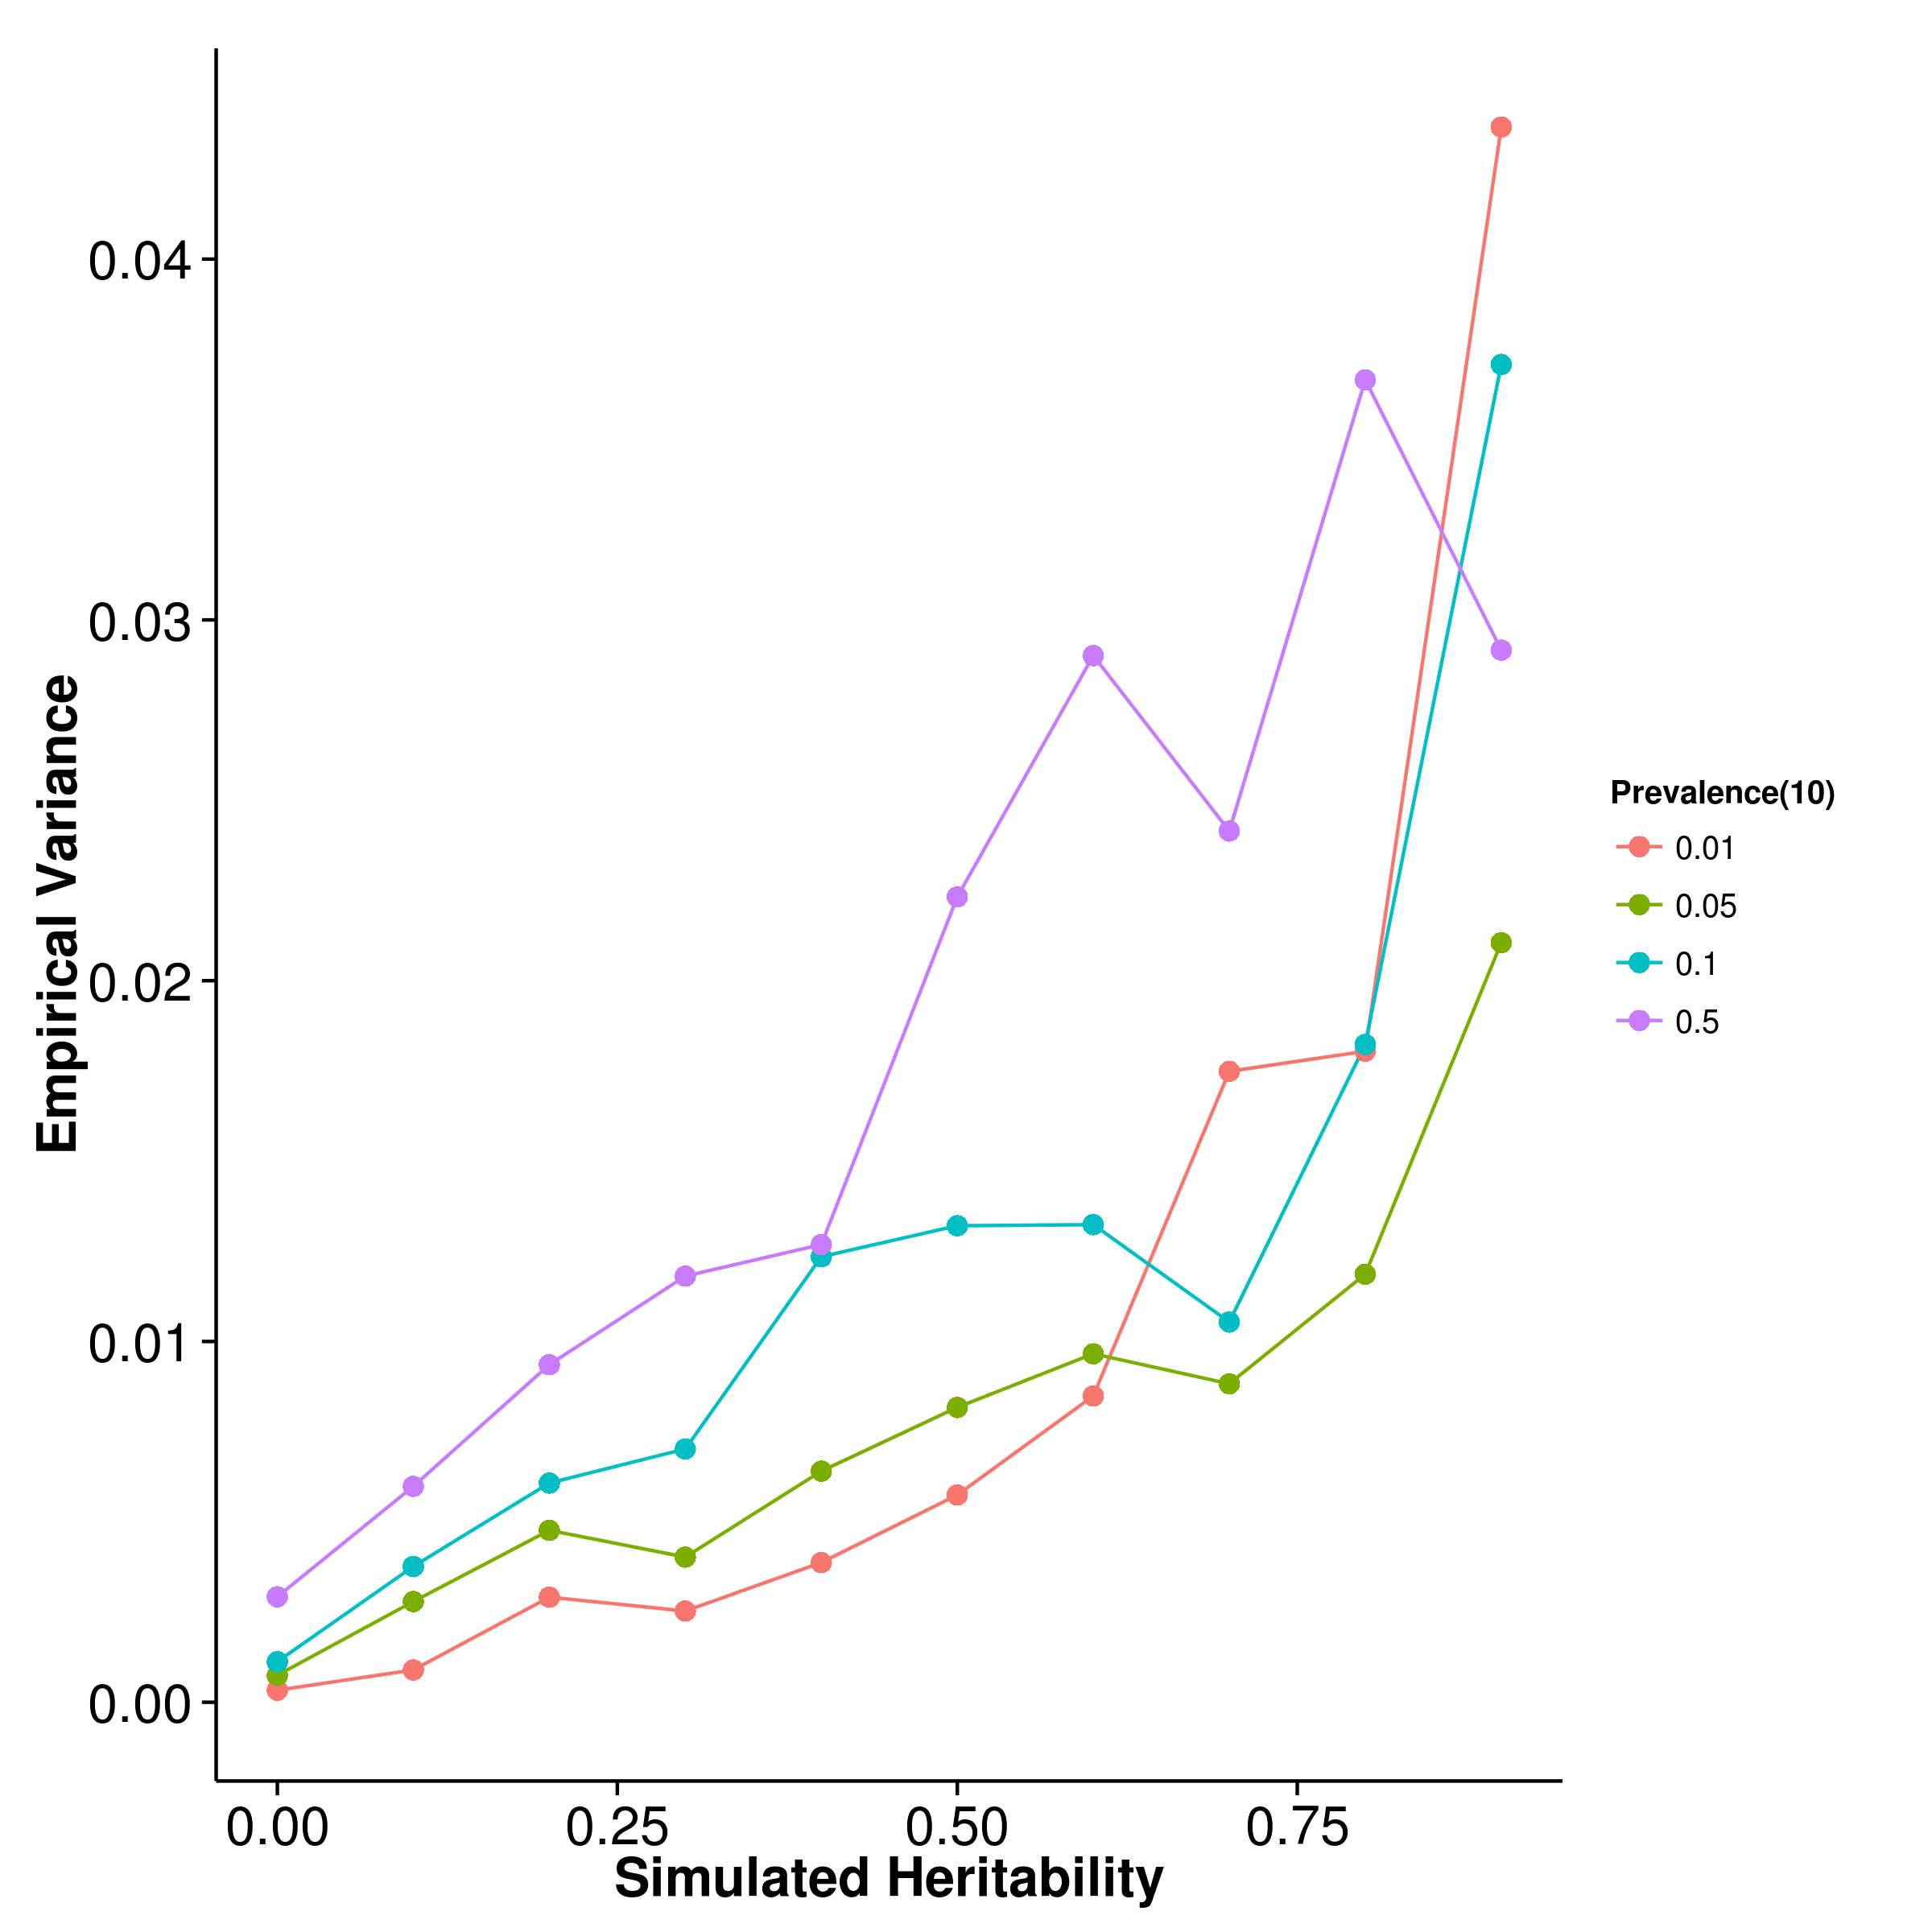

Figure 16: Variance of results from case control simulation with random effect size simulation with 10 causal SNP. There were no clear pattern as to how the prevalence affect the empirical variance of estimates from shrek and ldsc. For gcta, it seems like a larger prevalence tends to result in a larger empirical variance. Again, gcta has the lowest variance, follow by shrek and ldsc with fixed intercept. Nonetheless, it was important to remember that in case control simulation, a much smaller amount of SNP was used, thus the results was not directly comparable to results from the quantitative simulation.

[SHREK] 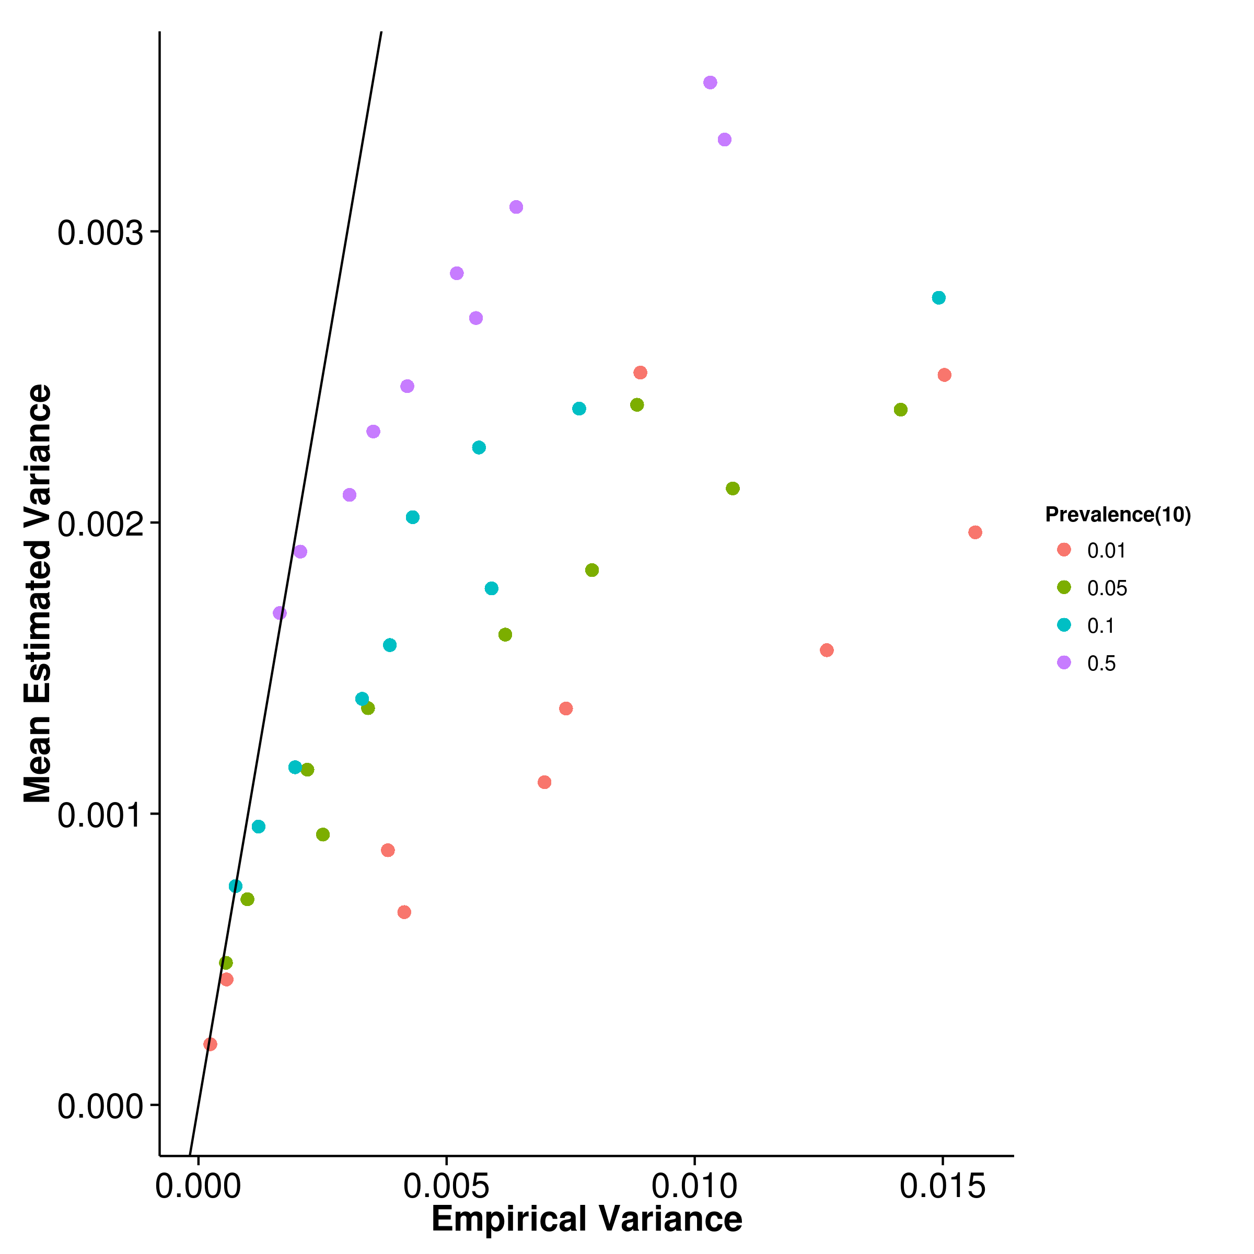 [GCTA] 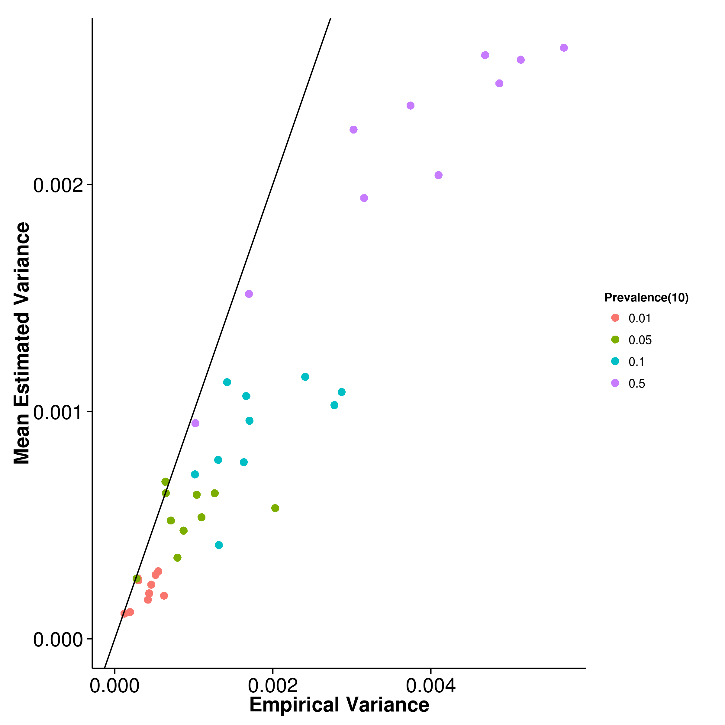

[LDSC with fix intercept] 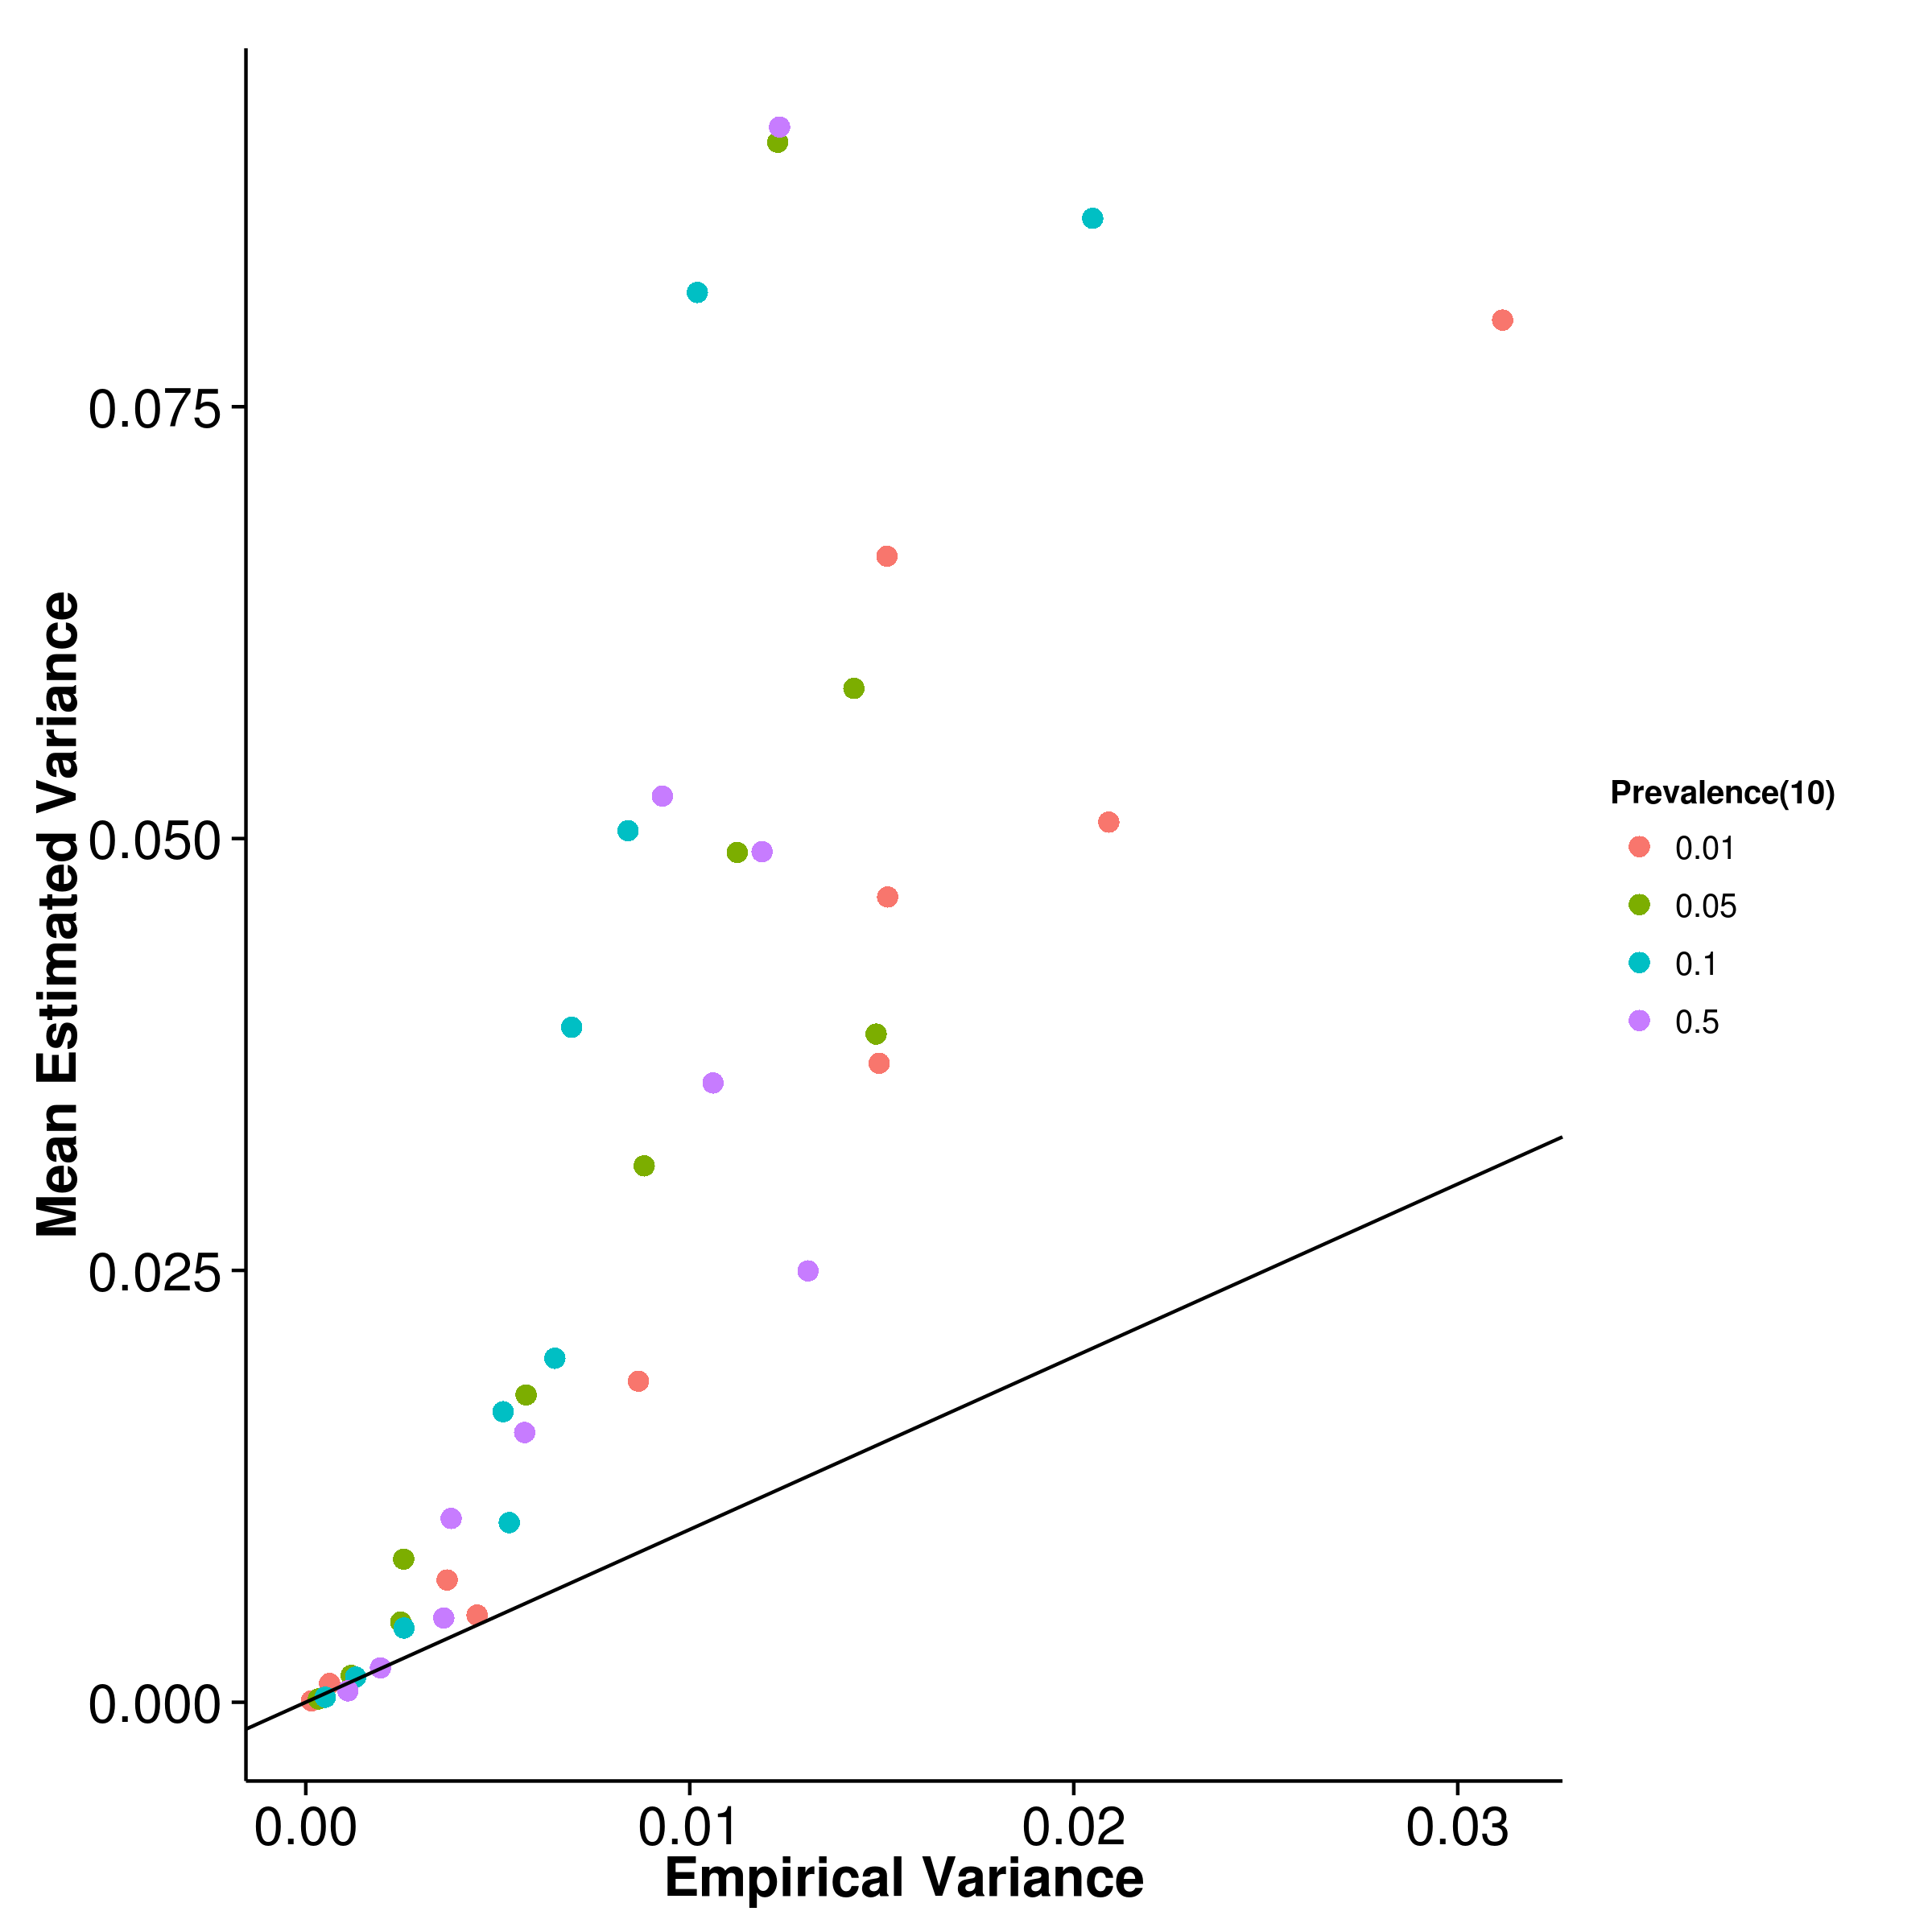 [LDSC with intercept estimation]

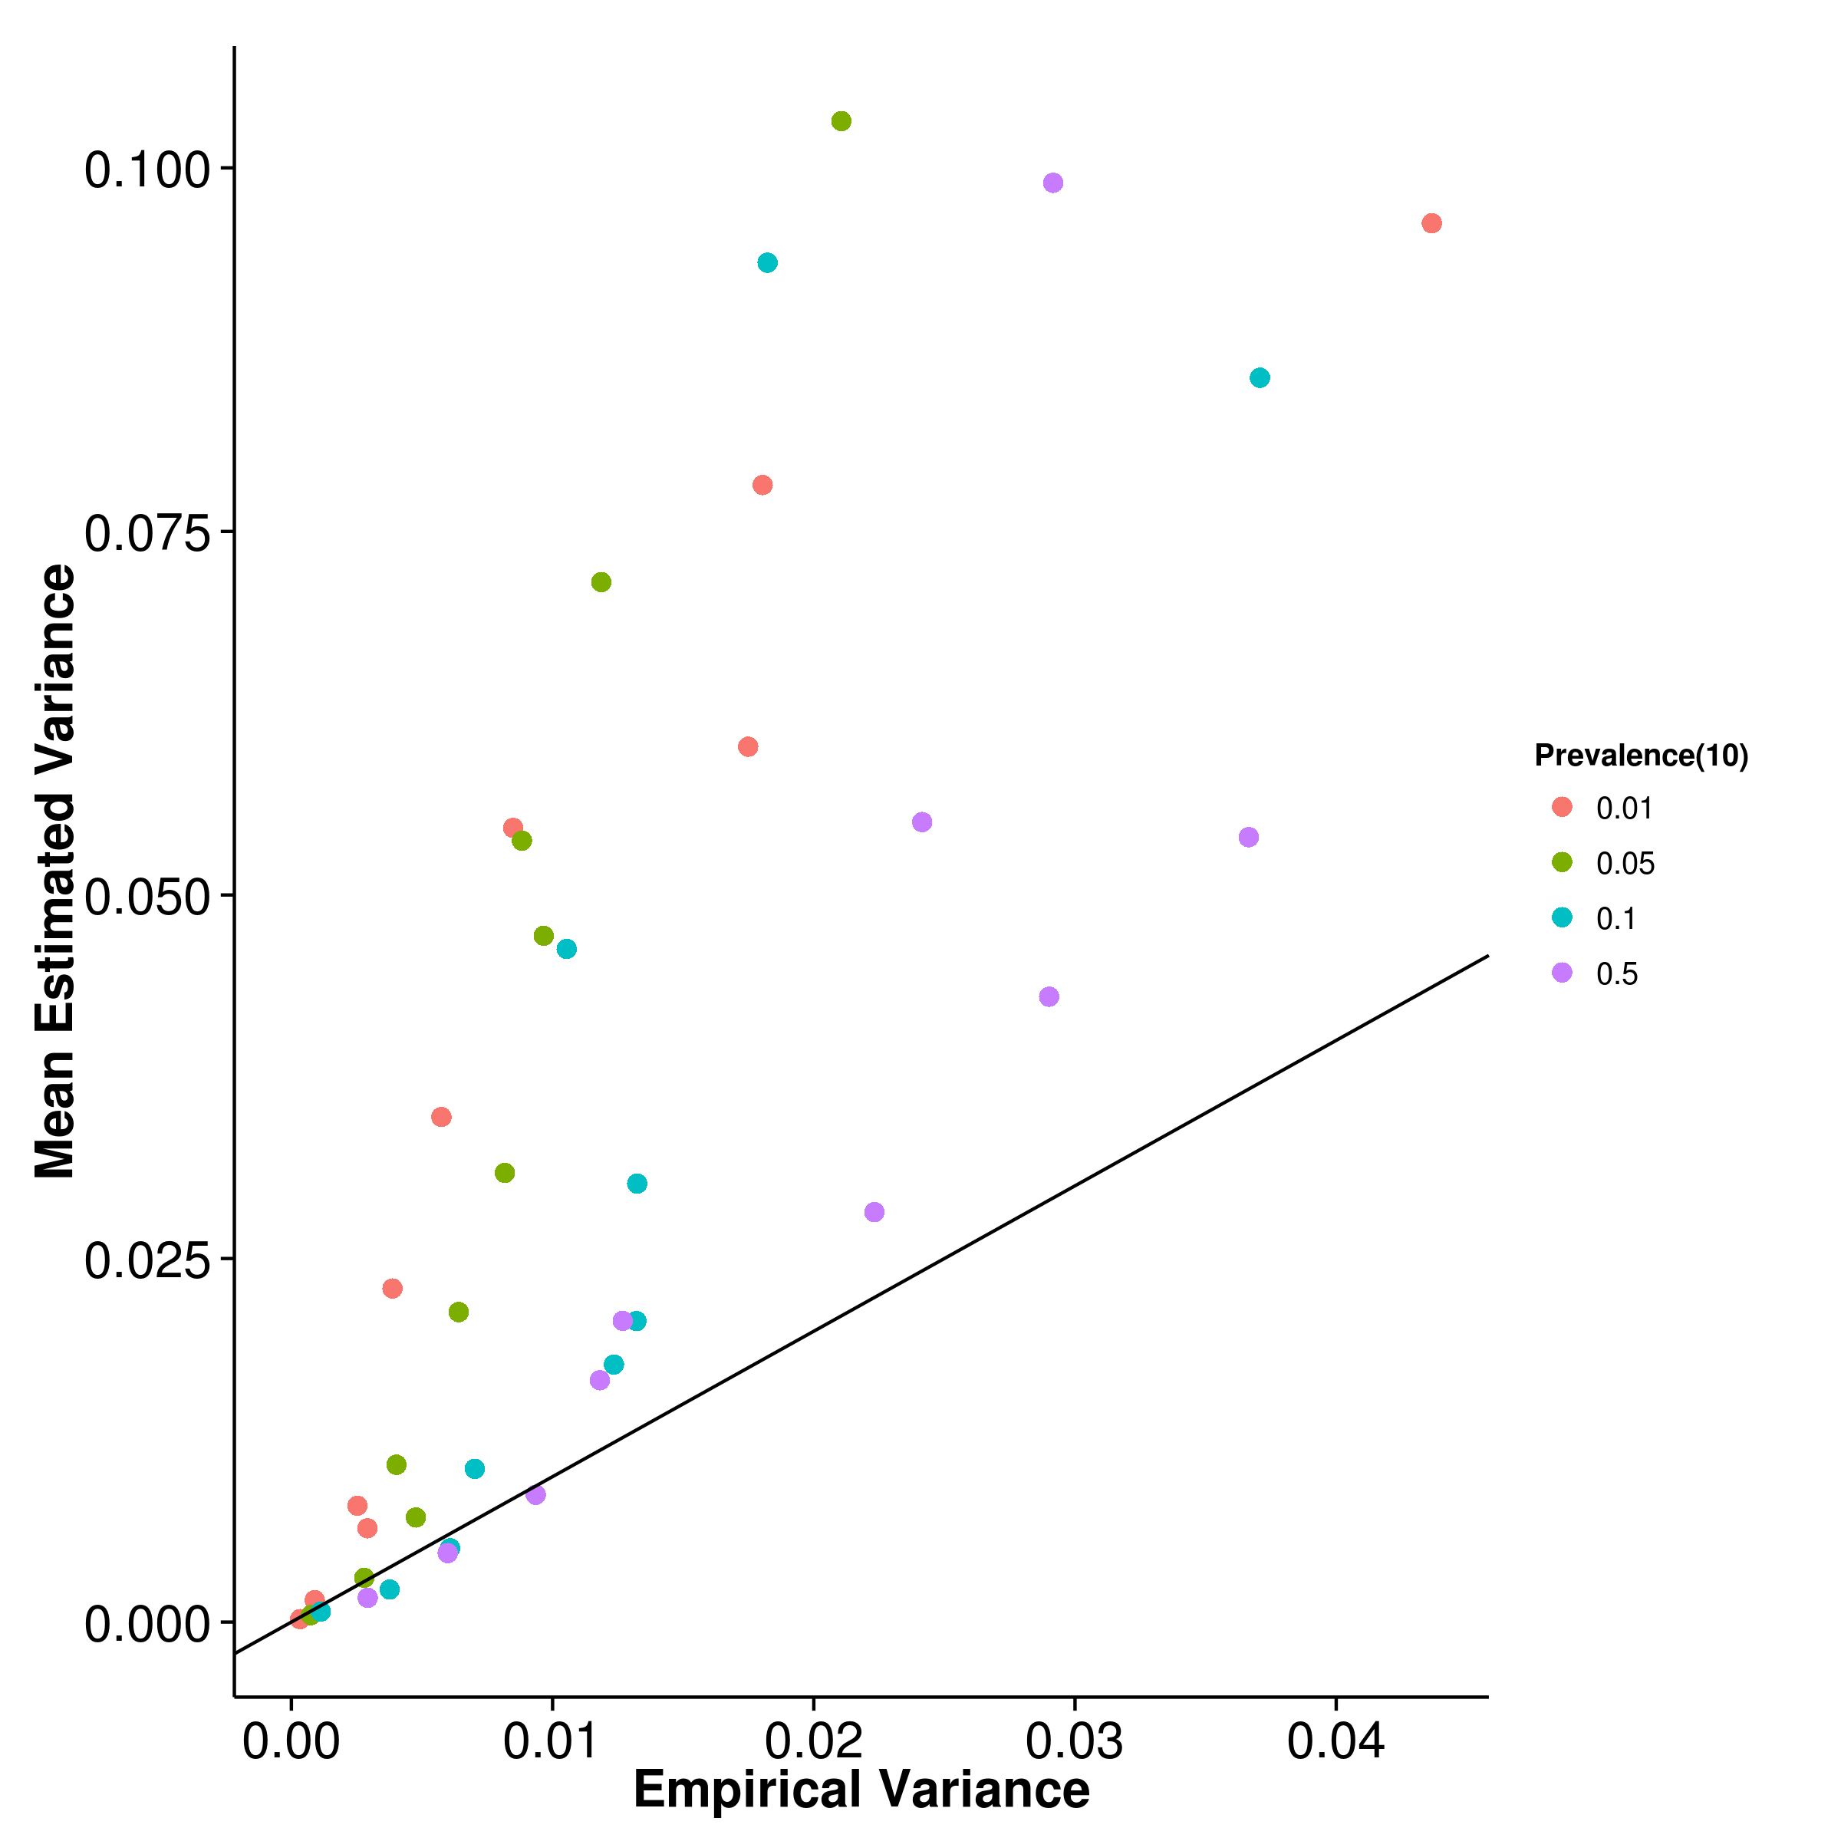

Figure 17: Estimated variance of results from case control simulation with random effect size simulation when compared to empirical variance when 10 causal SNP was simulated. A general underestimation was observed for shrek and gcta whereas a larger upward bias was observed for ldsc.

Nowadays, most of the GWAS are Case Control studies, thus it is important to test the performance of the algorithms when dealing with case control samples. In the case control simulation, we varied the population prevalence and the trait heritability. We also varied the number of causal SNP to assess the combine effect of these parameters to the performance of the algorithms.

First, we simulated traits with 10 causal SNP. From the graph, it is clear that the population prevalence has a significant impact to the performance of the algorithms (fig:CC10RandMean). The performance of gcta is as suggested by [?] where the degree of underestimation increases as the prevalence decreases. On the other hand, the opposite effect is observed for shrek and ldsc with fixed intercept. Interestingly, when allow the estimate the intercept, the heritability estimated from ldsc becomes underestimated. The magnitude of the bias also decreases, suggesting that the intercept estimation might have corrected for part of the bias of ldsc. The same pattern are also observed when the number of causal SNP increases (fig:CC50RandMean,fig:CCRandMean,fig:CC500RandMean), suggesting that the effect of number of causal SNP are not the main contributor to the difference in bias.

As one inspect the empirical variance of the algorithms, gcta clearly has the smallest average empirical variance among the algorithms (fig:gctaCC10RandVar) where ldsc with intercept estimation has the largest empirical variance (fig:ldscInCC10RandVar). Unlike the quantitative trait simulation, the empirical variance of the estimates from shrek (fig:shrekCC10RandVar) are very close to that of ldsc with fixed intercept (fig:ldscCC10RandVar). When the heritability of the trait is high, the empirical variance of shrek is even lower than that of ldsc with fixed intercept. As one increases the number of causal SNP, the empirical variance of all algorithms decreases (fig:CC50RandVar,fig:CCRandVar,fig:CC500RandVar) agreeing with the results from the quantitative trait simulation.

On the other hand, both shrek (fig:shrekCC10RandVarCom) and gcta (fig:gctaCC10RandVarCom) underestimates their empirical variance whereas ldsc overestimates its empirical variance no matter if the intercept estimation was performed (fig:CC10RandVarCom). As the number of causal SNP increases (fig:CC50RandVarCom,fig:CCRandVarCom,fig:CC500RandVarCom), the bias of variance estimation remain unchanged for shrek. However, for ldsc, the magnitude of bias of variance estimation reduces as the number of causal SNP increases and are able to provide a relatively accurate estimation of its empirical variance when 500 causal SNP were simulated (fig:ldscCC500RandVarCom).

Taking into account of the bias and variance of the estimations (tab:mseCC), shrek has the best average performance of all the algorithm tested. Interestingly, the performance of ldsc with intercept estimation were better than ldsc with fixed intercept when the prevalence is small even-though we did not simulate any confounding factors. In such scenario, one would expect the intercept estimation to be unnecessary and will only increase the se of the heritability estimation without improving the estimates yet from the simulation results, it was suggested that the intercept estimation might helps correct for some of the bias in the estimates when the prevalence is small.

|  |  |  |  |  |  |
| --- | --- | --- | --- | --- | --- |
| Population Prevalence | Number of Causal SNPs | SHREK | LDSC | LDSC-In | GCTA |
| 0.01 | 10 | **0.0145** | 0.0361 | 0.0164 | 0.0675 |
| .01 | 50 | 0.0135 | 0.0254 | **0.00791** | 0.0702 |
| .01 | 100 | 0.0128 | 0.0227 | **0.0102** | 0.0698 |
| .01 | 500 | **0.0126** | 0.0214 | 0.0150 | 0.0710 |
| .05 | 10 | 0.0110 | 0.0201 | **0.00983** | 0.0302 |
| .05 | 50 | **0.00453** | 0.00974 | 0.0115 | 0.0299 |
| .05 | 100 | **0.00569** | 0.0113 | 0.00981 | 0.0304 |
| .05 | 500 | **0.00540** | 0.00999 | 0.0171 | 0.0305 |
| .1 | 10 | **0.00512** | 0.0109 | 0.0301 | 0.0165 |
| .1 | 50 | **0.00381** | 0.00824 | 0.0105 | 0.0152 |
| .1 | 100 | **0.00418** | 0.00802 | 0.0163 | 0.0148 |
| .1 | 500 | **0.00400** | 0.00740 | 0.0141 | 0.0155 |
| .5 | 10 | 0.00560 | 0.00749 | 0.0219 | **0.00410** |
| .5 | 50 | 0.00362 | 0.00528 | 0.0232 | **0.00244** |
| .5 | 100 | 0.00356 | 0.00460 | 0.0208 | **0.00225** |
| .5 | 500 | 0.00338 | 0.00365 | 0.0159 | **0.00200** |
|  | |

Table 5: mse of Case Control simulation. Algorithm with the best performance under each condition were bold-ed. When the population prevalence is 0.5, gcta has the best performance, followed by shrek. For most other conditions, shrek has the best performance. Of all the algorithms, shrek has the lowest average mse. Also, as the number of causal SNP increases, the mse tends to decrease for all algorithms, similar to what was observed in the quantitative simulation.

In general, the effects of the number of causal SNP in the case control simulation agrees with what was observed in the quantitative trait simulations. As the number of causal SNP increases the mse tends to decrease for all algorithms, with shrek least sensitive. Finally, it is important to note that for the case control simulations, a smaller amount of SNP was simulated when compared to the quantitative trait simulations. The total sample number involved was also larger (2,000 samples with 1,000 cases and 1,000 controls). Thus, the results from case control simulations are not directly comparable to the results from the quantitative trait simulations.

### 6.3 Extreme Phenotype Simulation

[SHREK] 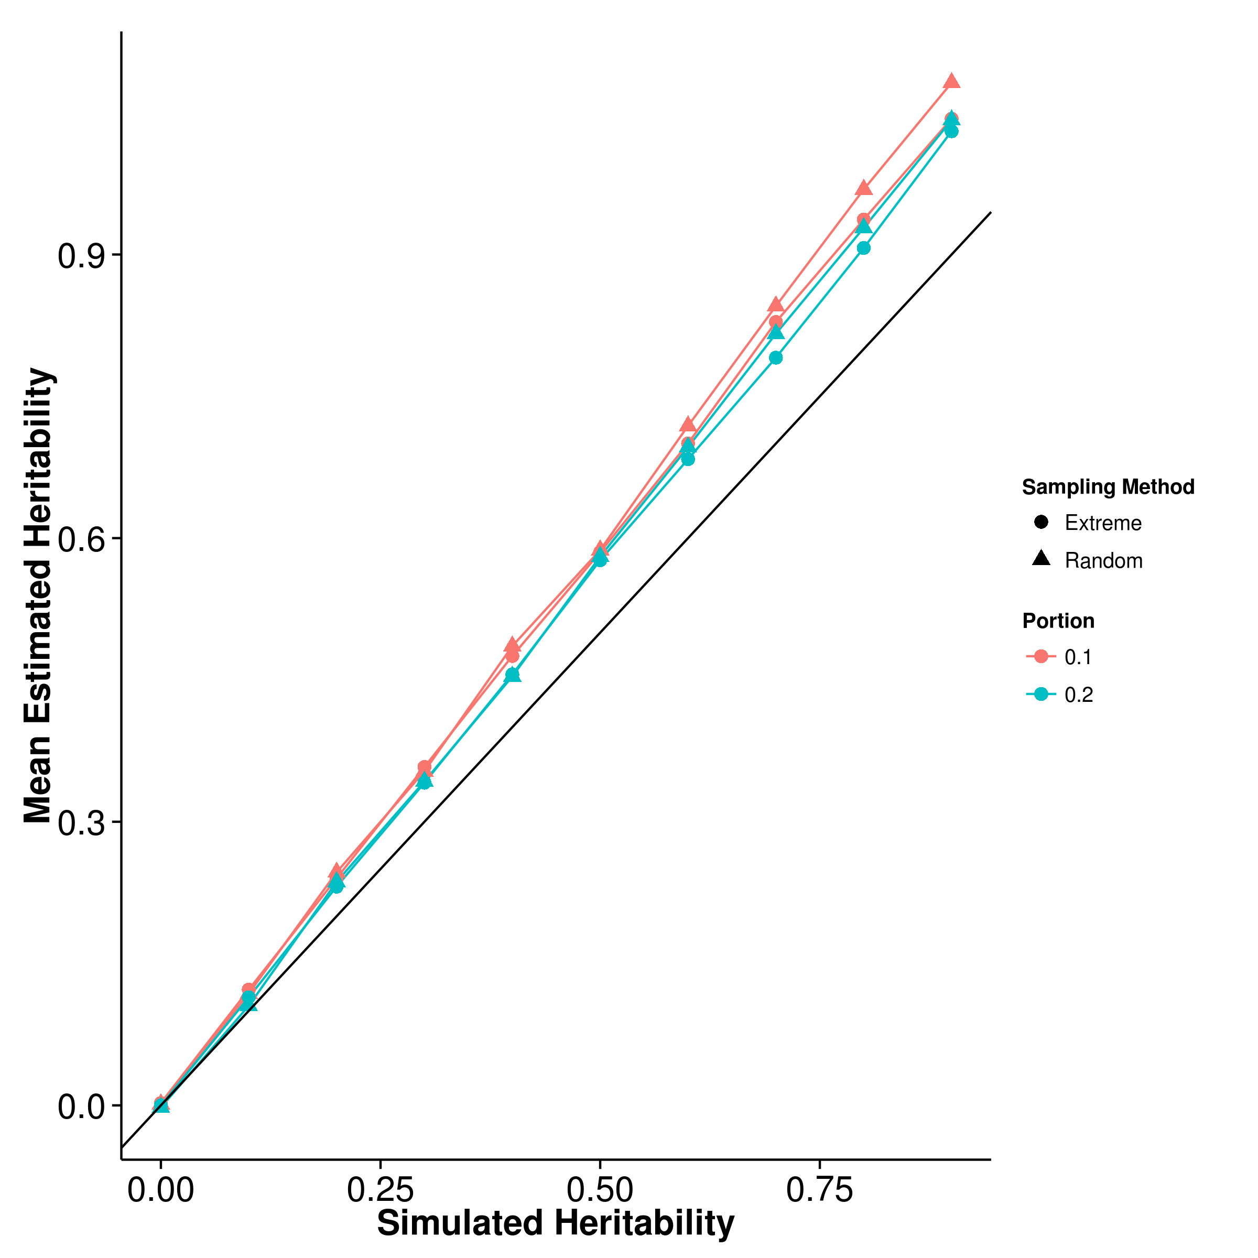 [GCTA] 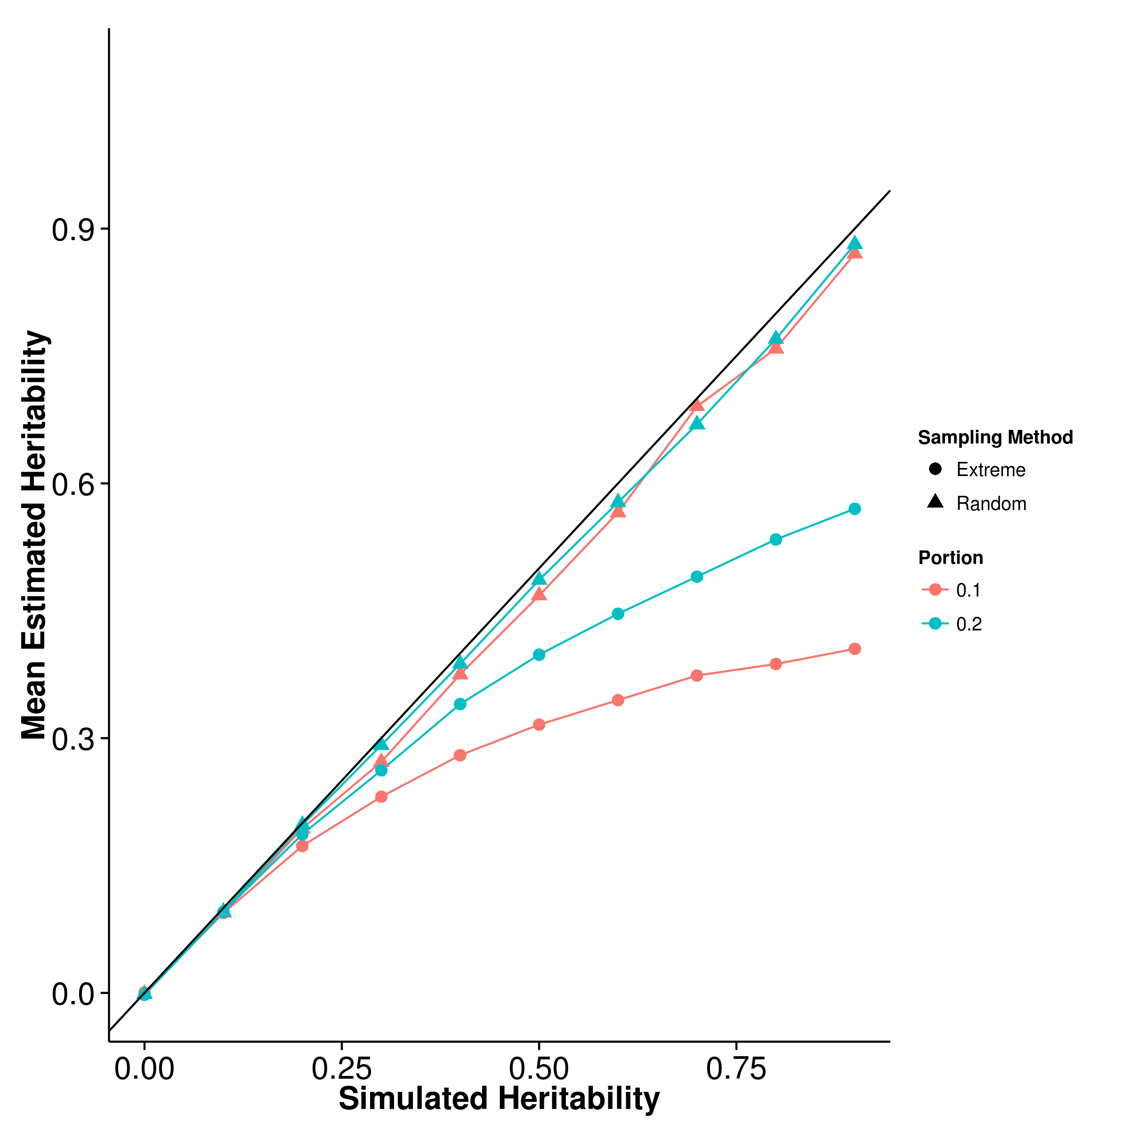

[LDSC with fix intercept] 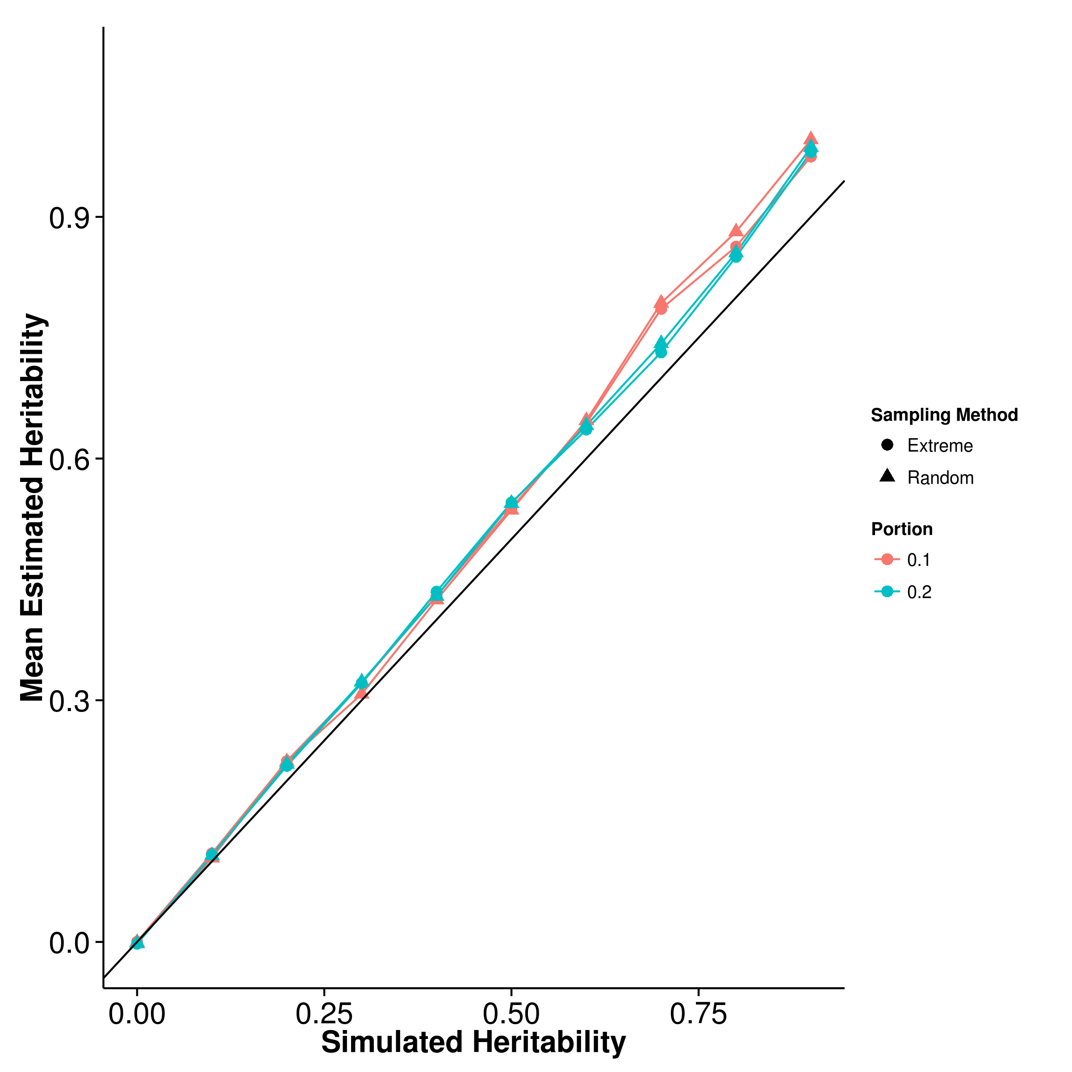 [LDSC with intercept estimation]

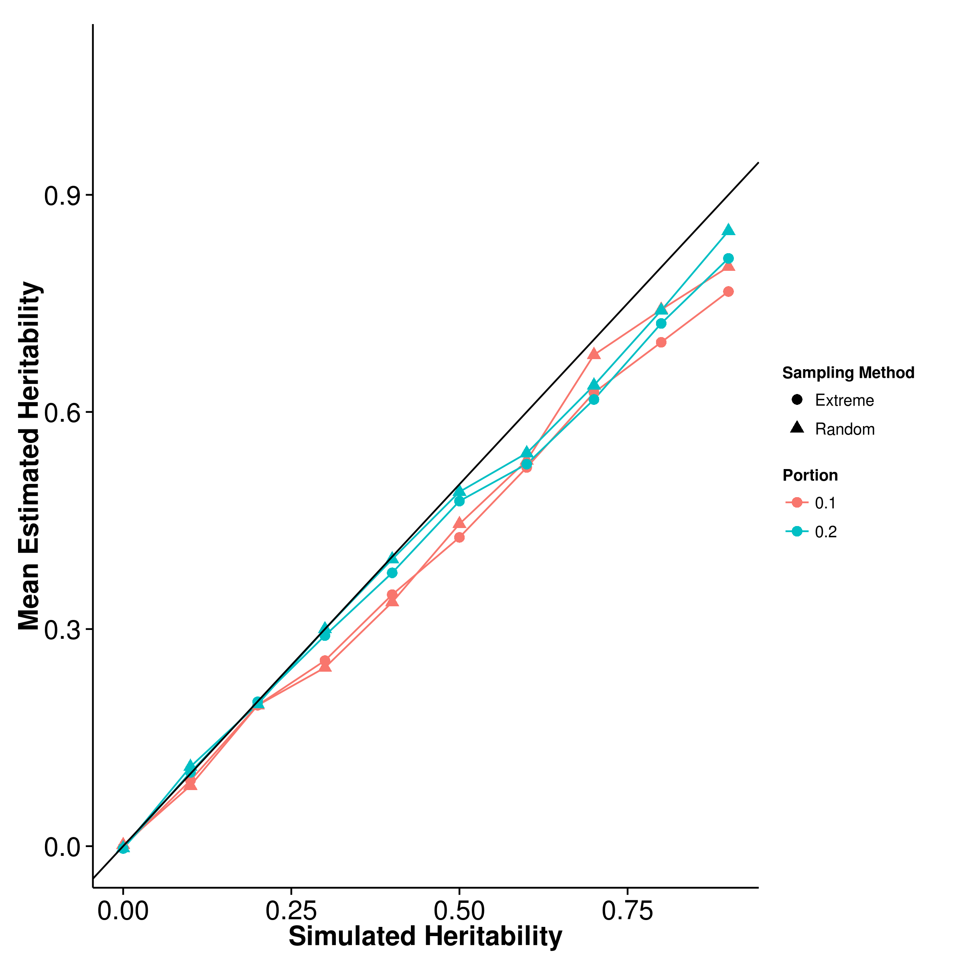

Figure 18: Mean of results from extreme phenotype simulation. The performance of the algorithms when random sampling was performed were similar to what was observed in the quantitative trait simulation. However, when extreme phenotype was performed, a larger under estimation was observed for gcta and it gets worst when the portion of sample selected decreases. On the other hand, the performance of shrek and ldsc under the extreme phenotype selection was similar to that from the random samplings.

[SHREK] 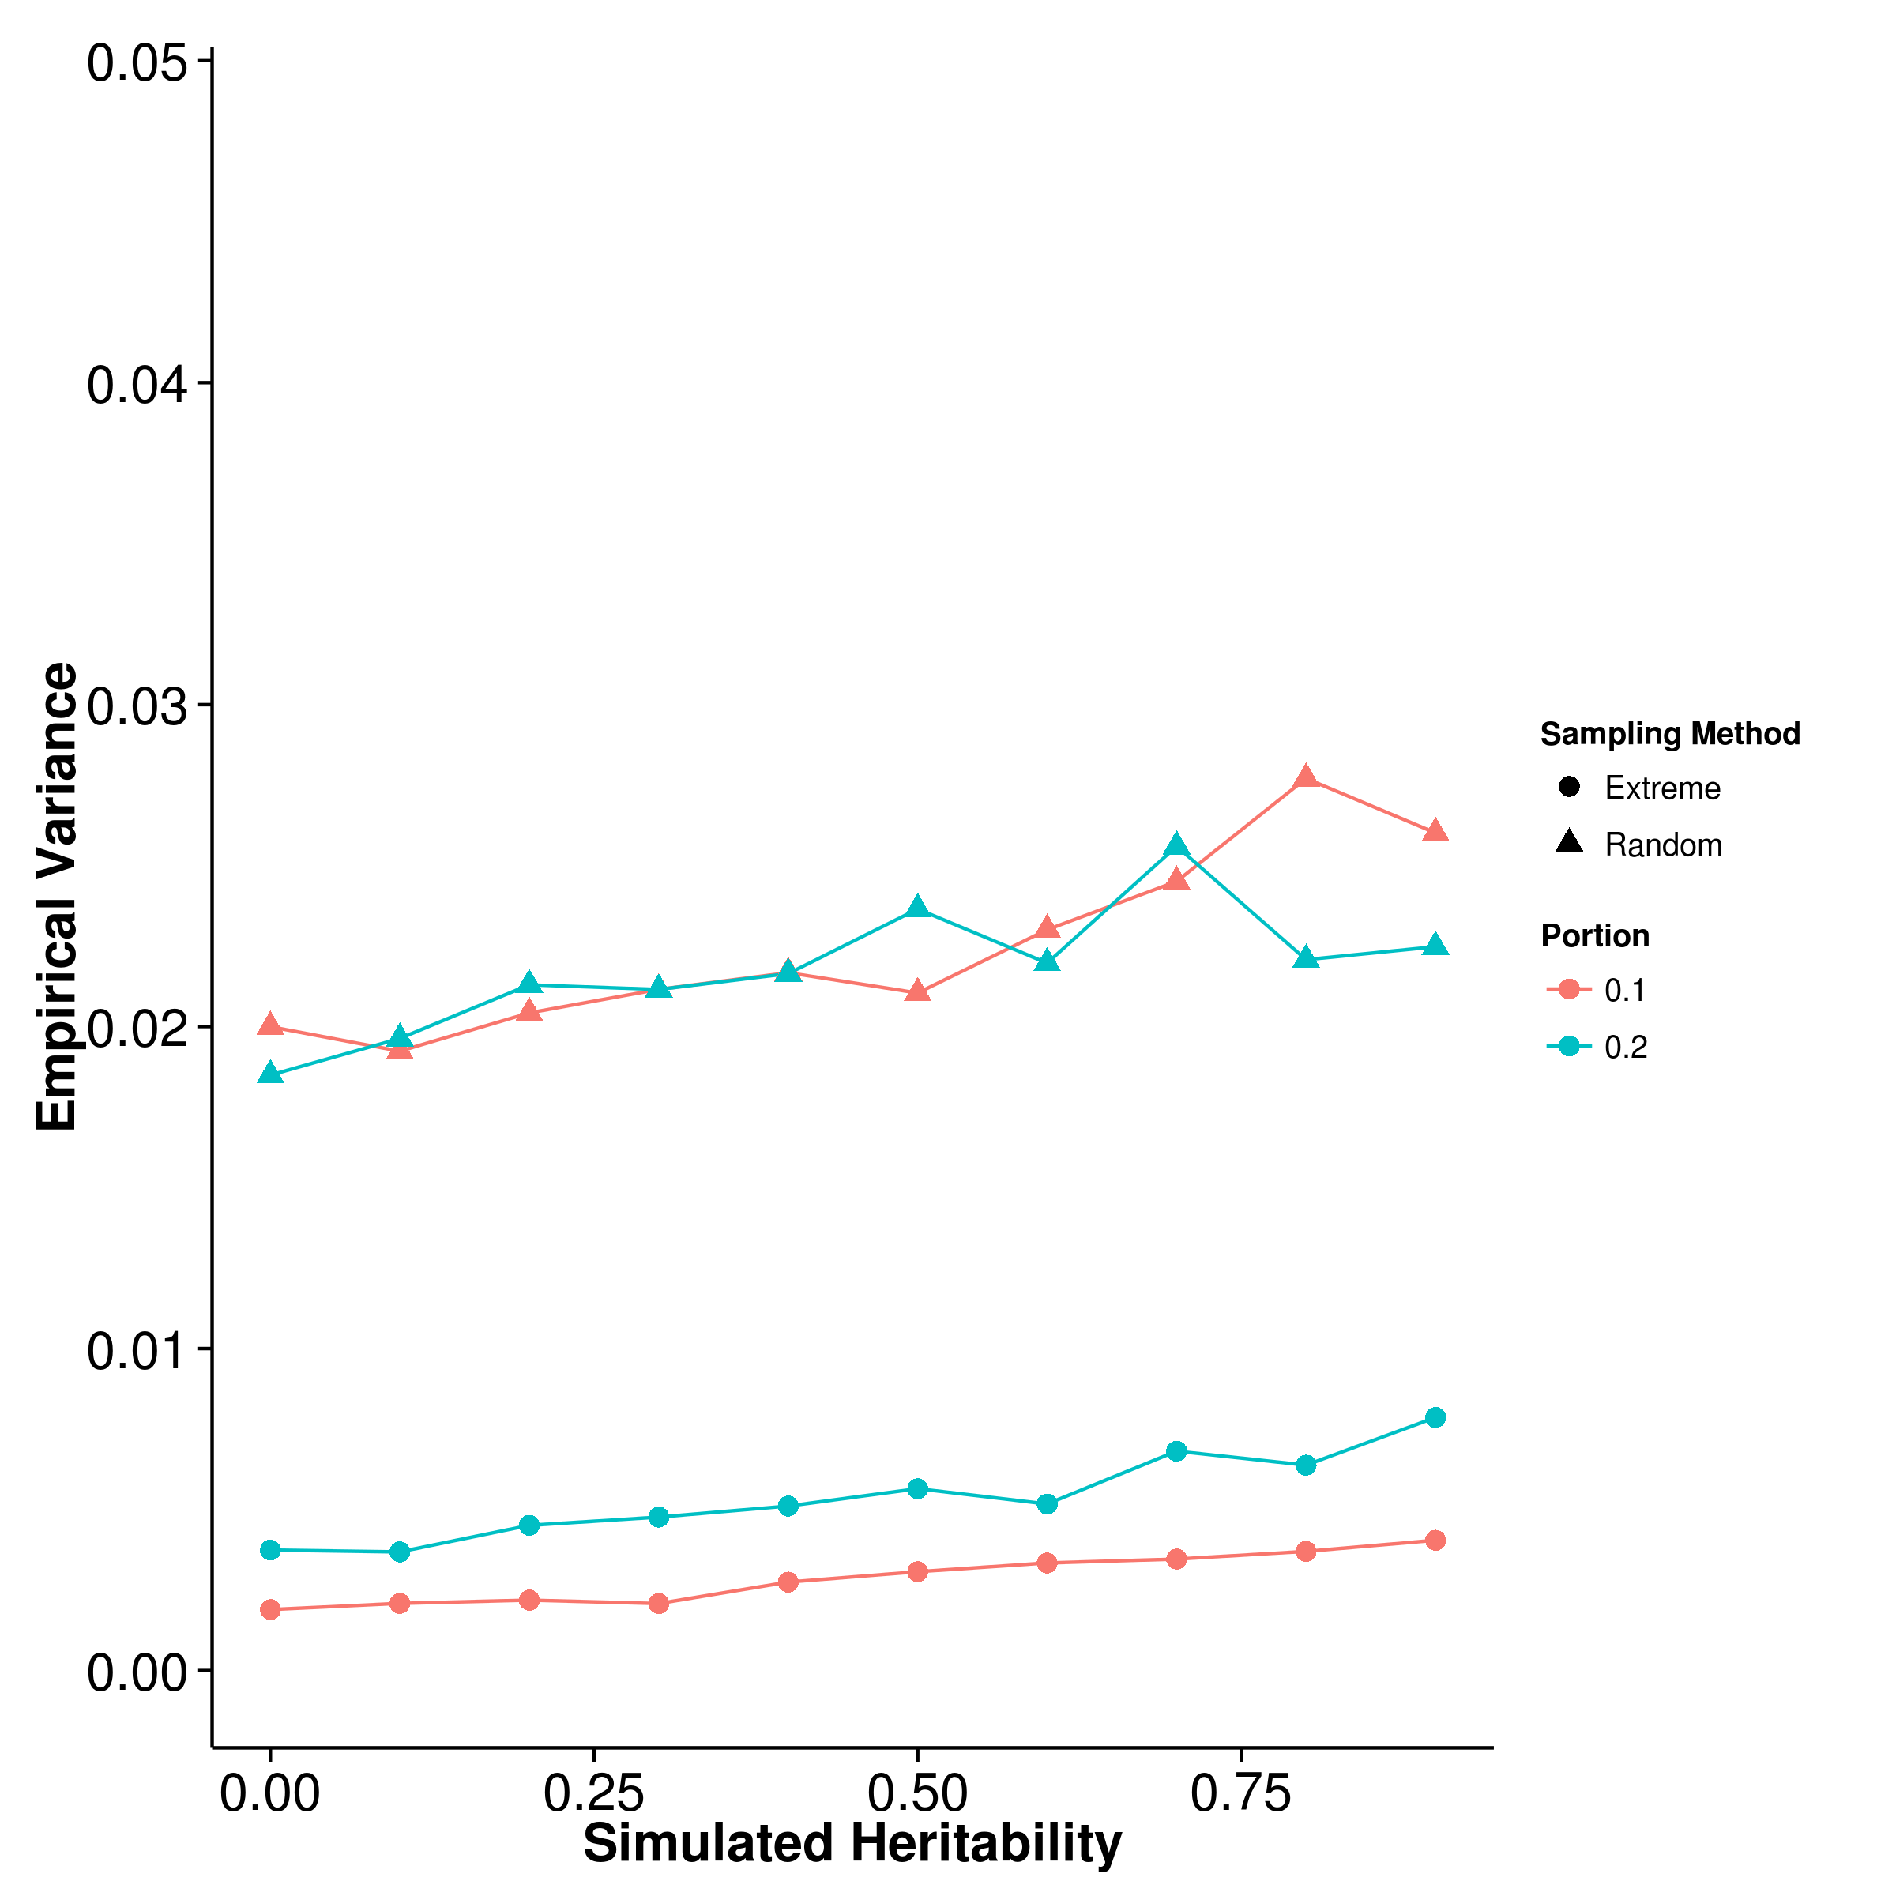 [GCTA] 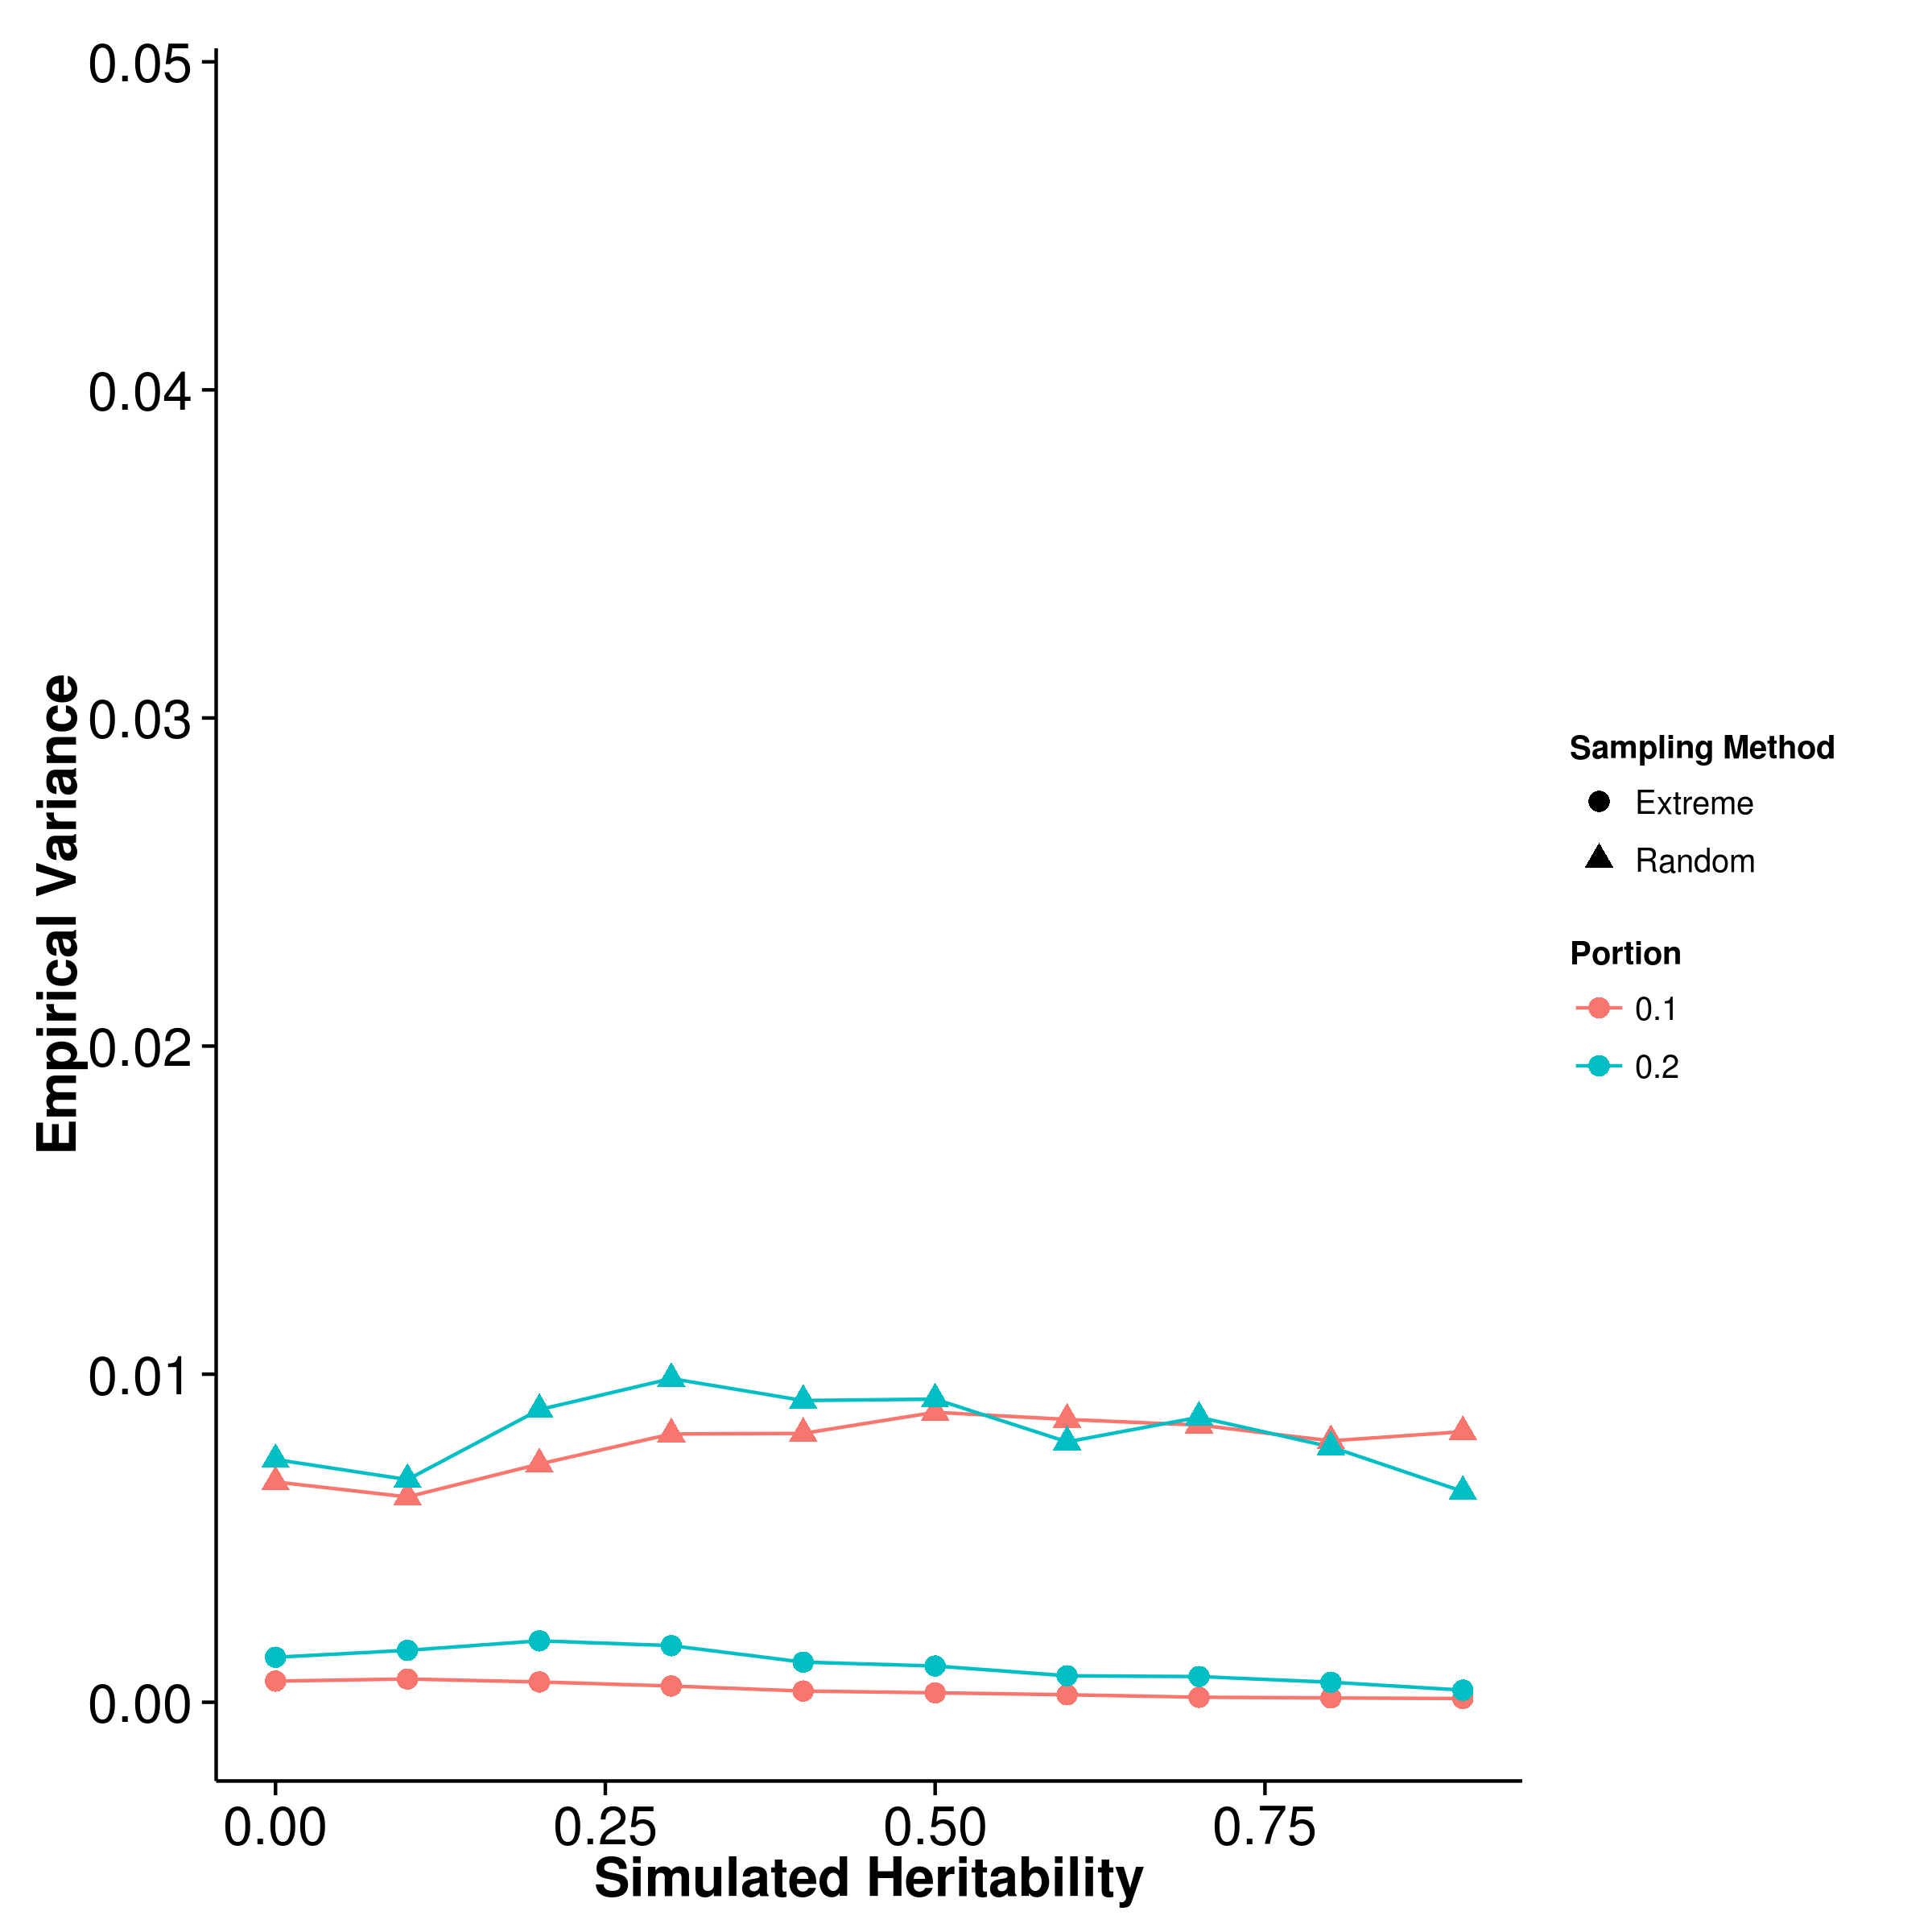

[LDSC with fix intercept] 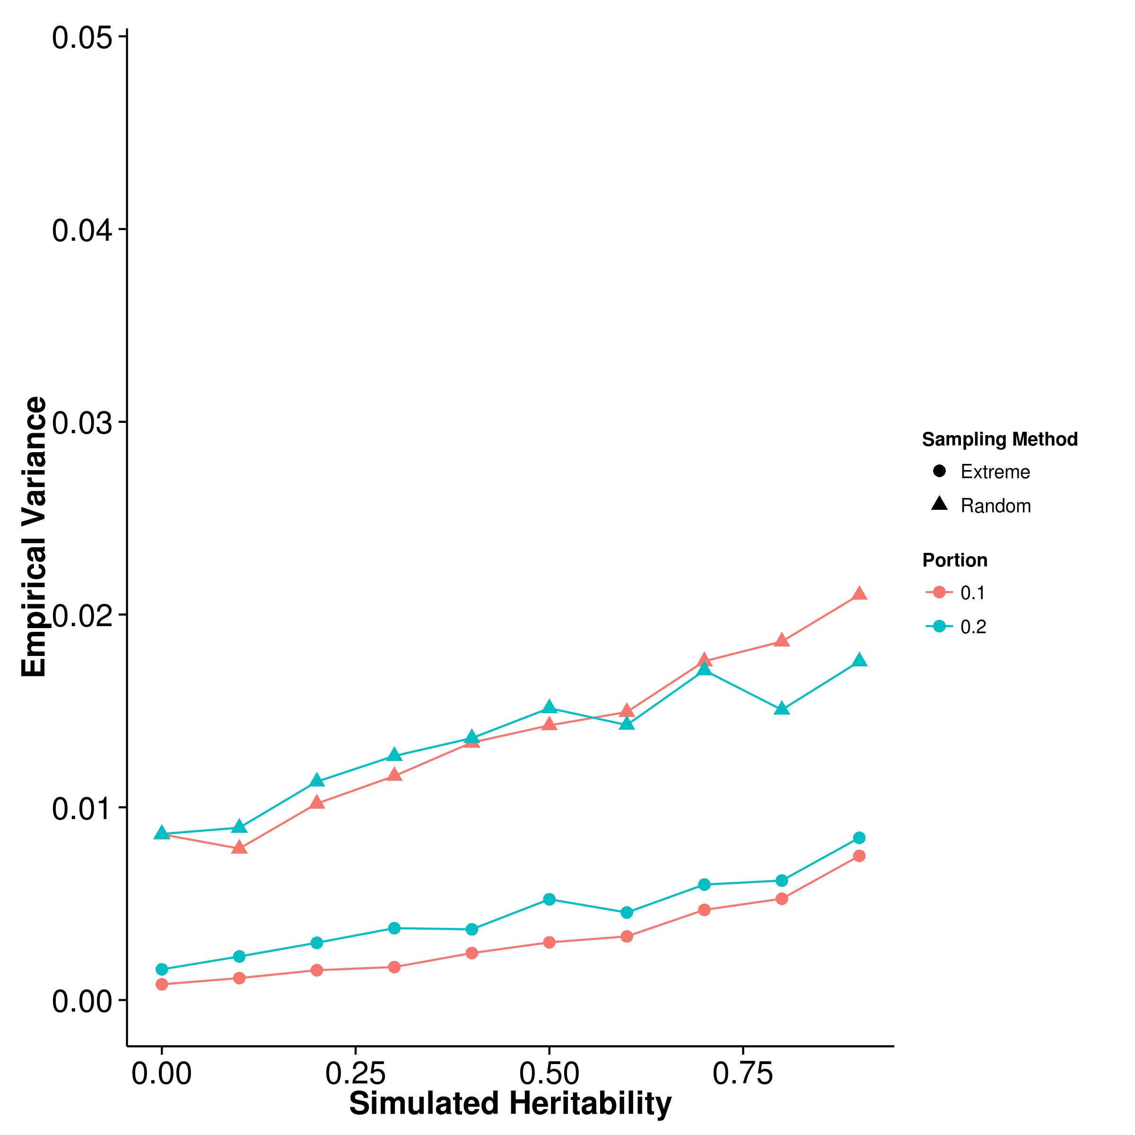 [LDSC with intercept estimation]

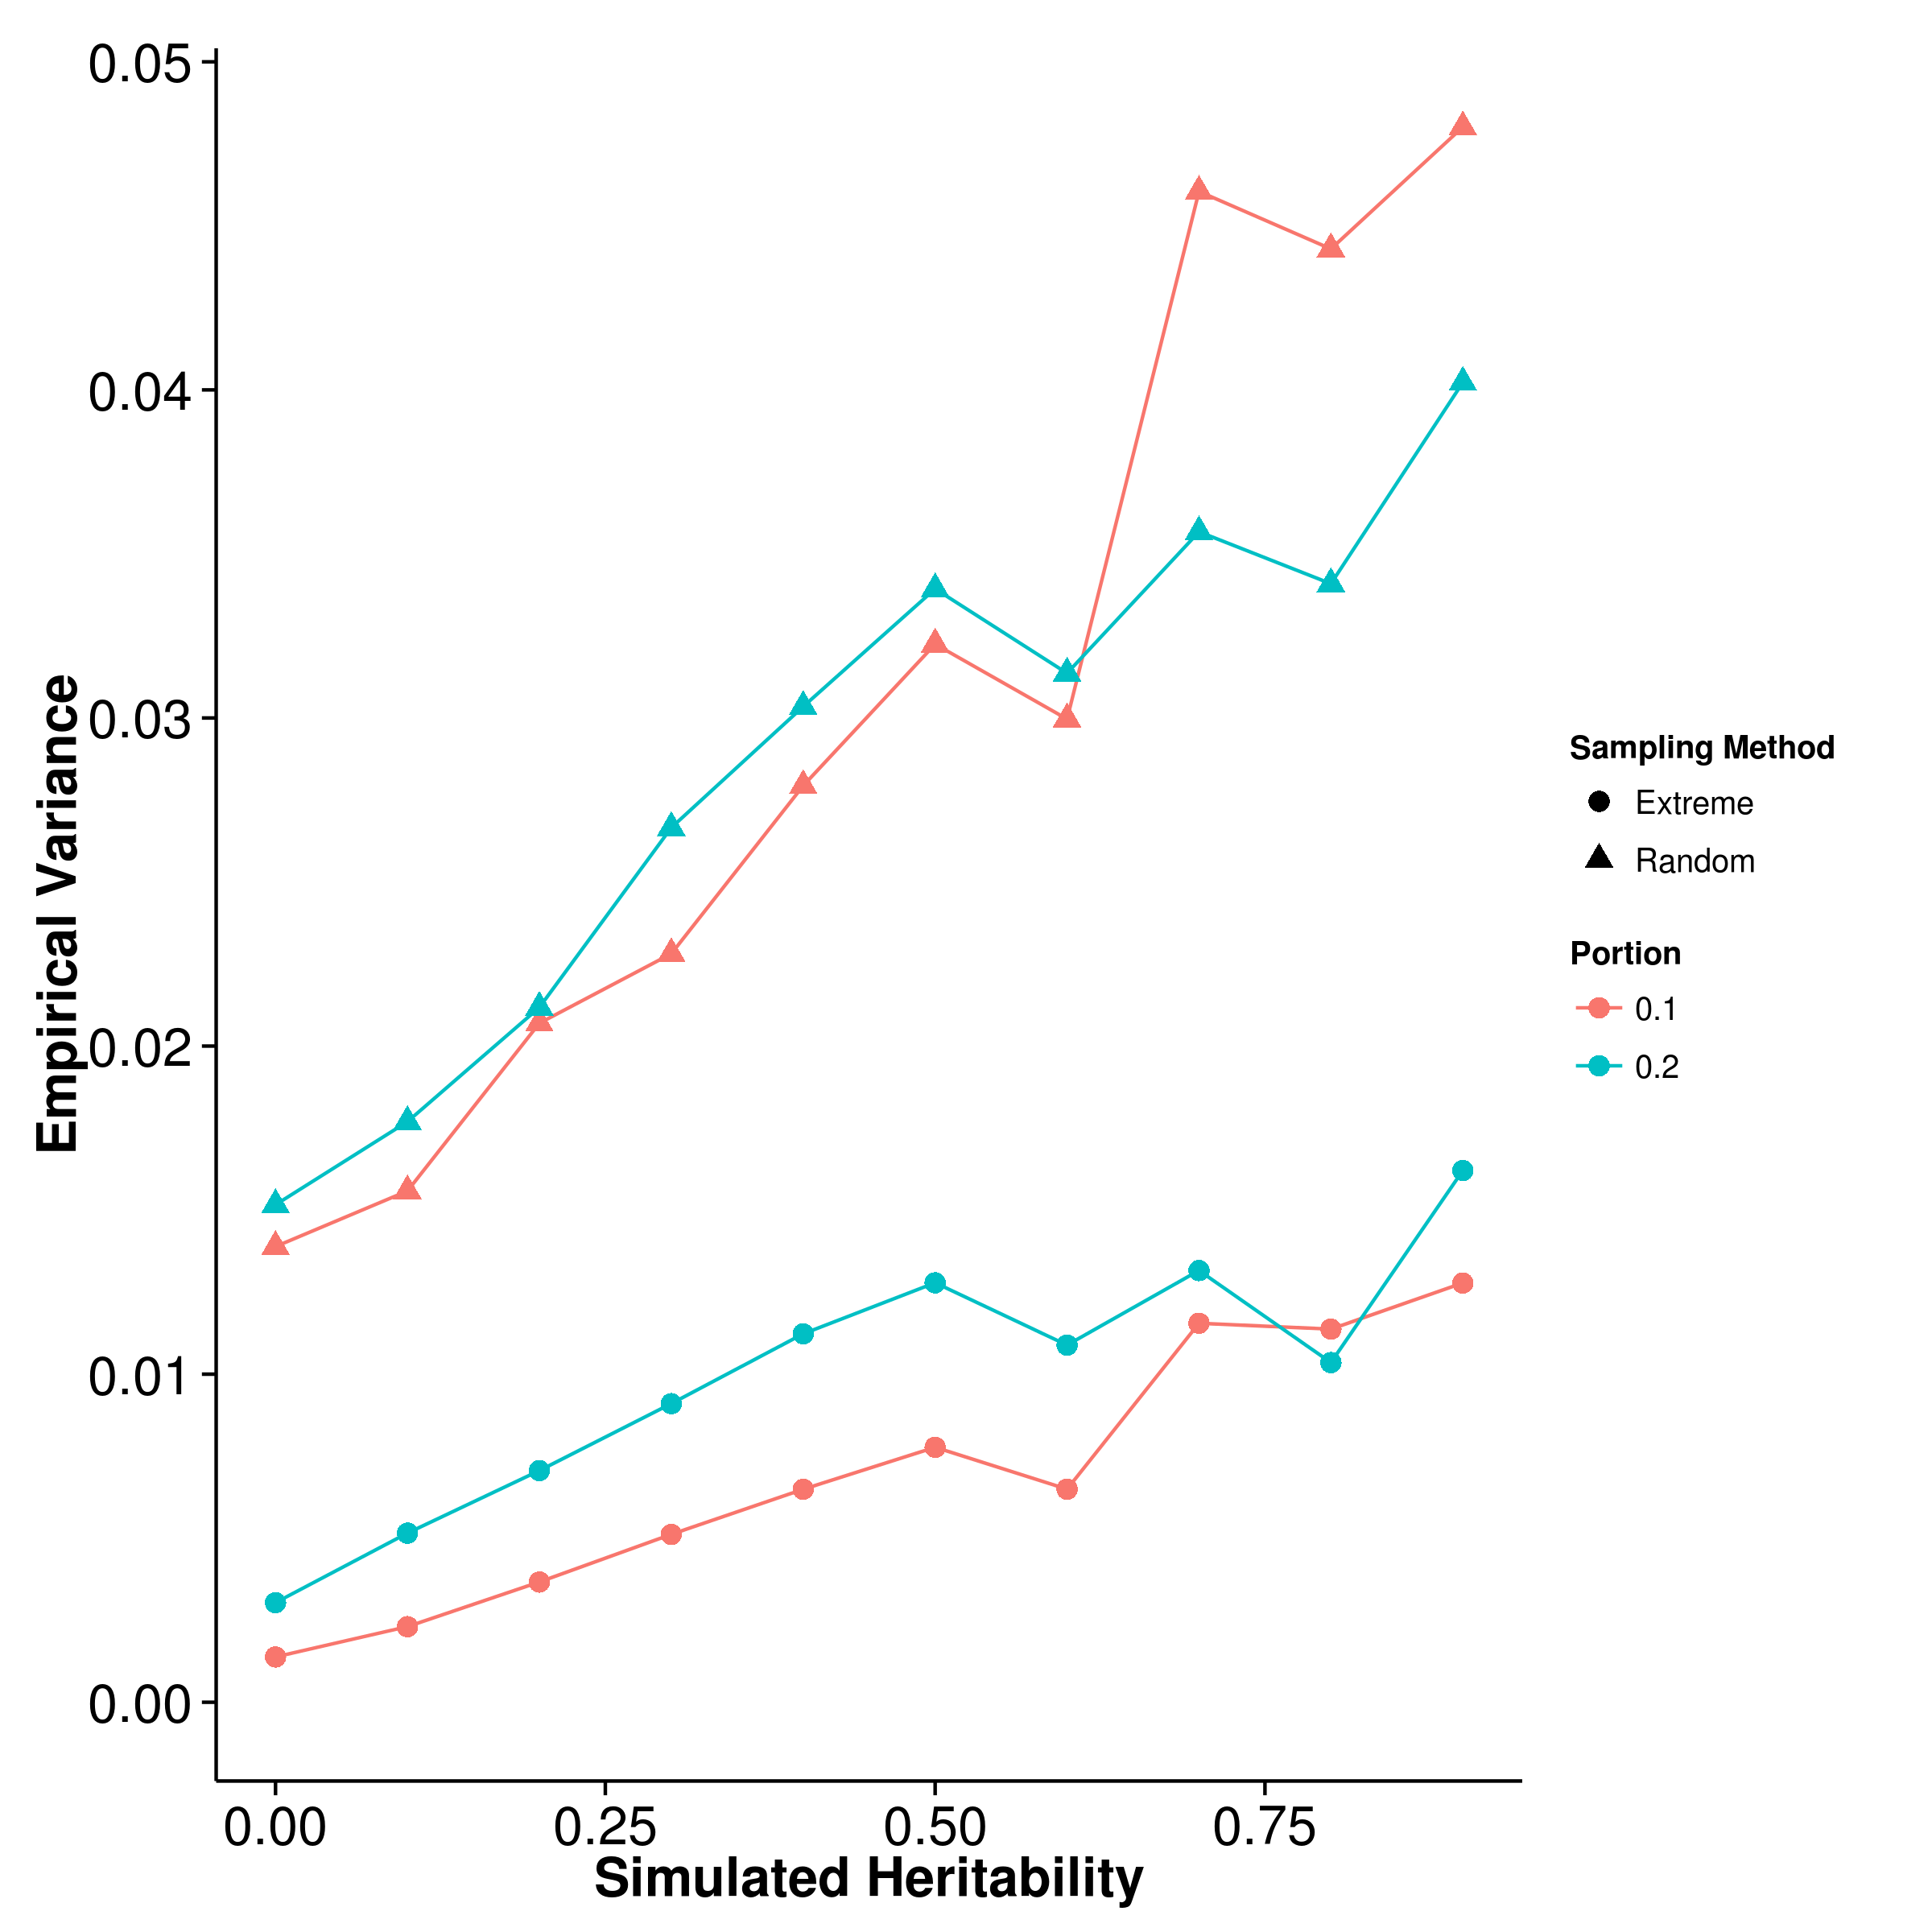

Figure 19: Variance of results from extreme phenotype simulation. It is obvious that when the extreme phenotype selection was performed, the empirical variance of all the algorithm decreases and is much smaller than the empirical variance of the estimation when random sampling was performed. We also compared the empirical variance of random sampling with those from quantitative trait simulation with 100 causal SNP and they are highly similar.

[SHREK] 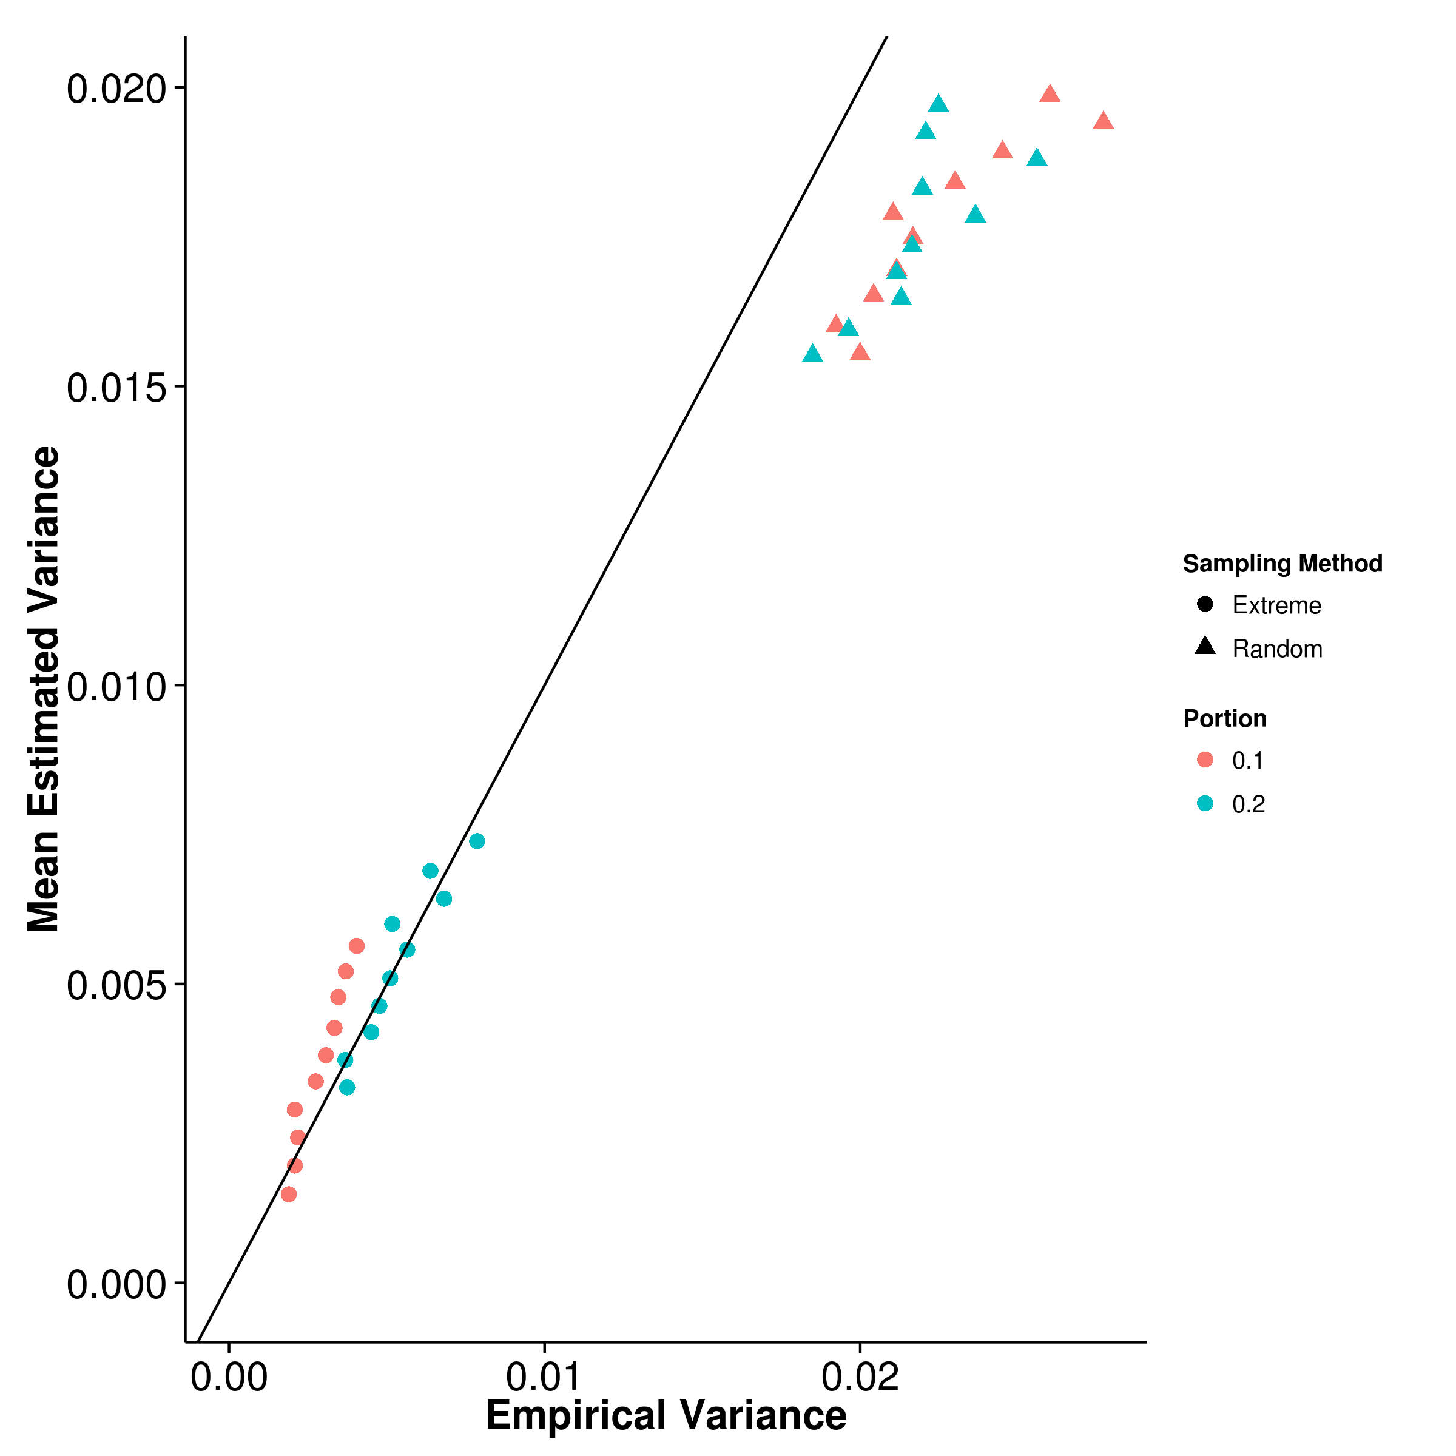 [GCTA] 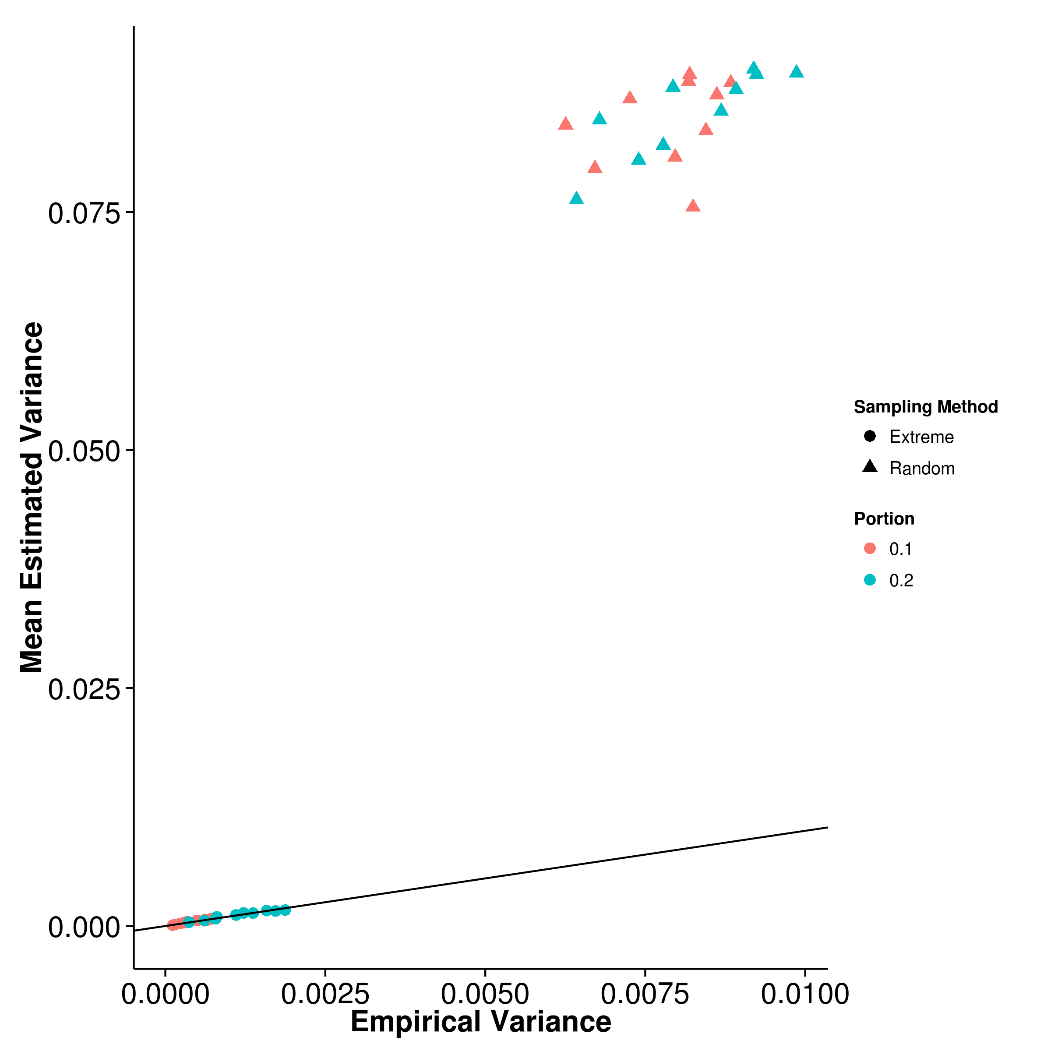

[LDSC with fix intercept] 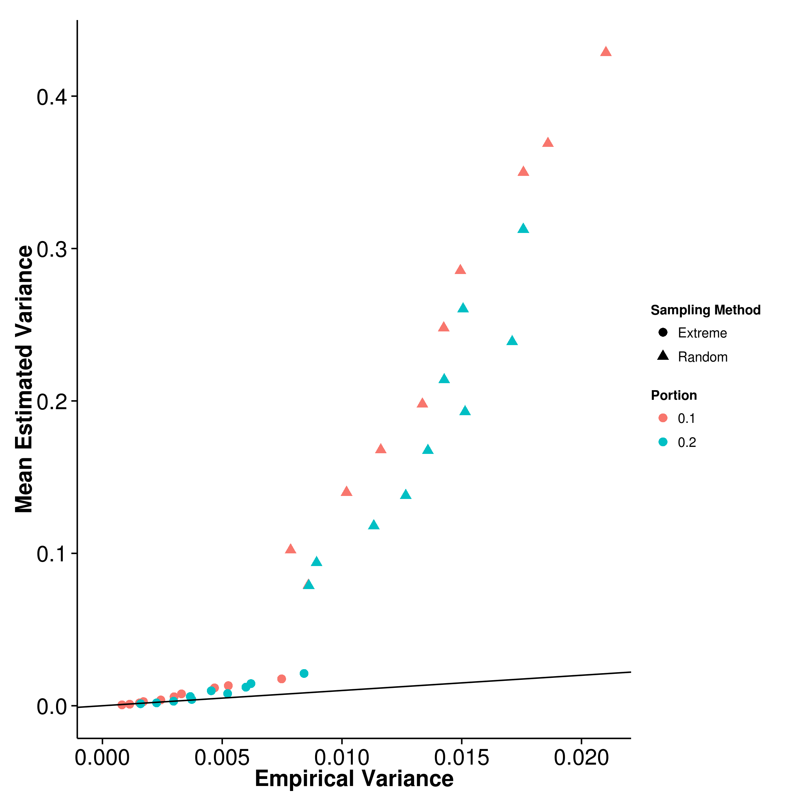 [LDSC with intercept estimation]

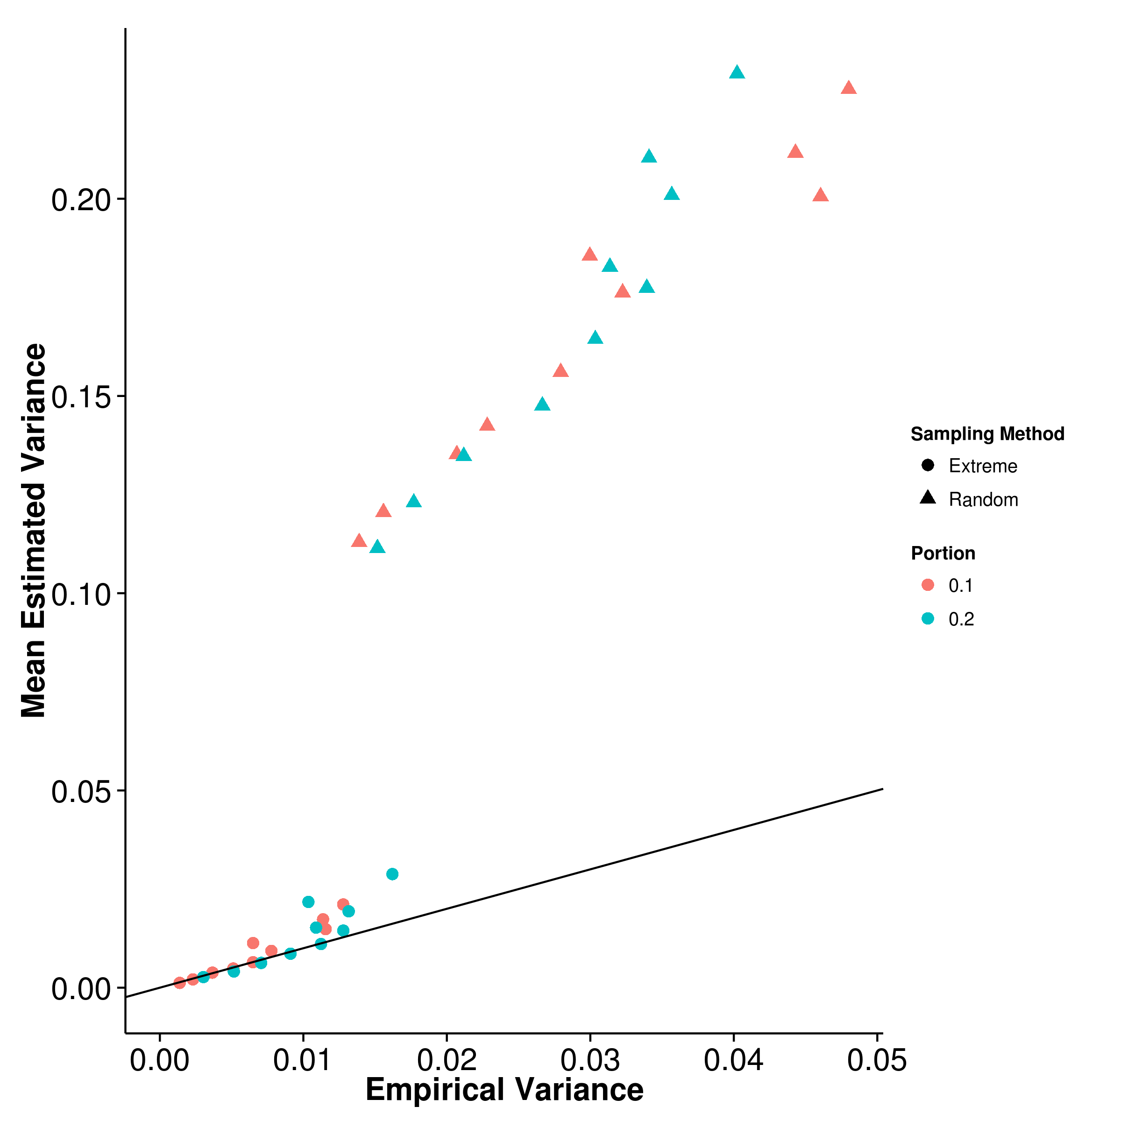

Figure 20: Estimated variance of results from extreme phenotype selection when compared to empirical variance. Surprisingly, except for shrek, the estimated variance from ldsc and gcta under the random sampling condition was much higher than the empirical variance. It is much different from the estimated variance from the quantitative trait simulation and further investigations are required to understand this discrepancy.

Sometimes, when budget is limited, it is not possible to include all samples in the final GWAS. By using appropriate sampling strategy, such as that of extreme phenotype sampling [?], one can increase the power of the association study. Here we perform simulations using extreme phenotype sampling and study the effect of this selection on the performance of heritability estimations. The random sampling procedure were also performed in our simulations such that a clear comparison can be made between the power of extreme phenotype sampling and the traditional random sampling.

From the graph (fig:ExMean), it is observed that performance of shrek and ldsc are similar to what was observed in the quantitative trait simulation. Moreover, when the random sampling strategy were used, a larger upward bias are usually observed. Interestingly, gcta performs poorly when extreme phenotype sampling was performed. As the portion of sample sampled decreases, the bias of the estimates from gcta increases (fig:gctaExMean).

When comparing the empirical variance, the random sampling strategy consistently results in larger variance when compared to extreme phenotype sampling strategy (tab:ratioEx). The mse from extreme phenotype sampling can be as much as 4 fold smaller for shrek and ldsc when compared to random sampling.

Strangely, although the empirical variance under the random sampling strategy is the same as what was observed in the quantitative trait simulation, there is a large discrepancy in the estimated variance where a tenfold overestimation is observed for ldsc and gcta (fig:ExVarCom). More surprisingly, shrek is unaffected. We are uncertain of the origin of such problem and further investigations are required.

|  |  |  |  |  |  |  |  |  |
| --- | --- | --- | --- | --- | --- | --- | --- | --- |
| 2[4]*Portion | Shrek | | LDSC | | LDSC-In | | GCTA | |
|  | Extreme | Rand | Extreme | Rand | Extreme | Rand | Extreme | Rand |
| 0.1 | 0.0113 | 0.0341 | 0.00537 | 0.0167 | 0.0119 | 0.0329 | 0.0644 | 0.00849 |
| .2 | 0.0109 | 0.0290 | 0.00599 | 0.0152 | 0.0126 | 0.0299 | 0.0274 | 0.00852 |
|  | |

Table 6: Here, we compared the mse of random sampling (Rand) against the mse of Extreme phenotype sampling (Extreme). With the exception of gcta, the extreme phenotype selection generally produce a smaller mse when compared to random sampling. However, for gcta, because of the large bias introduced by extreme phenotype sampling (fig:gctaExMean), the mse is much higher when extreme phenotype sampling was performed.

### 6.4 Application to Real Data

We applied our method and ldsc to the pgc scz, major depression disorder, autism and bipolar data sets. To adjust for the confounding factors, intercept estimation were performed for ldsc.

It is estimated that the heritability for major depression disorder is around 0.256 by shrek and 0.161 by ldsc whereas the heritability of bipolar is estimated to be around 0.312 by shrek and 0.185 by ldsc (tab:realData). As for scz, the heritability is estimated to be around 0.133 by ldsc and 0.174 by shrek. The estimated intercept from ldsc for bipolar and major depression is 1.06 and 1.026 respectively suggesting there is little confounding factors. On the other hand, the estimated intercept is around 1.21 for scz, suggesting there might be small amount of confounding effect in the estimation. Indeed, in pgc scz study [?], a small amount of Asian samples were included. As shrek does not adjust for the population stratification, caution must be paid when interpreting the results.

|  |  |
| --- | --- |
|  | |
|  | Major Depression Disorder | Bipolar | scz |
| shrek | 0.256 (0.0273) | 0.312 (0.0168) | 0.174 (0.00453) |
| ldsc | 0.161 (0.0317) | 0.185 (0.0211) | 0.133 (0.0071) |
|  | |

Table 7: Heritability estimated for PGS data sets. The heritability estimation form shrek tends to be higher than that from ldsc. One major difference between ldsc and shrek is that ldsc can remove confounding factors such as population stratifications from their estimation using the intercept estimation function. If there is any confounding factors, they can possibly inflate the estimates from shrek

## 7 Discussion

In order to study complex disorders such as scz, large amount of samples are required and often it is not possible for one single group of researchers to collect sufficient samples. Therefore, collaboration and large scale consortium becomes vital and allow for sufficient sample size to be collected. However, due to privacy concerns, the raw genotypes of the participants were usually not shared amount groups or that the genotype is only provided through a tedious and lengthy application process (e.g. dbGaP). Thus these large scale studies relies on the meta analysis and only the summary statistics of the final analysis were provided to the public.

Traditional SNP heritability estimation algorithms for GWAS such as gcta and pcgc relies on the genetic relationship matrix which can only be calculated based on the genotypes of the subjects. Not until the development of ldsc and shrek was there a way to estimates the SNP heritability without the raw genotypes. By being able to estimate the SNP heritability from only the summary statistic from a GWAS, one can now compare the difference between the heritability estimated from twin studies and the SNP heritability estimated from GWAS to estimate the relative contribution of SNP to the disease variance without requiring the raw data. The relative contribution of SNP will allow researchers to plan subsequent studies accordingly. For example, if the SNP heritability is much smaller than the heritability of the disease, alternative strategies like whole genome sequencing would be more efficient for identifying additional genes associated with the disease, compared to GWAS.

Despite the promise of ldsc and shrek, their developments were far from completion. For example, a big issue observed in our simulation was the influence of the sampling bias of the LD which is one of the key element required for ldsc and shrek.

### 7.1 LD Correction

It was known that the LD contains sampling bias and the sample  is usually bigger than the true . Therefore it is important for one to adjust for the sampling bias before applying them in the estimation of heritability.

When comparing impact of different bias correction algorithm on the performance of shrek, it is observed that majority of the algorithms, except that of eq:weir, inflates the heritability estimated, suggesting that there is an overestimation, whereas when the sampling bias left uncorrected, the estimates are biased downward, as one would expect. The superior performance of eq:weir lead us to use it as our default LD sampling bias correction algorithm.

What was surprising is that in the quantitative trait simulation, an overestimation of heritability is observed despite using eq:weir for LD correction. This overestimation is similar to what was observed in the previous LD correction simulations where 5,000 SNP on chromosome 22 were simulated. It is possible that despite the superior performance of eq:weir, small imprecisions were introduced to the LD matrix during the bias correction. When the number of SNP increases, these imprecisions cumulates, thus leads to bias in the final heritability estimates.

Intriguingly the same overestimation is not observed in ldsc. When inspecting the algorithm of ldsc, it is observed that ldsc also correct for the sampling bias in  using:

 (60)

which was not tested in our previous LD correction simulation.

An interesting analysis will be to test the performance of the LD correction algorithm when the number of SNP is higher (e.g 50,000 SNP on chromosome 1) and whether if eq:ldscR2 produce a better results. We therefore repeated the LD correction simulation by increasing the number of simulated SNP to 50,000 on chromosome 1. To reduce the run time of the simulation, we only compared the performance of shrek when eq:ldscR2, eq:weir and eq:pratt were used for the LD correction.

[Mean Estimation] 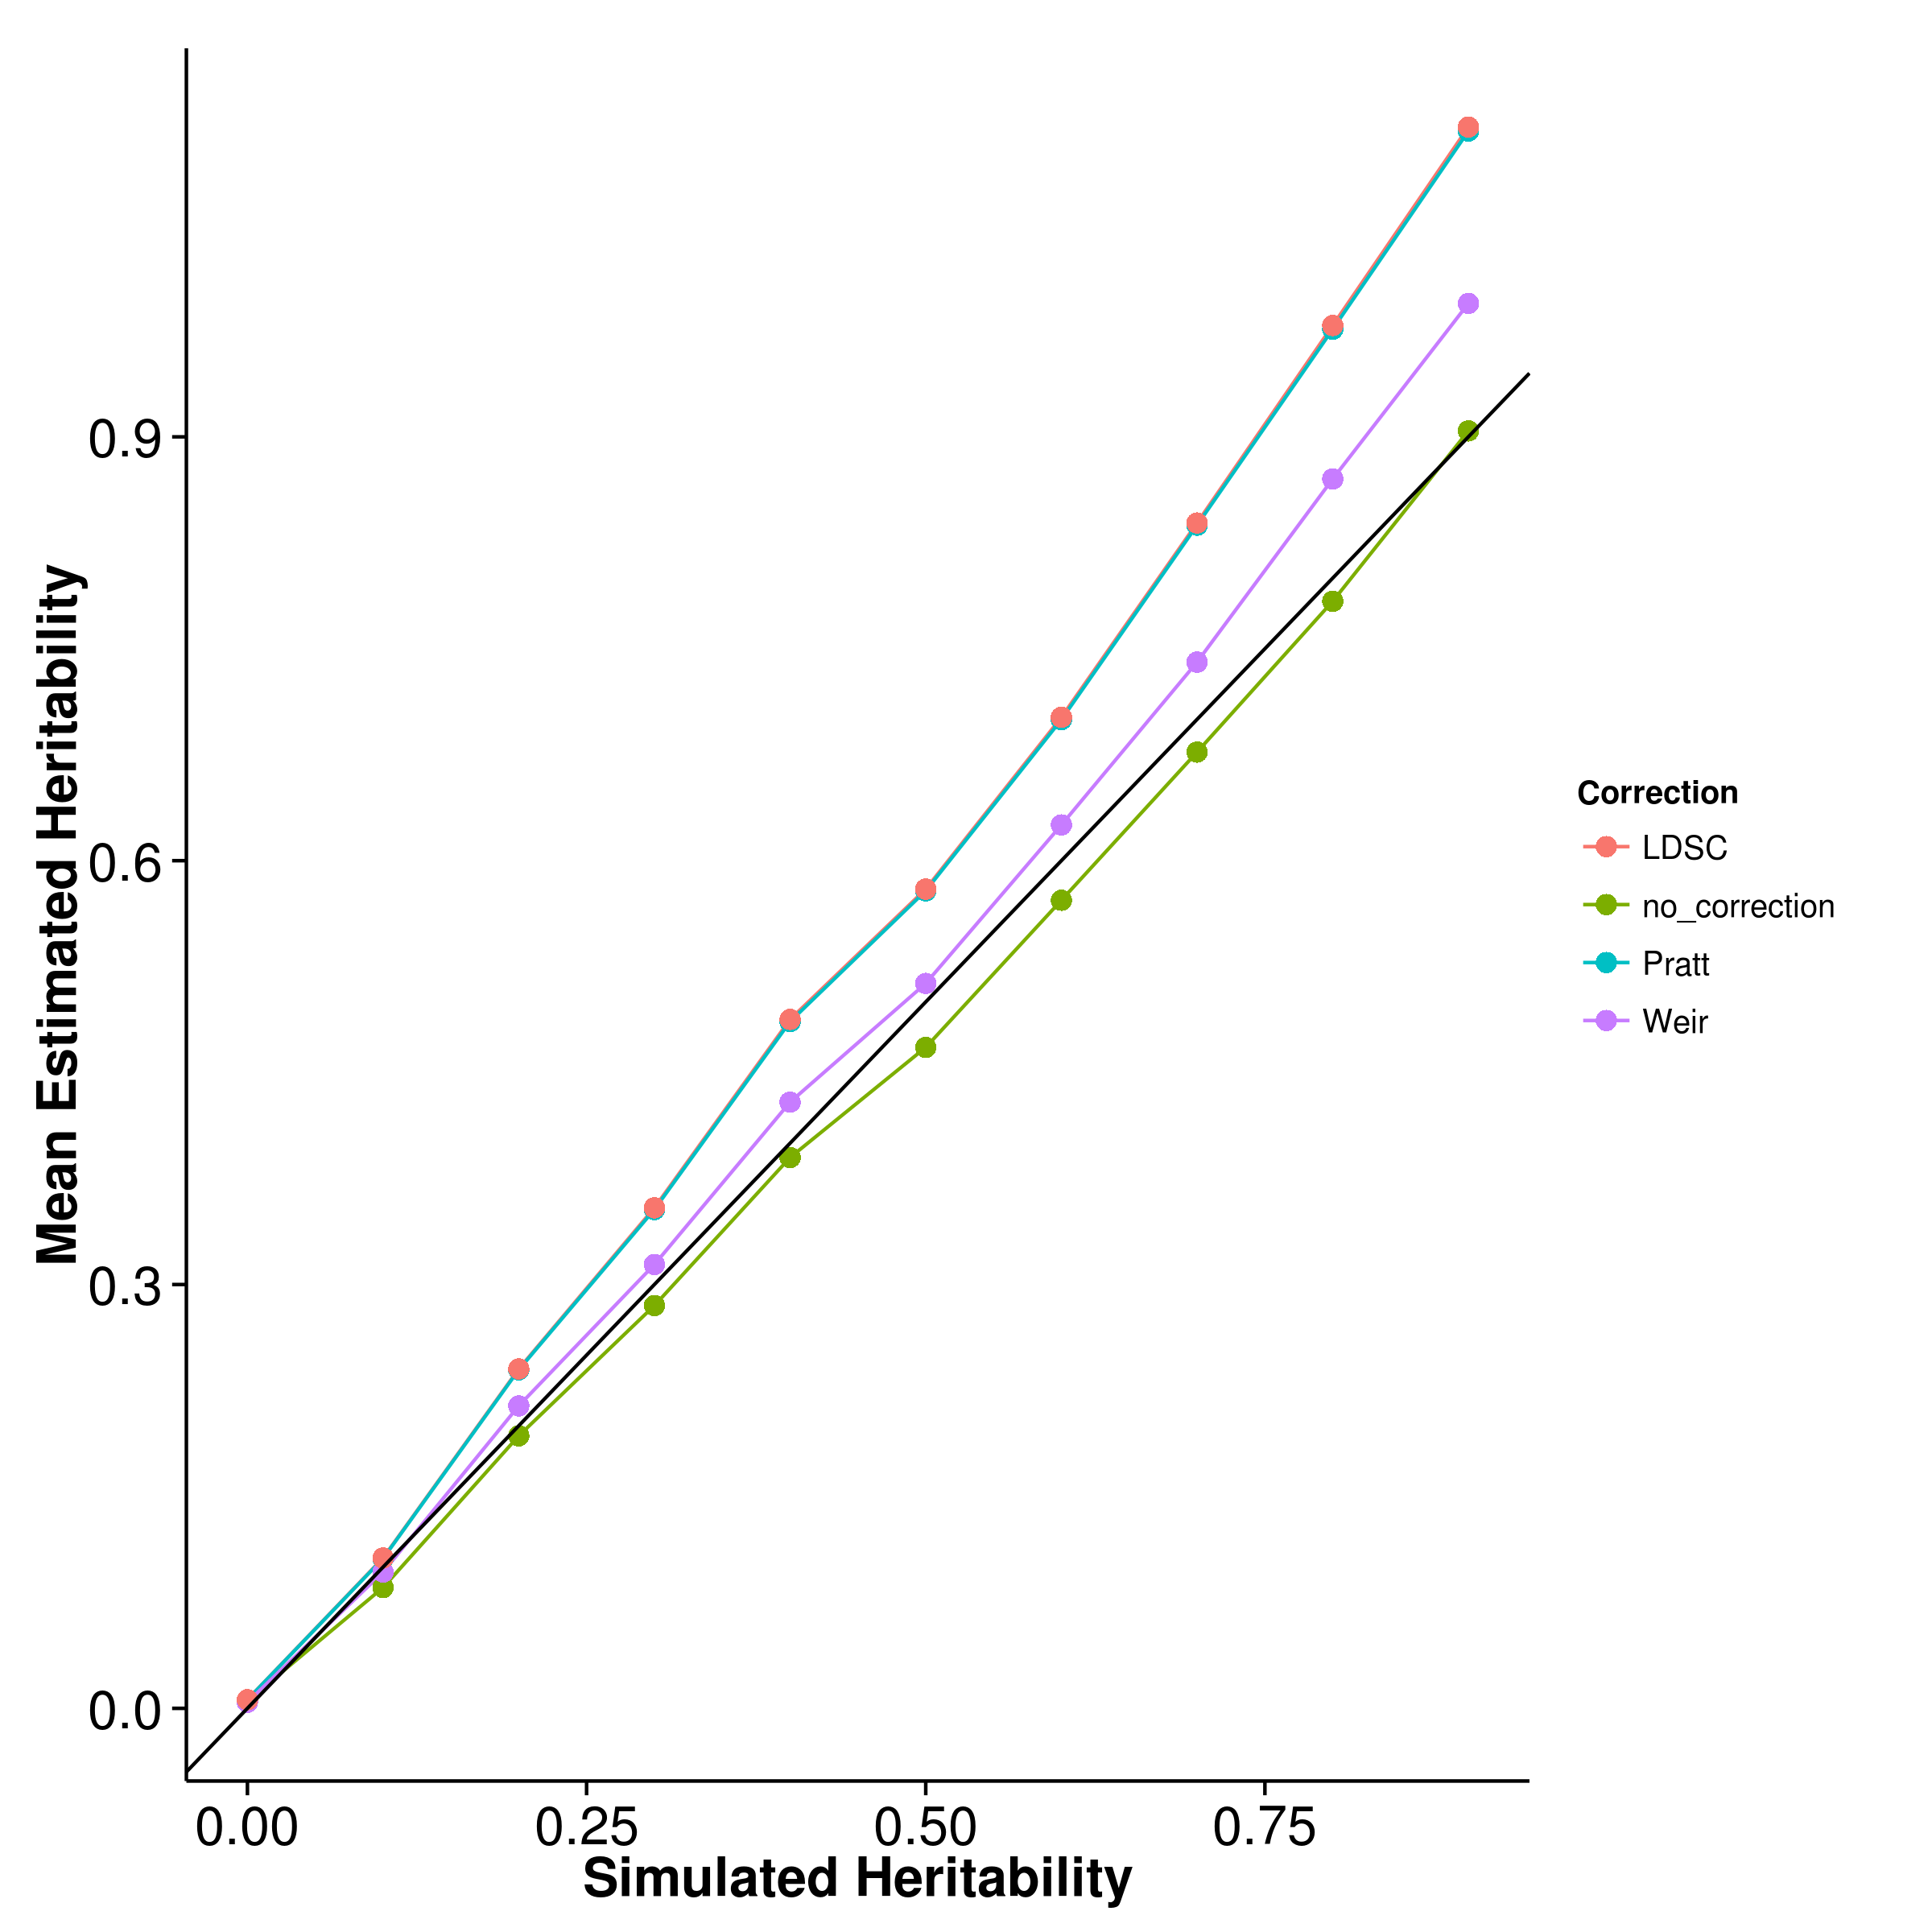 [Empirical Variance] 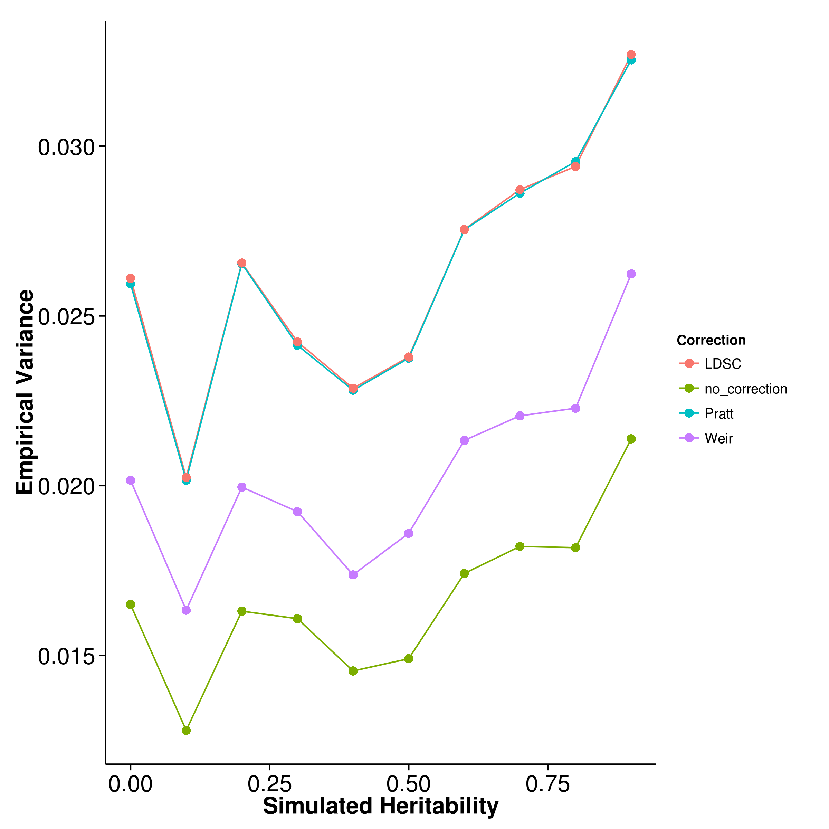

Figure 21: Effect of LD correction to Heritability Estimation when 50,000 SNP were simulated. As an overestimation is observed in the quantitative trait simulation, we performed a short simulation to assess the impact of LD correction to the heritability of shrek when the there is a larger number of SNP. From the graph, it is observed that all LD correction algorithms inflate the heritability estimation when large number of SNP were simulated. In fact, the bias is the smallest when no LD correction was performed.

From the results (fig:ldCorBigCom), it is clear that all LD correction algorithms inflates the heritability estimation from shrek in oppose to the underestimation observed when no LD correction was performed. The underestimation is as expected because the positive sampling bias in  will lead to an “over correction” of the collinearity, thus results in lower estimates. As mentioned, it is possible that eq:weir does introduce small imprecision (e.g. overcorrection) to the LD matrix which accumulates as the number of SNP increases, leading to overestimation of the heritability. Our simulation results do support that as one of the possible explanation. What is interesting though is that the mse is the lowest when no LD correction was performed, suggesting that when the number of SNP increases, these LD correction algorithms actually has a negative impact to the performance of shrek.

It is noted that most LD correction algorithm assumes the correlation was calculated on normally distributed data. However, genomic data follows a binomial distribution, which might violates the assumption, leading to a biased correction. This will be an important area for further research. Without a good bias correction algorithm, the estimates from shrek will most likely be biased downward, especially when the reference panel is small. Meanwhile, we allow users the freedom to disable the LD correction in shrek.

Another important observation is the overestimation observed when we use the LD correction algorithm from ldsc on shrek. Using the same algorithm, the estimates from shrek are biased upward whereas the same bias was not observed in ldsc. This observation suggests that shrek might be more sensitive to the errors in the LD matrix when compared to ldsc. Indeed, shrek requires the inverse of the LD matrix and considering the large condition number of the LD matrix, any errors can be multiplied during the inversion. On the other hand, ldsc does not compute the inverse of LD matrix. Instead, they only require the *sum* of  for the regression model. By avoiding the inverse of the matrix, the algorithm will then be less sensitive to the imprecision in the LD, thus result in a better estimates. However, it will still be interesting to see whether if the application of a better LD correction algorithm can help to improve the estimates from ldsc.

### 7.2 Simulation Results

To understand how the performance of the heritability estimation algorithm was influenced by different genetic architectures, we performed a series of simulations.

#### 7.2.1 Quantitative Trait Simulation

In the quantitative trait simulation, it is clear that for most situation, gcta has the best performance. By using the genetic relationship matrix, the estimation from gcta are more accurate when compared to ldsc and shrek. However, when the sample genotypes are unavailable, it is not possible to calculate the genetic relationship matrix required by gcta. Thus one can only rely on ldsc and shrek.

When the trait is polygenic, it is observed that the estimates of ldsc with fixed intercept are more accurate than the estimates from shrek. However, under the oligogenic condition (e.g with only 5 or 10 causal SNP), the variance of ldsc increases, thus increasing the mse. On the other hand, the estimates of shrek are relatively insensitive to the number of causal SNP. As a result of that, under the oligogenic condition, shrek has a better performance when compared to ldsc.

An important factor to remember is that in our simulation, we did not simulate any confounding factors, therefore the intercept estimation in ldsc was expected to only increase the variance without any gain in estimation power. The results from the simulation agrees with the hypothesis and demonstrated that the intercept estimation does increase the variance of the estimates, leading to a higher mse.

It will be interesting to assess the performance of these algorithms when there is confounding effects such that one can test the importance of the intercept estimation function in the correction of confounding effects. However, the simulation of population and, especially cryptic relationship, is nontrivial. For example, although one can provide haplotype from different population to HAPGEN2, there is a lot of uncertainties in the simulation of the individual phenotypes: Should one standardize the genotype of the two population independently in the calculation of phenotype? Should the two population have the same causal SNP? If not, should we limit the causal SNP within the same biological pathway / function?

Moreover, heritability is dependent on the environment and genotype frequency. Theoretically, it is possible for different population to have a different heritability for a particular trait. The possible combinations and the complexity of the problem is beyond the scope of this thesis but we do acknowledge that it is an important subject and further research is required.

Overall, when compared to ldsc, the only advantage of shrek is its relative robustness to change in genetic architecture of the trait. Under extreme scenarios such the oligogenic condition, or when there is one SNP with extreme effect size, the performance of shrek remains relatively unaffected when compared to ldsc which usually result in a larger variance under the extremes. Whereas under polygenic condition ldsc outperforms shrek. It is important to note that the bias of shrek is mainly due to the LD correction algorithm, if LD correction was not performed, the mse of the estimates form shrek will be reduced (e.g. from 0.0217 to 0.0166 in the LD correction simulation), reducing the difference in performance between ldsc. Nonetheless, the sensitive to errors in the LD matrix remains to be one of the biggest weakness of shrek.

#### 7.2.2 Case Control Simulation

More often than not, researchers are interested in case control studies where “affected” and “normal” samples were compared. This is particular useful for the studies of disease traits such as scz. However, the heritability estimation is not as straight forward and requires the adaptation of the liability threshold model. It was known that gcta, the most widely adopted algorithm for heritability estimation in GWAS is unable to provide accurate estimates in case control scenarios and its estimates are affected by the population prevalence and sample size of the studies [?]. Our simulation results agree with the observation of [?], suggesting that as the population prevalence decreases, the magnitude of bias in the estimates of gcta increases.

According to [?], in case control studies there is an oversampling of the cases relative to their prevalence in the population. The case control sampling induced a positive correlation between the genetic and environmental effects for the samples in the study even when there is no true genetic and environmental interaction in the population [?]. This leads to heritability estimates from gcta to be strongly downward biased where the magnitude of bias increases as the population prevalence decreases, heritability increases and when the proportion of cases is closer to half.

The question then is whether if this artificial correlation will affect the performance of shrek and ldsc. First, it is observed that as the population prevalence decreases, the magnitude of bias for both ldsc with fixed intercept and shrek increases suggesting that the population prevalence and the sampling bias might indeed be influential to the estimates of ldsc and gcta. However, the direction of bias is opposed to what was observed in gcta where a smaller population prevalence leads to a larger *overestimation* in the heritability. Considering that for shrek, we adjusted the estimates by multiplying eq:transform to the estimates, an overestimation might suggest that we have an under correction of the bias. Of course the bias introduced by the LD correction is another factor to be considered, but considering that only 5,000 SNP were simulated, the bias introduced by LD sampling bias should be relatively small as suggested by our LD correction simulation. To understand the effect of LD correction in case control scenario, we will need to increase the number of SNP simulated yet that is only possible when additional computation resources are made available.

What is most surprising in the case control simulation is the performance of ldsc with intercept estimation. As we did not simulate any confounding factors, we expect the performance of ldsc with intercept estimation would be worst compared to ldsc with fixed intercept because of the unnecessary additional degree of freedom in the estimation. However, it is observed that unlike shrek and ldsc with fixed intercept, the bias of ldsc with intercept estimation is robust to the change in population prevalence (fig:CC10RandMean,fig:CC50RandMean,fig:CCRandMean,fig:CC500RandMean), thus when the population prevalence is small, the bias of ldsc with intercept estimation is relatively smaller when compared to ldsc with fixed intercept.

Taking into consideration of the empirical variance and the bias of the estimates, shrek has better average performance when compared to ldsc. It is important to remember that the case control simulation is not comparable to the results from the quantitative trait simulation, not only because the addition of the liability model, but also that in the case control simulation, we only simulated 5,000 SNP on chromosome 22. Based on the LD correction simulation, it is observed that bias from the LD correction algorithms is smaller when less SNP were simulated. On top of that, the total amount of samples included in the simulation was doubled that from the quantitative trait simulation, with 1,000 cases and 1,000 controls whereas we only simulated 1,000 total samples in the quantitative trait scenario. Nonetheless, our case control simulation does highlights the effect of population prevalence on the performance of the heritability estimation algorithms. It will be an important topic to develop better algorithm for adjusting the attenuation bias introduced by case control sampling when the population prevalence of the disease is small.

Finally, it is noted that in order to provide an accurate estimation of the heritability, one needs to know the population prevalence of the disease beforehand. Without the information of the population prevalence, it will be difficult for one to estimates the heritability from GWAS with case control design. Therefore once should always be cautious with the heritability estimations from a case control designs when the population prevalence is unknown.

#### 7.2.3 Extreme Phenotype Sampling

Other than the case control study design, extreme phenotype sampling is another common experimental design for it can helps to increase the power of an association studies given the same amount samples. Compared with the same number of randomly selected individuals, the extreme selection design can increase the power by a factor of  where  is variance of the trait of the selected sample and  is the trait variance of the general population. So for example, if one only include the samples from the top 5% and bottom 5% of the phenotype distribution, one can achieve the same power as a study with random sampling design that has 4 times the sample size [?].

[No Extreme sampling] 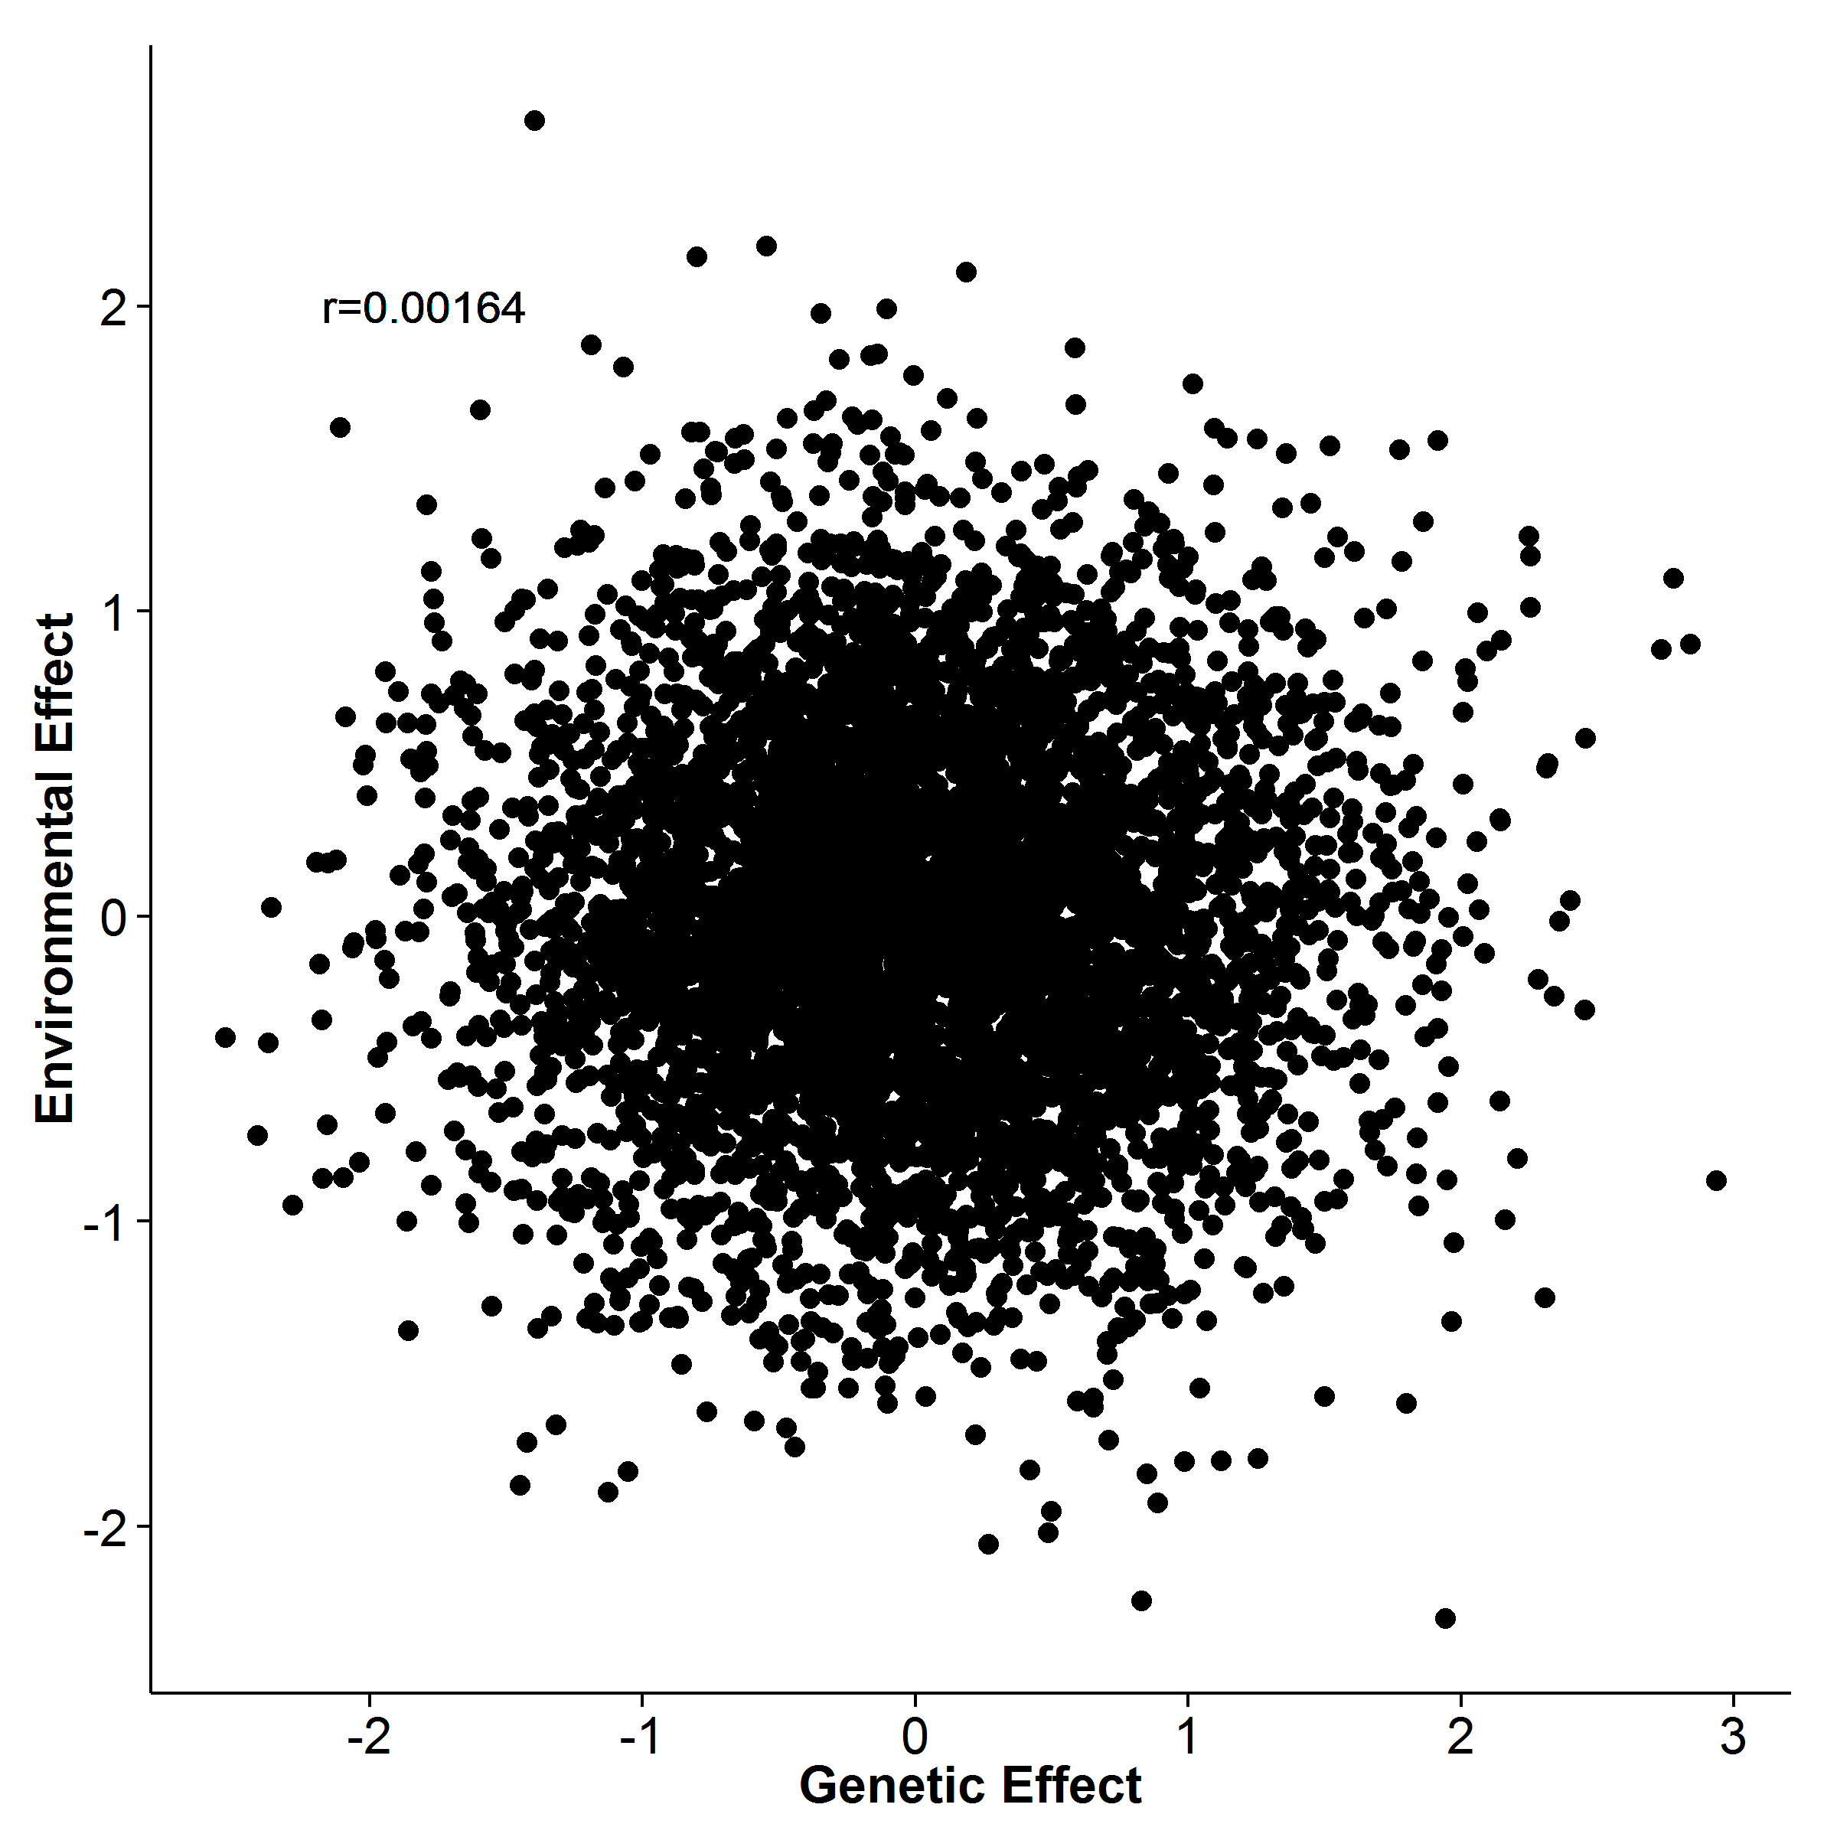 [Extreme Sampling] 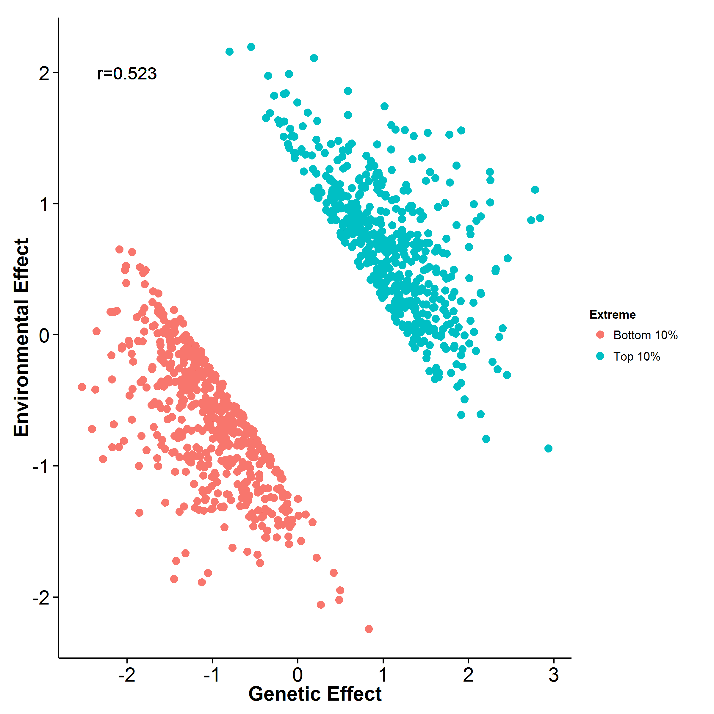

Figure 22: Effect of extreme sampling design. Here we simulated the genetic and environmental effect independently. When no extreme sampling was performed, there is no correlation between the environmental effect and genetic effect as expected. However, when extreme sampling was performed, an artificial correlation is observed. This might be the main reason why the estimates from gcta are downward biased.

Herein, we simulated the situation where an extreme selection design was performed to assess the performance of the heritability estimation algorithms. We were also interested in comparing the performance between extreme phenotype sampling and random sampling strategy. First, it is observed that when extreme phenotype sampling was performed, the estimates from gcta are biased downward. This observation is similar to what was observed in the case control simulation. It is noted that although we were simulating independent environmental and genetic effects, the extreme phenotype sampling strategy does introduced an artificial correlation between the two effects, similar to what was observed in case control scenario (fig:extremeSampling). This might therefore affect the performance of gcta where as the portion of sample selected decreases, the magnitude of bias increases, similar to the change of population prevalence in case control studies.

On the other hand, an upward bias is observed in the estimates from shrek and ldsc. Although the same bias can be observed in the random sampling scenario, the bias is slightly high when a smaller portion of samples were selected. This level of bias concurs with the biased observed when a trait has a smaller population prevalence suggesting that the sampling method might introduce bias in the SNP heritability estimate. Studies are therefore required to identify a better algorithm for the correction of the attenuation bias. Overall, the performance of shrek and ldsc are more than 3 fold better when extreme selection was performed, suggesting that the extreme selection does help to improve the power in estimation even though the same amount of samples were used.

However, although the empirical variance observed in the random sampling for all the algorithm are the same as what was observed in the quantitative trait simulation with 100 causal SNP, the estimated variance for gcta and ldsc are much worst. A larger upward bias is observed in the estimates from ldsc with fixed intercept, suggesting there might be some difference between the simulation of random sampling and the simulation of quantitative trait, even though most of the parameter for simulation are the same. The only difference in the two simulation was the standardization of genotype when calculating the phenotype. For the quantitative trait simulation, the genotype was standardized based on the genotype of 1,000 samples of which all were included in the analysis. However, in the simulation of the random sampling design, 5,000 samples were used to standardize the genotype, of which only 1,000 out of 5,000 were included in the final analysis. It is uncertain how this affects the performance of the algorithm and further analysis might be required.

Nonetheless, in this simulation, we first simulated the individuals and their phenotype *then* we perform the sampling. The only difference between the two sets of data is the sampling performed. Thus it is safe to conclude that the extreme phenotype sample does provide more power than the random sampling in heritability estimation.

Finally, we only tested the performance of the algorithms when the trait is polygenic (e.g. 100 causal SNP). Further simulation should be performed to test the effect of extreme phenotype selection on traits with different genetic architecture.

### 7.3 Application to Real Data

Our main question of interest is to understand what is the true contribution of common genetic variants, such as SNP, to the variance of scz. Although [?] estimated that the SNP heritability of scz is around 0.555, it is still interesting to see if the same results can be calculated when different method was used. In order to make sure our analysis is correct and that the concordance between estimates from different tools were not merely by chance, we also estimated the heritability for bipolar disorder and major depression disorder as a reference point.

What is most surprisingly os that the ldsc estimated heritability is much smaller than the estimates from the supplementary materials of [?] (e.g. for scz, 0.555 compared to 0.133). From [?], the formula of ldsc is

 (61)

where  is the LD score of variant ,  is the sample size,  is the contribution of confounding biases,  is the heritability and  is the number of SNP. When contact the author about the discrepancy of the estimation between our run of ldsc and the estimates shown in the supplementary table, [?] replied that the estimated from the supplementary table define  as the total number of SNP in the reference panel used to estimated LD score whereas the current version of ldsc defines  as the number of SNP with maf in the reference panel used to estimate LD score which they deem more appropriate based on new data they observed after their original paper was published. Based on the caption of their supplementary, they stated that “ if the average rare SNP explains less phenotypic variance than the average common SNP, then a smaller value of  would be more appropriate, and the estimates in the supplementary table will be biased upwards.” [?]. This explain the smaller estimates from our run.

Another interesting observation from the estimates in real data is that shrek consistently return a higher estimates when compared to ldsc Considering the fact that shrek cannot account for confounding effects such as cryptic relationship and population stratification, it is likely that the estimates are inflated by these confounding factors. A straight forward test is to perform ldsc without the intercept estimation and compare the estimates with that from shrek such that it is clear whether if the difference of the estimates was due to the ability of estimating the intercept by ldsc. Indeed, when the intercept estimation was not performed, the estimates from the two algorithms converges (tab:realDataNoIn). Therefore, it is likely that the difference in tab:realData is a direct result of the estimation of the intercept.

|  |  |
| --- | --- |
|  | |
|  | Major Depression Disorder | Bipolar | scz |
| shrek | 0.256 (0.0273) | 0.312 (0.0168) | 0.174 (0.00453) |
| ldsc | 0.235 (0.0241) | 0.267 (0.0147) | 0.197 (0.0058) |
|  | |

Table 8: Heritability estimated for PGS data sets without Intercept Estimation. Indeed, when the intercept estimation was not performed, the estimates from ldsc was very close to that of shrek.

However, it is very important for one to remember that it is difficult to tell which estimates is the “correct” estimate. For example, in the case control simulation, it was observed that shrek and ldsc with fixed intercept will *overestimates* the heritability when the prevalence is less than 0.5 whereas within the same range of population prevalence, ldsc with intercept estimation will *underestimate* the heritability. The problem of our simulation is that no confounding factors were simulated, thus it is uncertain whether if the same pattern can be observed when there is confounding factors. Nonetheless, as the confounding effects most likely will inflate the summary statistic of the association, the estimates of the heritability will likely to be biased upward. Moreover applying shrek to the real data, we performed the LD correction. As there is a large amount of SNP in the real data, the LD correction will inflate the estimates thus ensuring all biases were in the same direction (e.g. inflates our estimates). Because of the uni-directional bias, we can safely hypothesize that the estimates from shrek in tab:realData,tab:realDataNoIn is an upper-bound for the true SNP heritability in the current GWAS studies.

Based on our estimation, the pgc scz GWAS can at most account for  of the heritability of scz despite the amount of samples included. When compared to the heritability estimated from twin studies, there are around  of missing heritability unaccounted for. This suggested that rare variants or other factors (e.g. cnv) other than common SNP can account for the remaining heritability of scz.

If one would like to estimates the contribution of rare variants to scz, new algorithms might be required. This is mainly because the LD estimates form the rare variants usually have a large variability and might not be reliable, thus leading to unreliable estimates from shrek and ldsc. Therefore special cares are required if one would like to include the rare variants in the estimation process. Also, it is noted that we only performed the estimation on the autosomal chromosomes. The main reason behind was that there are large difference between male and female on the sex chromosomes (e.g. 2 X for female and XY for male). The proportion of male and female are usually not provided. This leads to difficulties in eq:defineF where the sample size is an important factor. Special consideration might therefore be required if one would like to estimates the contribution of variants on the sex chromosome to scz.

Moreover, considering that the risk of having scz of individual with a schizophrenic mother or schizophrenic father differs, it is possible that epigenetic or the mitochondrion which were mainly contributed by the mother also have their role in the heritability of scz. Therefore epigenetic might also have an important role in the etiology of scz.

Overall, the development of shrek and ldsc marks a new era in SNP heritability estimation and hopefully, with the continuous advancement of the methodology, problems in LD correction and the liability adjustment can all be solved in the near future.

### 7.4 Limitations and Improvements

One of the biggest disadvantage of shrek is its speed when compared to ldsc. To estimate the heritability, shrek requires the calculation of the inverse of the LD matrix, which is an  operation. Although the use of sliding window has significantly reduce the time requirement, the run time will still increase substantially as the density of the SNP increases. For example, it can take more than 2 days to process one chromosome of the pgc scz data set, where there can be more than 5,000 SNP per window. When applying shrek to the real data, the computation resources required to estimates heritability of the pgc scz GWAS were too high, forcing us to reduce the window size for the analysis. To make the use of shrek feasible, further development are required to improve the speed of shrek. An obvious choice might be to use the Armadillo library [?] together with the OpenBLAS library which can be more than 3 times faster when compared to the EIGEN C++ library [?].

On the other hand, the inverse of the LD matrix proves to be one of the biggest challenge for shrek not only because of the time required to invert the matrix, but also the accuracy of the inverse. Due to the inherently high collinearity of the LD matrix, the condition number of the matrix is very high, meaning that small imprecisions in the matrix can be amplified during the analysis. This makes shrek very sensitive to errors in the LD matrix. The use of tSVD does help to alleviate some of this problem yet it is still possible for it to break. A possible method to reduce the problem of the LD matrix is to remove any SNP in perfect LD with each other and we are going to implement this feature in shrek in future release and hopefully an improve in performance can be obtained.

Finally, we do acknowledge that we have not exhaust all possible combinations of genetic architectures in our simulation. For example, one can also test the performance of the algorithms when the observed prevalence was different (e.g. not 50%). It is also possible for one to investigate the effect of number of causal SNP on the performance of the algorithms when extreme phenotype sampling was performed. However, we do argue that we have performed a substantial amount of simulations and should be able to provide a general concept as to how the performance of shrek, ldsc and gcta are affected in the general scenarios.

## 8 Supplementary

[SHREK] 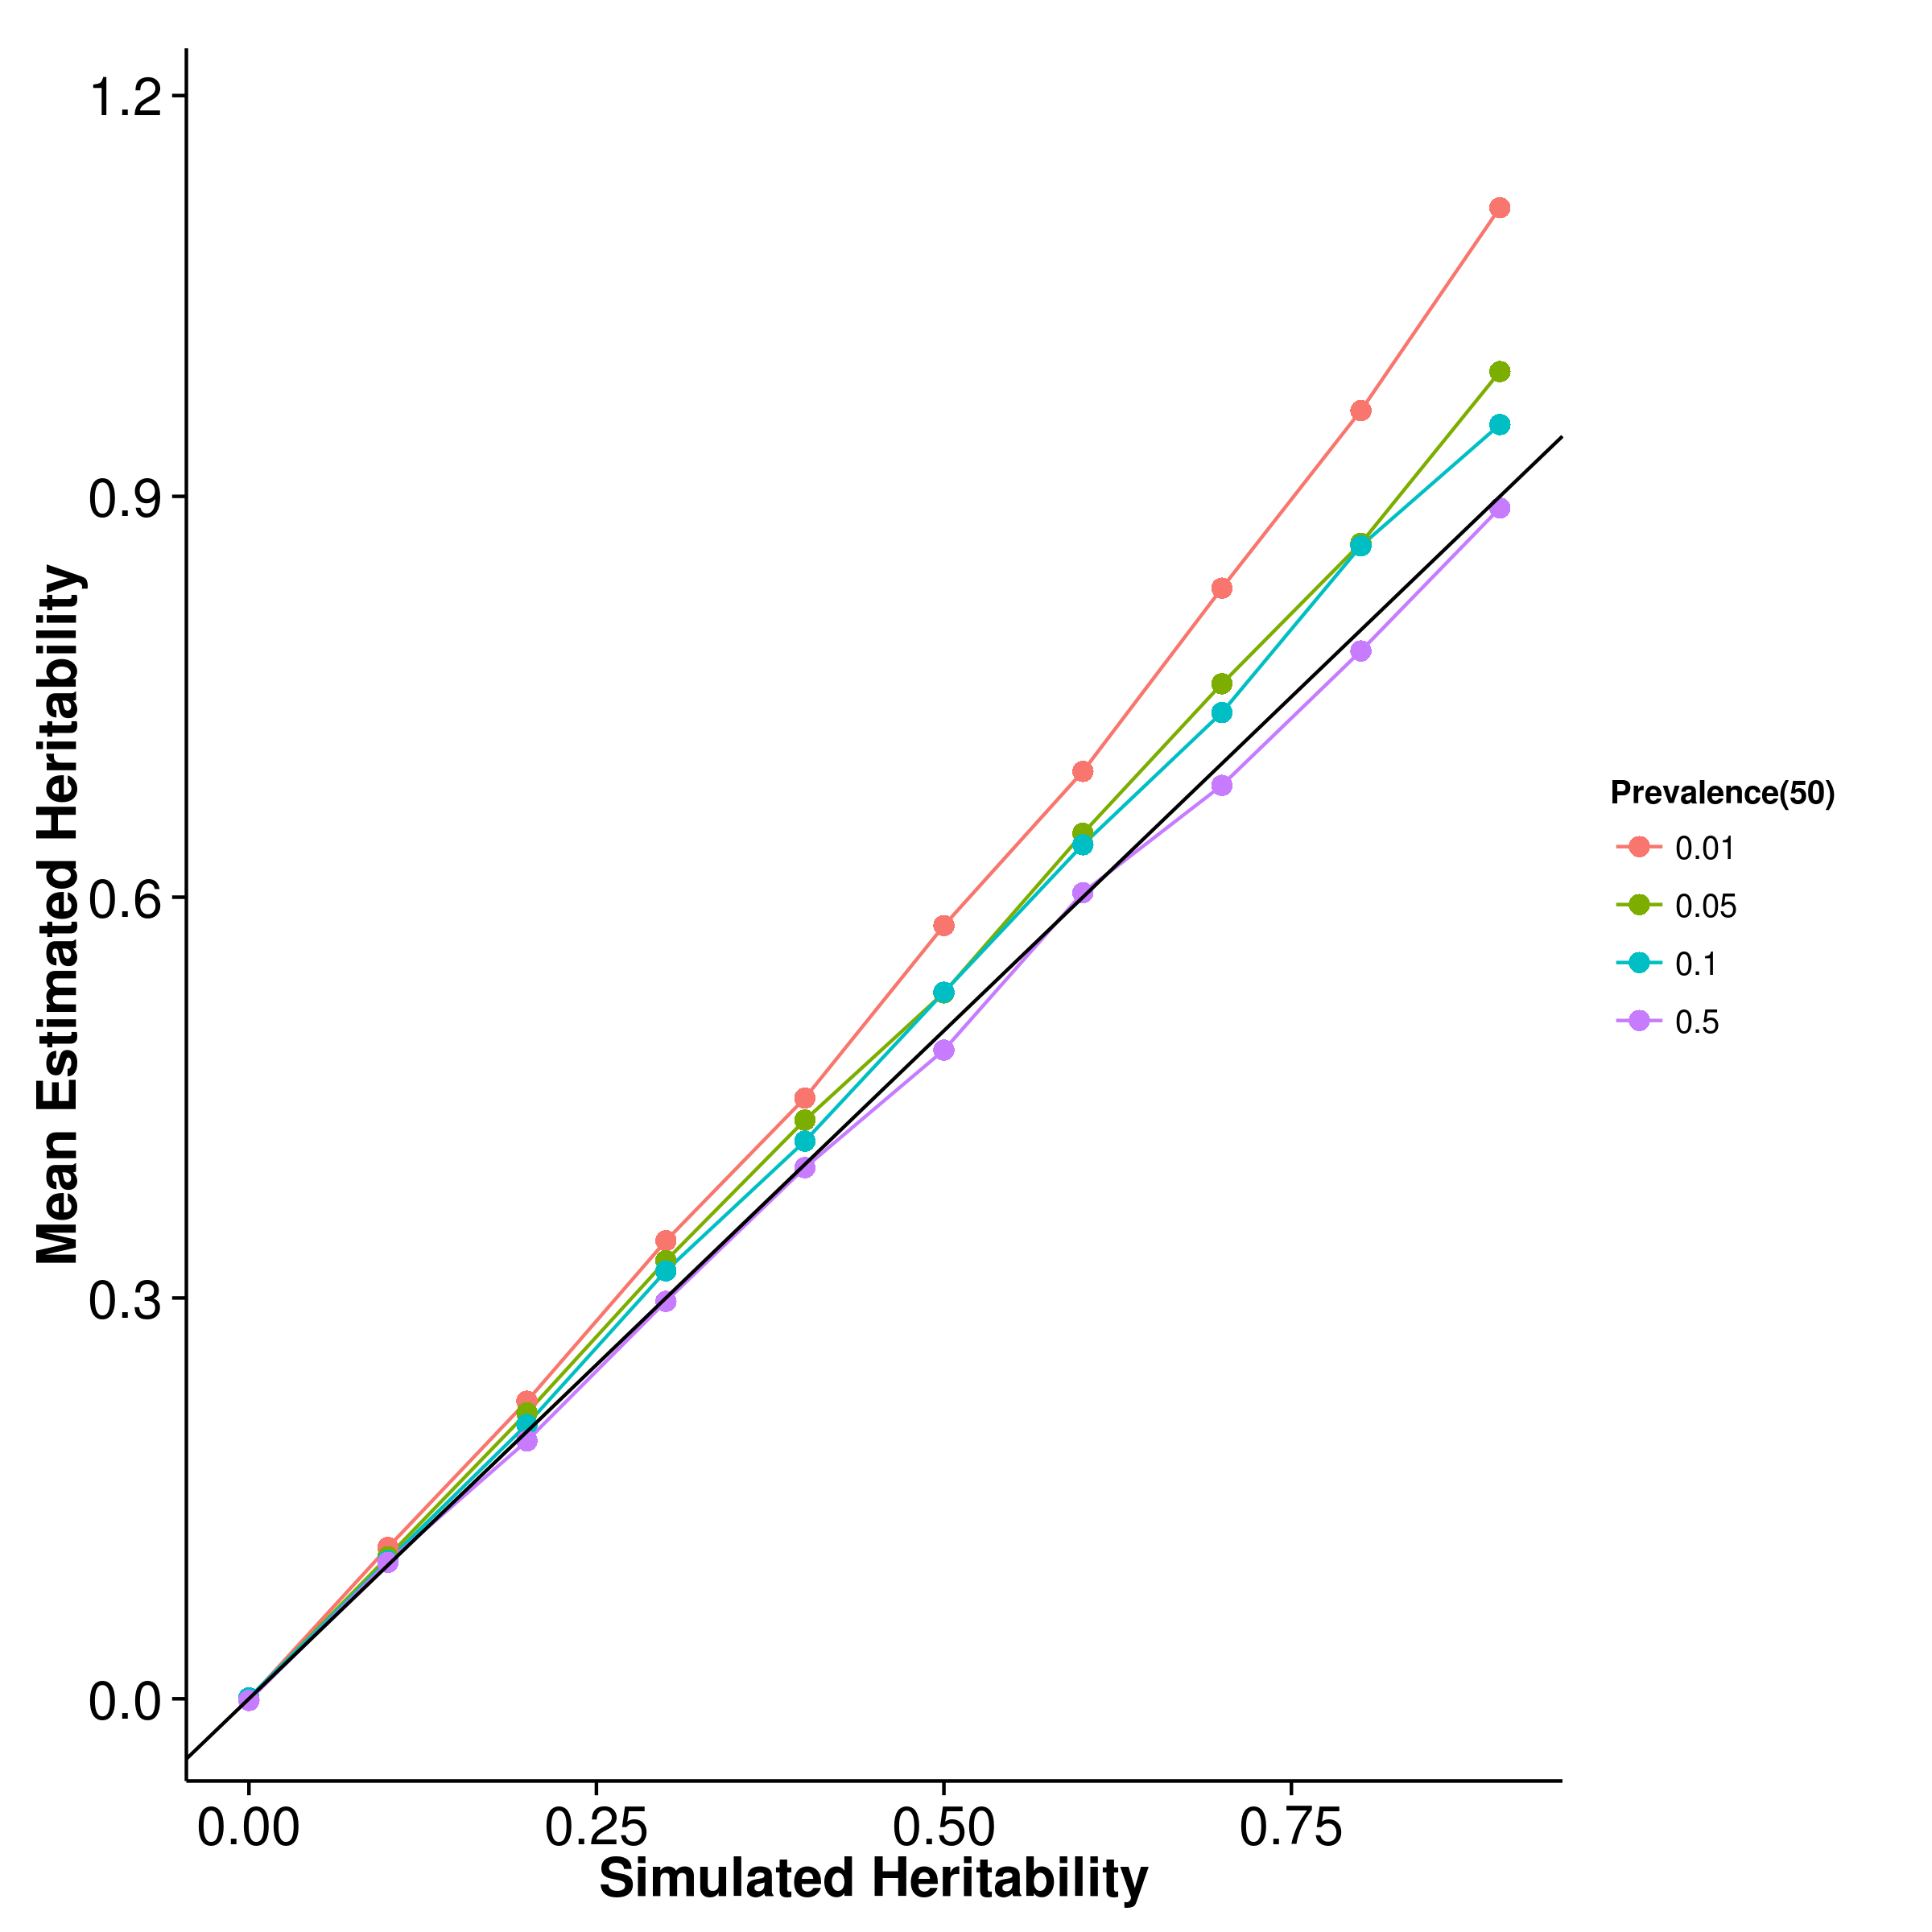 [GCTA] 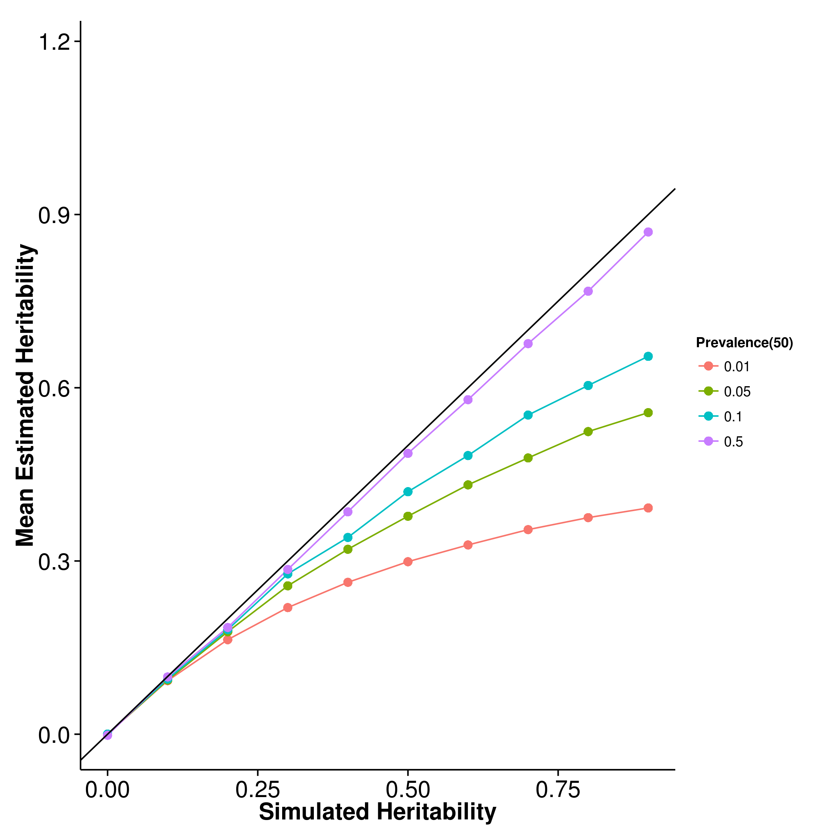

[LDSC with fix intercept] 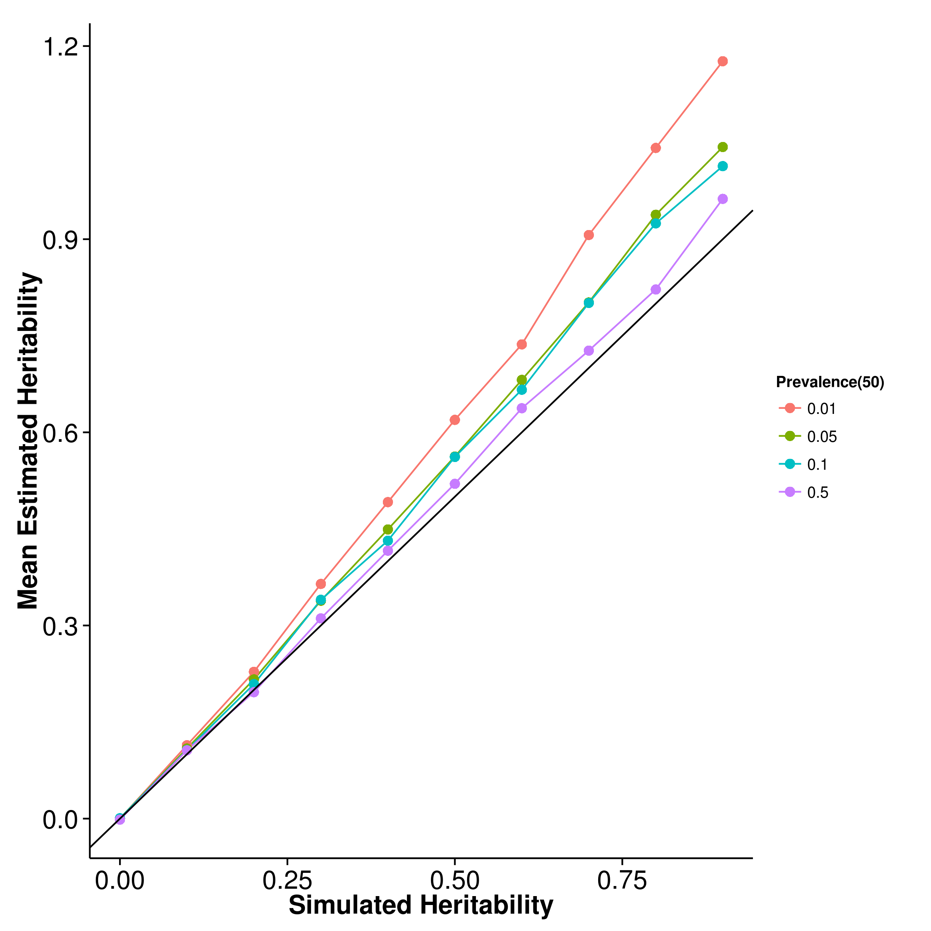 [LDSC with intercept estimation]

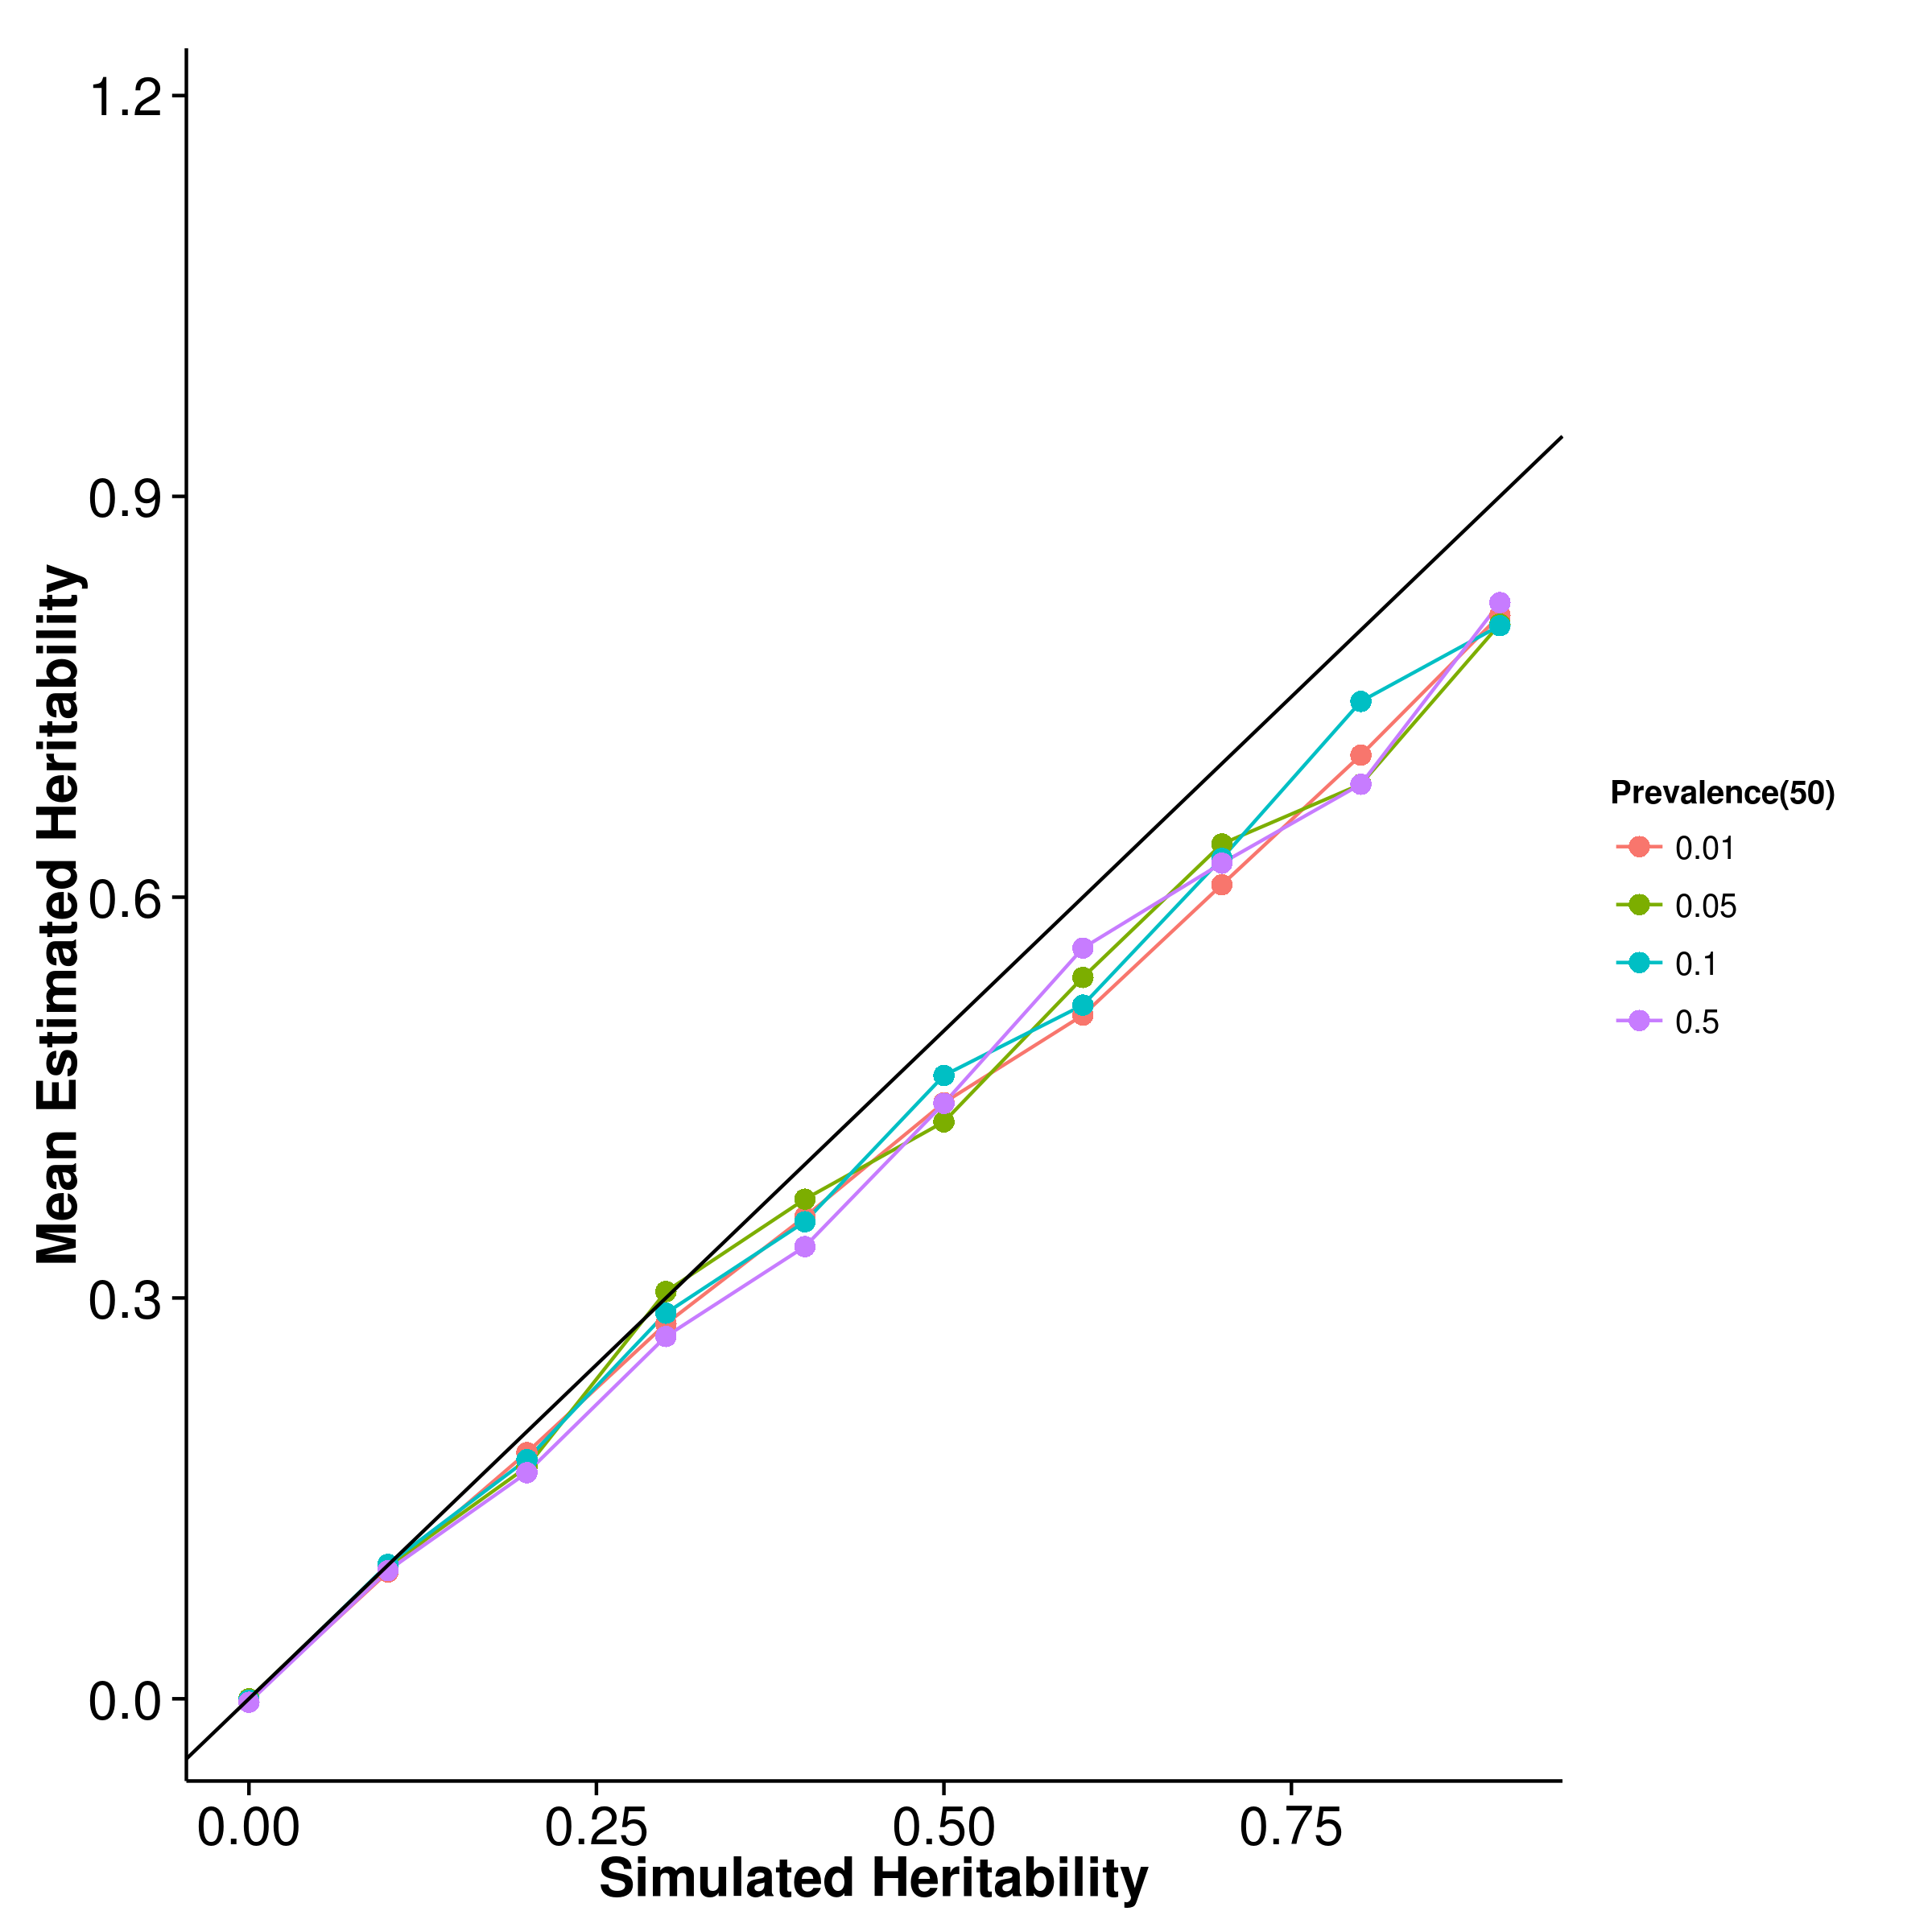

Figure 23: Mean of results from case control simulation with random effect size simulation with 50 causal SNP. In general, the results were similar to the scenario with 10 causal SNP with the only exception that the estimates from ldsc with intercept estimates seems to be less affected by the change in prevalence of the trait.

[SHREK] 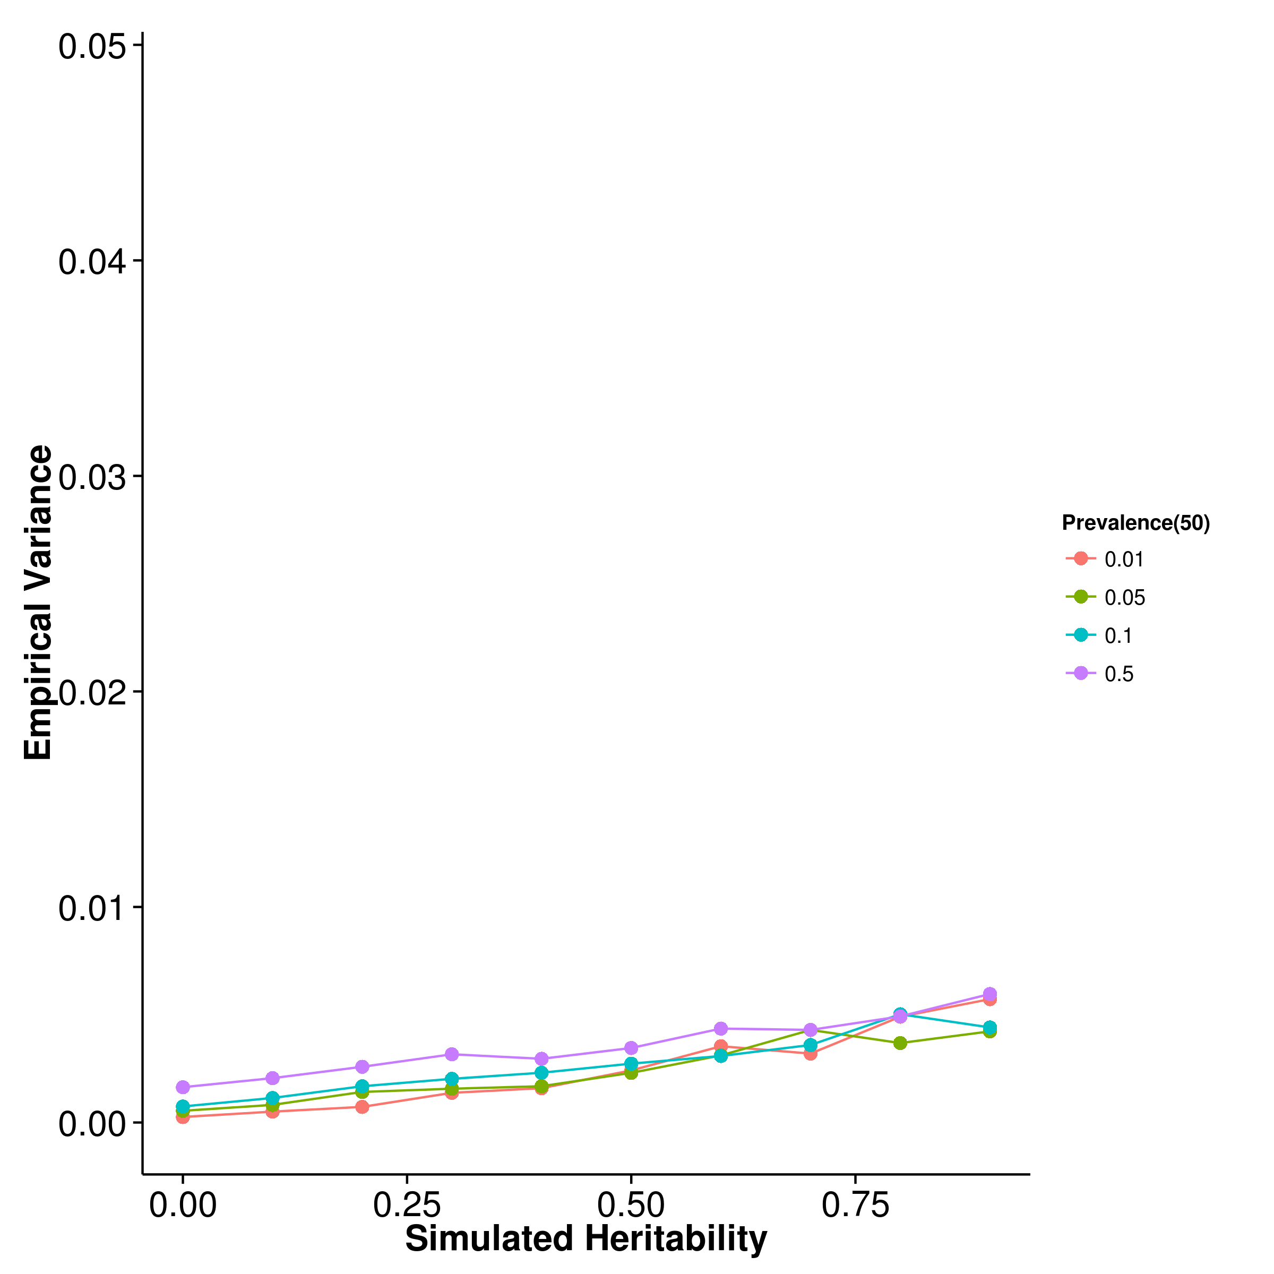 [GCTA] 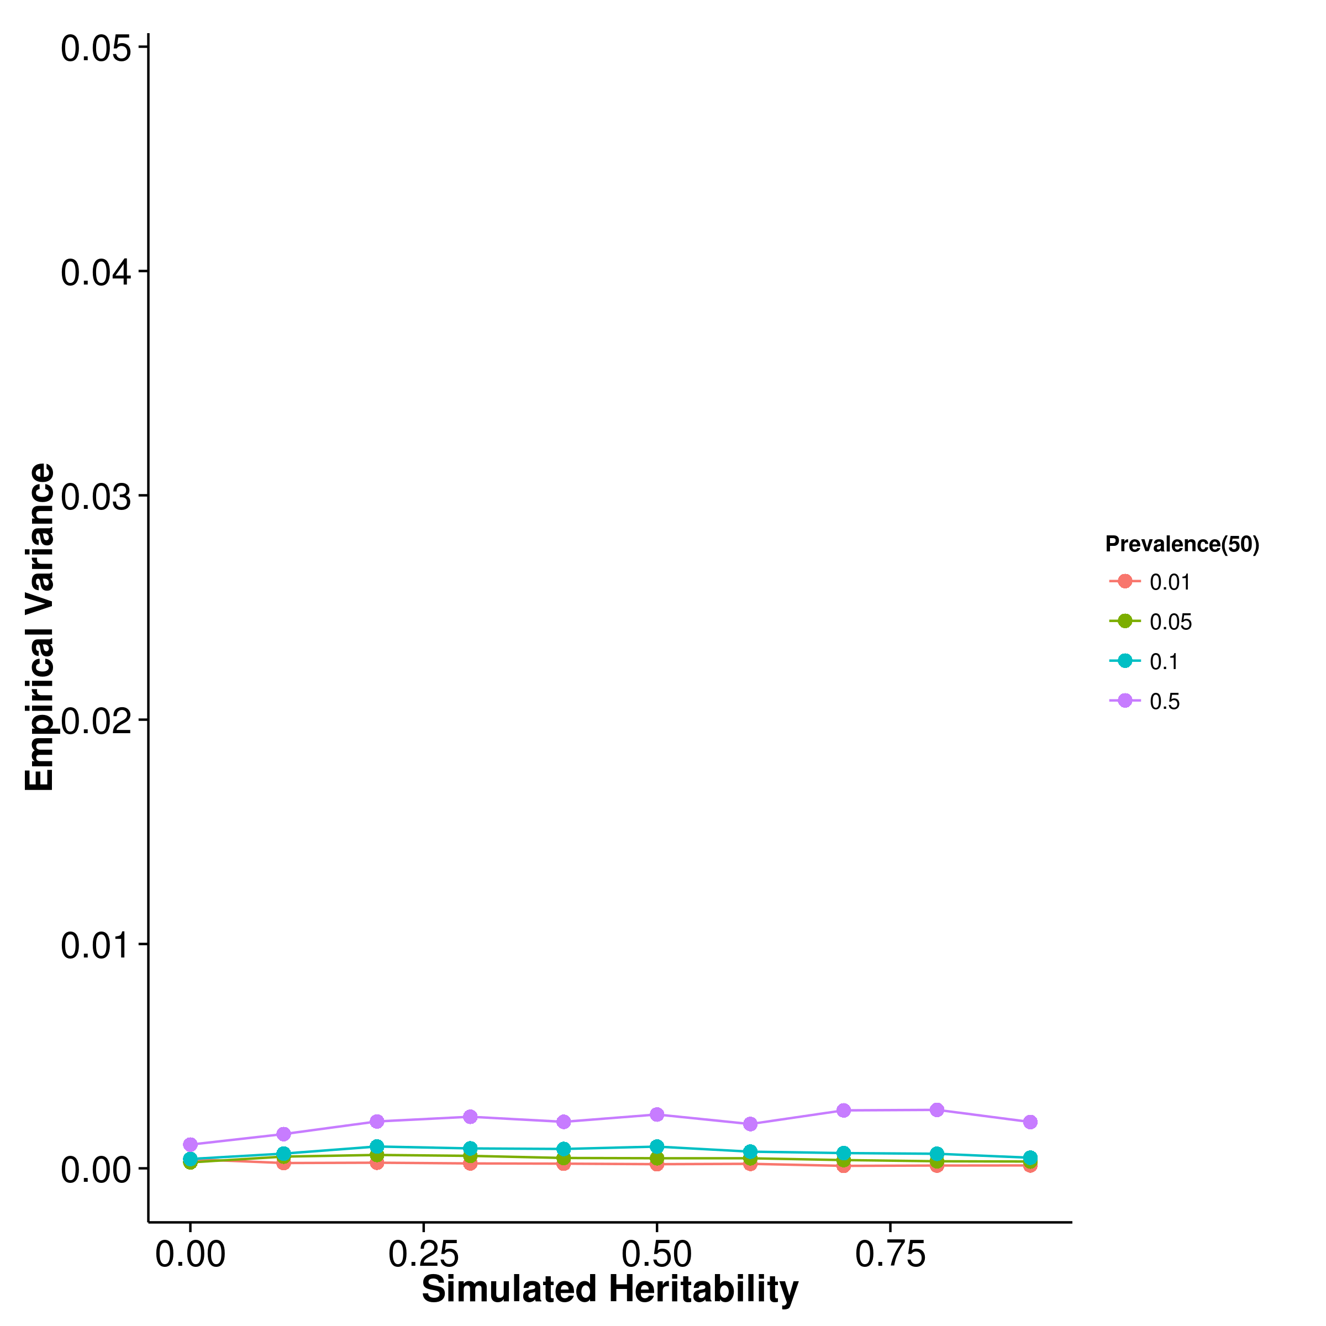

[LDSC with fix intercept] 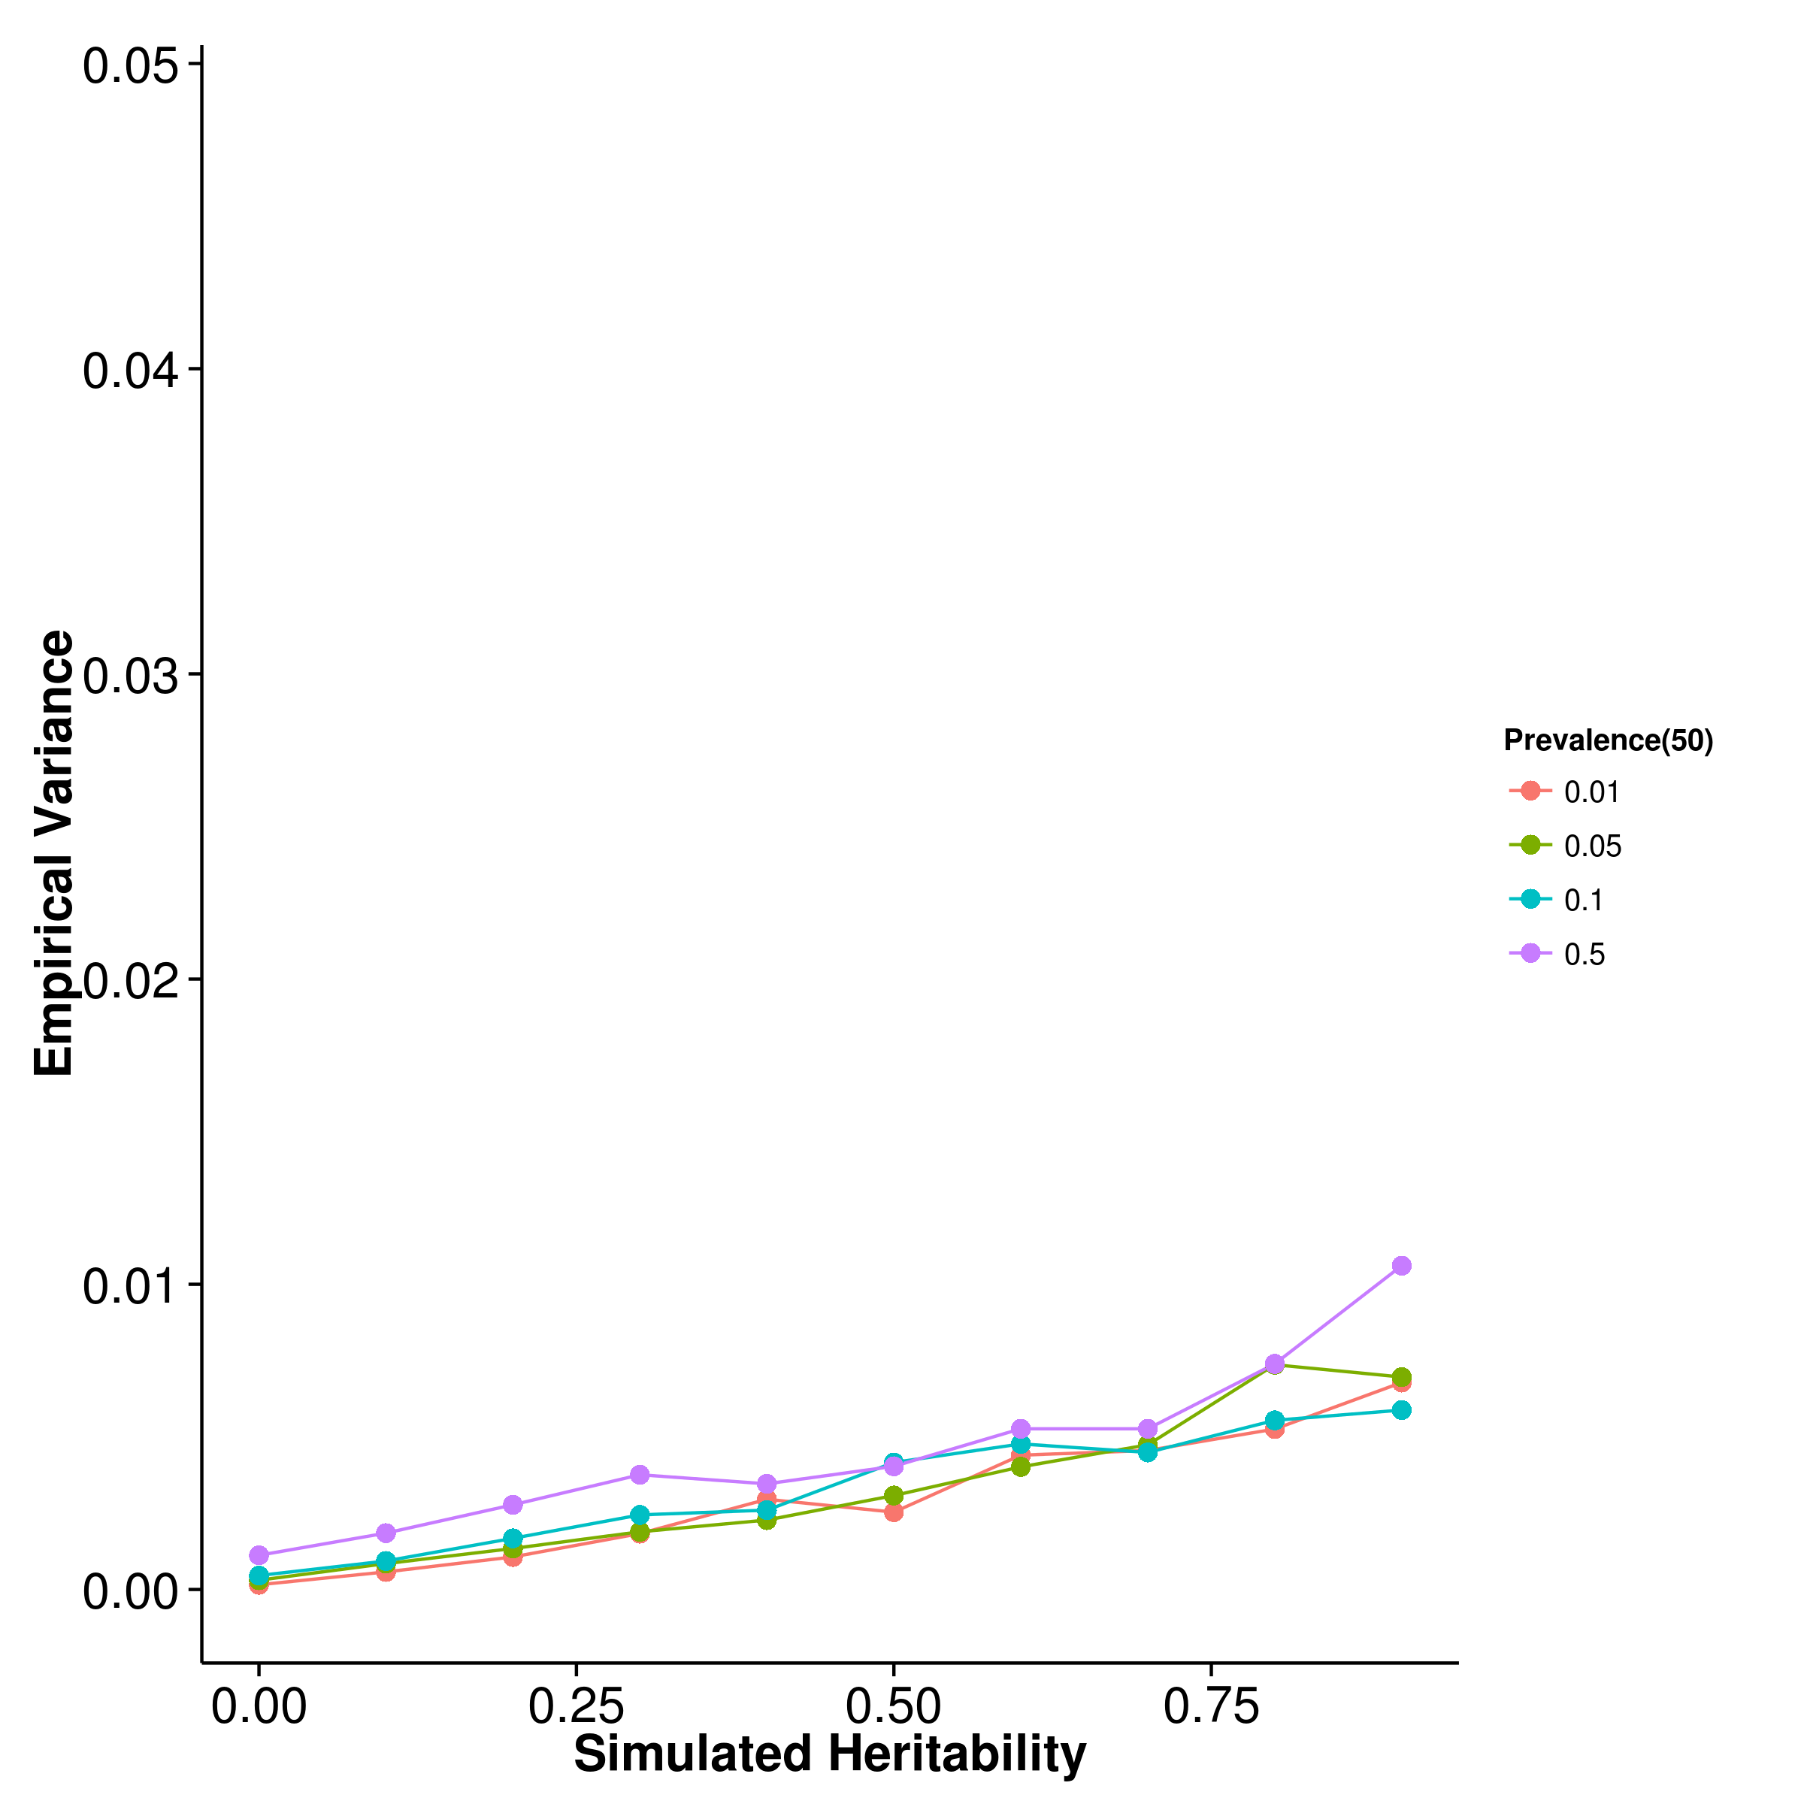 [LDSC with intercept estimation]

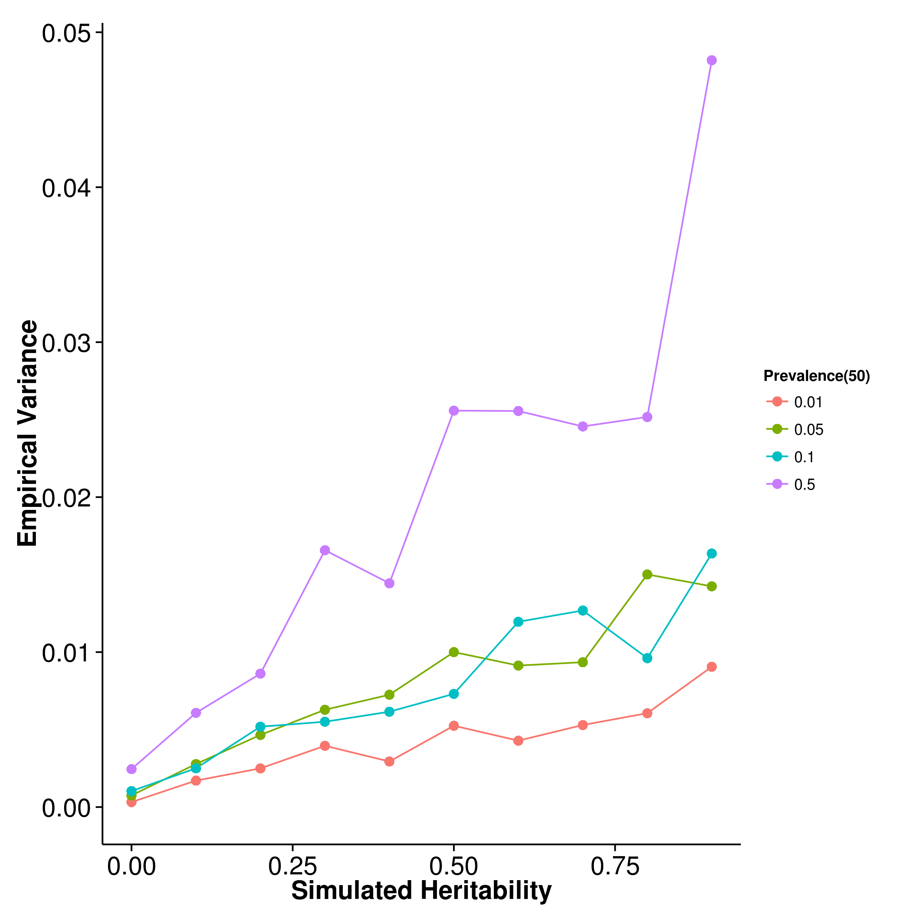

Figure 24: Variance of results from case control simulation with random effect size simulation with 50 causal SNP. For most algorithm except that of ldsc with fixed intercept, the empirical variance of the estimates increases as the population prevalence of the trait increases, with the estimations from ldsc with intercept estimation display the largest variance.

[SHREK] 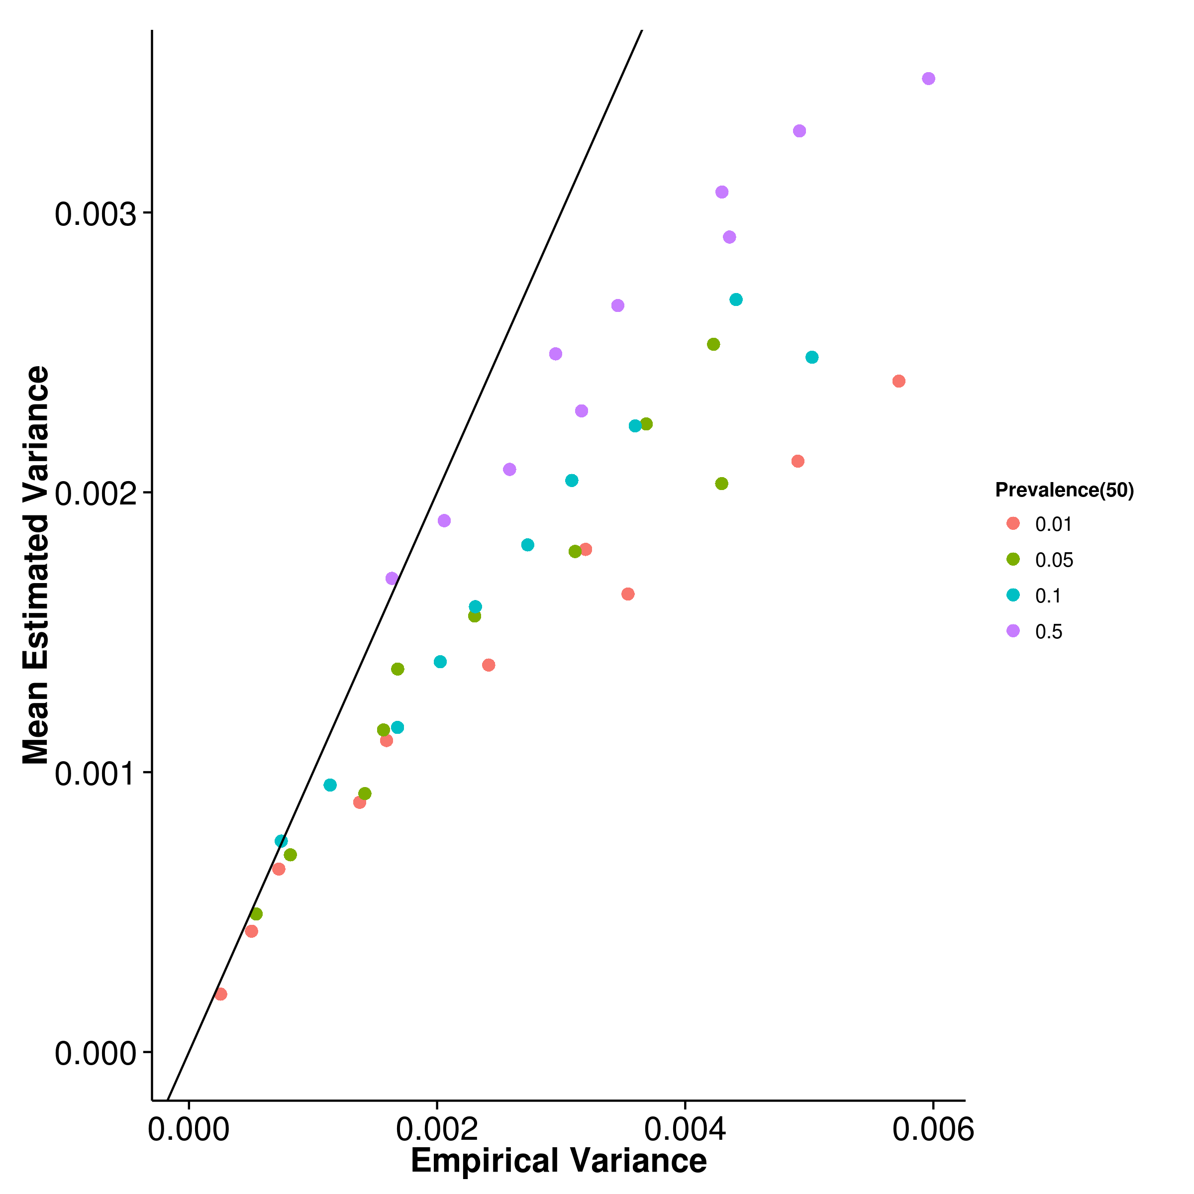 [GCTA] 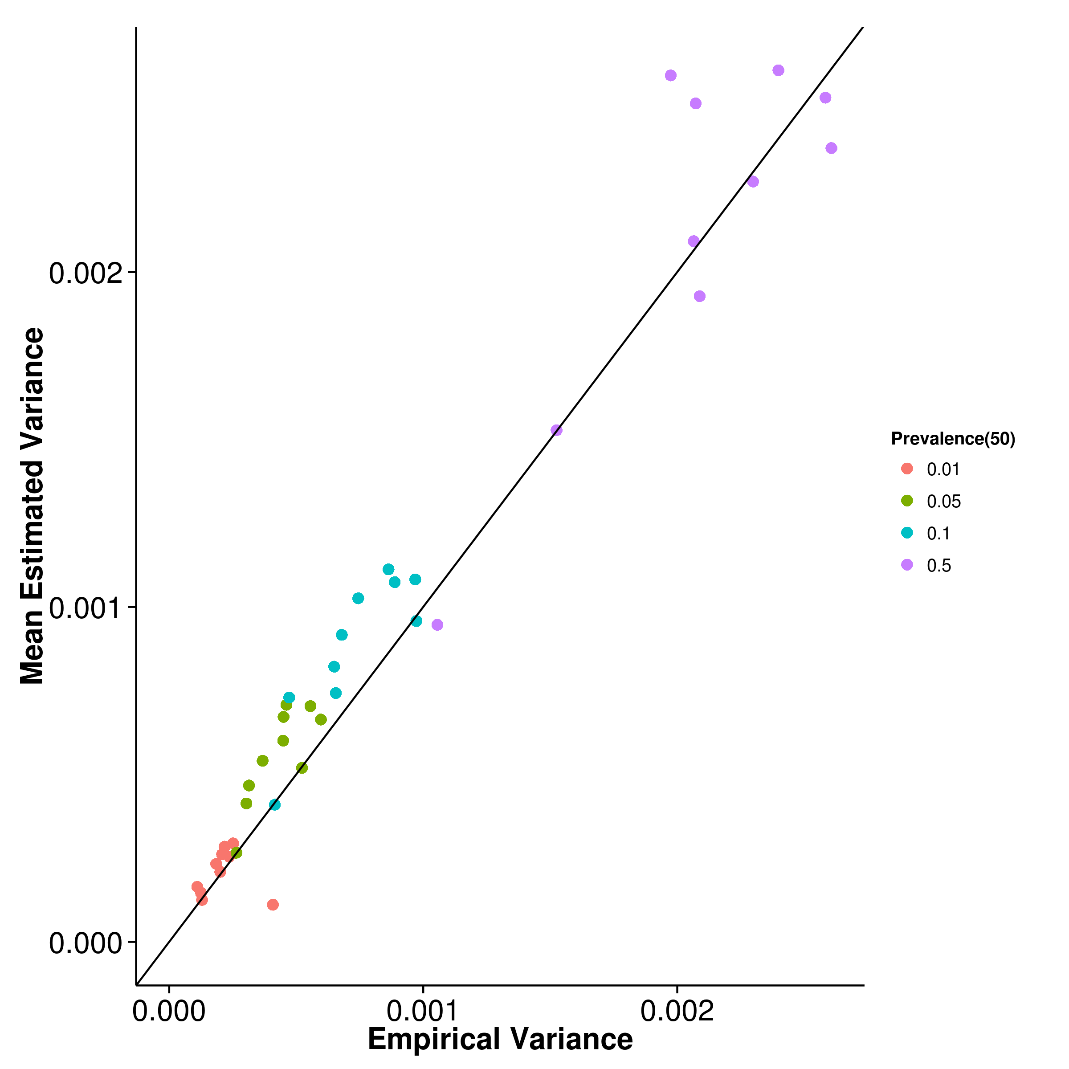

[LDSC with fix intercept] 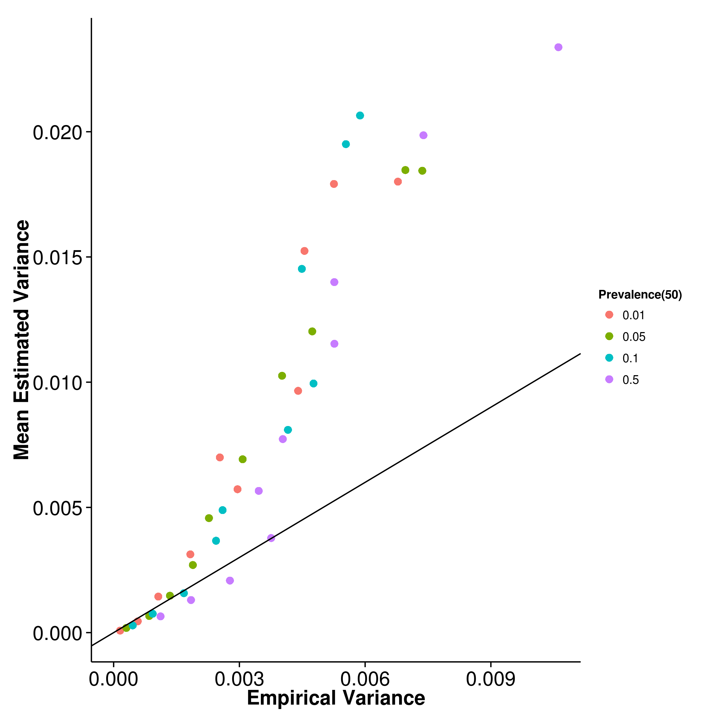 [LDSC with intercept estimation]

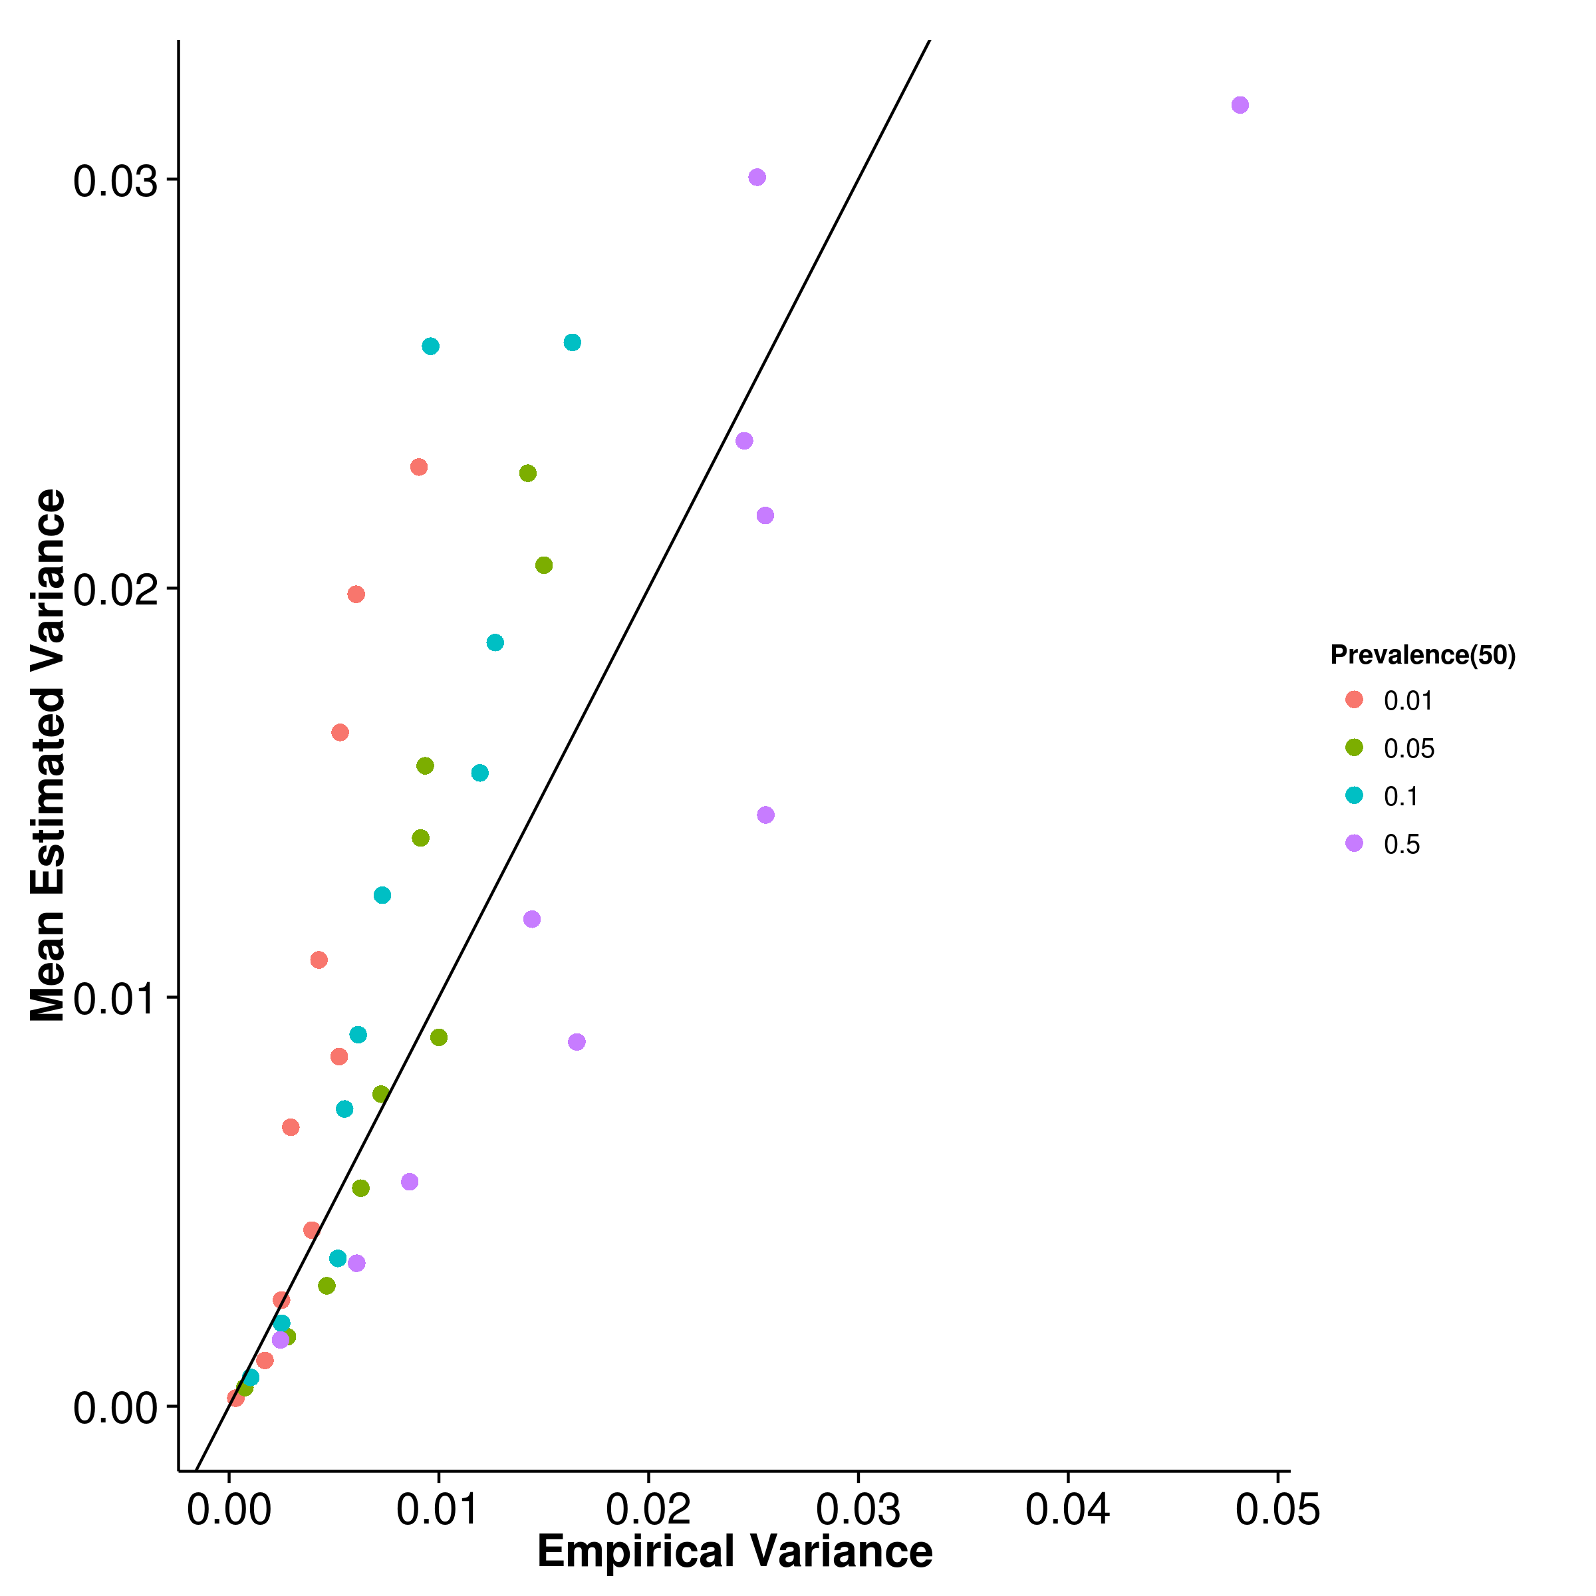

Figure 25: Estimated variance of results from case control simulation with random effect size simulation when compared to empirical variance when 50 causal SNP was simulated. Again, the estimation of variance from shrek tends to be downwardly biased and ldsc with fixed intercept tends to be upwardly biased. However, when intercept estimation was performed, the estimation of variance of ldsc improved.

[SHREK] 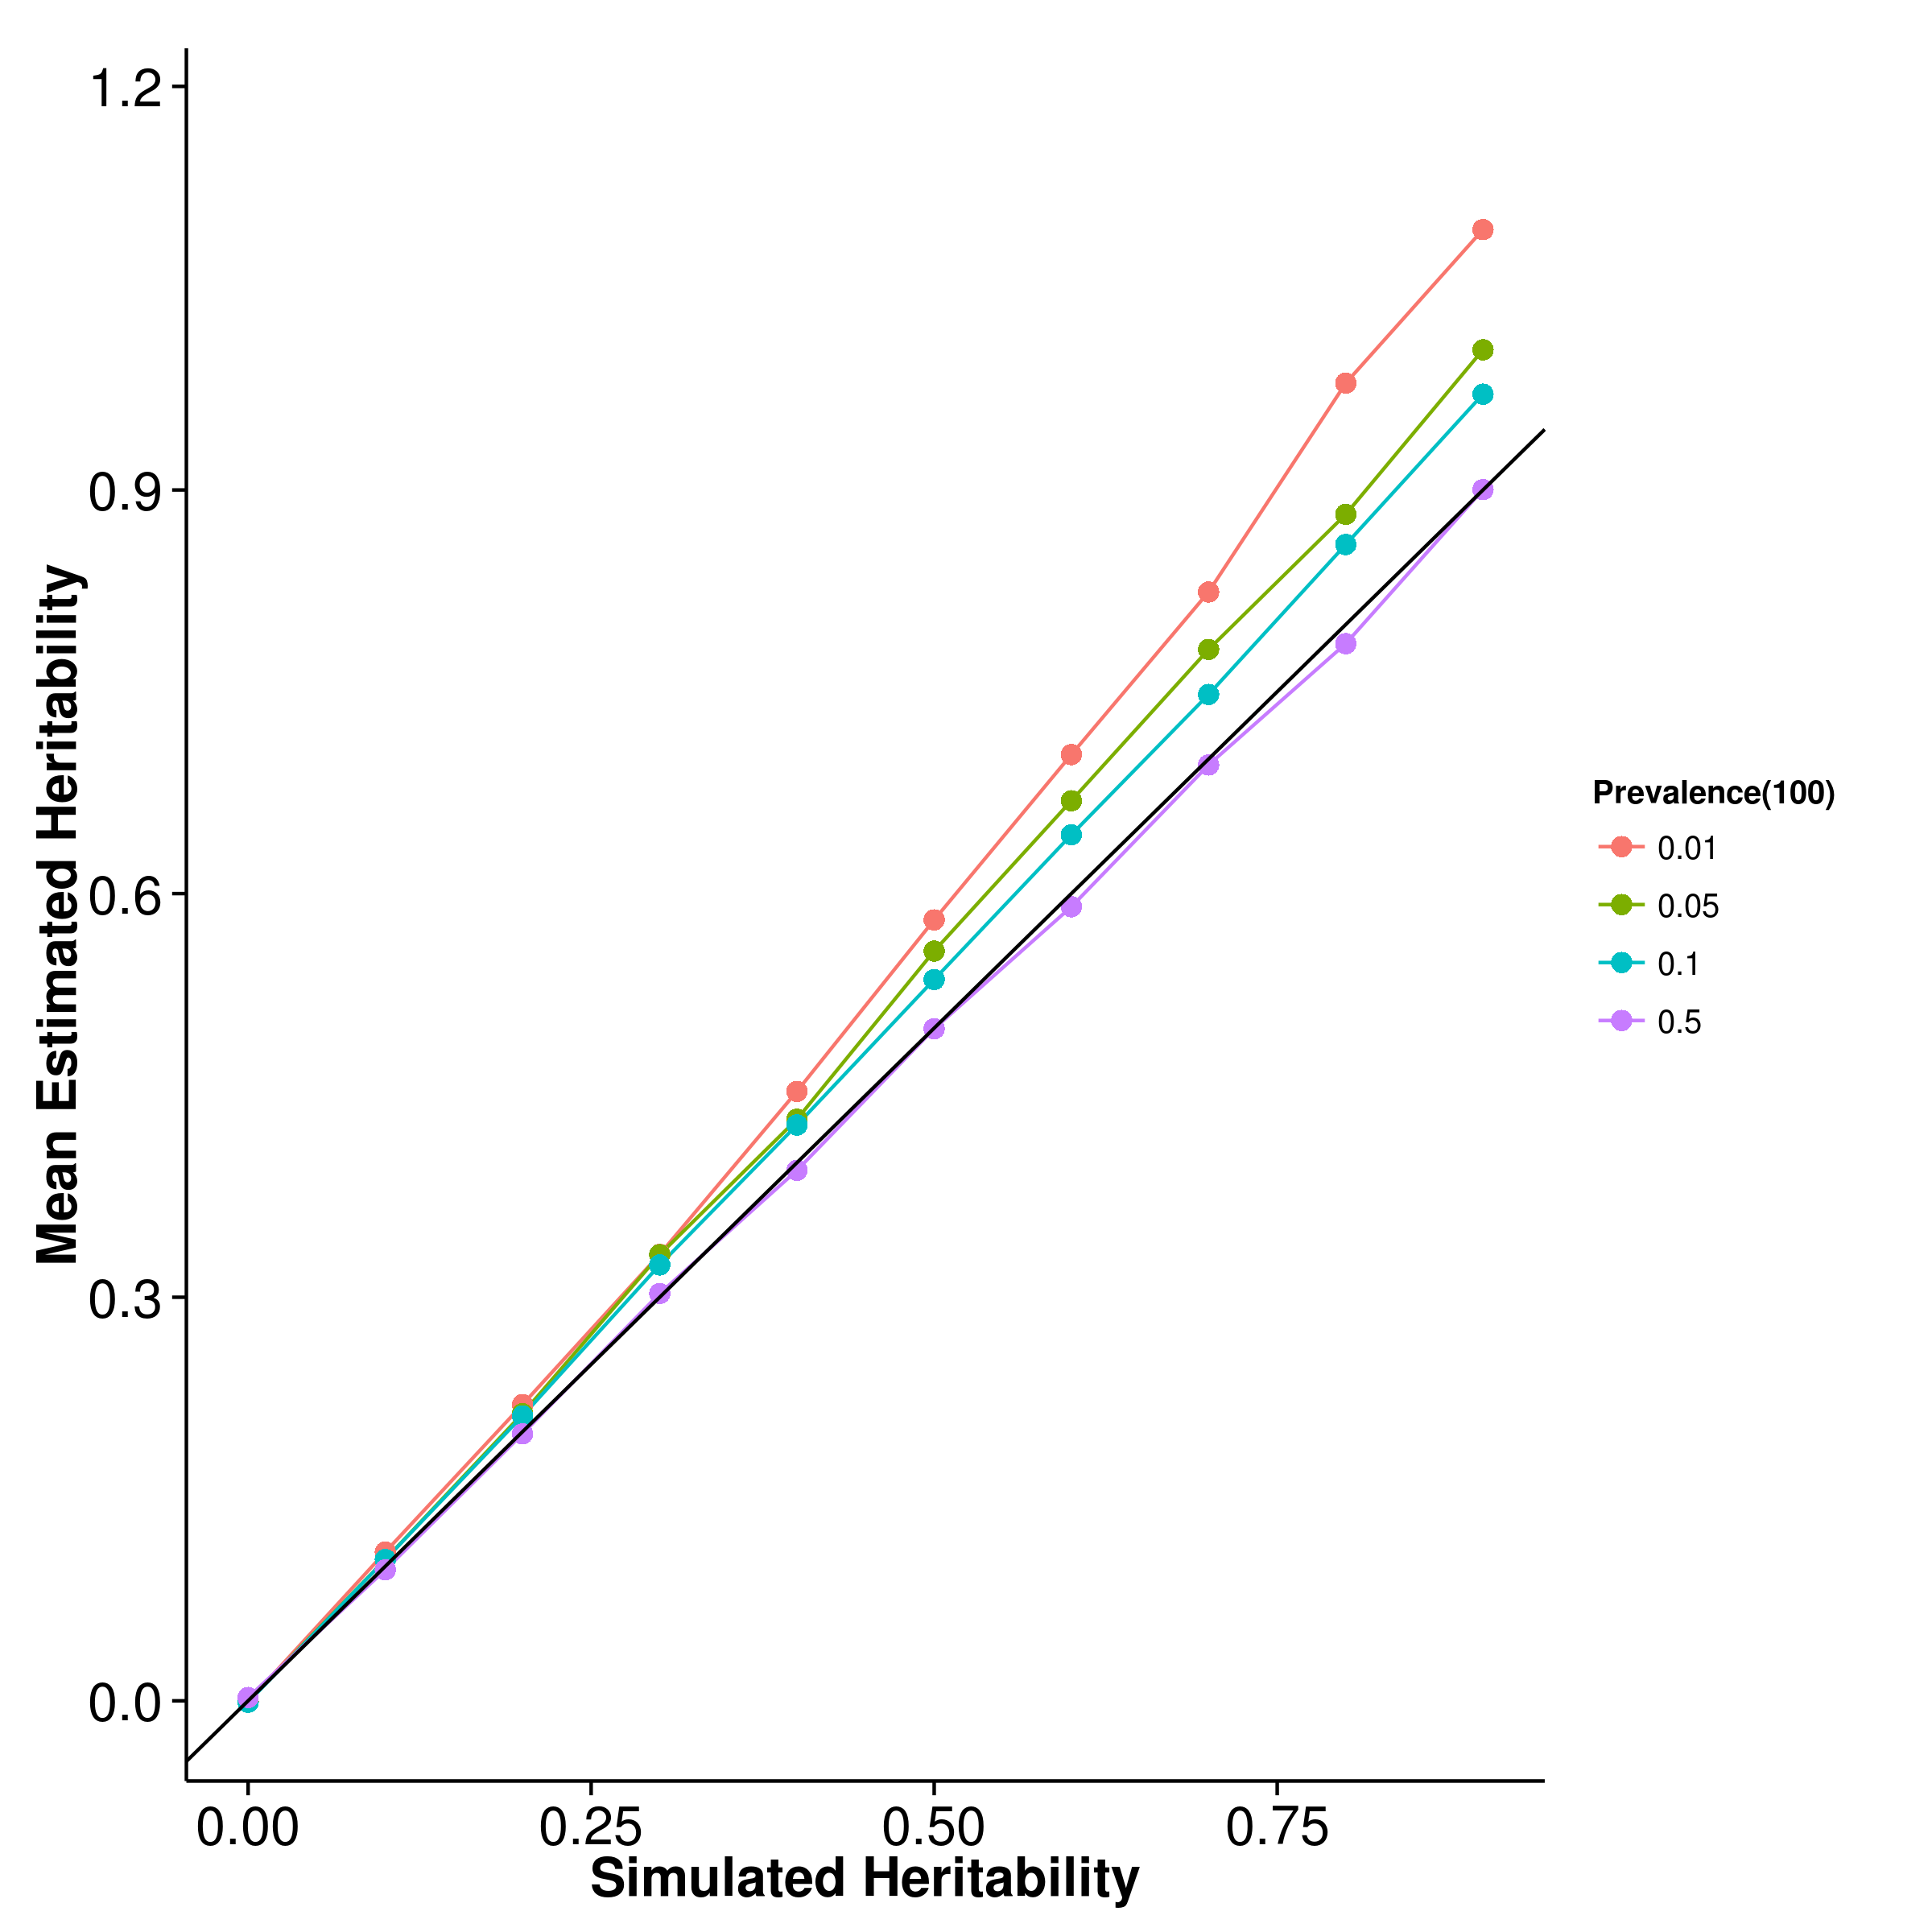 [GCTA] 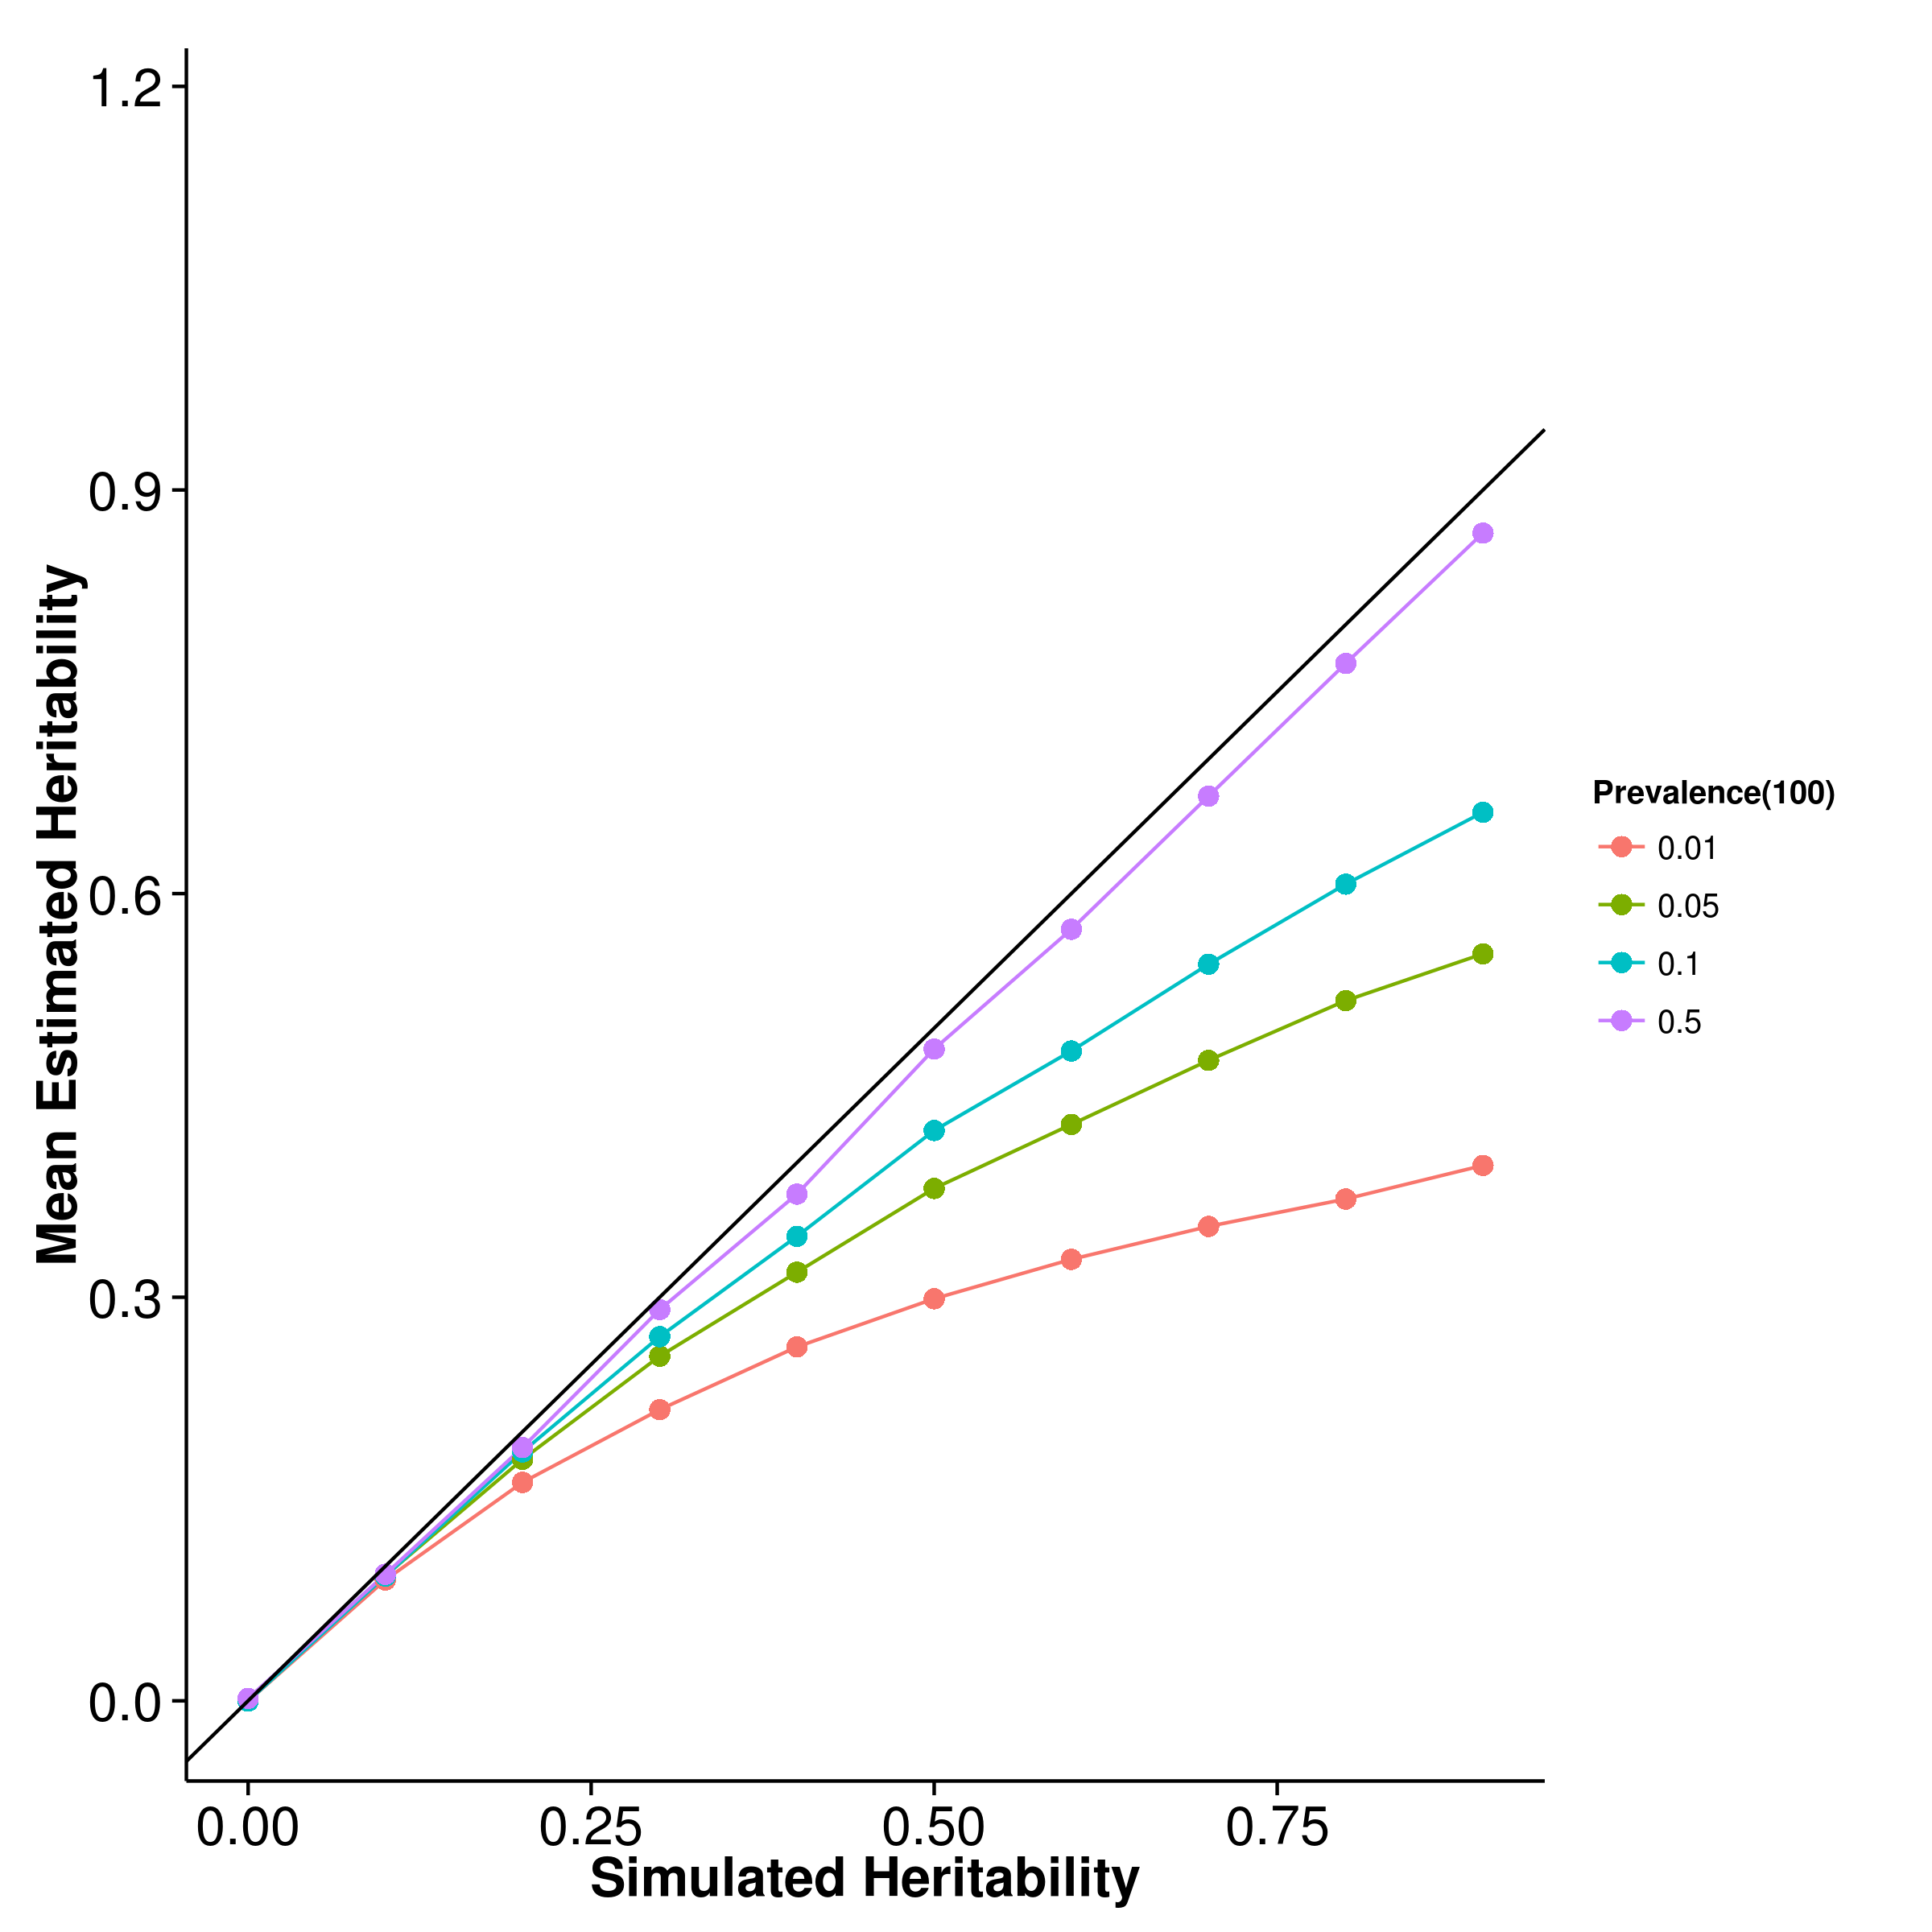

[LDSC with fix intercept] 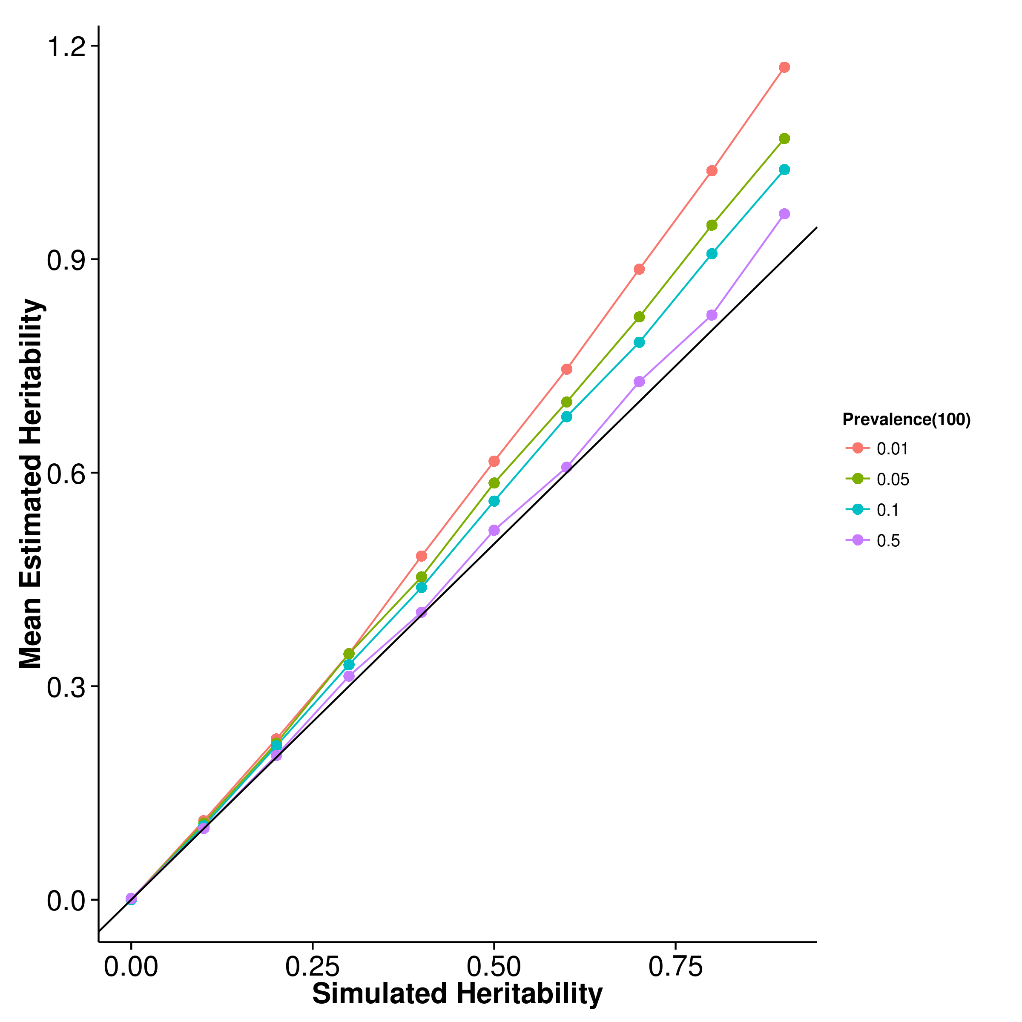 [LDSC with intercept estimation]

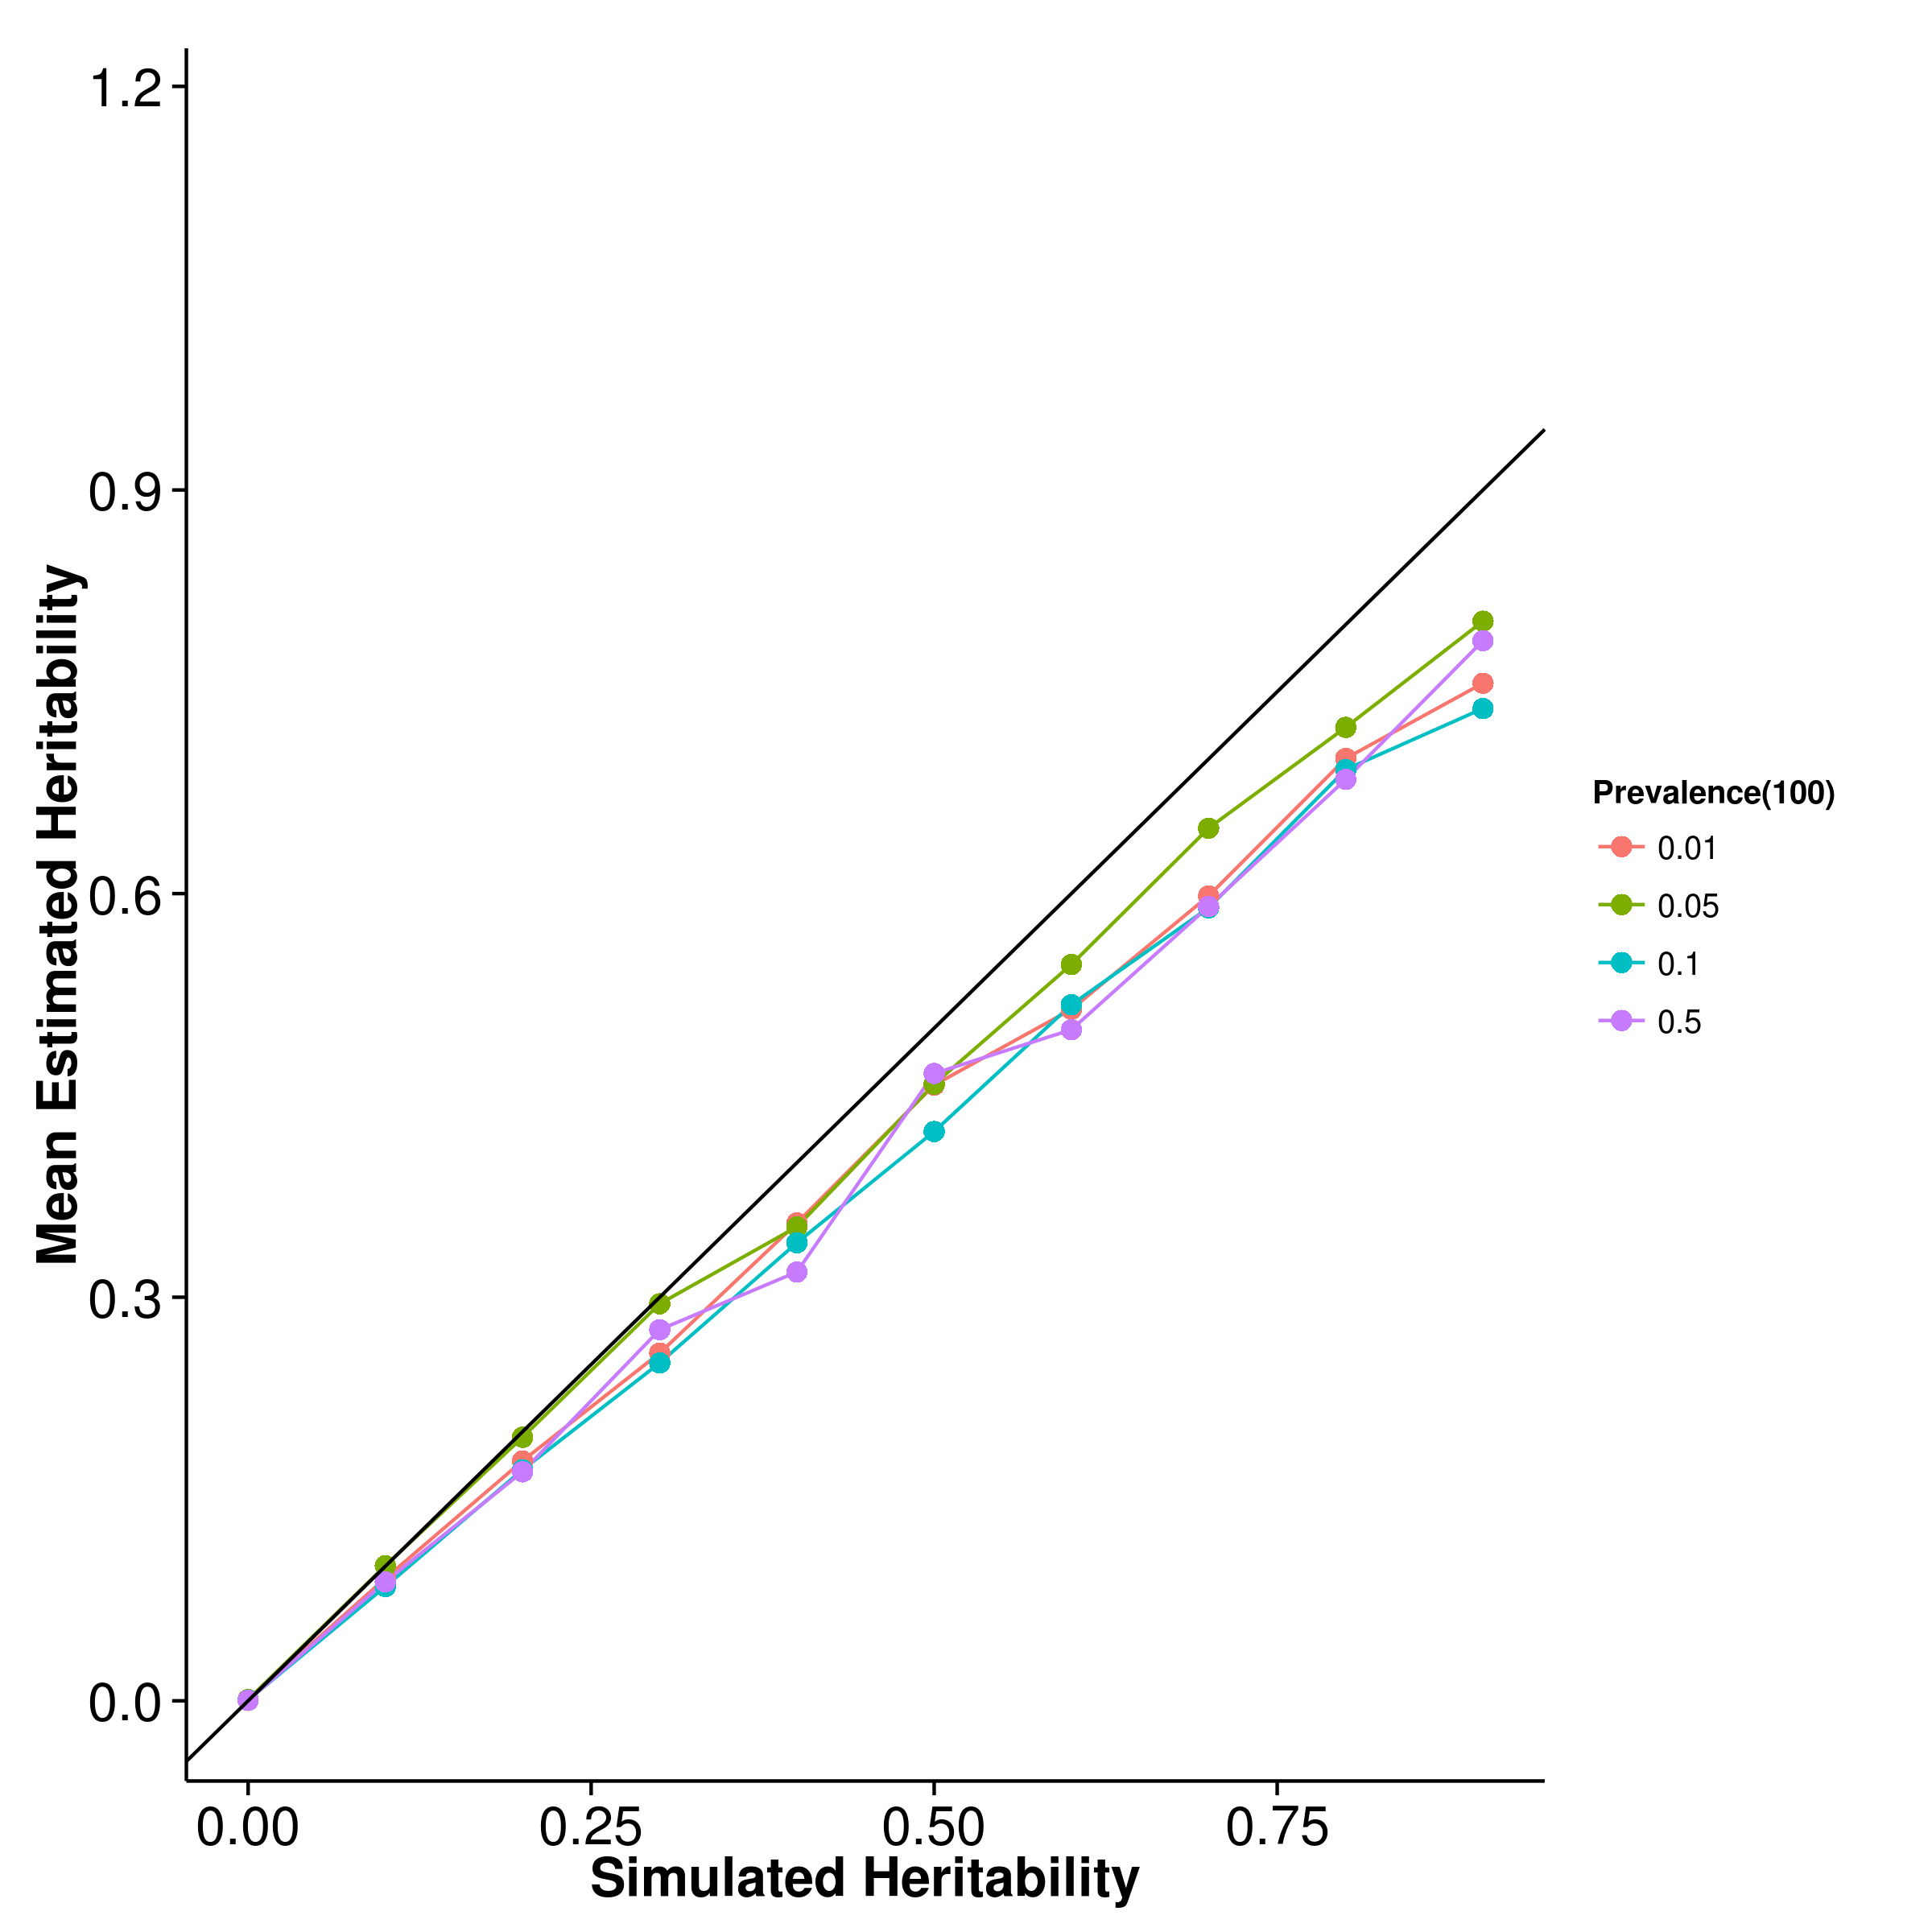

Figure 26: Mean of results from case control simulation with random effect size simulation with 100 causal SNP. The bias seems to be unaffected by the number of causal SNP and were the same as what was observed when there were 10 or 50 causal SNP.

[SHREK] 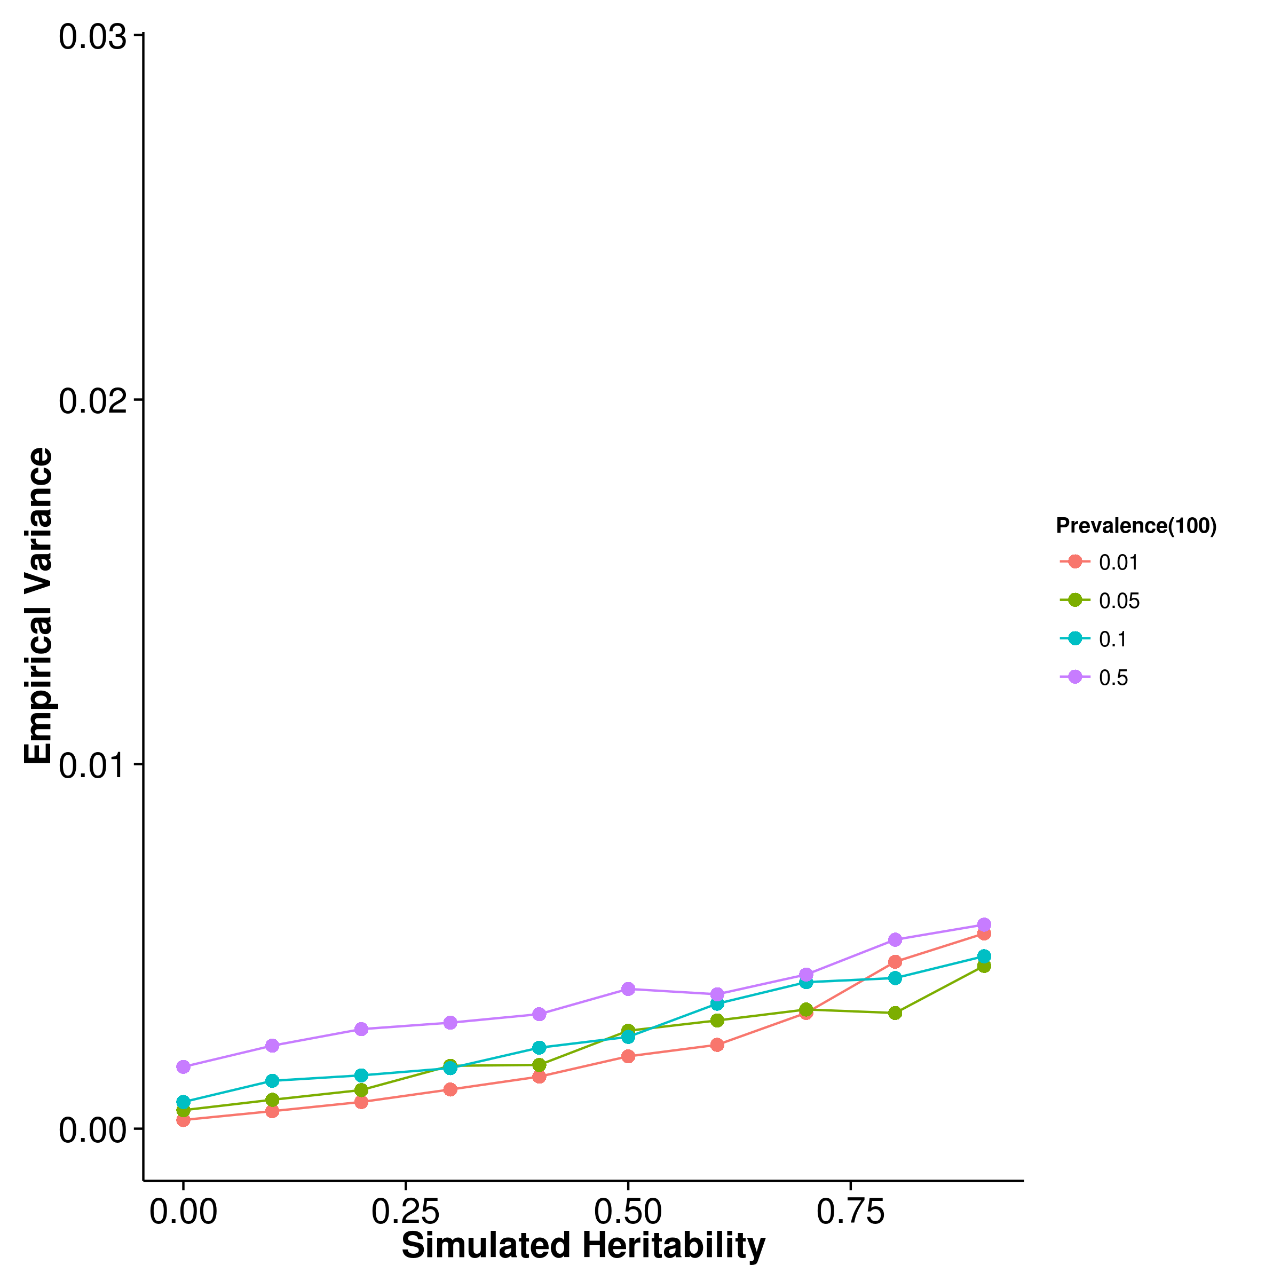 [GCTA] 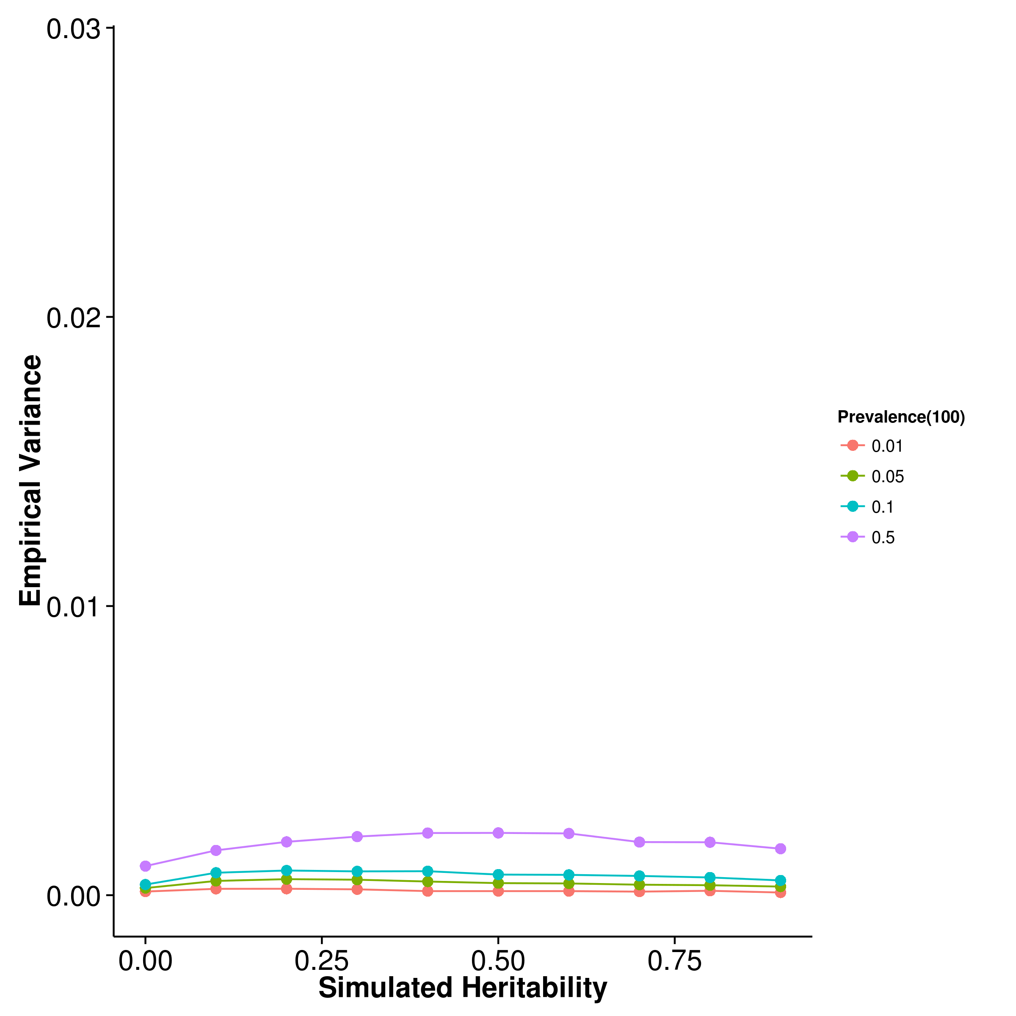

[LDSC with fix intercept] 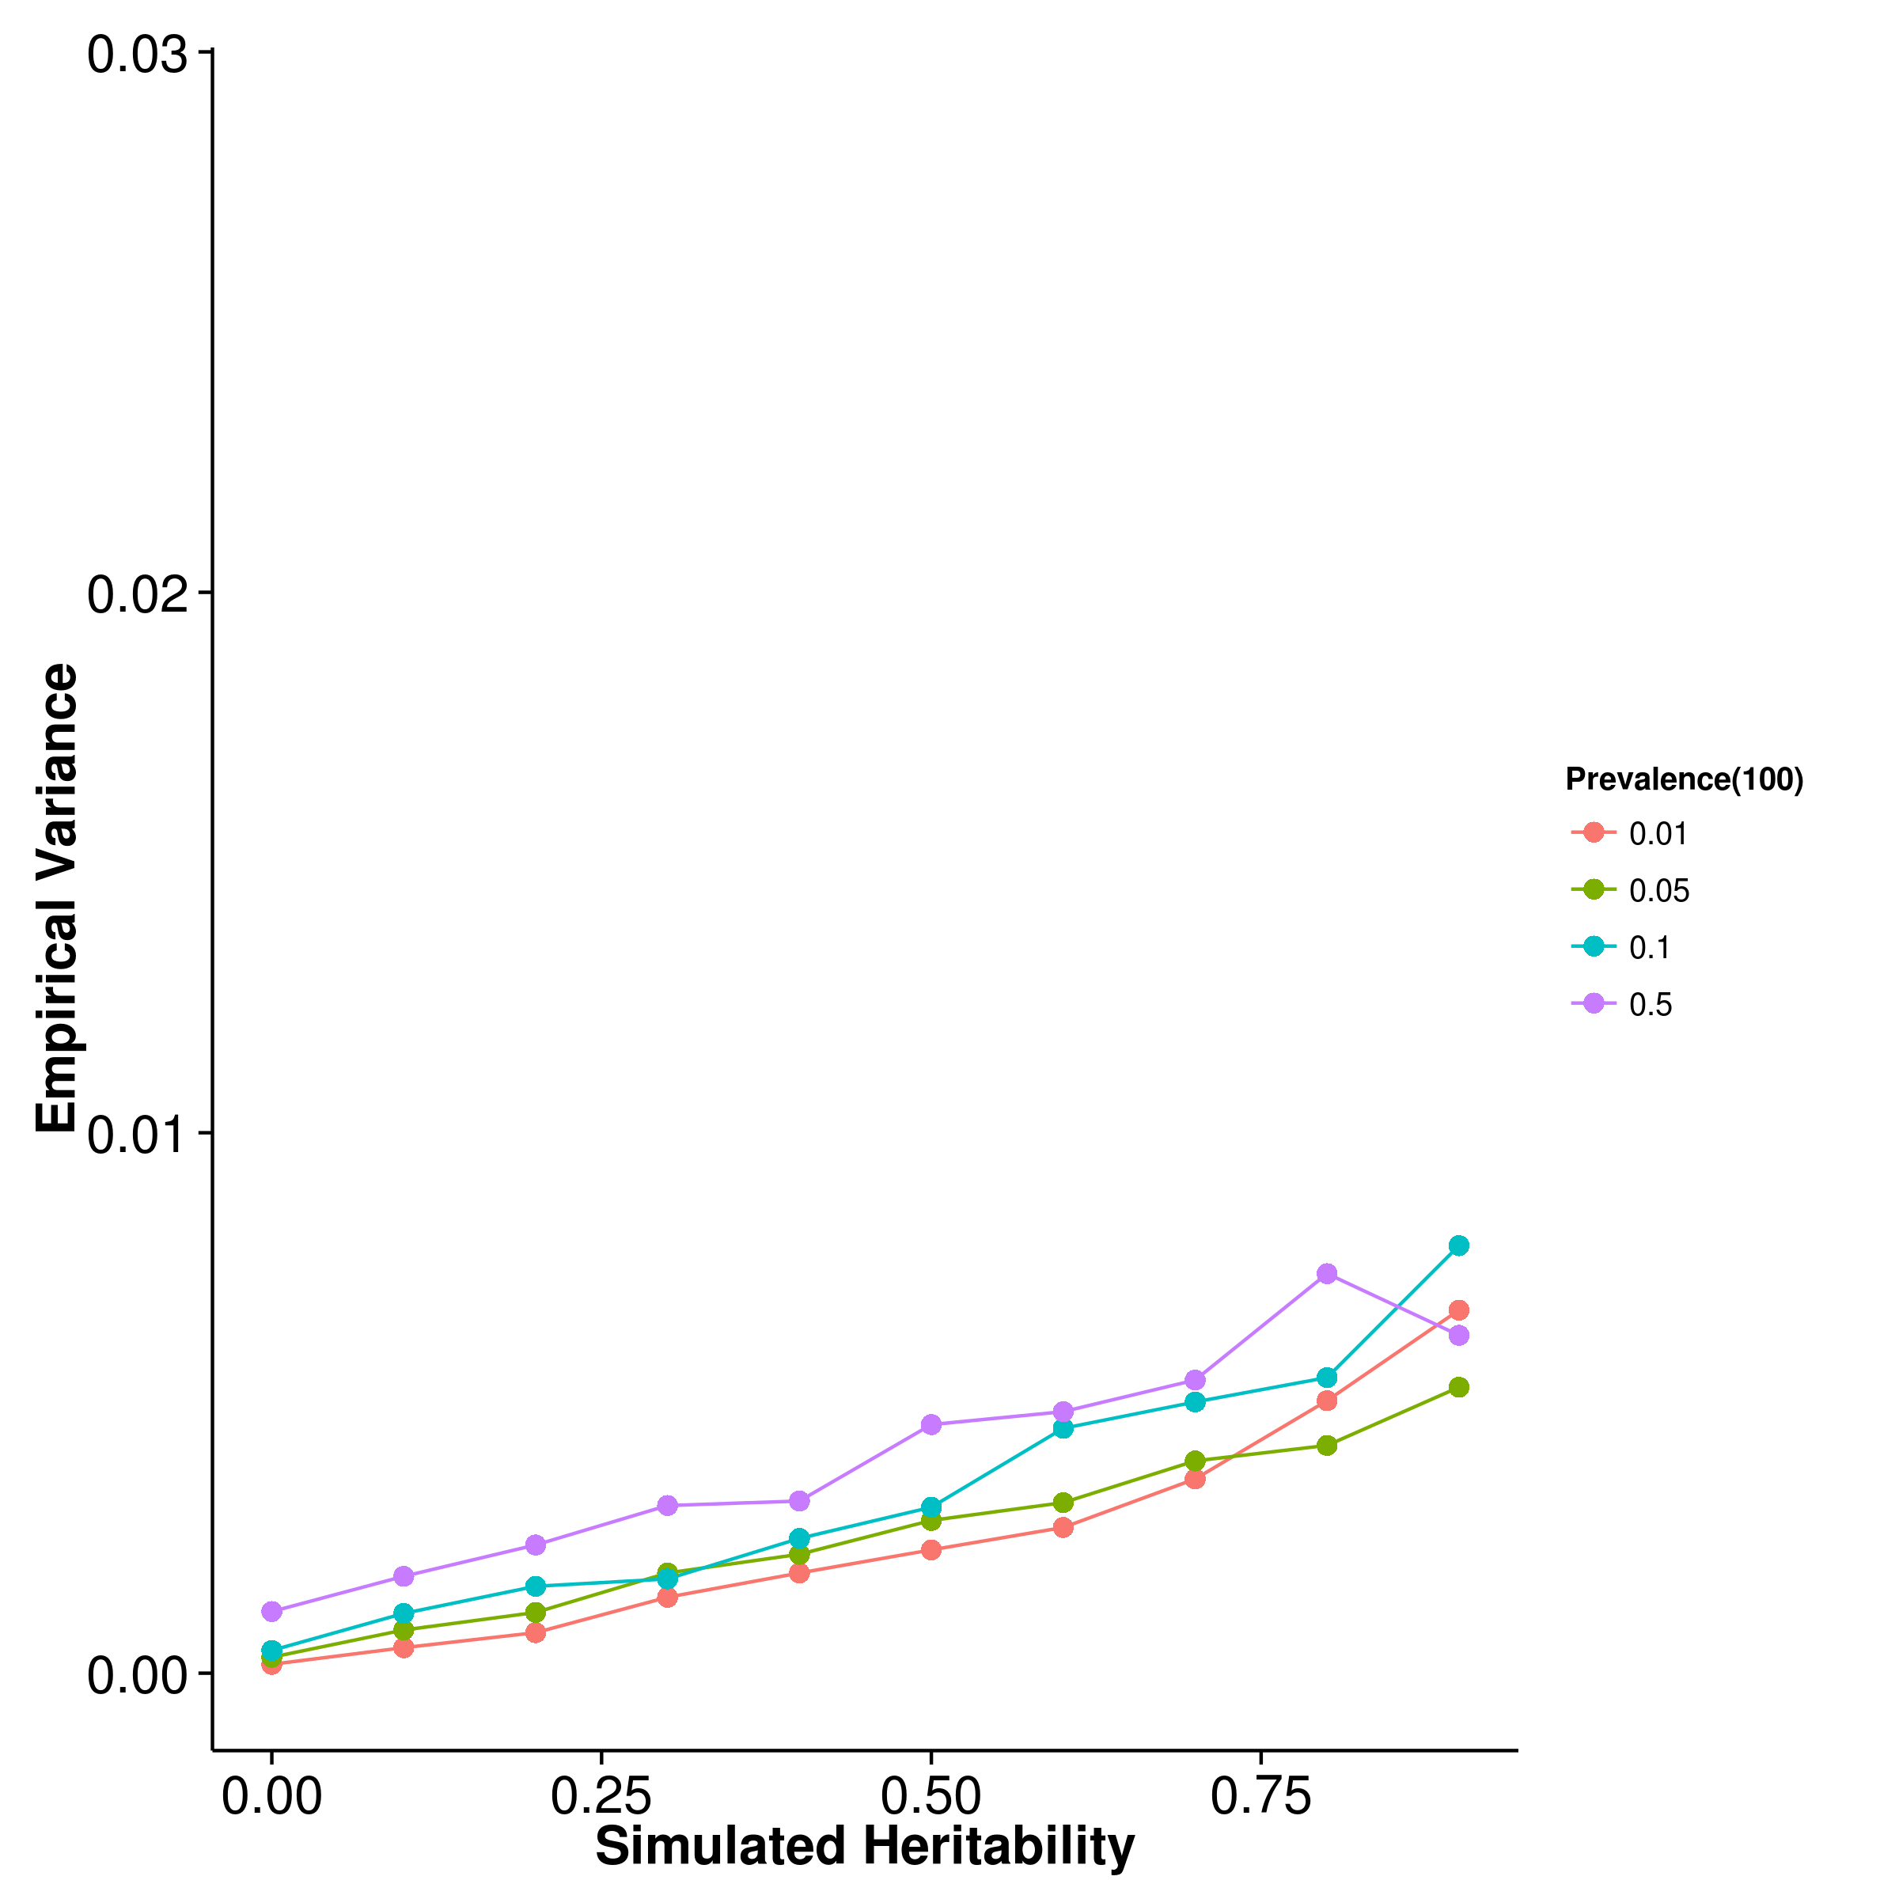 [LDSC with intercept estimation]

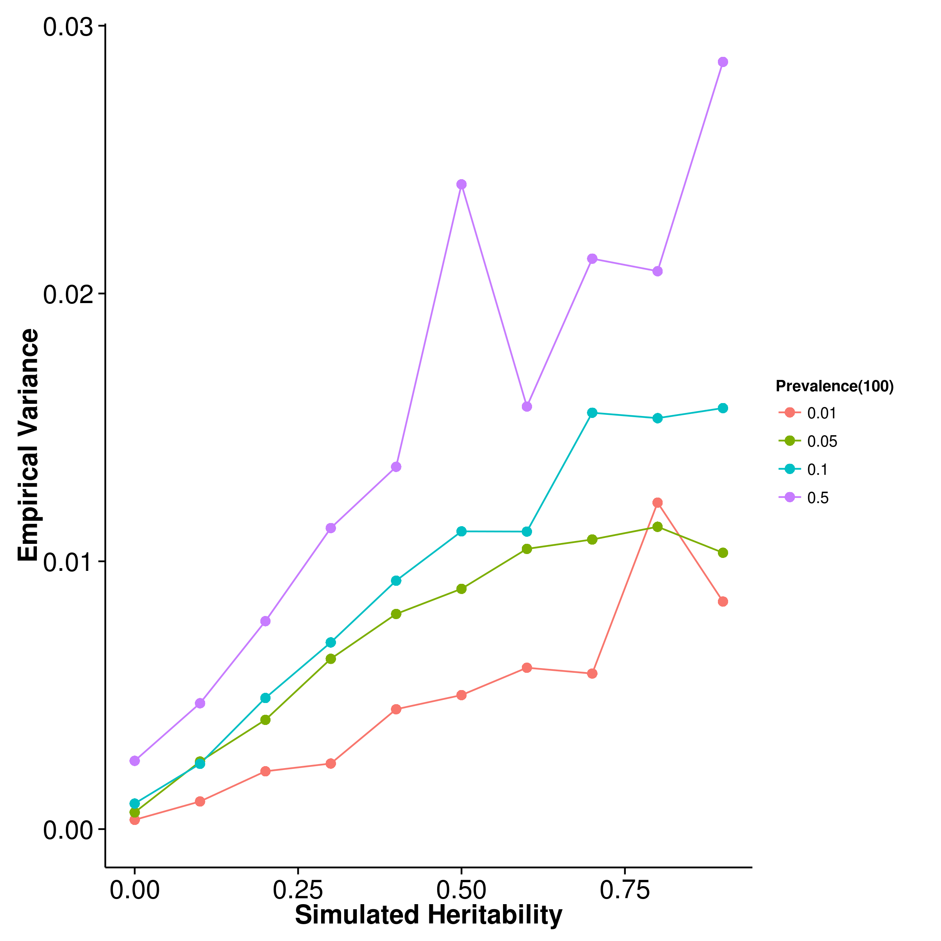

Figure 27: Variance of results from case control simulation with random effect size simulation with 100 causal SNP. As the number of causal SNP increased to 100, the relationship between the population prevalence and the empirical variance of the algorithms become clear where as the population prevalence increases, the empirical variance of all algorithm increases. Again, ldsc with intercept estimation has the largest variation of all the algorithms and the empirical variance of ldsc with fix intercept is only slightly higher than that of shrek.

[SHREK] 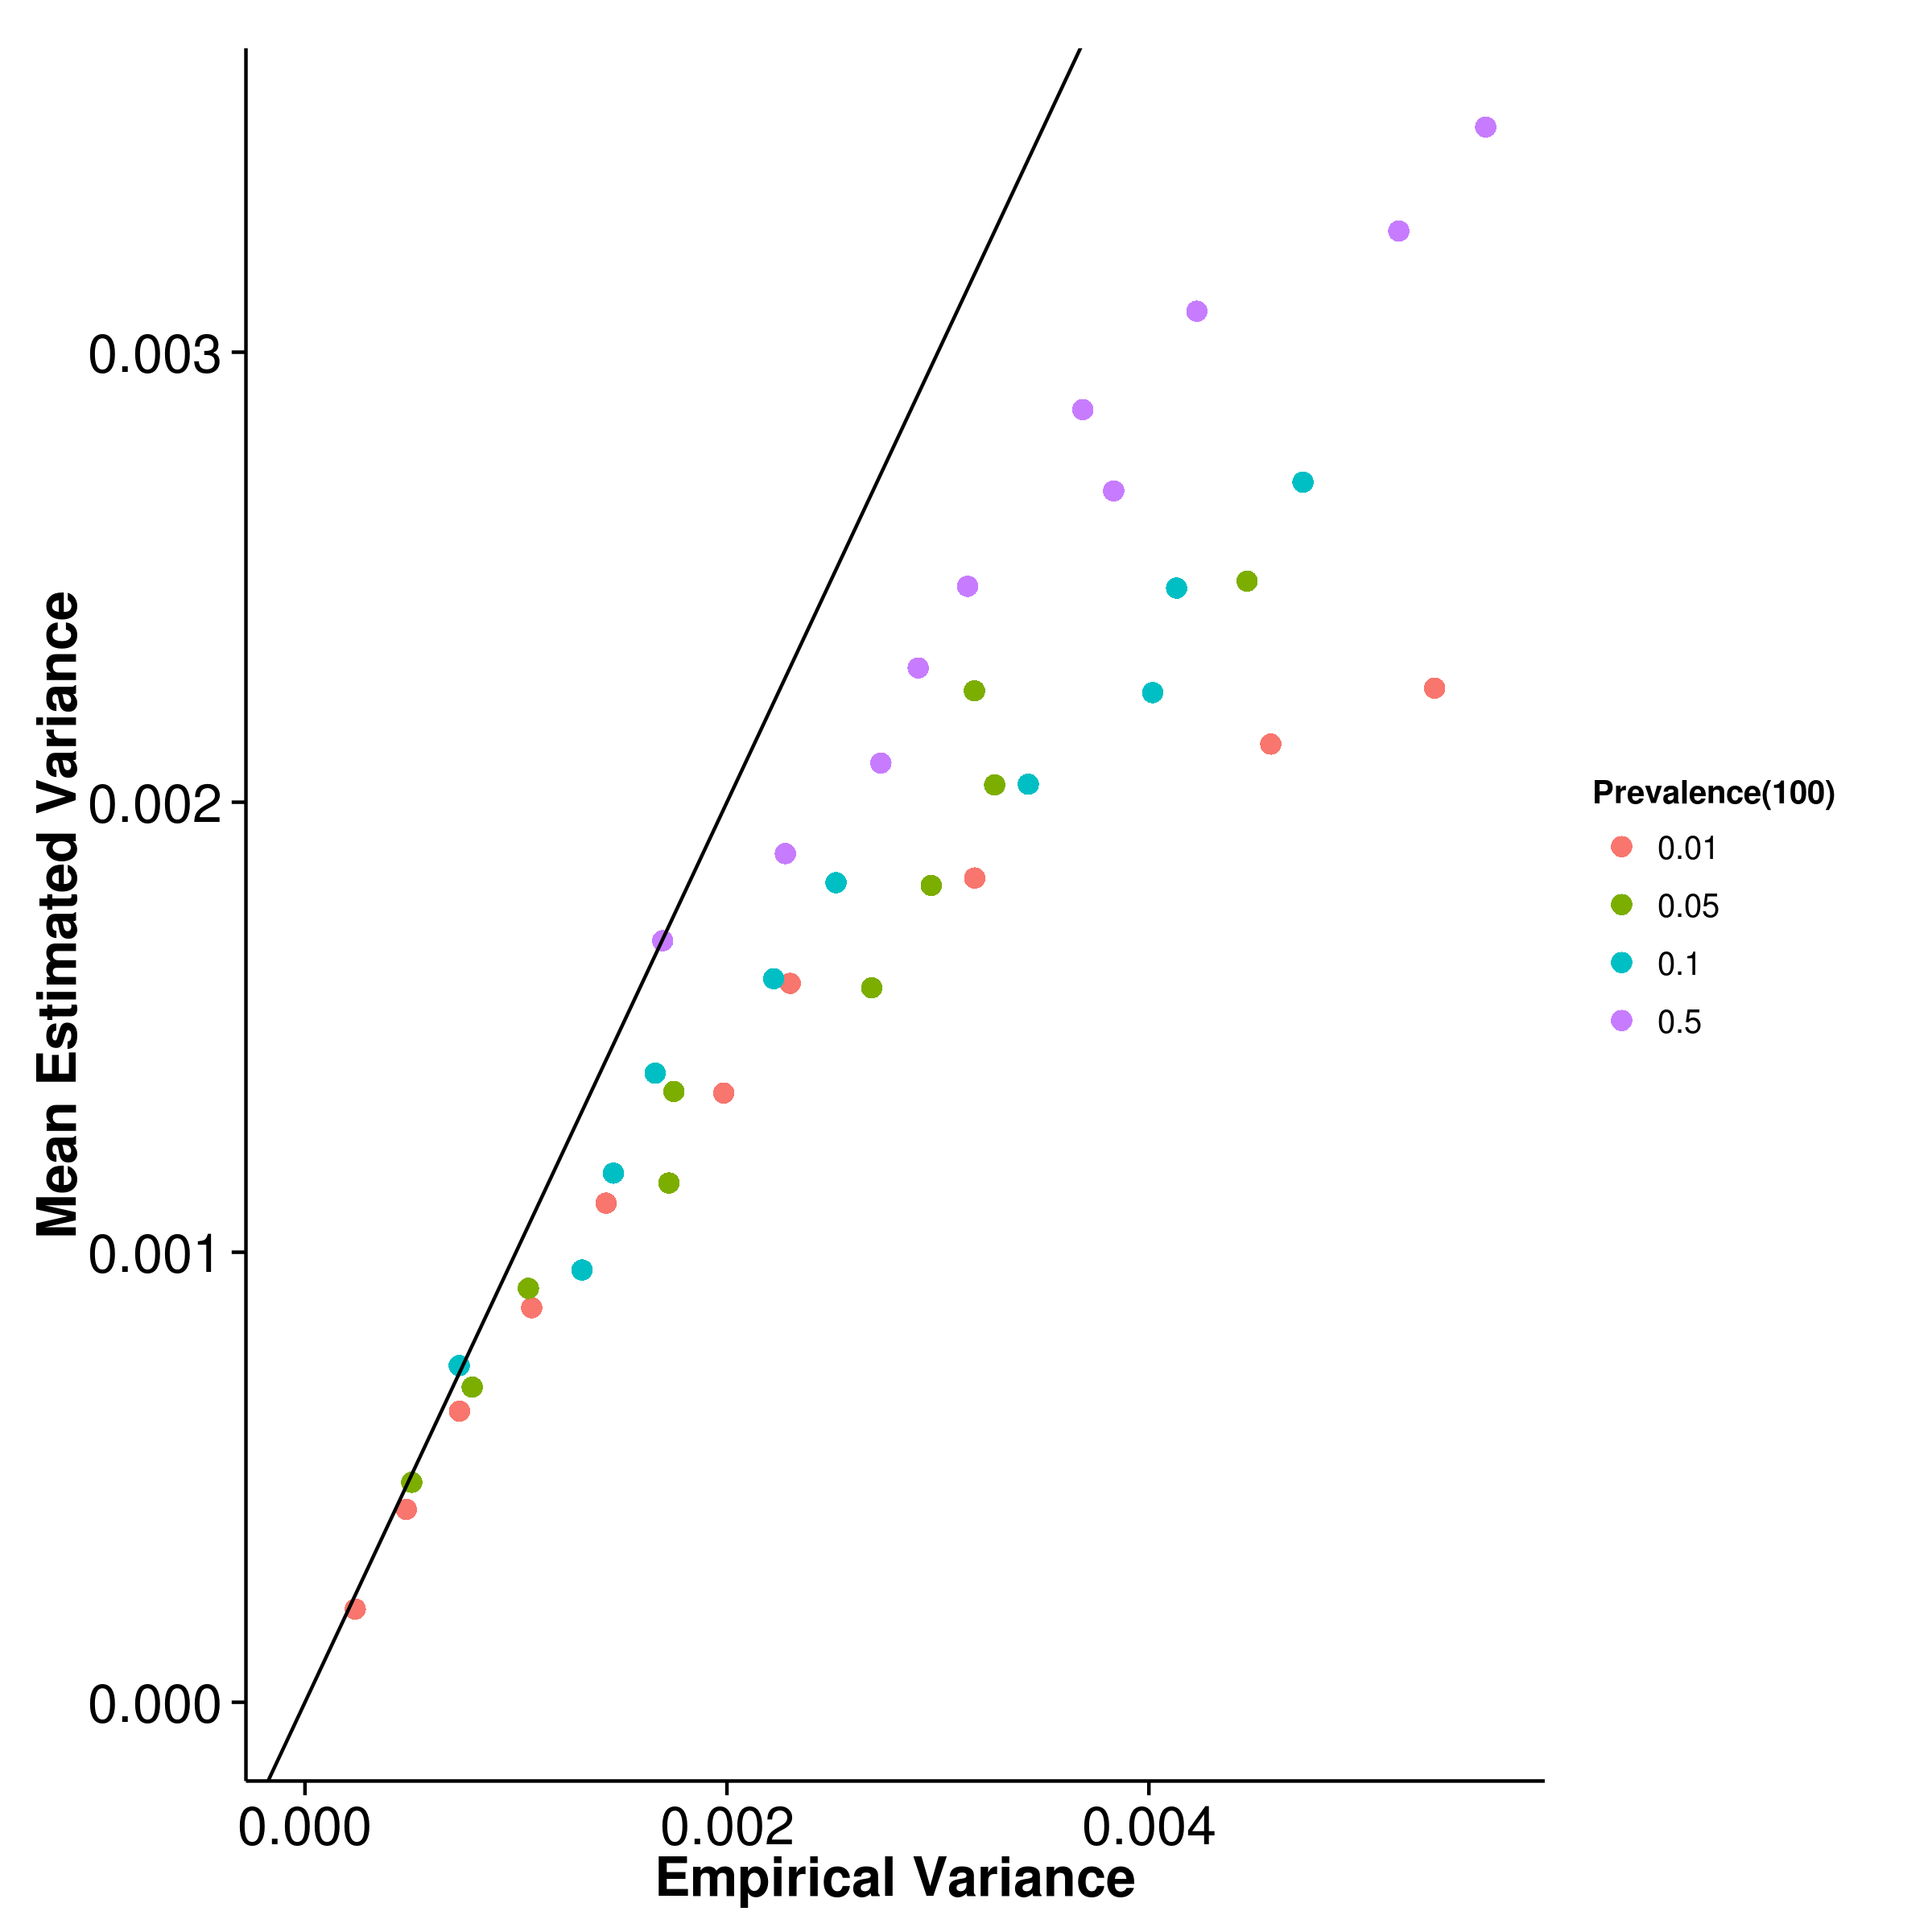 [GCTA] 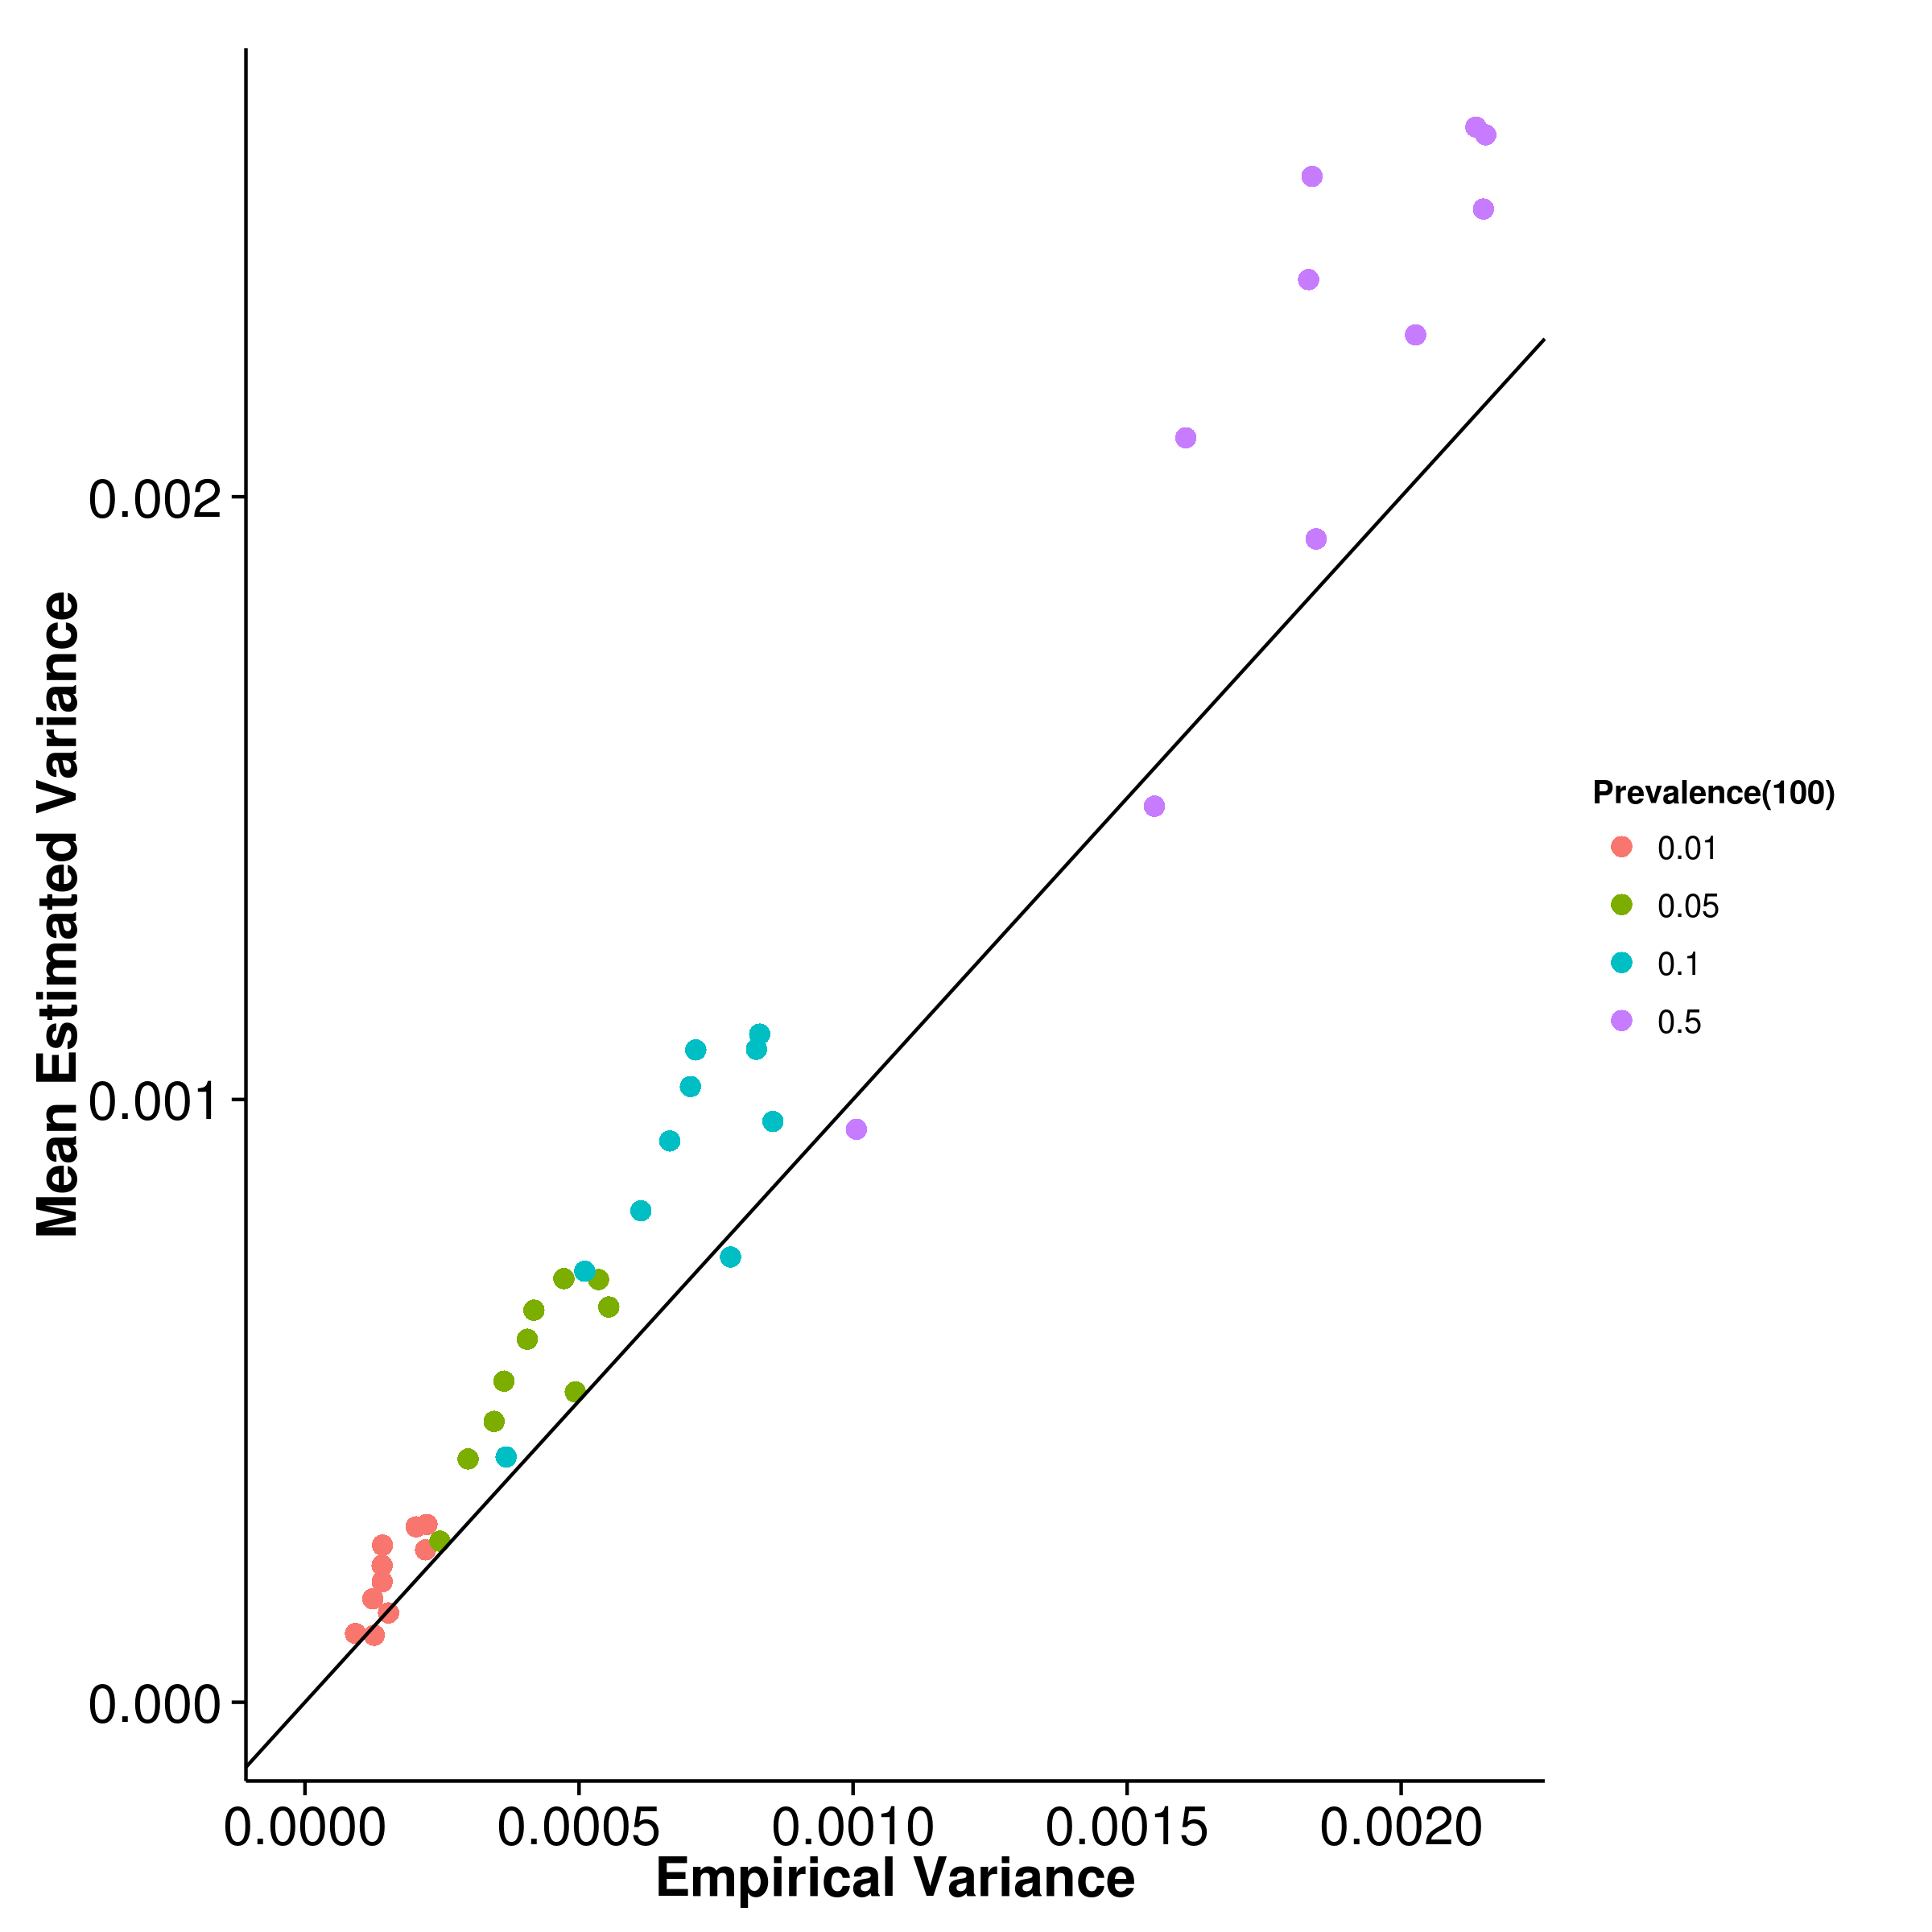

[LDSC with fix intercept] 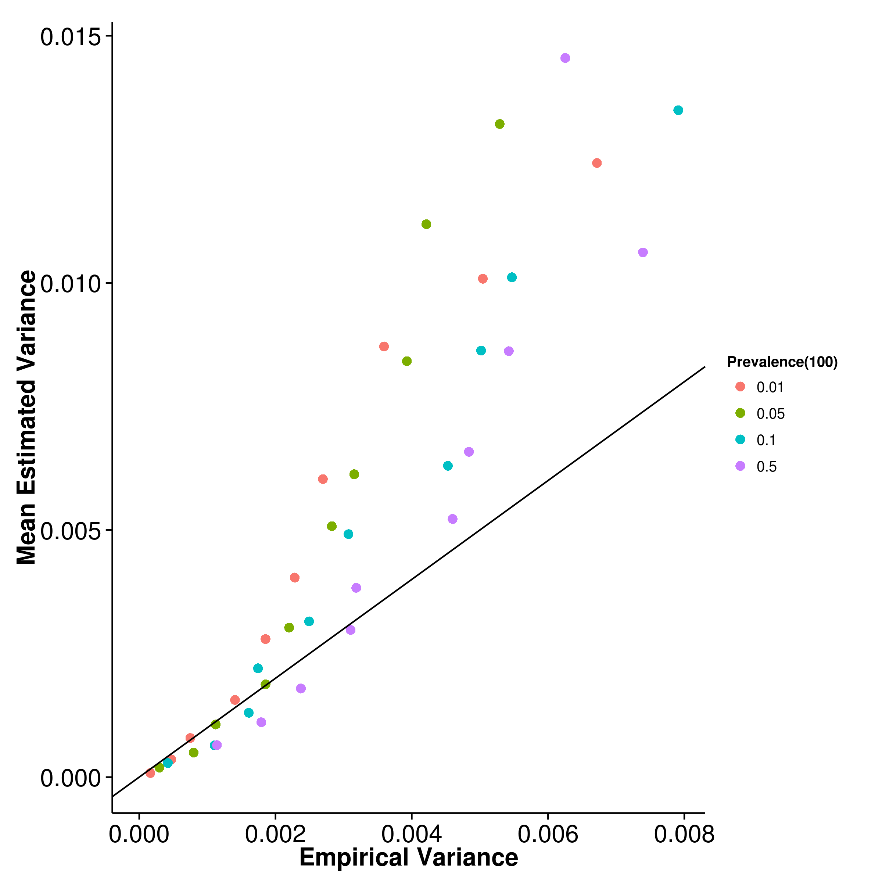 [LDSC with intercept estimation]

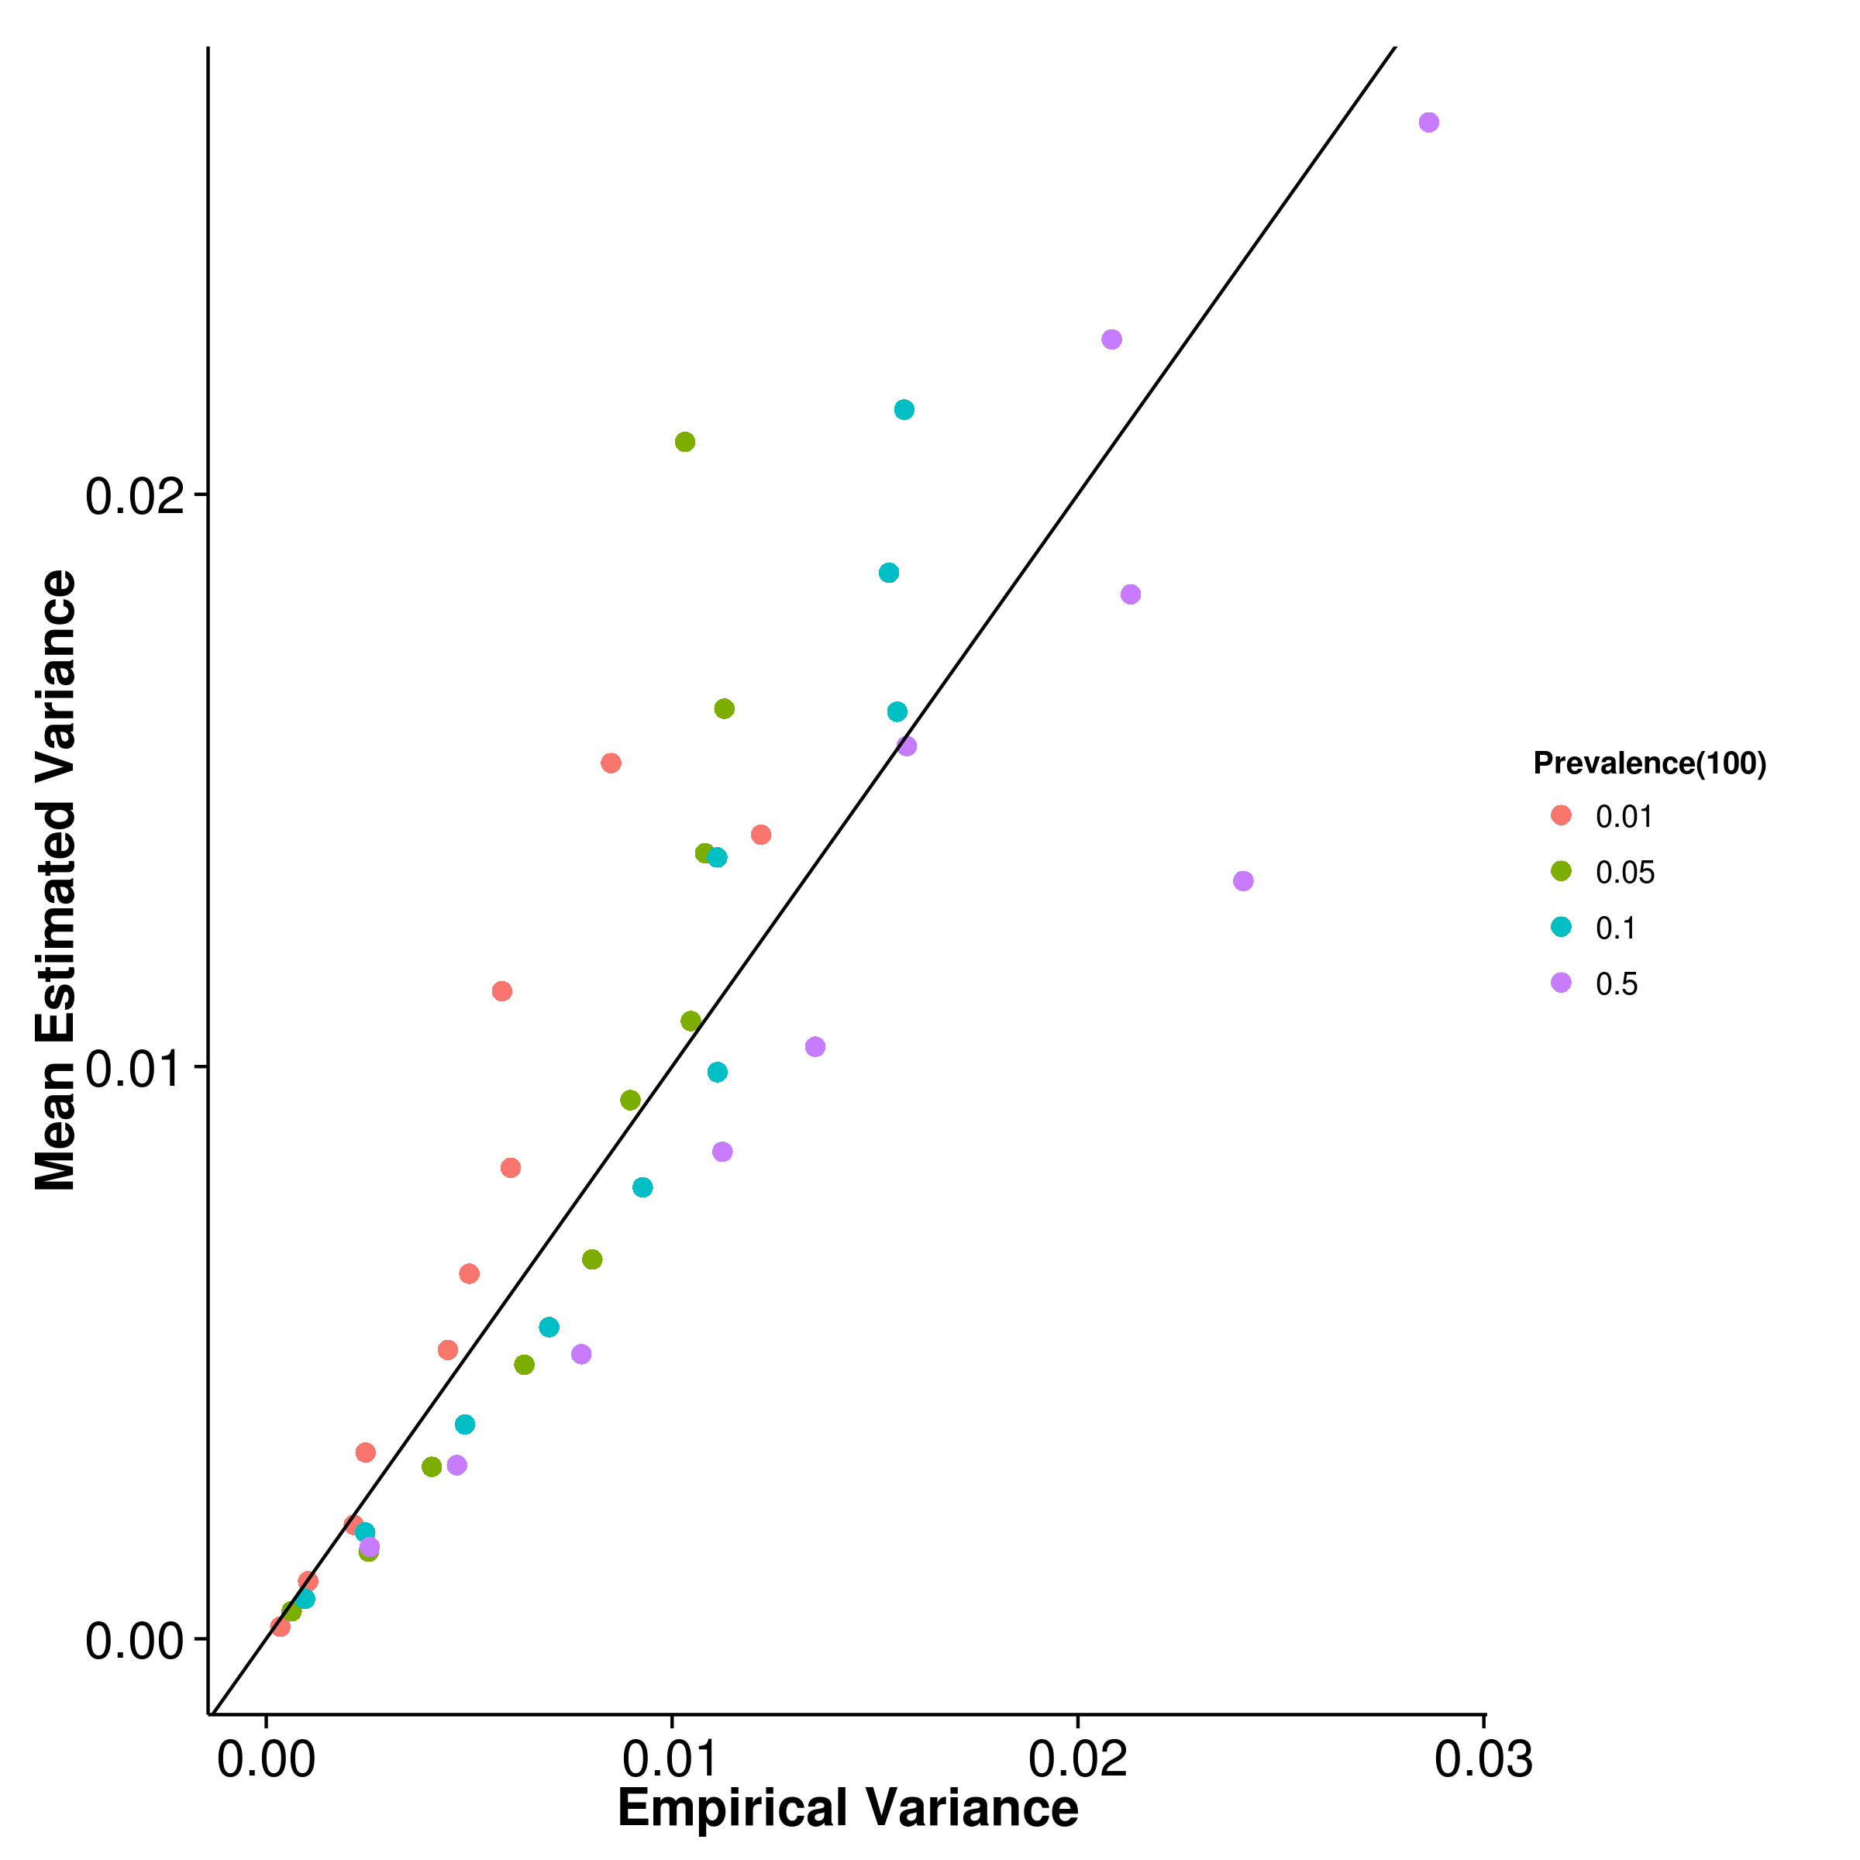

Figure 28: Estimated variance of results from case control simulation with random effect size simulation when compared to empirical variance when 100 causal SNP was simulated. Once again, shrek underestimated its empirical variance and ldsc with fixed intercept overestimates its empirical variance. However, the magnitude of overestimation of ldsc with fixed intercept decreased when compared to previous conditions.

[SHREK] 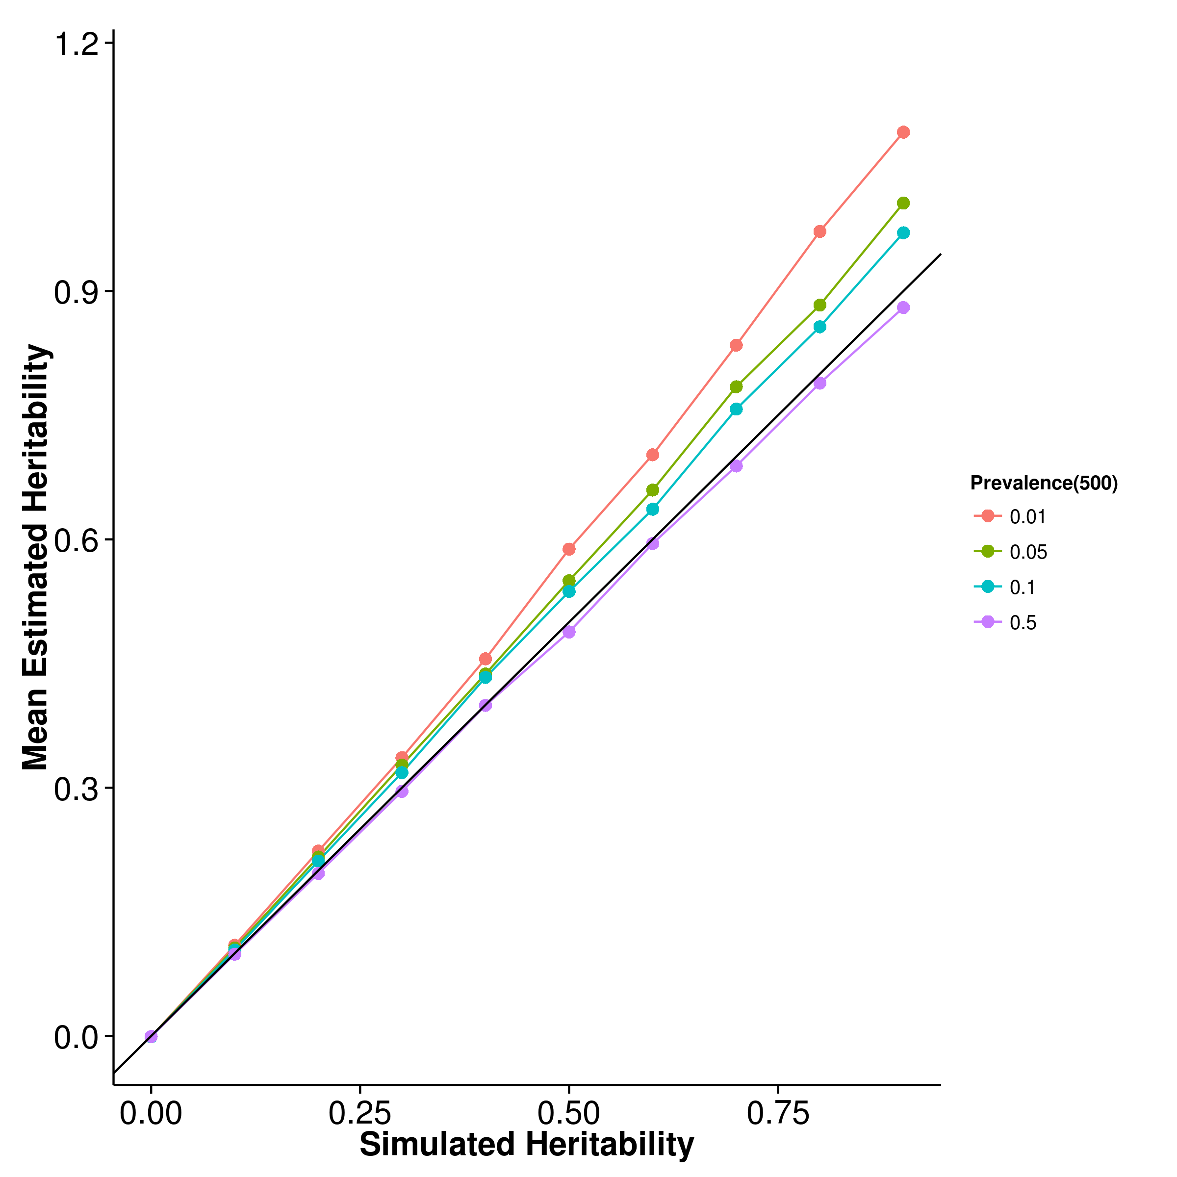 [GCTA] 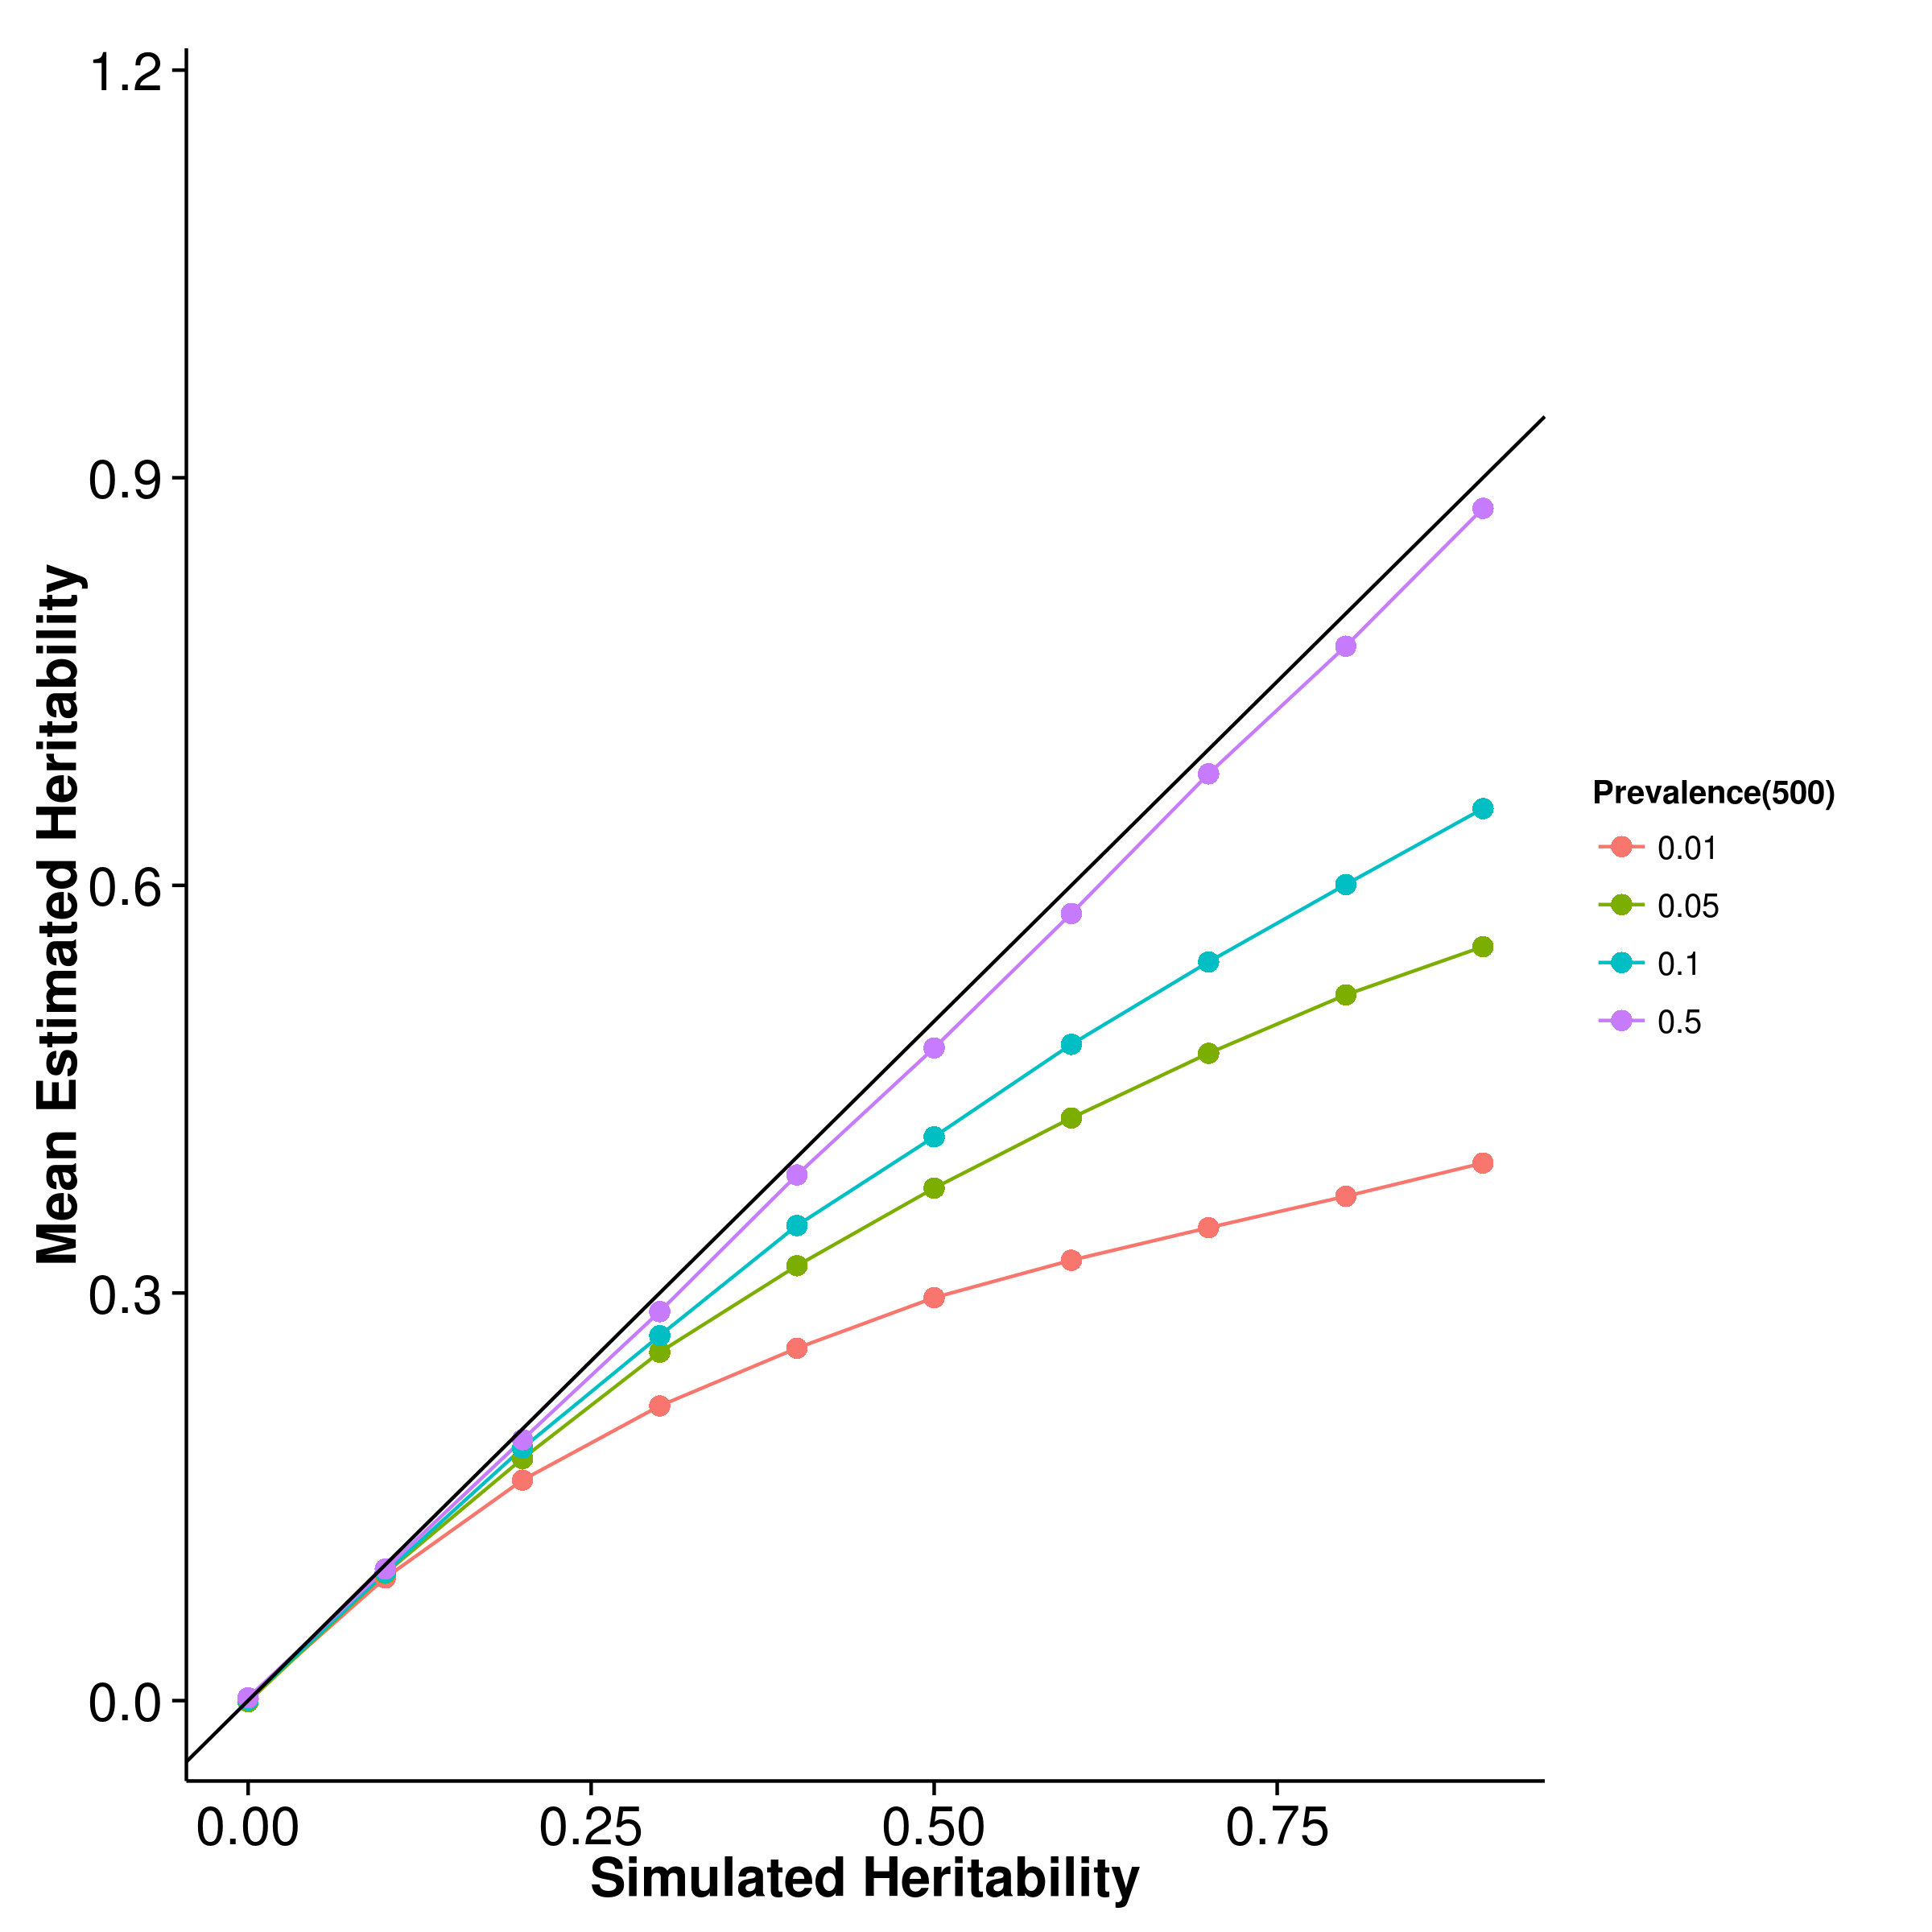

[LDSC with fix intercept] 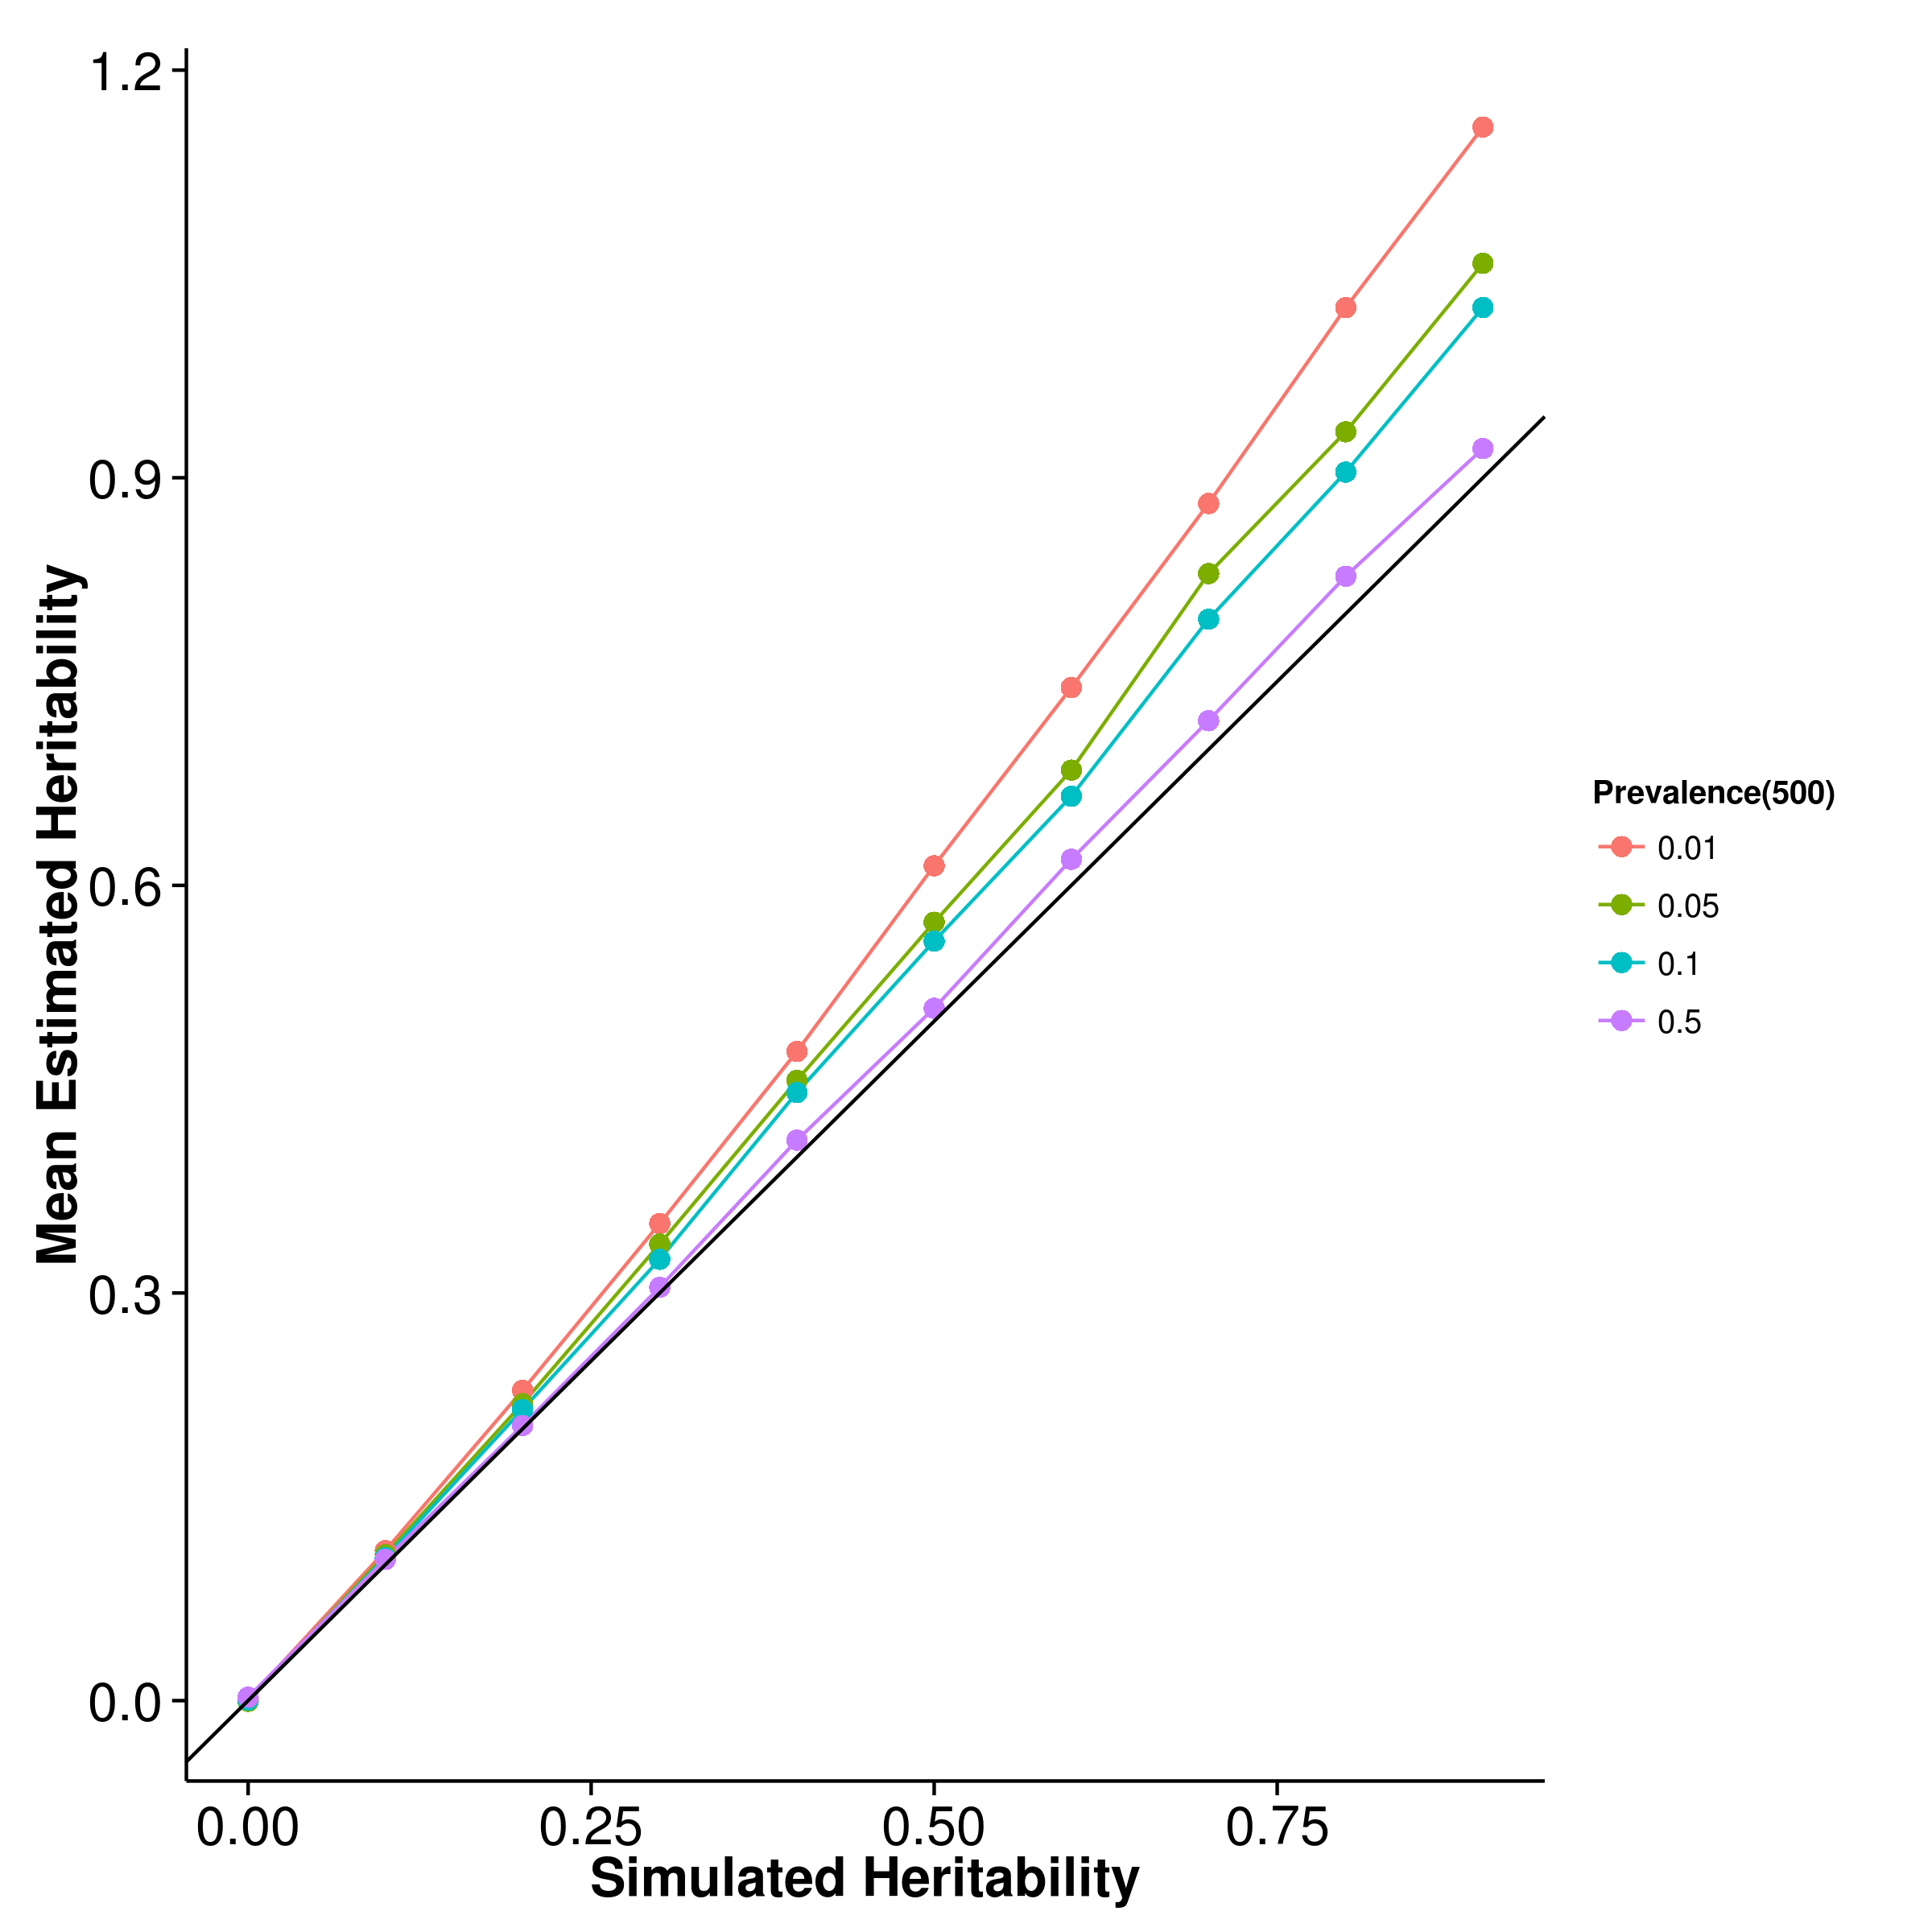 [LDSC with intercept estimation]

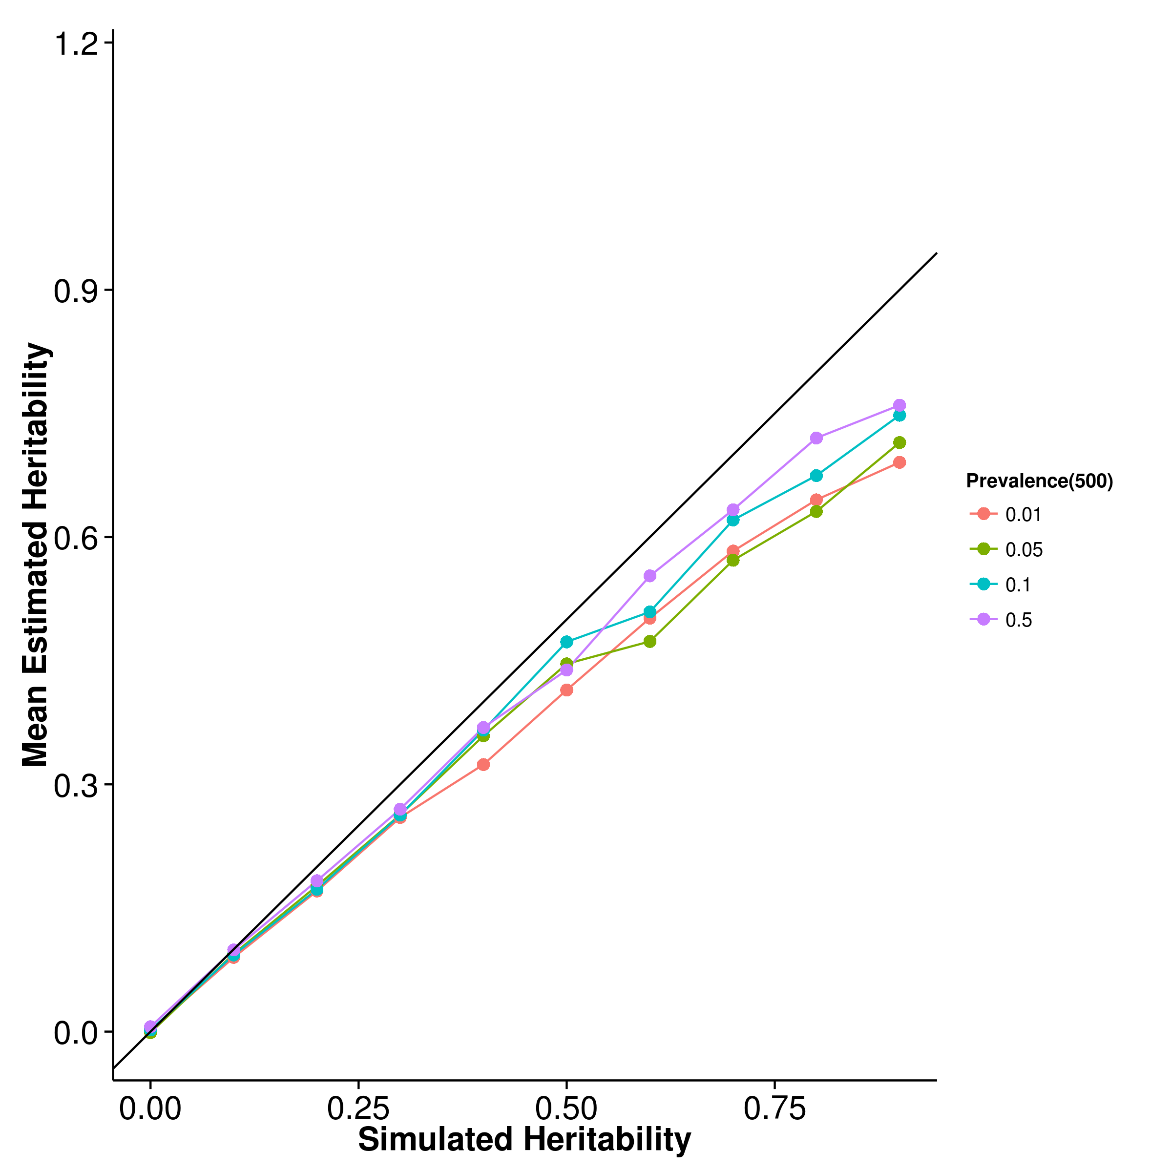

Figure 29: Mean of results from case control simulation with random effect size simulation with 500 causal SNP. Again, a clear pattern of underestimation was observed for gcta and ldsc with intercept estimation whereas estimations from shrek and ldsc with fixed intercepts tends to be upwardly biased, with the magnitude of bias increases as the population prevalence decreases.

[SHREK] 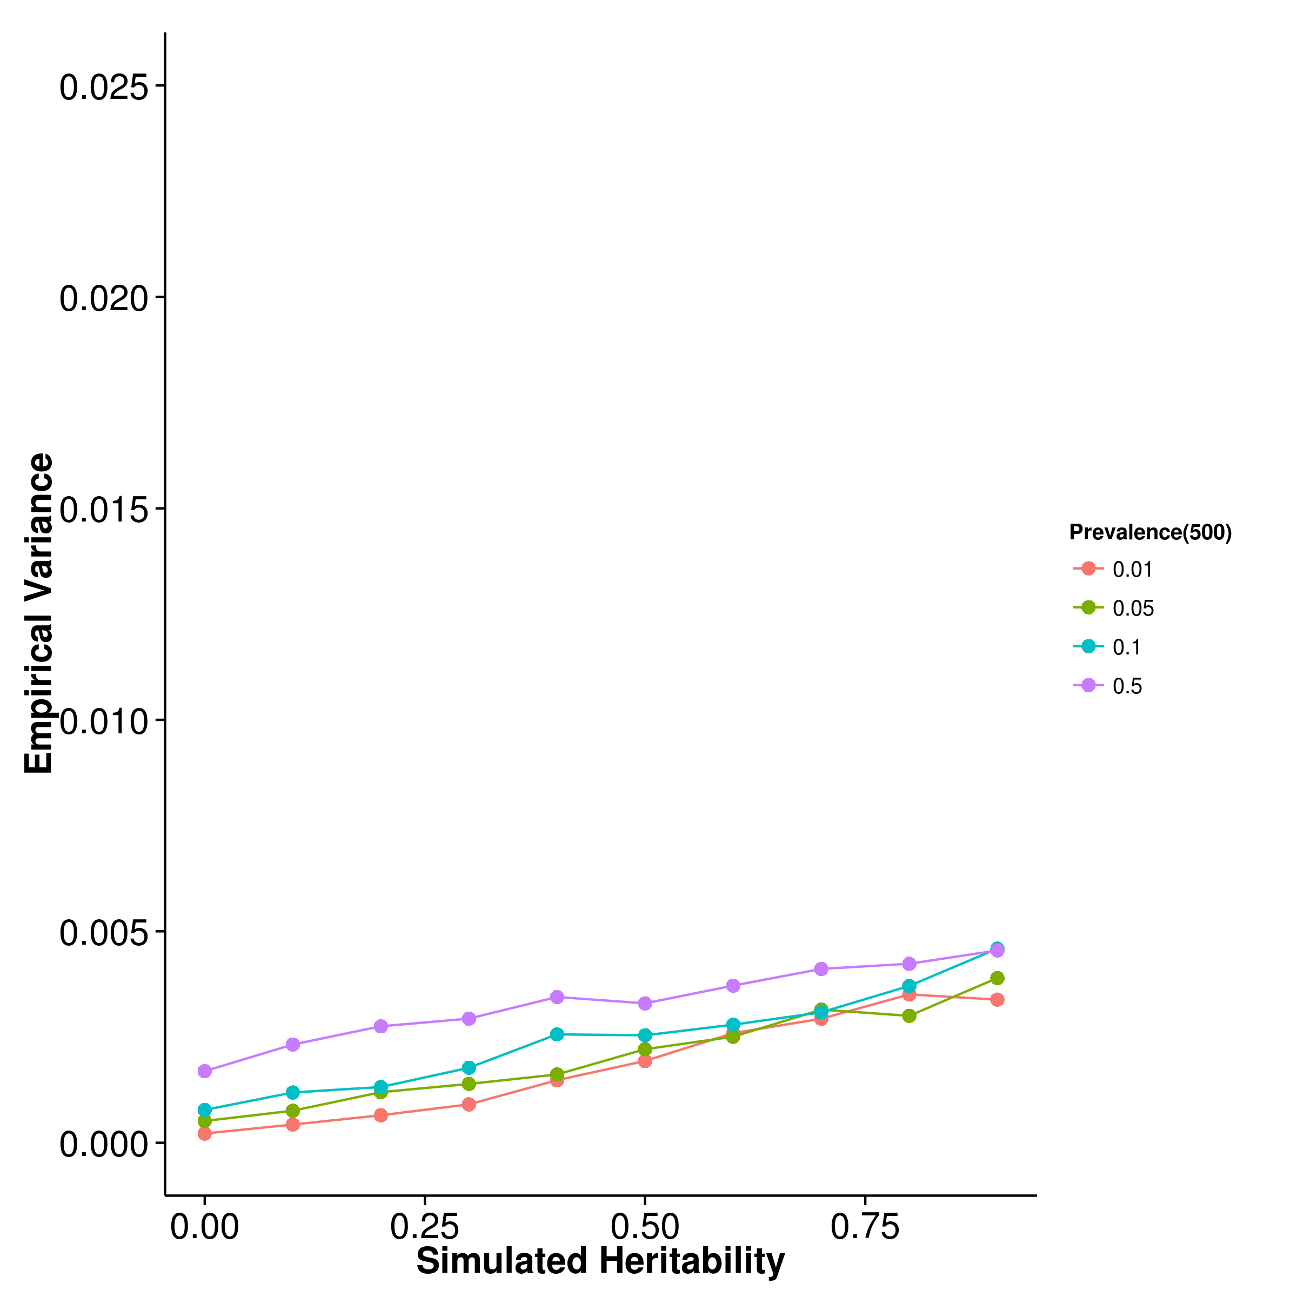 [GCTA] 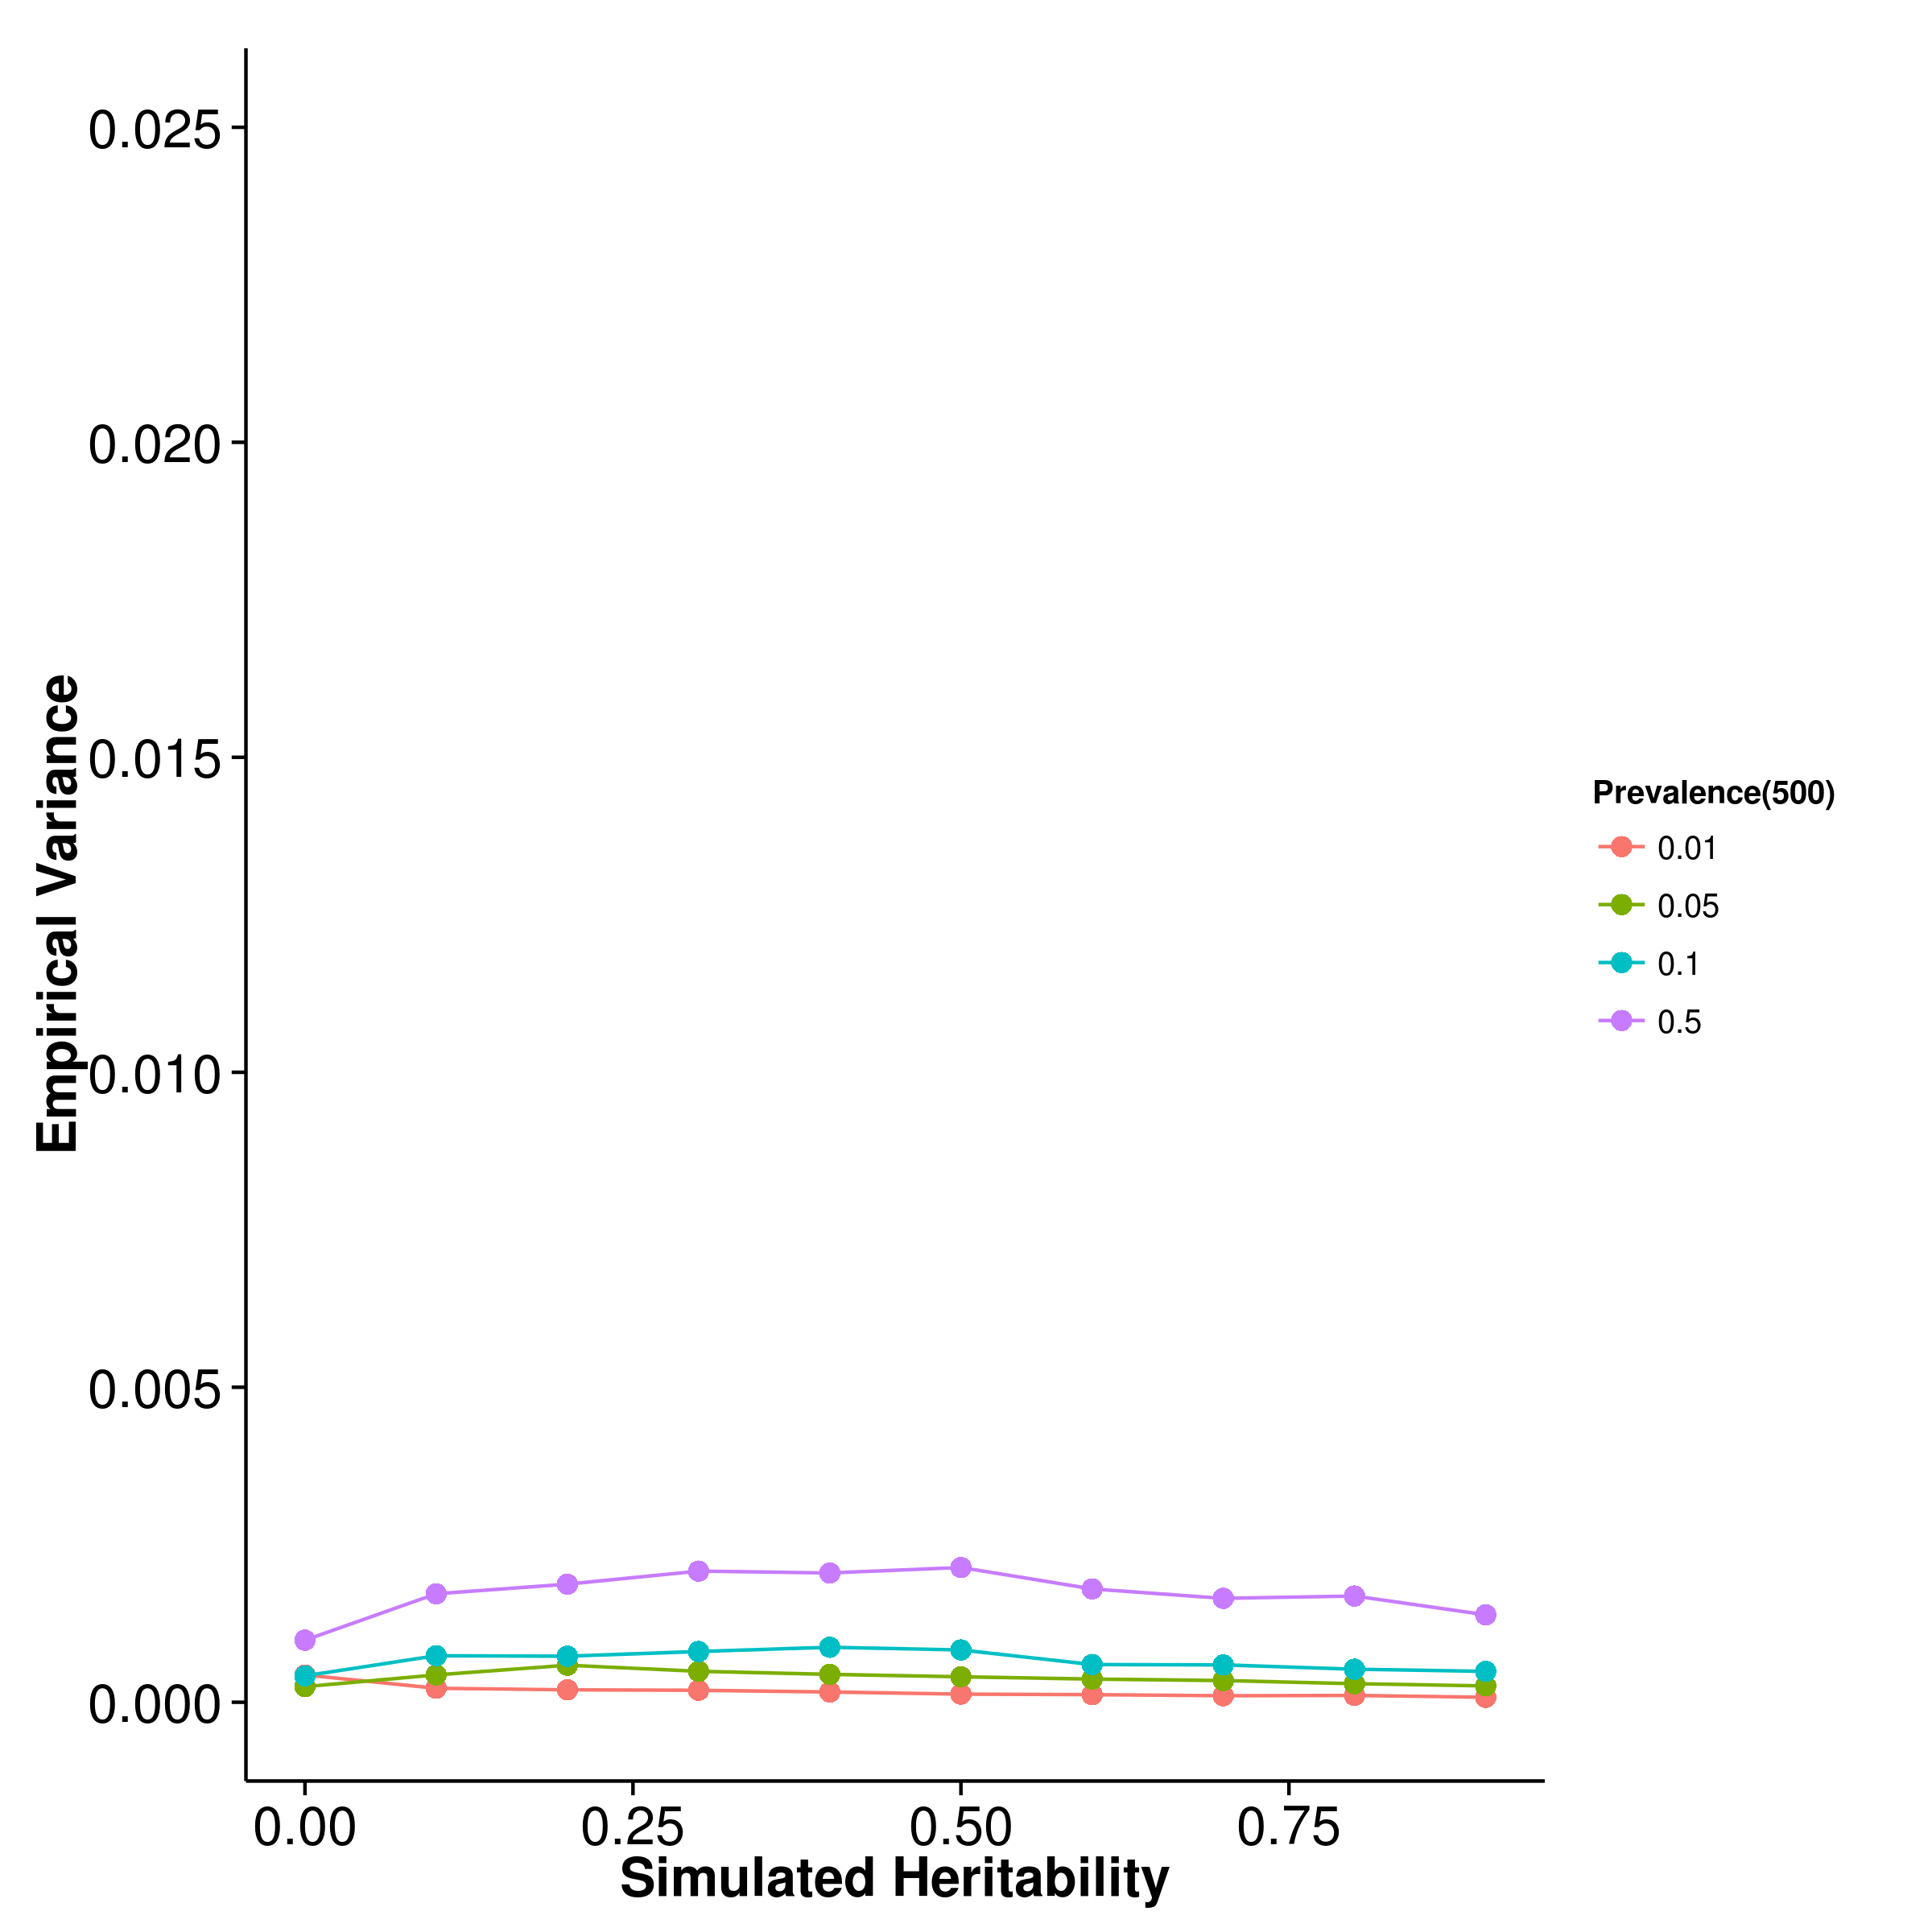

[LDSC with fix intercept] 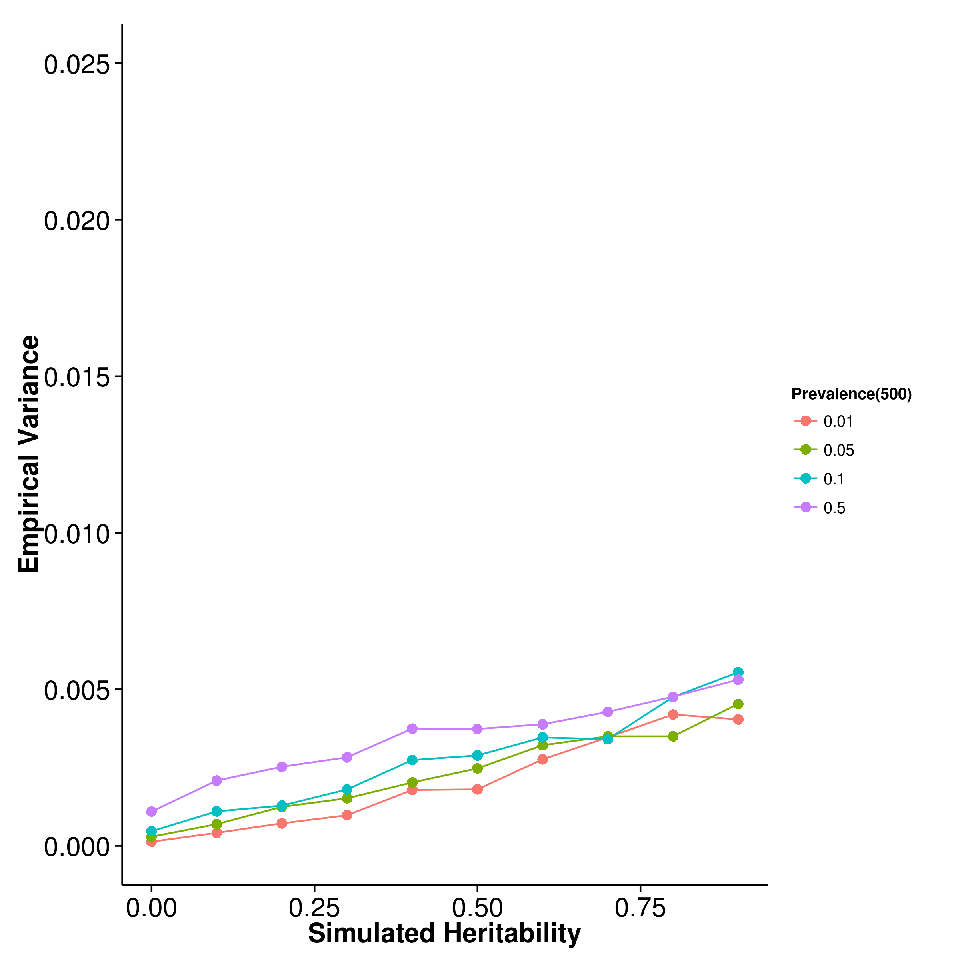 [LDSC with intercept estimation]

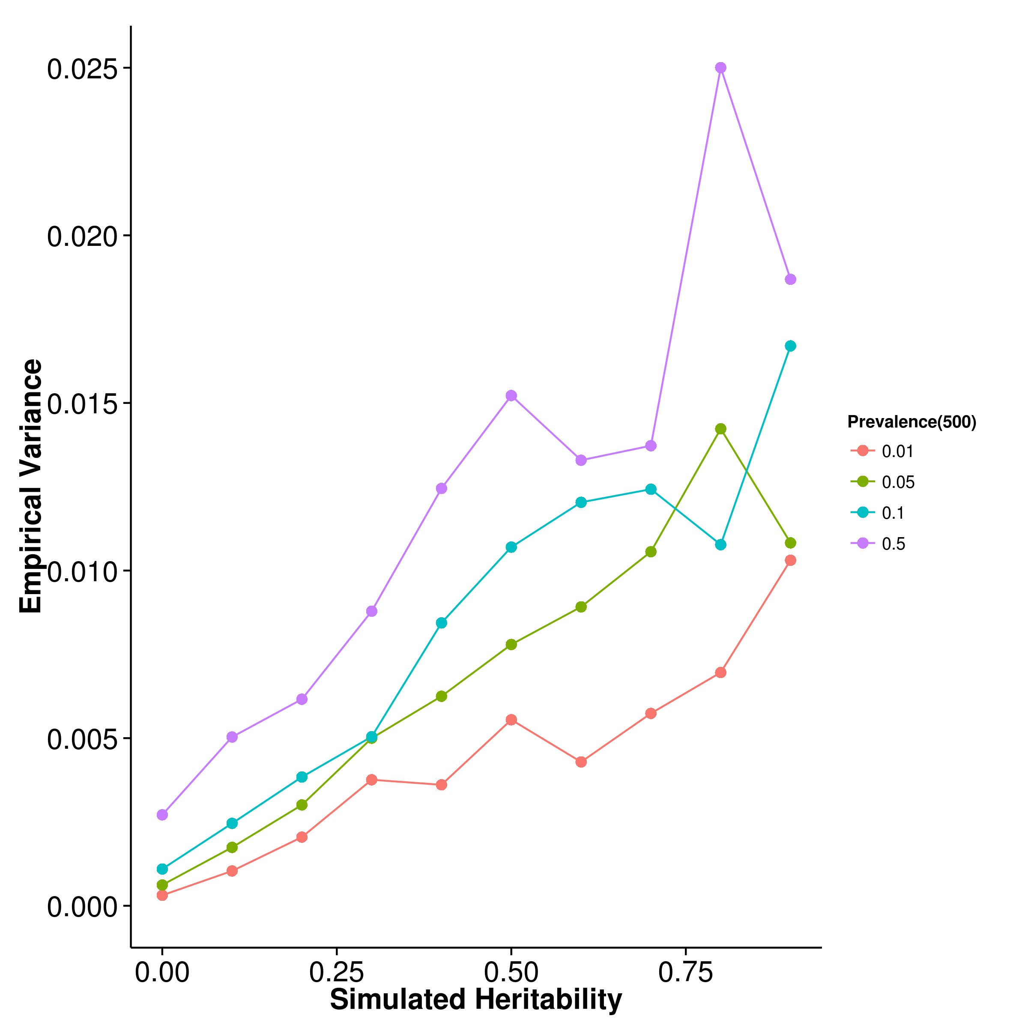

Figure 30: Variance of results from case control simulation with random effect size simulation with 500 causal SNP. As the number of causal SNP increased to 500, the empirical variance of shrek and ldsc with fixed intercept converges. However, the empirical variance of ldsc with intercept estimations remains high.

[SHREK] 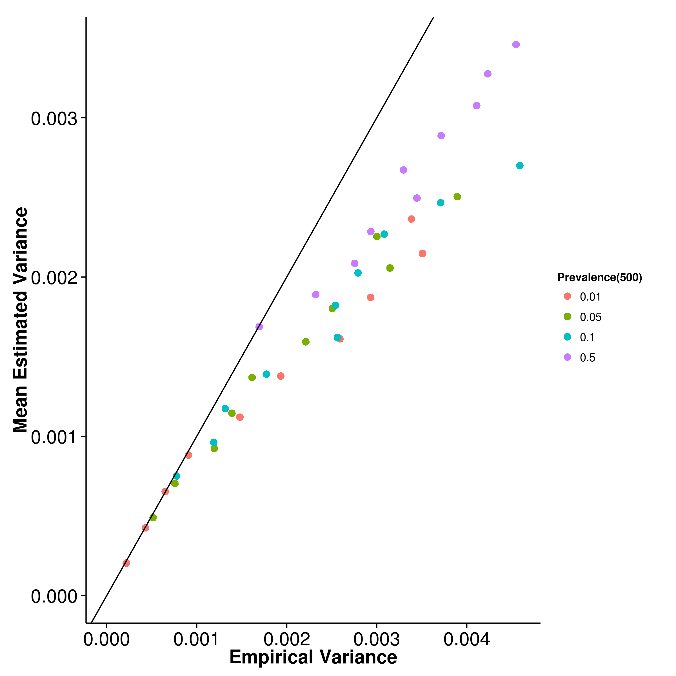 [GCTA] 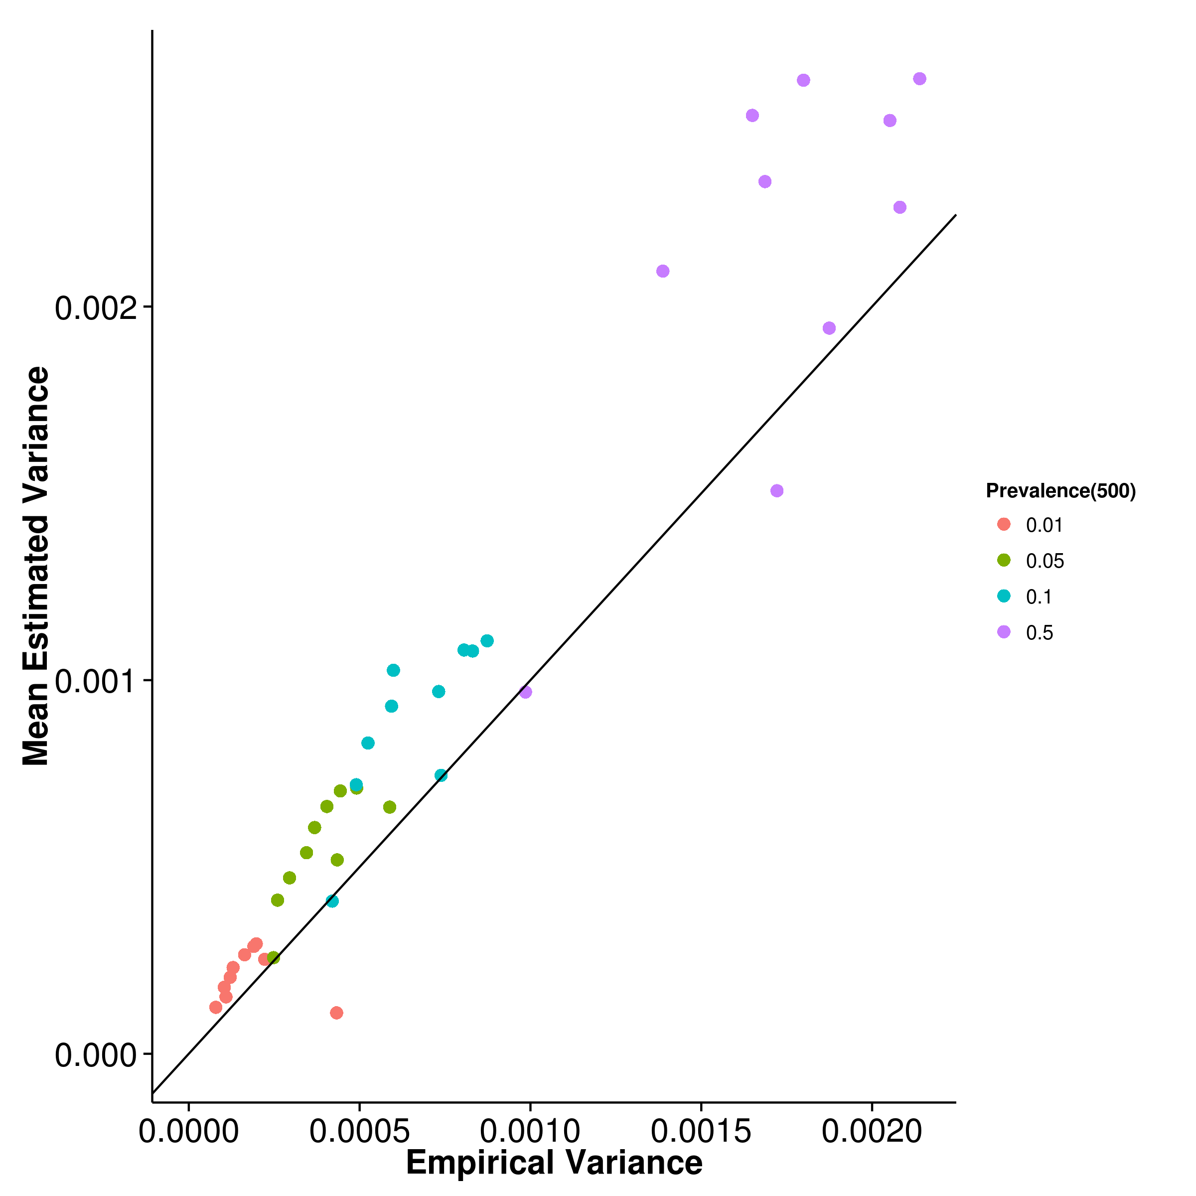

[LDSC with fix intercept] 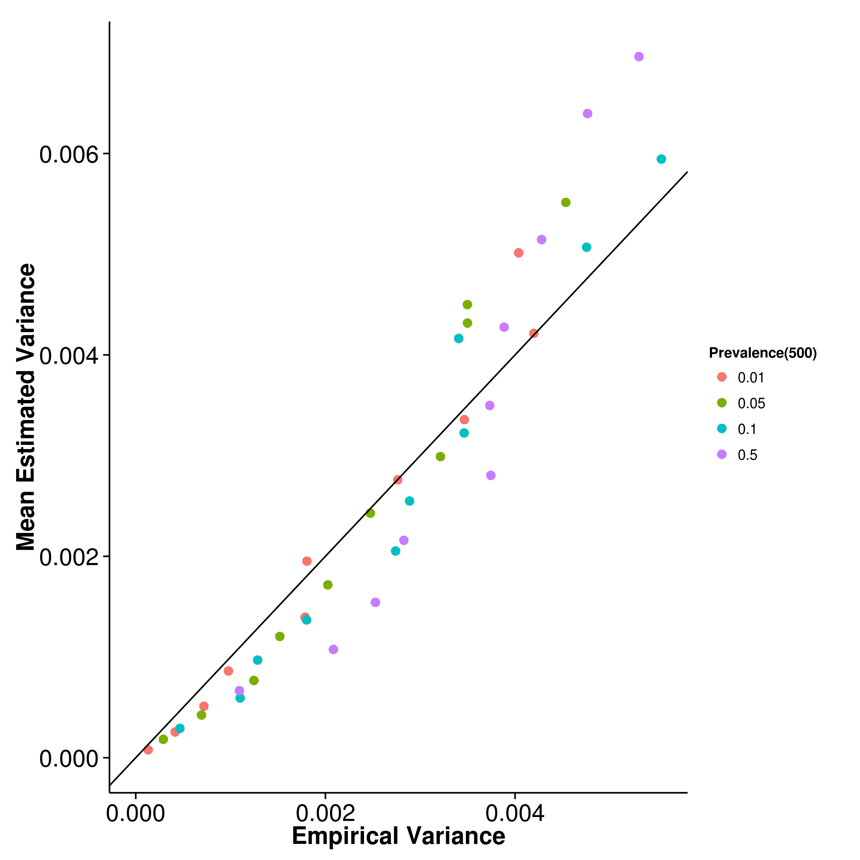 [LDSC with intercept estimation]

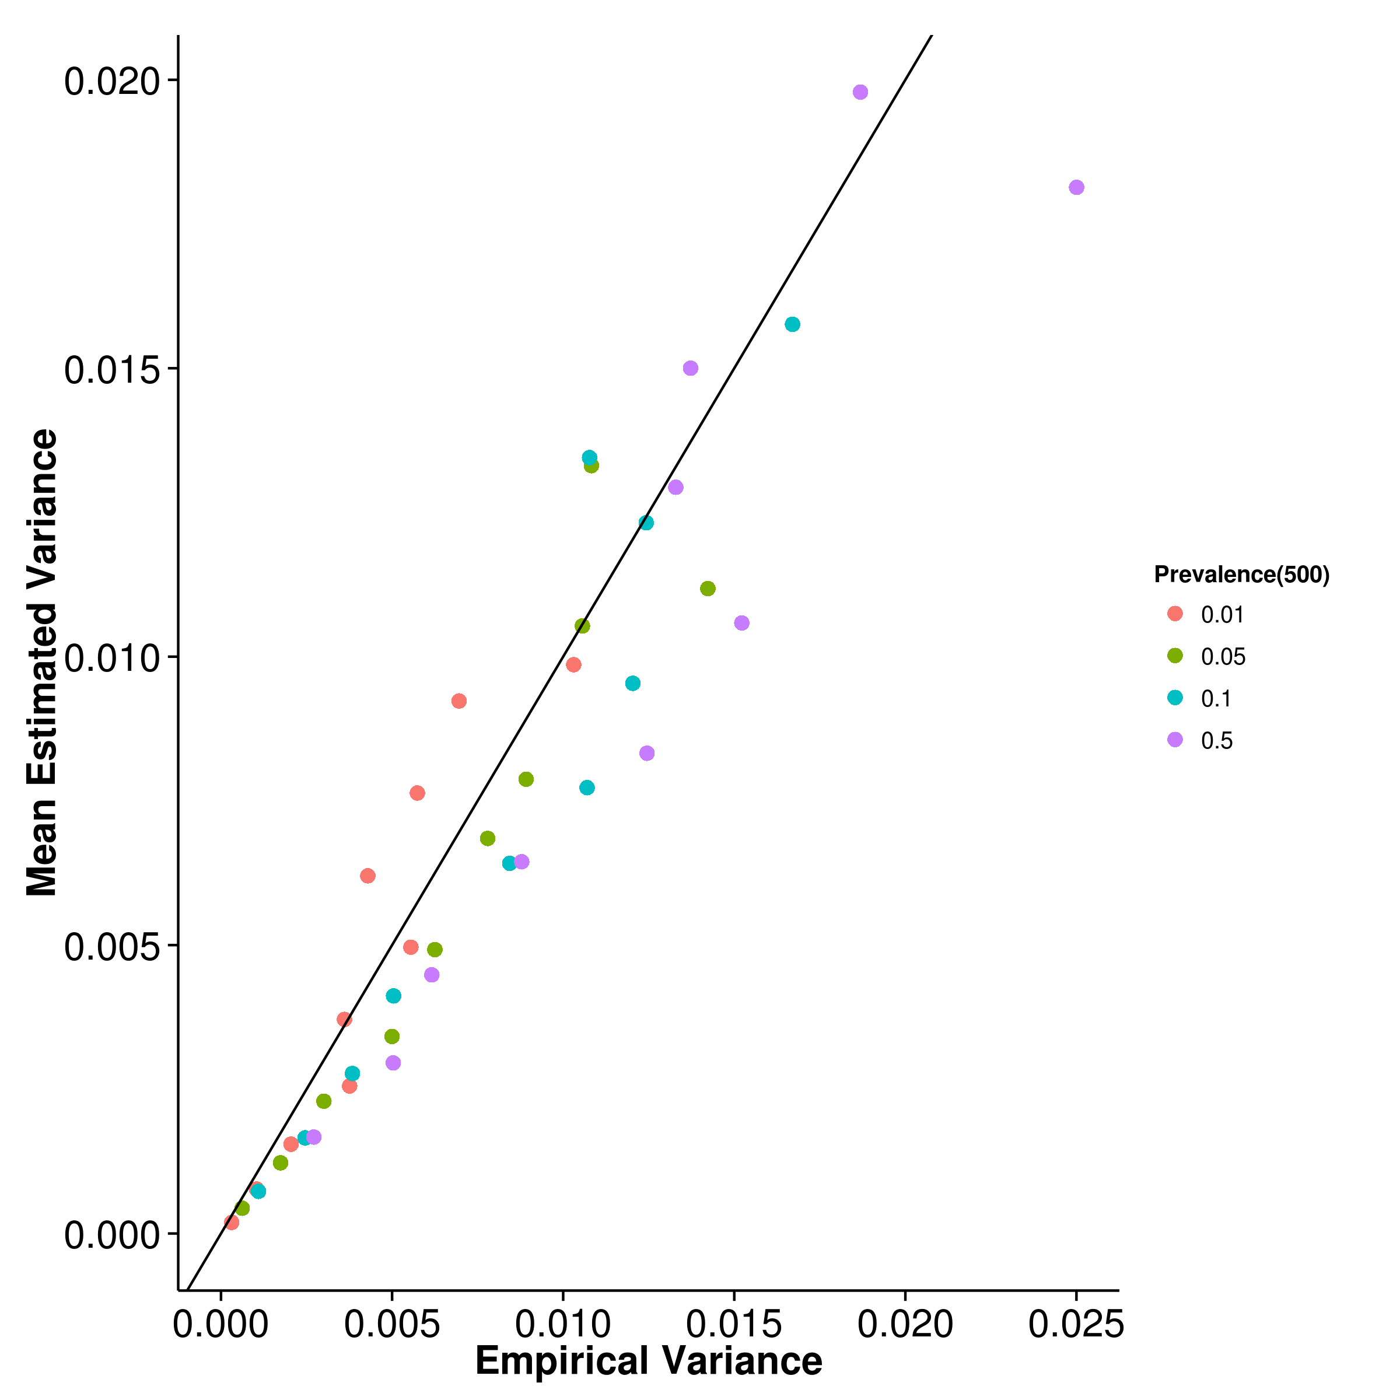

Figure 31: Estimated variance of results from case control simulation with random effect size simulation when compared to empirical variance when 500 causal SNP was simulated. When the trait contains 500 causal SNP, ldsc begins to provide a good estimation of its own empirical variance both with and without intercept estimation. On the other hand, shrek’s estimation of its own empirical variance remains consistently lower than the true empirical variance.

# 3 n-3 Polyunsaturated Fatty Acid Rich Diet in Schizophrenia

## 1 Introduction

mia pufa In the previous chapter, we have found that the SNP heritability of scz was much smaller than expected, accounting for only 20% of the variance in scz. This suggest that other factors such as rare variants and epigenetic factors might have contributed to the heritability of scz. Another possibility will be the gene environmental interaction ().

Previous studies have suggested there might be interaction between prenatal infection and genetic variations in the development of scz [?, ?]. Evidences now suggest that the effect of prenatal infection was mainly mediated by maternal immune response instead of the specific infection [?] therefore it is likely that the perturbation induced by mia are interacting with genetic variations in the development of scz. With the development of ldsc, we may now perform the partitioning of SNP heritability using summary statistics from GWAS. This allow one to investigate whether if a particular functional pathway perturbed by early mia contributes disproportionately to the heritability of scz.

On the other hand, one of the main goal in scz research is to identify effective treatments for scz such that the quality of life of schizophrenic patients can be improved. Based on the mia model, one possible candidate might be the n-3 pufa rich diet. It has been suggested that n-3 pufa can inhibits the production of il6 [?], which is a major mediator in mia [?]. Moreover, n-3 pufa also plays a critical role in the development of central nervous system [?] and it has robust anti-inflammatory properties [?]. Therefore it is possible that a n-3 pufa rich diet can help to alleviate the symptoms of scz. Indeed, previous study from our lab suggested that an n-3 pufa rich diet can help to reduce the schizophrenia-like phenotype in mice exposed to early mia insults [?].

Herein, we introduce a hypothesis generation study aiming to investigate the gene expression changes induced by early mia exposure in the brain of the adult offspring and also expression changes induced by n-3 pufa rich diet using RNA Sequencing. We would also like to investigate whether if functional pathways perturbed by mia or changed by diet contributes more to the heritability of scz using ldsc.

In this study we selected the cerebellum as the target tissue for our experiment. Although hippocampus [?, ?] and prefrontal cortex [?, ?] are the two most studied region in scz, the cerebellum has also been reported to be related to scz [?, ?]. Moreover, the cerebellum plays a central role in the cortico-cerebellar-thalamic-cortical neuronal circuit which is important to scz. pet studies have shown that a dysfunction in this circuit can contribute to “cognitive dysmetria”, e.g. impaired cognition and other symptoms of scz [?]. Altogether, this makes the cerebellum an interesting target to investigate.

The work in this chapter were done in collaboration with my colleagues who have kindly provide their support and knowledges to make this piece of work possible. Dr Li Qi and Dr Basil Paul were responsible for generating the animal model and providing the sample for our study; Dr Li Qi and Dr Desmond Campbell helped with the experimental design; Vicki Lin has helped with the RNA extraction; Tikky Leung for her high quality sequencing service; Nick Lin for his help in tackling problems encountered during sequencing quality control; Dr Johnny Kwan, Dr Desmond Campbell, Dr Timothy Mak and Professor Sham for their guidance in the statistical analysis.

## 2 Methodology

### 2.1 Sample Preparation

Female and male C57BL6/N mice were bred and mated by The University of Hong Kong, Laboratory Animal Unit. Timed-pregnant mice were held in a normal lightâ€“dark cycle (light on at 0700 hours), and temperature and humidity-controlled animal vivarium. All animal procedures were approved by the Committee on the Use of Live Animals in Teaching and Research (CULATR) at The University of Hong Kong.

The mia model was generated following procedures previously reported [?]. A dose of 5mg kg polyic in an injection volume 5ml kg, prepared on the day of injection was administered to pregnant mice on gd 9 via the tail vein under mild physical constraint. Control animals received an injection of 5ml kg 0.9% saline. The animals were returned to the home cage after the injection and were not disturbed, except for weekly cage cleaning. The resulting offspring were weaned and sexed at postnatal day 21. The pups were weighed and littermates of the same sex were caged separately, with three to four animal per cage. Half of the animal were fed on diets enriched with n-3 pufa and half were fed a standard lab diet until the end of the study. The latter ‘n-6 pufa’ control diet had the same calorific value and total fat content as the n-3 pufa diet. The diets were custom prepared and supplied by Harlan Laboratories (Madison, WI, USA). The n-6 and n-3 pufa were derived from corn oil or menhaden fish oil, respectively. The n-6 pufa control diet, was based on the standard AIN-93G rodent laboratory diet [?], and contained 65 g kg corn oil and 5 g kg fish oil with an approximate (n6)/(n3) ratio of 13:1. The n-3 pufa diet contained 35 g kg corn oil and 35 g kg fish oil with an approximate (n6)/(n3) ratio of 1:1 [?]. To avoid being confounded by sex difference, we only use the male offspring for our analysis. The male offspring were sacrificed by cervical dislocation on postnatal week 12, which roughly correspond to adulthood in human, and the cerebellum was extracted and stored in -80C until RNA extraction.

### 2.2 RNA Extraction, Quality Control and Sequencing

Total RNA was extracted from each cerebellum tissue using RNeasy midi kit (Qiagen) following the manufacturer’s instructions. RNA quality was assayed using the Agilent 2100 Bioanalyzer and RNA was quantified using Qubit 1.0 Flurometer. Samples with rin  were not included in our study as the RNA are most likely degraded. As a hypothesis generation study, we select a minimum of 3 samples per group and each samples must come from a different litter to control for littering effect. The RNA Sequencing library was performed at the Centre for Genomic Sciences, the University of Hong Kong, using the KAPA Stranded mRNA-Seq Kit. All samples were sequenced using Illumina HiSeq 1500 at 2 lanes (2101 bp paired end reads). We distribute the samples such that each lane contain roughly the same amount of samples from different conditions.

|  |  |  |  |  |  |  |
| --- | --- | --- | --- | --- | --- | --- |
| SampleID | Litter | Diet | Condition | Lane | Batch | Rin |
| B1 | 3 | O3 | POL | 1 | B | 7.7 |
| B2 | 6 | O3 | POL | 2 | B | 7.7 |
| F1 | 4 | O3 | POL | 1 | F | 7.6 |
| F4 | 1 | O3 | SAL | 2 | F | 8.1 |
| B4 | 5 | O3 | SAL | 1 | B | 7.8 |
| B5 | 14 | O3 | SAL | 2 | B | 7.7 |
| F2 | 2 | O6 | POL | 1 | F | 7.5 |
| E3 | 11 | O6 | POL | 2 | E | 7.8 |
| C2 | 7 | O6 | POL | 2 | C | 7.9 |
| B6 | 13 | O6 | SAL | 2 | B | 7.4 |
| E6 | 14 | O6 | SAL | 1 | E | 8 |
| C6 | 1 | O6 | SAL | 1 | C | 7.8 |
|  | |

Table 9: Sample information. O3 = n-3 pufa diet; O6 = n-6 pufa diet; POL = polyic exposed; SAL = Saline exposed. We have tried to separate the samples into different lane and batch to control for the lane and batch effect. Samples from different litters were also used with the exception of 1M_2 and 1M_3 which came from the same litter but were given a different diet.

### 2.3 Sequencing Quality Control

qc of the RNA Sequencing read data were rather standardized where FastQC [?] is the most widely adopted tools. It can generate the required per base qc and provide a general picture of how well the sequencing were done.

From the FastQC report, it was noted that some adapter sequences remained in the final sequence, by using trim_glore, a wrapper for cutadapt (version 1.9.1) [?], we trim the adapter sequences from the sequence reads and only retain reads that were at least 75 bp long for subsequent alignment.

### 2.4 Alignment

In a recent review by [?], it was demonstrated that STAR [?] has the best performance of all the aligners investigated taking into account of accuracy and speed. Thus STAR aligner was used in our study. The RNA Sequencing reads were mapped to the *Mus musculus* reference genome (mm10, Ensembl GRCm38.82) using the STAR aligner (version 2.5.0a) [?]. And the quantification of the gene expression levels were conducted using featureCounts (version 1.5.0) [?].

### 2.5 Differential Expression Analysis

There are many statistical tools available for the differential gene expression analysis. Based on the review of [?], it was suggested that DESeq2 and limma are the most robust statistical packages for analyzing RNA Sequencing data. As the author of DESeq2 were very active in providing supports for the package, we selected DESeq2 (version 2.1.4.5) [?] as the statistic package for the differential gene expression analysis.

Perhaps one of the most controversial study in RNA Sequencing was the mouse ENCODE paper by [?] where [?] demonstrated that most of the findings from [?] was confounded by lane and batch effect. This highlights the importance of lane and batch effect in the design of RNA Sequencing. To avoid batch and lane effect, the whole sampling collection procedure and sequencing was performed in a way where we minimize the batch and lane difference between conditions (tab:sampleInfo). However, because of the sample quality differs across different batches, we were unable to fully balance out the batch effect. Therefore, in our analysis, we must control for the batch effect.

In our study, we were interested in the following comparisons:

1. Saline exposed samples with n-3 pufa rich diet vs Saline exposed samples with n-6 pufa rich diet

2. PolyI:C exposed samples with n-3 pufa rich diet vs PolyI:C exposed samples with n-6 pufa rich diet

3. Saline exposed samples with n-6 pufa rich diet vs PolyI:C exposed samples with n-6 pufa rich diet

To obtain the desire comparison, and also control for batch effect, we used  as our model of statistical analysis where Condition is the mia exposure status. We did not incorporate the rin into our statistic model because it was advised against by the author.

We would also like to see if the batch effect can leads to false positive results. Therefore we performed the lrt to investigate the effect of batch on our result. The lrt examines two models for the counts, a full model with a certain number of terms and a reduced model, in which some of the terms of the full model are removed. The test determines if the increased likelihood of the data using the extra terms in the full model is more than expected if those extra terms are truly zero. Thus we compared the full model  with  to understand the effect of batch on our data.

In our analysis, we removed all genes with base mean count  10 to reduce the noise associated with low expression and the Benjamini and Hochberg method were then used to correct for multiple testing.

### 2.6 Functional Annotation

One of the most important aim of the current study is to investigate whether if functional pathways perturbed by mia or affected by diet contribute to larger amount of SNP heritability. It is therefore important to perform functional annotation of the deg in order to identify pathways that were affected (e.g. enriched by the deg).

Because of the limited number of deg identified, we performed the Wilcoxon Rank Sum test to test whether if genes within the pathway are more significant the genes outside pathway. The canonical pathways annotations obtained from the msigdb (v5.0 updated April 2015) [?] were used for our analysis. To avoid testing overly narrow or broad functional pathways, pathways with more than 300 genes or less than 10 genes were removed from our analysis. Pathways with adjusted p-value  (using Benjamini and Hochberg adjustment) were considered as significant.

### 2.7 Partitioning of Heritability

We then tried to perform partitioning of heritability using the significant pathways as our annotation. One problem with the pathways is that they can overlap with each other and can even be a sub-pathway of another pathway. We therefore calculated the Jaccard distance between each pathways:

 (62)

For pathways with a Jaccard distance greater than 0.2, we removed the smaller pathway, thus reducing the number of pathways in the analysis. Two “super pathways” were also generated which included all the genes in the pathways perturbed in mia or genes in pathways affected by diet.

SNP from the 1000 genome was first associated with genes using SnpEFF [?] with the GRCh37.75 annotation, where SNP within kb region of a gene was considered to be associated. The annotation file required by ldsc was then generated by identifying SNP participated in the significant pathways from sec:function. If a SNP was found to be associated with more than 1 genes, then it was considered to be within all pathways where its associated genes were part of.

Finally, we performed the partitioning of heritability using ldsc [?] --annot and --overlap-annot options using 1000kb window size and the reference panel generated from sec:realData. We removed the mhc region from this analysis. Pathways with positive proportion of heritability explained and a fdr q-value  were considered significant. We considered the “super pathways” as a super test which included all the pathways tested, therefore we did not perform any multiple testing correction on it.

### 2.8 Designing the Replication Study

Another important goal of our current study is to provide information for further replication studies. In order to estimate the power and required samples for the replication studies, we performed the power estimation using Scotty [?]. We provided the count data from our pilot samples to Scotty to estimate the minimal required samples for our replication study if we would like to detect at least 90% of the genes that are differentially expressed by a 2 fold change at p and that at least 80% of genes has at least 80% of the maximum power.

## 3 Results

### 3.1 Sample Quality

On average, 87 million reads were generated for each sample of which more than 90% of the read bases has quality score . A quality score at 30 represents the probability of having an incorrect base call is less than 1 in 1,000. After removing the adapter sequences from the reads, more than 97% of the reads remains. Over 90% of the trimmed reads could be uniquely mapped to the *Mus musculus* reference genome (mm10, Ensembl GRCm38.82) using the STAR aligner (version 2.5.0a) [?]. To obtained the expression count, we used the featureCounts (version 1.5.0) [?] to generate the count matrix required for downstream analysis.

Next, we were interested in whether if there are any contamination of samples or series confounding effect of bath or lane. We therefore performed an unsupervised clustering on the sample count data. It was observed that none of the samples were clustered by lane or batch, suggesting that there were no serious batch or lane effect presented in our samples. However, one sample from the n3-polyic group was found to be substantially different from all other samples (fig:distMatrix). It was unclear whether if the difference was due to sample contaminations (from other source) or was due to sample mis-label. To avoid problems in down-stream analysis, we excluded this sample from subsequent analyses

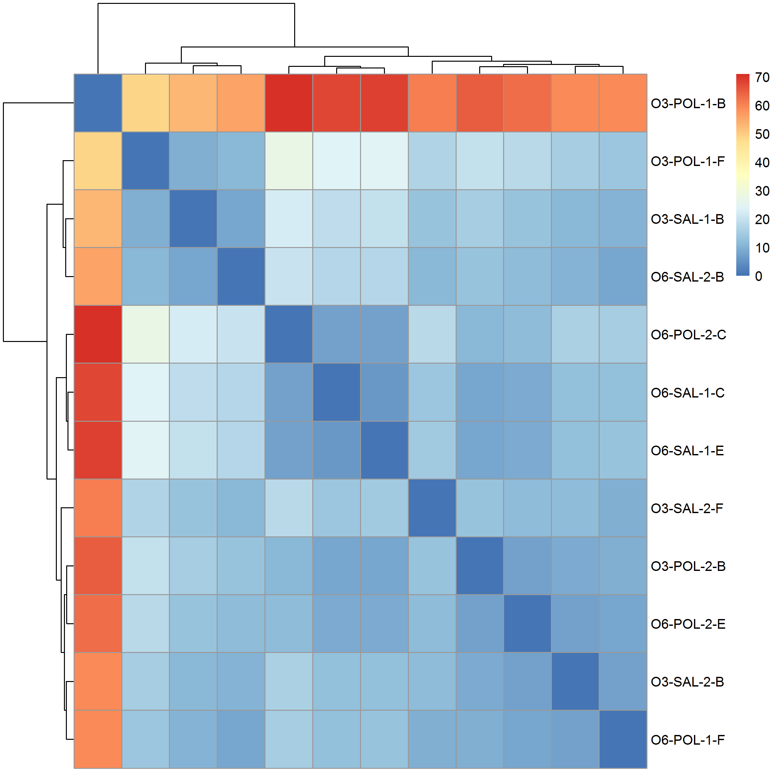

Figure 32: Sample Clustering results. It was observed that there was no clear clustering for lane or batch effects. However, one sample from the n3-pufa-polyic group was found to be substantially different from all other samples. It was unclear whether if the difference was due to sample contaminations or was due to sample mis-label. To avoid problems in down-stream analysis, we excluded this sample from subsequent analyses.

### 3.2 Differential Expression Analysis

[O6-Saline mice vs O6-PolyI:C mice] 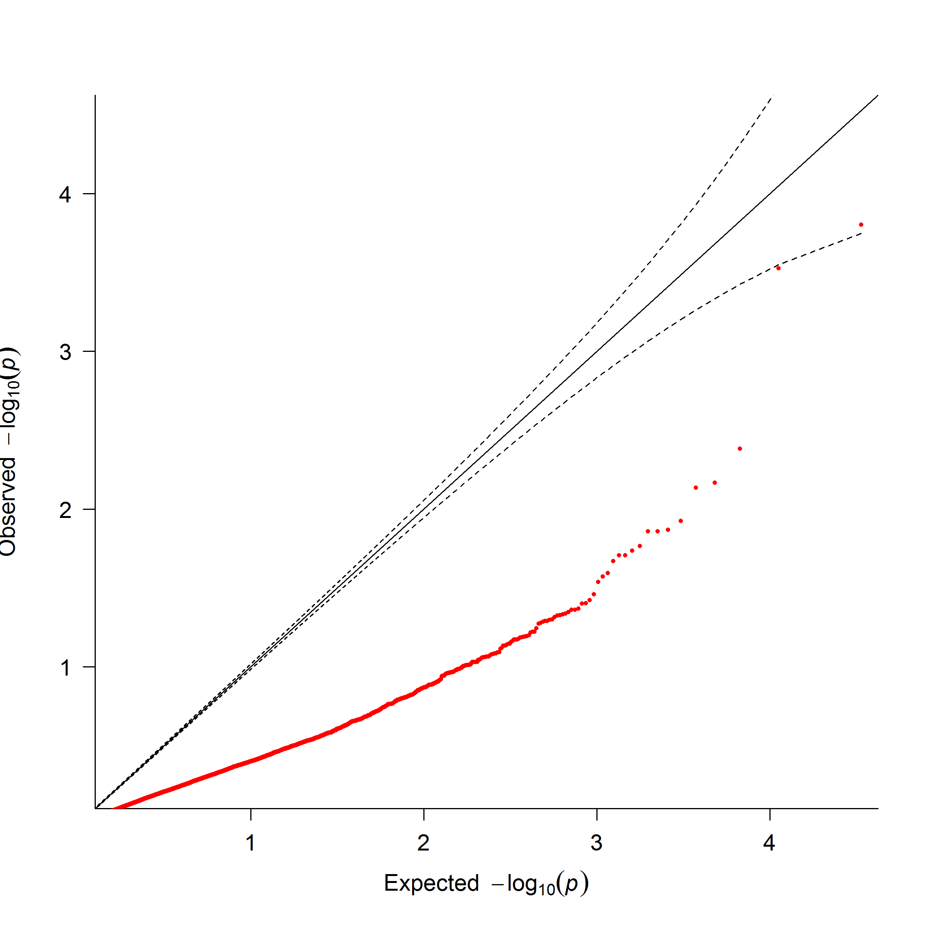 [O6-Saline mice vs O3-Saline mice] 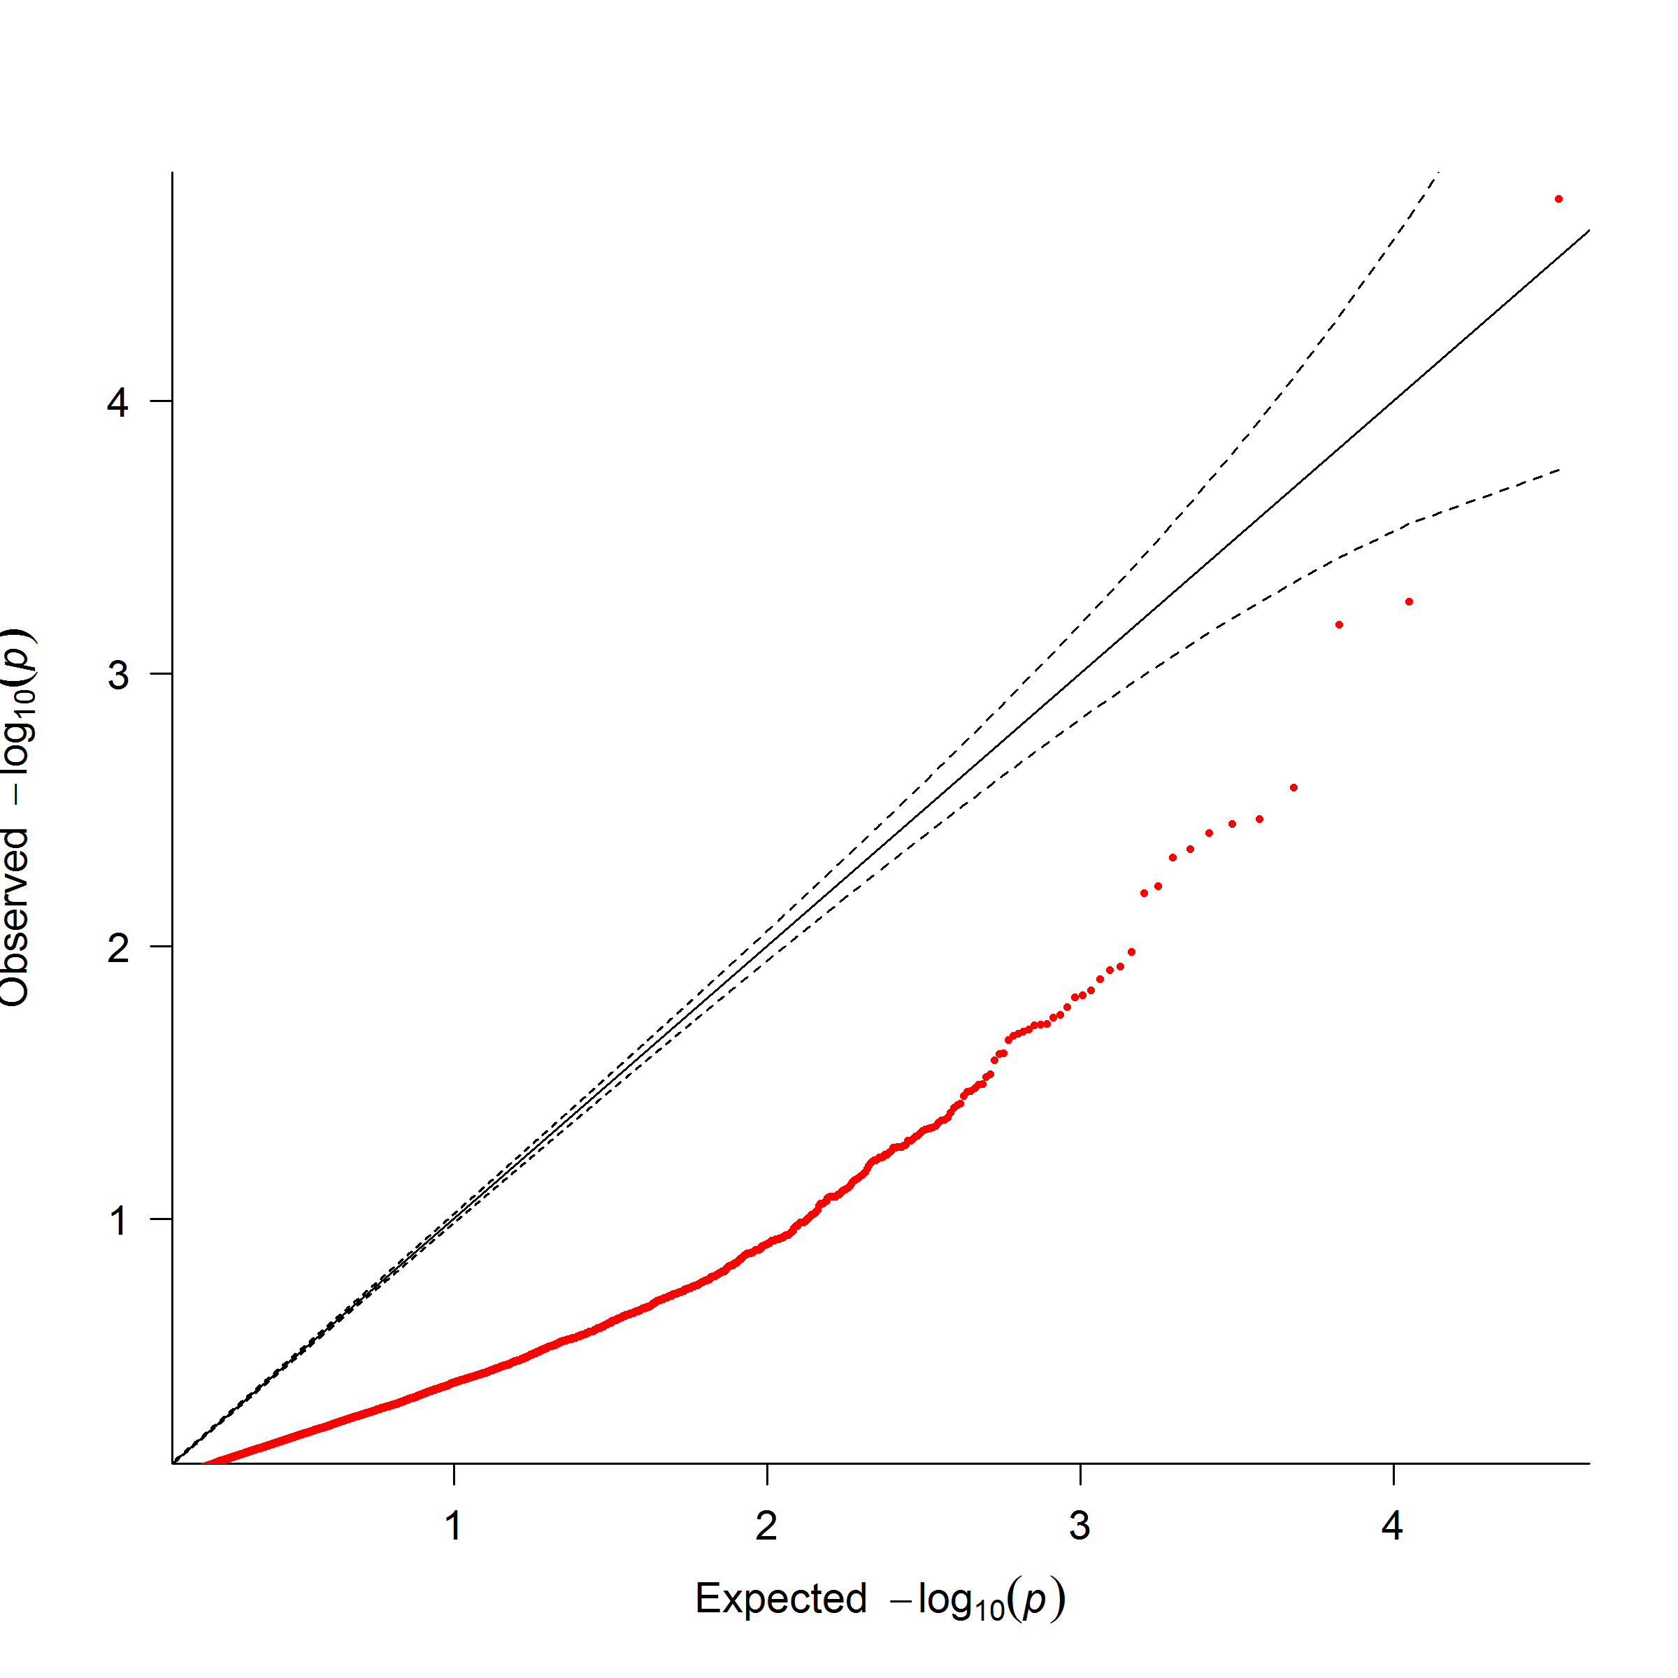

[O6-PolyI:C mice vs O3-PolyI:C mice] 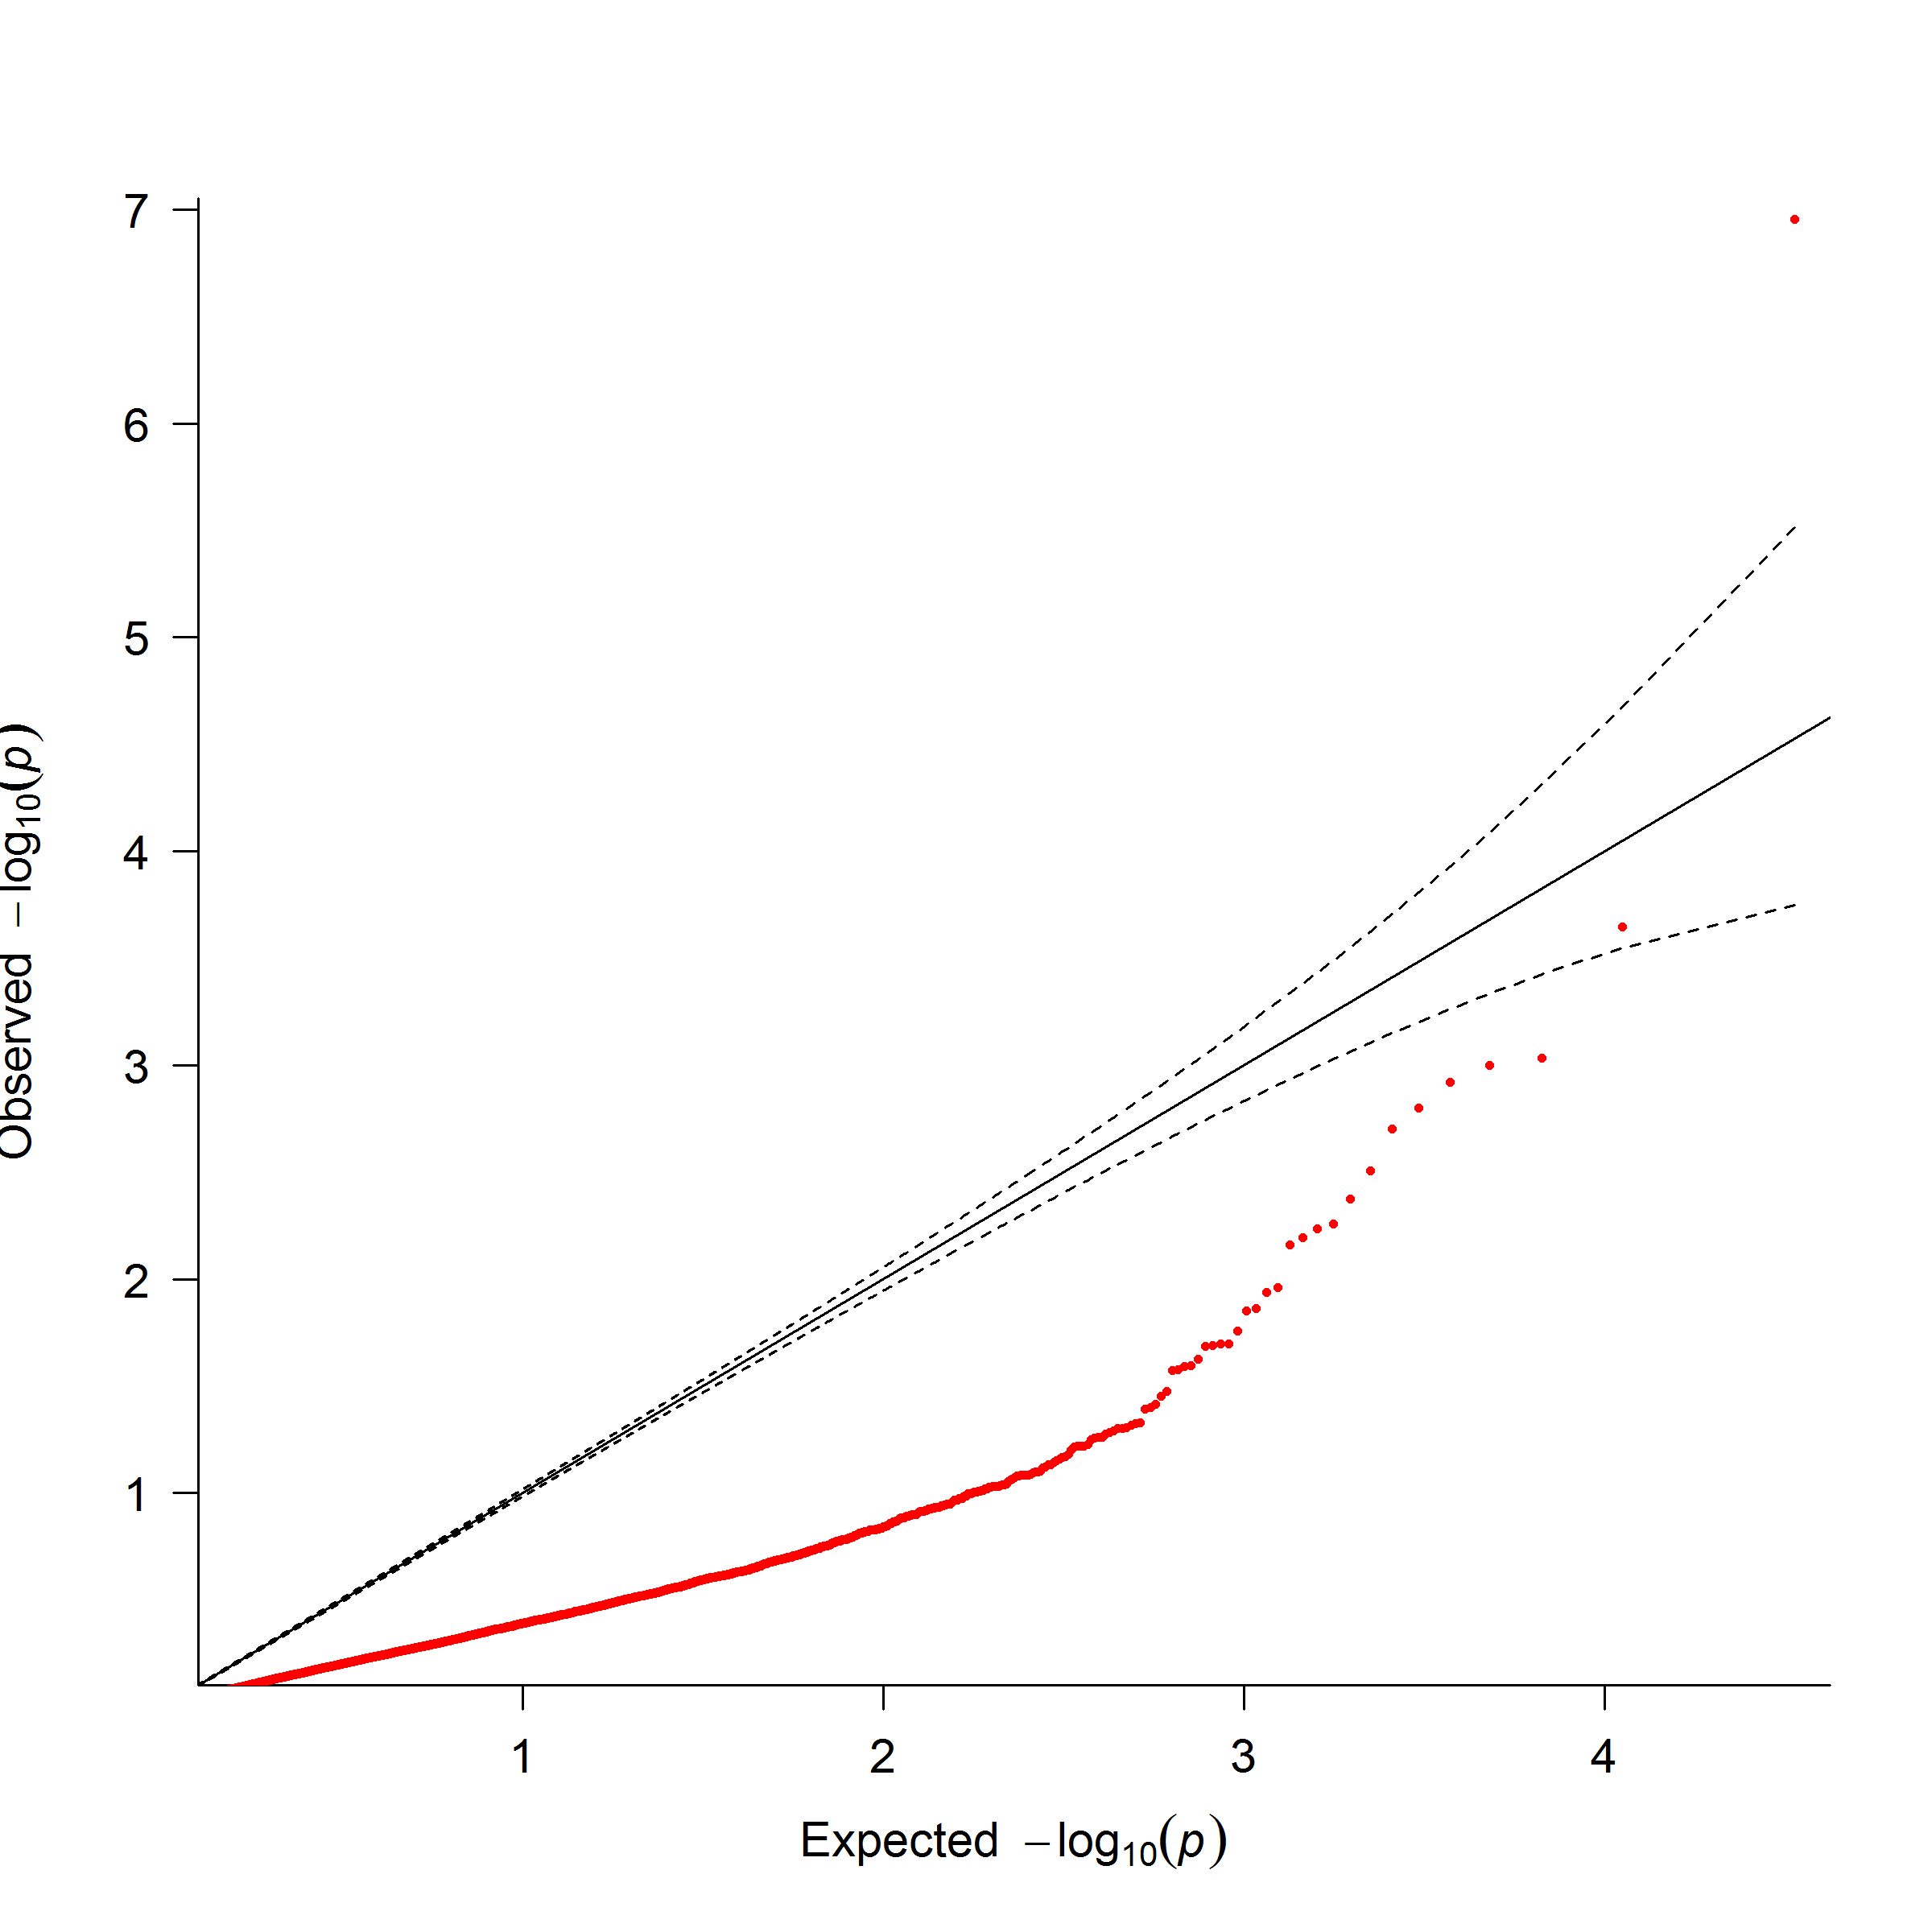 [Batch Effect] 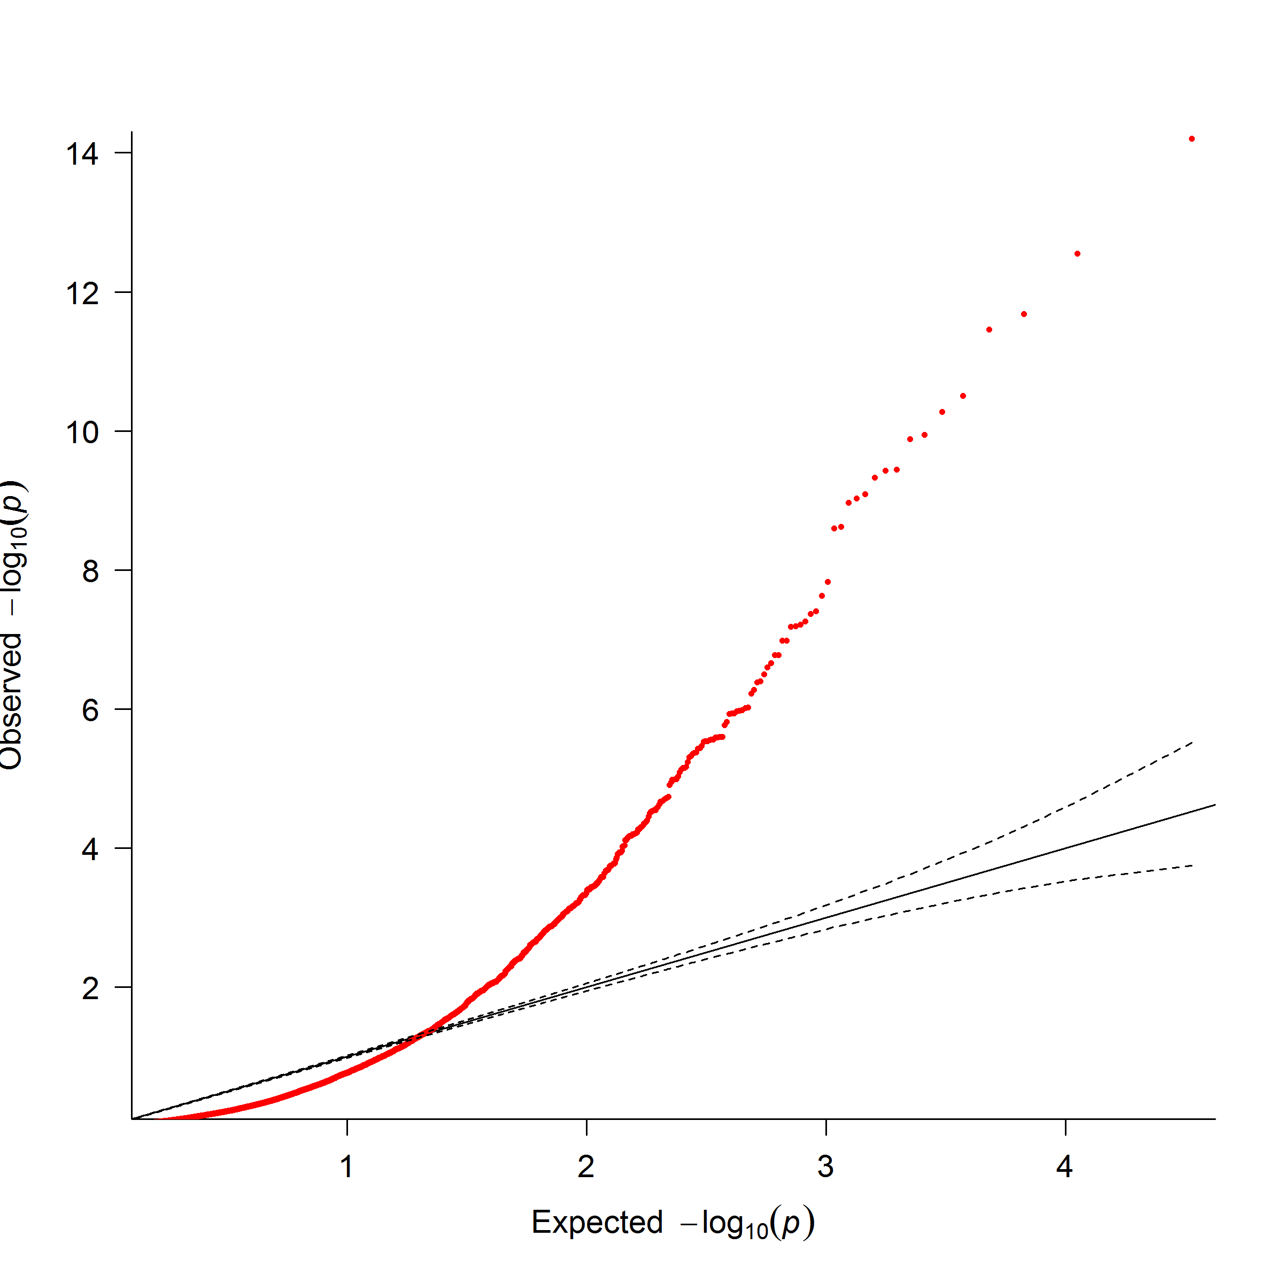

Figure 33: QQ Plot of statistic results. From the qqplot, it was observed that most of the observed p-value was less than what would have been expected. This is likely due to the small sample size of our study which leads to an under powered association. The only exception was the analysis of batch effect were a large amount of genes were found to be significant. This demonstrate the importance of adjusting for batch effect

After excluding the problematic samples, we performed the DESeq2 analysis. Of the 16,747 genes that passed through quality control, only one gene, *Sgk1* (p-adjusted=0.00186) was found to be significantly differentiated when we examines the effect of n-3 pufa rich diet on the gene expression in the cerebellum of polyic exposed mice (fig:omegaPOLWald). No genes were found to be significant for the other two comparisons (fig:miaO6Wald,fig:omegaSALWald).

We also performed the lrt to compare test the effect of batch on our analysis. A total of 178 genes were found to be significant differentiated (fig:batchLRT), suggesting that the “Batch” is indeed an important factor to consider in our analysis.

### 3.3 Functional Annotation

It is common practice to try and perform functional annotation to the deg. However, in most of our analysis, there were either no deg or only 1 deg, making it difficult to perform functional annotation. We therefore used the Wilcox rank sum test to analysis whether if a pathway contain genes that are more significant than genes not within the pathway instead of trying to identify pathways that were *enriched* by deg.

None of the pathway were found to be significant when comparing the effect of the n-3 rich diet in Saline exposed mice. On the contrary, 17 pathways were found significant when comparing the effect of n-3 pufa rich diet in polyic exposed samples (tab:o6polyPath) where 4 pathways were related to growth factors such as fgf or egf and 4 others were related to kinases such as pi3k or mapk.

Finally, 12 pathways were found to significant when comparing Saline and polyic exposed mice given the n-6 pufa rich diet (tab:miaPath) with pathways such as neuroactive ligand-receptor interaction (p-adj = ), calcium signaling pathway (p-adj = ) and genes involved in Neuronal System (p-adj=0.00153) among the significant pathways.

### 3.4 Partitioning of Heritability

Given the significant pathways, we performed the partitioning of heritability using ldsc [?]. In total, 14 unique pathways were included in the analysis were 4 of them were found to have non-negative contribution to the heritability of scz, including the pathway related to neuronal system, ecm glycoprotein, calcium signaling and mapk signaling (tab:partitioning). All of these pathways were affected by mia and only the ecm pathways were also found to be affected by n-3 pufa rich diet in polyic exposed mice. Moreover, the “super pathway” for mia were found to be significant (p-value=0.0402) yet the “super pathway” for diet was found to be insignificant (p-value=0.414).

### 3.5 Designing the Replication Study

Other than generation of hypothesis, we would also like to use the current information to help designing subsequent replication studies. Using Scotty [?], given that we would like to detect at least 90% of the genes that are differentially expressed by a 2 fold change at p and that at least 80% of genes has at least 80% of the maximum power, we will need at least 10 samples per group in the replication study given the current sequencing depth.

|  |  |  |  |  |
| --- | --- | --- | --- | --- |
| ID | Size | Source | Description | Adjusted P-Value |
| M508 | 78 | REACTOME | Genes involved in Signaling by SCF-KIT | 0.00671 |
| M570 | 44 | REACTOME | Genes involved in PI3K events in ERBB2 signaling | 0.0242 |
| M3008 | 196 | NABA | Genes encoding structural ECM glycoproteins | 0.0309 |
| M1090 | 112 | REACTOME | Genes involved in Signaling by FGFR | 0.0309 |
| M563 | 109 | REACTOME | Genes involved in Signaling by EGFR in Cancer | 0.0309 |
| M17776 | 100 | REACTOME | Genes involved in Downstream signaling of activated FGFR | 0.0309 |
| M1076 | 83 | REACTOME | Genes involved in Amyloids | 0.0309 |
| M850 | 56 | REACTOME | Genes involved in PI-3K cascade | 0.0309 |
| M10450 | 38 | REACTOME | Genes involved in GAB1 signalosome | 0.0309 |
| M16227 | 24 | REACTOME | Genes involved in Cholesterol biosynthesis | 0.0309 |
| M5872 | 17 | KEGG | Steroid biosynthesis | 0.0309 |
| M16334 | 10 | BIOCARTA | Eph Kinases and ephrins support platelet aggregation | 0.0309 |
| M5884 | 275 | NABA | Ensemble of genes encoding core extracellular matrix including ECM glycoproteins, collagens and proteoglycans | 0.0456 |
| M635 | 127 | REACTOME | Genes involved in Signaling by FGFR in disease | 0.0456 |
| M568 | 38 | REACTOME | Genes involved in PI3K events in ERBB4 signaling | 0.0456 |
| M165 | 32 | PID | Syndecan-4-mediated signaling events | 0.0456 |
| M1262 | 15 | REACTOME | Genes involved in GRB2:SOS provides linkage to MAPK signaling for Intergrins | 0.0456 |
|  | |

Table 10: Significant Pathways when comparing effect of diet in polyic exposed mice. The pathway IDs are the systematic name from msigdb. Most of the significant pathways were related to the kinase such as PI3K and MAPK or growth factors such as fgf and egf.

|  |  |  |  |  |
| --- | --- | --- | --- | --- |
| ID | Size | Source | Description | Adjusted P-Value |
| M13380 | 272 | KEGG | Neuroactive ligand-receptor interaction |  |
| M2890 | 178 | KEGG | Calcium signaling pathway |  |
| M12289 | 188 | REACTOME | Genes involved in Peptide ligand-binding receptors | 0.00118 |
| M5884 | 275 | NABA | Ensemble of genes encoding core extracellular matrix including ECM glycoproteins, collagens and proteoglycans | 0.00119 |
| M735 | 279 | REACTOME | Genes involved in Neuronal System | 0.00153 |
| M15514 | 186 | REACTOME | Genes involved in Transmission across Chemical Synapses | 0.00401 |
| M4904 | 121 | REACTOME | Genes involved in G alpha (s) signalling events | 0.0127 |
| M3008 | 196 | NABA | Genes encoding structural ECM glycoproteins | 0.0131 |
| M752 | 137 | REACTOME | Genes involved in Neurotransmitter Receptor Binding And Downstream Transmission In The Postsynaptic Cell | 0.0131 |
| M10792 | 267 | KEGG | MAPK signaling pathway | 0.0195 |
| M17 | 59 | PID | Notch signaling pathway | 0.0406 |
| M18437 | 184 | REACTOME | Genes involved in G alpha (q) signalling events | 0.0406 |
|  | |

Table 11: Significant Pathways When Comparing Effect PolyI:C in Mouse Given n-6 pufa Rich Diet. The pathway IDs are the systematic name from msigdb. Interestingly, we observed a lot of neural related pathways and even got significant signal in the calcium signaling pathway, which was reported to be associated with scz [?].

|  |  |  |  |  |  |  |
| --- | --- | --- | --- | --- | --- | --- |
| ID | Size | Source | Description | Proportion of | SE | Enrichment Q-Value |
| M735 | 279 | REACTOME | Genes involved in Neuronal System | 0.0287 | 0.00627 | 0.0456 |
| M5884 | 275 | NABA | Ensemble of genes encoding core extracellular matrix including ECM glycoproteins, collagens and proteoglycans | 0.00363 | 0.00342 | 0.0456 |
| M2890 | 178 | KEGG | Calcium signaling pathway | 0.0260 | 0.00856 | 0.127 |
| M10792 | 267 | KEGG | MAPK signaling pathway | 0.0257 | 0.008713 | 0.127 |
|  | |

Table 12: Pathways significantly contributes to SNP heritability of scz.

## 4 Discussion

In this hypothesis generation study, we demonstrated that *Sgk1* might be affected by n-3 pufa rich diet in the cerebellum of mia exposed mice. *Sgk1* is a serine/threonine kinase activated by pi3k signals and studies have shown that the expression of *Sgk1* is associated with spatial learning, fear-conditioning learning and recognition learning in rat [?, ?]. For example, [?] observed a 4 fold increase of *Sgk1* in the hippocampus of fast learners when compared to slow learners where transfection of *Sgk1* mutant DNA impairs the water maze performance in rat.

On the other hand, it was found that *Sgk1* can regulates the AMPA and kainate glutamate receptors, especially GluR6 which is encoded by *Grik2* [?, ?]. The kainate receptors contributes to the excitatory postsynaptic current and are important to the synaptic transmission and plasticity in the hippocampus [?]. The upregulation of AMPA and kainate receptors are therefore expected to enhance the excitatory effects of glutamate [?]. Moreover, *Sgk1* also up-regulates the glutamate transporters such as EAAT4 [?]. The glutamate receptors are vital for clearance of glutamate from the synaptic cleft. This prevents excessive glutamate accumulation and therefore help to prevent the neurotoxic effects of glutamate [?]. Considering the complexity of the glutamatergic system and the conflicting role of *Sgk1*, it is likely for more genes to play a role in the tight regulation of the glutamatergic system. However, it is likely that the disruption of *Sgk1* might be have an impact to the normal functioning of the glutamatergic system.

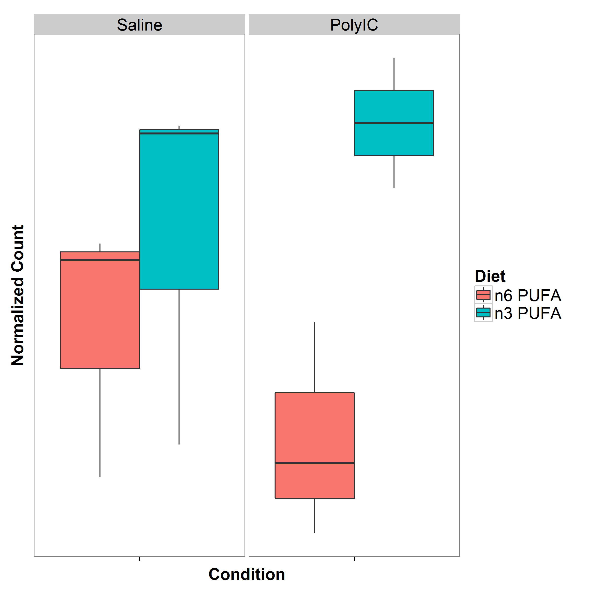

Figure 34: Normalized Expression of *Sgk1*. It was observed that the expression level of *Sgk1* increases after the mice was given a n3-pufa rich diet where a significant increase was observed in mice exposed to polyic.

In our study, it was observed that upon given the n-3 pufa rich diet, the *Sgk1* expression in the cerebellum increases (fig:sgk1Express). Although the increase was not significant in the saline mice, a significant up-regulation was observed in the polyic exposed mice (fig:sgk1Express). Additionally, it was also observed that pi3k pathways and pathways related to fgf receptors and egf receptors were significant when studying the effect of n-3 pufa rich diet to polyic exposed mice. Upon further investigation, it was found that the fgf receptors and egf receptors are upstream of the pi3k-Akt pathway (fig:pi3kPathway) which is responsible for the activation of *Sgk1*. Although we were unable to provide direct connection between the expression of *Sgk1* and the improve functioning of the polyic mice given n-3 pufa diet, our results do suggest a possible effect of the n-3 pufa rich diet in the expression of genes related to the pi3k/Akt pathway and might affect the expression of *Sgk1*. Further studies are therefore required to understand whether if the change in expression of *Sgk1* can account for the improved functioning of the polyic mice. A possible design will be to induce the expression of *Sgk1* in polyic mice through transfection and examine whether if the polyic mice with higher expression of *Sgk1* display a reduction in scz-like behaviours.

An important point to note was that previous research of *Sgk1* has been focusing on the hippocampus and not the cerebellum. Thus, it is possible that *Sgk1* might have a different function in the cerebellum. It is therefore vital for subsequent research to study the effect of *Sgk1* in the cerebellum or for one to study the effect of n-3 pufa rich diet on the gene expression in the hippocampus.

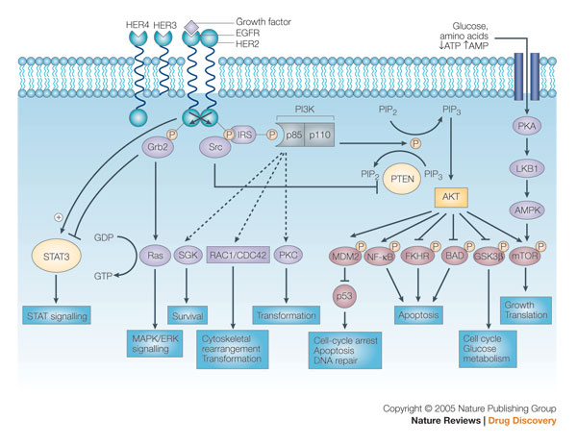

Figure 35: Schematic of signalling through the pi3k/AKT pathway. It was observed that the growth factors were upstream of the pi3k/AKT pathway of which *Sgk1* is one of the member of the pathway. Figure adopted from [?] with permission from journal.

When examine the expression change in mice exposed to polyic, none of the genes were significantly differentiated. However, we do observe 12 pathways that contains genes that were more significant than genes not within the pathway (tab:miaPath). Interestingly, of the 12 significant pathways, 5 pathways were related to neuronal functions such as neuroactive ligand-receptor interaction (padj=), genes involved in neuronal system (padj=0.00153) and genes involved in transmission across chemical synapses (padj=0.00401). It has long been developed that the neuronal system and the neurotransmitter regulation plays a critical role in scz. For example, the disruption of the GABAergic and glutamtergic neuronal system might leads to excitation/inhibition imbalance which might ultimately lead to scz [?]. Moreover, the alteration in balance betweem excitation and inhibition can distort the connectivity patterns between different brain regions, thus leads to developmental and behavioral deficits [?].

Additionally, it was found that the calcium signaling pathway was significant when comparing the effect of mia. The association of the calcium signaling pathway with scz was not a new finding [?, ?, ?]. Previous exome sequencing study of scz by [?] has already report the enrichment of non-synonymous variants within the voltage gate calcium ion channel genes in the scz cases and the pgc scz GWAS has also found association between genes encoding the calcium channel subunits with scz. As calcium signaling pathway is the key component of the mechanism responsible for regulating neuronal excitability [?], the disruption of the calcium signaling pathway is likely to have a profound effect on the neural function. Together, our results suggest that mia might have disrupted the normal functioning of the neural system in the cerebellum, thus lead to schizophrenia-like behaviours in the adult mice yet follow up studies are required to validate our findings.

Moreover, we performed the partitioning of heritability hoping to see whether if the significant pathways have contributes disproportionately to the SNP heritability of scz. Interestingly, all 4 significant pathways that were found to be contributing a significantly higher portion to the SNP heritability were affected by mia. To assess whether if the significance of these pathways were driven by a small number of very significant genes, we compared the qqplot of SNP within the pathway and all the SNP included in the pgc GWAS (fig:qqAll). It is observed that for most of the pathways, there is a general inflation of summary statistics when compared to the full set, suggest that the significance was not driven by a single significant gene. However, for the ecm related pathway, only a small inflation was observed. This is therefore likely that the significance was driven by a small number of significant genes.

[ecm] 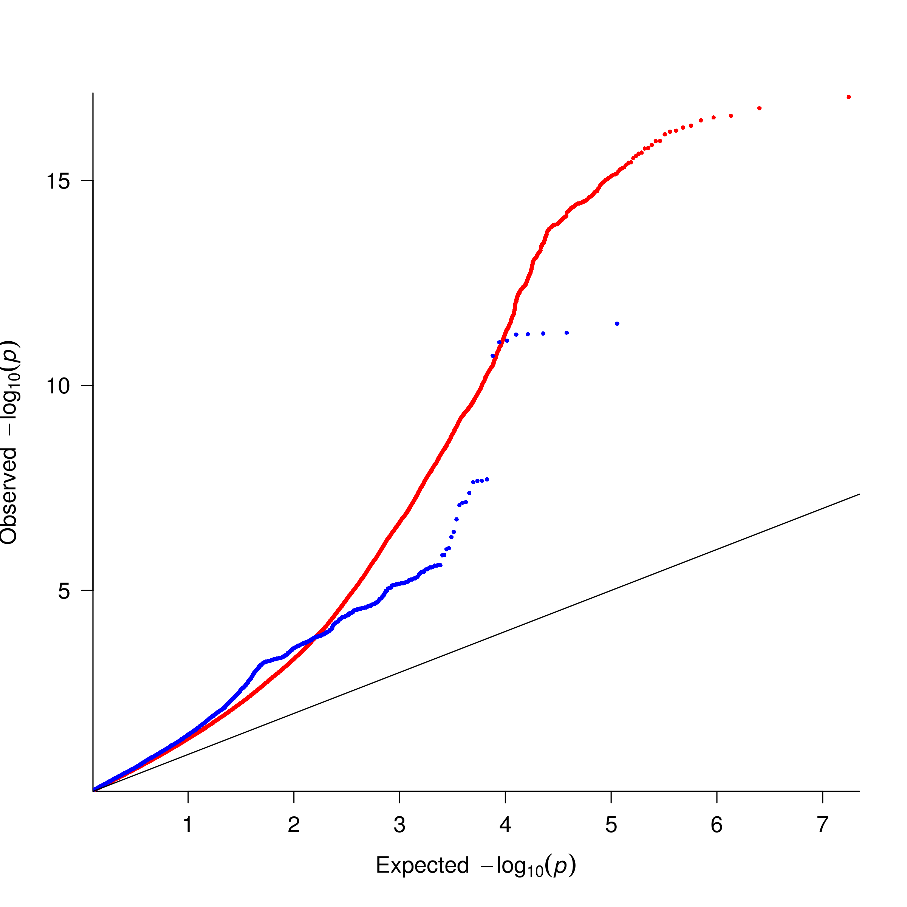 [MAPK Signaling] 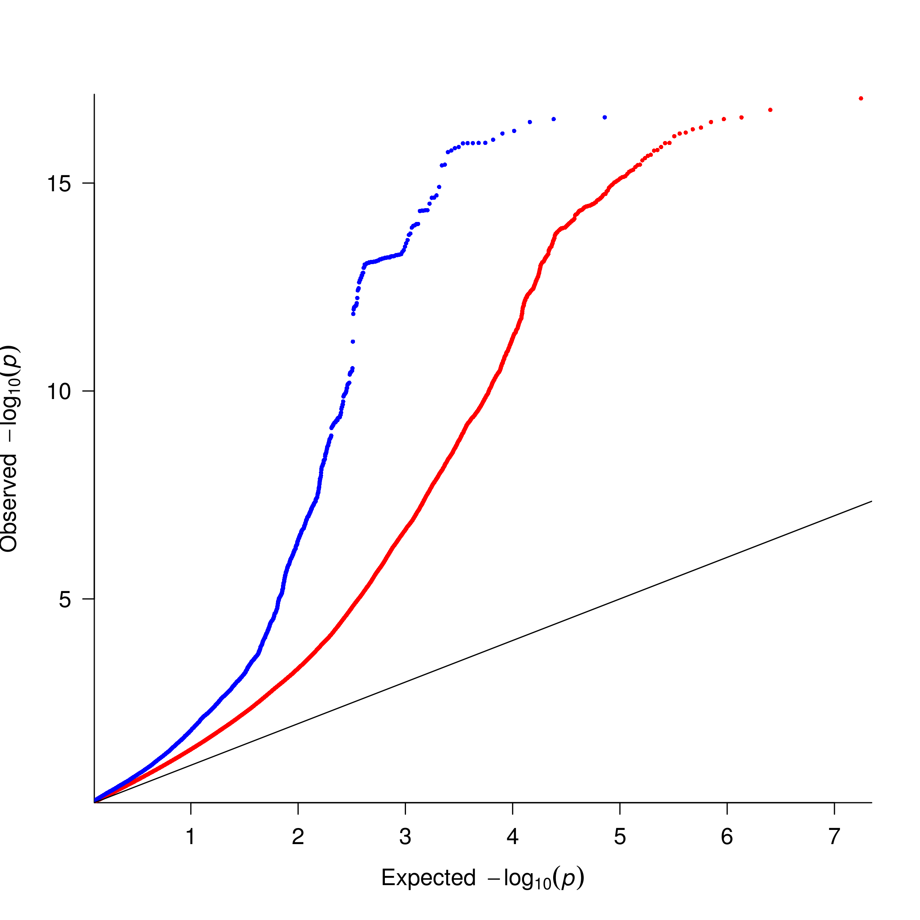

[Neuronal System] 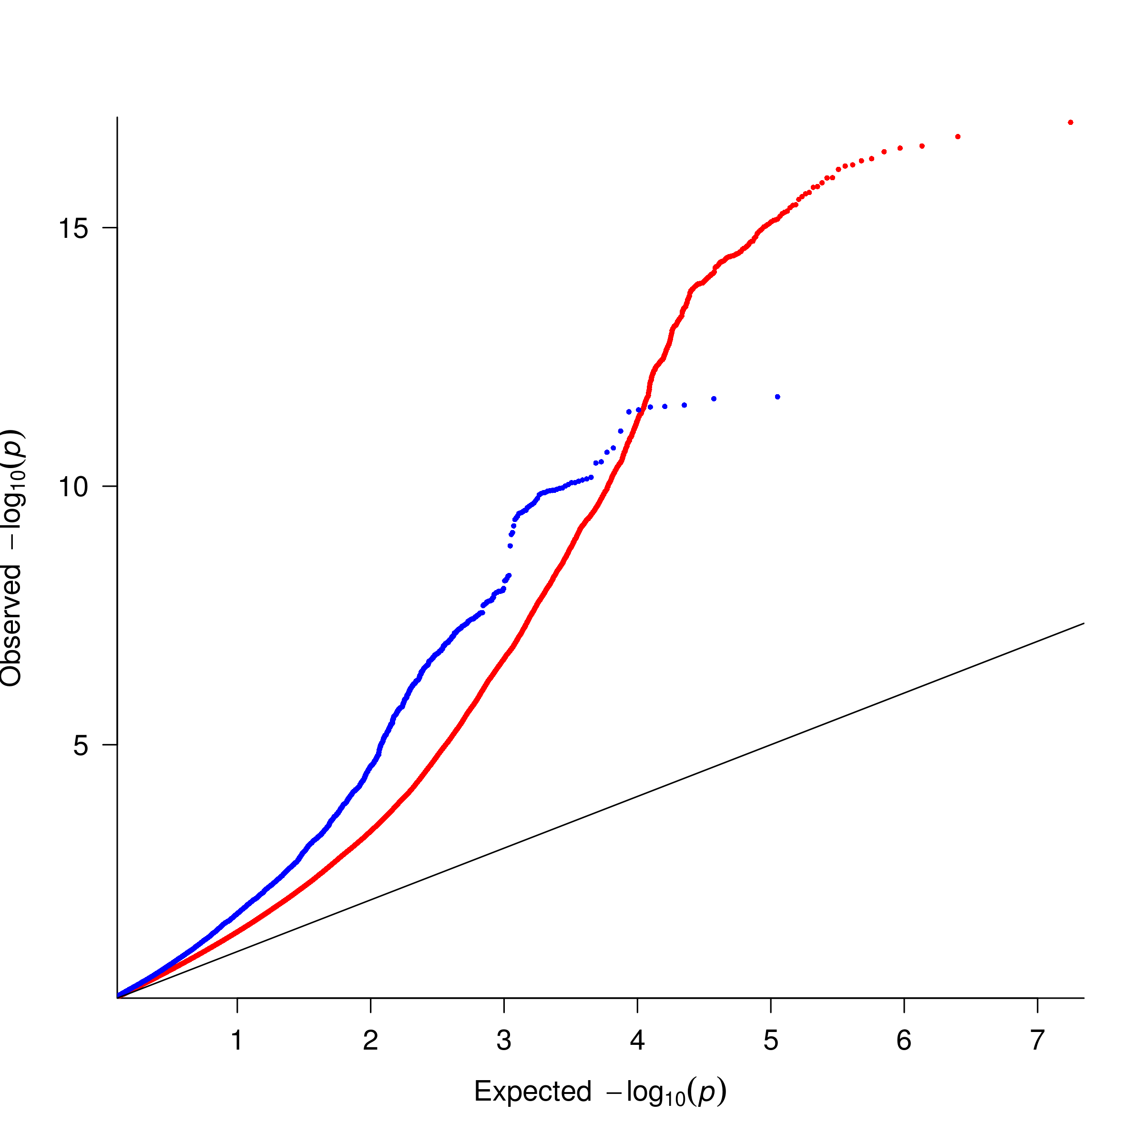 [Calsium Signaling]

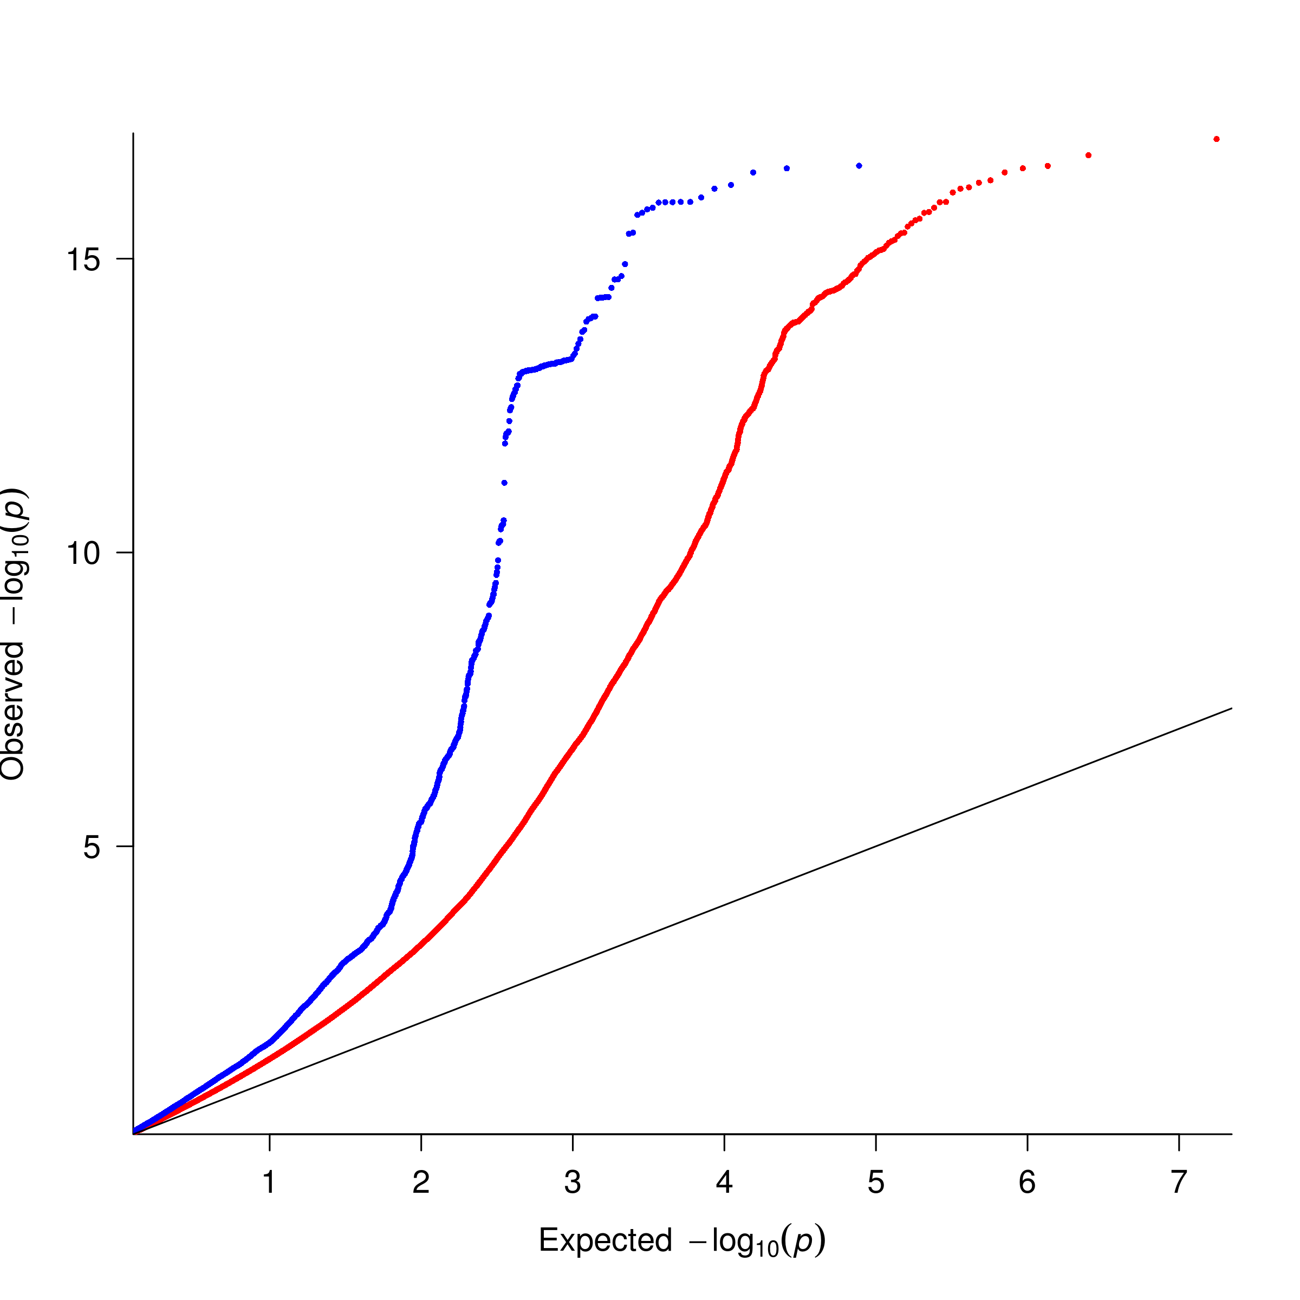

Figure 36: Comparing the qqplot with pgc SNP. SNP found within the pathways were colored in blue whereas the all the full set of SNP from the pgc GWAS was coded in red. It is observed that for most of the pathways, there is a general inflation of summary statistics when compared to the full set, suggest that the significance was not driven by a single significant gene. However, for the ecm related pathway, only a small inflation was observed. This is therefore likely that the significance was driven by a small number of significant genes.

The “super pathway” containing all the genes participating in the mia related pathways were also found to be significant (tab:partitioning) suggest that the differential gene expression in the cerebellum induced by early mia events and the genetic variants to act upon similar pathways in the development of scz.

Specifically, among the 4 pathways found to be significantly contributes to the SNP heritability, only the pathway related to the assembly of core ecm molecules such as the ecm glycoproteins, were also found to be significantly affected by the n-3 pufa rich diet in the polyic exposed mouse. Although the qqplot suggest that a small number of genes might have driven the significance of this pathway, it is nonetheless an interesting candidate.

Emerging evidences suggest that the ecm abnormality might be associated with scz [?]. The ecm glycoprotein Reelin has been reported to have a decreased expression in the cerebellum of scz patients [?] and were found to be accompanied by decreased expression of glutamic acid decarboxylase 67 [?]. Studies also suggested that Reelin might have important role in corticogenesis and synaptic maturation and stabilization [?]. Moreover, another ecm molecule, Semaphorin 3A has been reported to be increased in the cerebellum of subjects with scz [?]. The Semaphroin 3A protein was found to regulates axonal guidance and has a critical role in the regulation of tangential migration of cortical GABAergic interneurons [?]. It was also reported that the elevated Semaphorin 3A is associated with down-regulation of genes involved in synaptic formation and maintenance [?]. Together, these evidence suggest that the ecm molecules might have critical role in the development of scz.

It has been reported that the n-3 pufa diet can modulate the mmp [?, ?] which can regulates the ecm composition [?]. Therefore it is possible that the n-3 pufa diet has exerted its effect to the ecm through mmp. However, from the qqplot, it was noted that only a modest inflation was observed (fig:ecm). This suggest that the significance of the ecm pathway might have been driven by a small number of significant genes. Due to difficulties in delineating the individual SNP effect, it is difficult for us to pin-point the “driver” genes of this pathway. Therefore we urge that further studies are required to understand how the n-3 pufa direct interacts with the ecm or the ecm related genes and the effect of such interaction in mia exposed individuals.

Finally, it is important to note that the current study serves only as a hypothesis generation study and the sample size was modest. We therefore like to use the current results to provide an estimation of sample size required for a replication study. By using Scotty [?], we have estimated that the replication study should contain at least 10 samples for each group in order for us to detect at least 80% of genes has at least 80% of the maximum power. We have also demonstrated that the batch effect can have a big impact to the association (fig:batchLRT), therefore one should always control for the batch effect whenever possible. Given the current resources, one of the preferred design for the follow up study are given in tab:bestdesign.

### 4.1 Limitation

We first acknowledge that the sample size of the current study is small and are underpowered. This is reflected in the qqplot (fig:waldQQ) where the observed p-values were generally smaller than would have expected. A better study design will include more samples yet we are limited by our budget. However, the importance of a pilot study is to identify potential targets for replications, hypothesis generation or to provide guidance for follow up studies. In this study, we have identified *Sgk1* as an interesting candidate gene that might have an important role in the effect of n-3 pufa in polyic exposed individuals. Our results also suggested that the differential expression induced by early mia might act on the same functional pathways as genetic variations observed in scz. These provide interesting candidates for follow studies and we were able to estimate and design a better replication study based on the current data. Therefore we argue that as a hypothesis generation study, our study is successful.

Second, we examined only the male brains in the current study. The decision to direct experimental resources to males was made because there is evidence that the male fetus is more vulnerable to environmental exposures such as inflammation in prenatal life [?, ?]. We acknowledge that an interesting follow up study would be to investigate the gender difference in response to mia and dietary change.

Third, although RNA Sequencing was performed, we have not performed any analysis on possible alternative splicing events or denovo transcript assembly. The reason behind such decision is that our sample size is simply too small. Without sufficient information, denovo transcript assembly can return noisy results. On the other hand, in order to investigate possible alternative splicing events, we would need to perform the analysis on transcript level instead of gene level. This increase the possible candidates from 47,400 genes to 114,083 transcripts. Combined with the difficulties of the quantification of different isoforms, a much larger power is required for the alternative splicing analysis. On top of that, the functional annotation of transcripts is another difficult aspect to tackle. While there are a lot of information for the annotation of genes, information on functional difference between isoforms of the same gene were generally lacking. The lack of annotation simply leads to difficulties in making sense of the data. Thus although we acknowledge the possible importance of alternative splicing and denovo transcripts, we did not perform any alternative splicing analysis or denovo transcripts assembly. Nonetheless, the use of RNA Sequencing allow us to easily perform these experiments once sufficient samples are obtained.

Forth, it is important to note that a high RNA expression level does not guarantee a high protein concentration [?]. Post transcriptional, translational and degradation regulation can all affect the rates of protein production and turnover, therefore contributes to the determination of protein concentrations, at least as much as transcription itself [?]. The RNA Sequencing thus only provide an approximation to the concentration of a particular protein in the samples. However, we do argues that RNA Sequencing can help to identify potential targets for protein assays where detail analysis can be performed on the protein level.

Finally, at the time of this thesis, we have yet completed any rtpcr or any functional studies to validate our findings. One of the most vital steps after any RNA Sequencing results is to validate the differential expression findings using the rtpcr. Ideally, not only should one perform the rtpcr on the sequenced samples, one should also perform the rtpcr on an independent set of samples. Moreover, the RNA Sequencing only helps to identify possible candidates that were “associated” with a particular trait. It does not however provide any causal linkage between the phenotype and the differential expression. If one would like to establish a direct linkage between the phenotype and the gene, one will need to carry out functional studies such as knock-in knock-out mouse design. So take for example, in order to understand the functional impact of the differential expression of *Sgk1*, one might try to examine whether if the pure up-regulation of *Sgk1* through transfection can reduce the scz-like behavior in polyic exposed mice.

Currently, we are planning to perform the rtpcr on *Sgk1* on all available samples. Shall the results be validated, we can then perform subsequent functional studies.

## 5 Supplementary

|  |  |  |  |  |  |
| --- | --- | --- | --- | --- | --- |
| Litter | Condition | Diet | Cage | Batch | Lane |
| Continued | | | | | |
| 1 | PolyIC | n-3 PUFA | 1 | 1 | 1 |
|  | PolyIC | n-6 PUFA | 2 | 5 | 1 |
|  | PolyIC | n-3 PUFA | 3 | 4 | 2 |
|  | PolyIC | n-6 PUFA | 4 | 3 | 3 |
|  | PolyIC | n-3 PUFA | 5 | 2 | 4 |
|  | PolyIC | n-6 PUFA | 6 | 1 | 1 |
|  | PolyIC | n-3 PUFA | 7 | 5 | 1 |
|  | PolyIC | n-6 PUFA | 8 | 4 | 2 |
|  | PolyIC | n-3 PUFA | 9 | 3 | 3 |
|  | PolyIC | n-6 PUFA | 10 | 2 | 4 |
|  | PolyIC | n-3 PUFA | 1 | 2 | 1 |
|  | PolyIC | n-6 PUFA | 2 | 1 | 2 |
|  | PolyIC | n-3 PUFA | 3 | 5 | 2 |
|  | PolyIC | n-6 PUFA | 4 | 4 | 3 |
|  | PolyIC | n-3 PUFA | 5 | 3 | 4 |
|  | PolyIC | n-6 PUFA | 6 | 2 | 1 |
|  | PolyIC | n-3 PUFA | 7 | 1 | 2 |
|  | PolyIC | n-6 PUFA | 8 | 5 | 2 |
|  | PolyIC | n-3 PUFA | 9 | 4 | 3 |
|  | PolyIC | n-6 PUFA | 10 | 3 | 4 |
|  | Saline | n-3 PUFA | 1 | 3 | 1 |
|  | Saline | n-6 PUFA | 2 | 2 | 2 |
|  | Saline | n-3 PUFA | 3 | 1 | 3 |
|  | Saline | n-6 PUFA | 4 | 5 | 3 |
|  | Saline | n-3 PUFA | 5 | 4 | 4 |
|  | Saline | n-6 PUFA | 6 | 3 | 1 |
|  | Saline | n-3 PUFA | 7 | 2 | 2 |
|  | Saline | n-6 PUFA | 8 | 1 | 3 |
|  | Saline | n-3 PUFA | 9 | 5 | 3 |
|  | Saline | n-6 PUFA | 10 | 4 | 4 |
|  | Saline | n-3 PUFA | 1 | 4 | 1 |
|  | Saline | n-6 PUFA | 2 | 3 | 2 |
|  | Saline | n-3 PUFA | 3 | 2 | 3 |
|  | Saline | n-6 PUFA | 4 | 1 | 4 |
|  | Saline | n-3 PUFA | 5 | 5 | 4 |
|  | Saline | n-6 PUFA | 6 | 4 | 1 |
|  | Saline | n-3 PUFA | 7 | 3 | 2 |
|  | Saline | n-6 PUFA | 8 | 2 | 3 |
|  | Saline | n-3 PUFA | 9 | 1 | 4 |
|  | Saline | n-6 PUFA | 10 | 5 | 4 |
|  | |

Table 13: Design for follow up study. This will be the idea design for follow up study where litter effect, cage effect, batch effect and lane effects are all balanced out for the conditions. One can also include the ercc spike in control to serves as an internal standard for additional level of control [?].

# 4 Conclusion

In this thesis, we presented shrek, an robust algorithm for the estimation of SNP heritability using GWAS summary statistics, an alternative to ldsc. Through simulations, it was suggested that when compared to ldsc, shrek can provide a more robust estimate for oligogentic traits and in case-control designs where no confounding variables was present. Using the latest GWAS summary statistics released by the pgc, we estimated that scz has a SNP-heritability of 0.174 (SD=0.00453), which is similar to the estimate of 0.197 (SD=0.0058) by ldsc.

When compared to the heritability estimated from twin studies () [?] and large scale population based study (64%) [?], the SNP heritability is much lower, suggesting that factors other than common SNP might have accounted for the remaining heritability.

On the other hand, we also performed an RNA sequencing on the polyic mia mouse model to investigate if differential gene expression induced by mia and genetic variations observed in scz were acting on the same functional pathway in the development of scz. We were able to identify a total of 12 pathways that might be perturbed by early mia events in the cerebellum of the mouse, including calcium ion signaling and pathways related to neural or synaptic functioning.

Providing that recent study suggest a n-3 pufa rich diet can help to reduce the scz-like behaviour in mouse exposed to early mia events [?], we also investigated how the n-3 pufa rich diet affect the gene expression pattern in the adult cerebellum. *Sgk1*, a gene that regulates the glutamatergic system, were found to be significant in polyic exposed mouse given different diet. Most importantly, we found that pathways related to ecm were affected not only by mia, but also in polyic samples given different diets. Pathways related to ecm were also found to contributes a disproportionate amount of SNP heritability to scz, suggesting that it is a potential target for future research.

## 1 Challenge in SNP-Heritability Estimation

Although it is now possible to estimates the SNP heritability based on the summary statistic from GWAS, a lot of questions remain unanswered in the estimation of SNP heritability. One major problem of shrek and ldsc is that they both heavily relies on the LD structures from the reference panel. However, GWAS samples can come from large variety of ethnic background thus the LD pattern estimated from the reference panel might not be representative of the sample LD. If the fundamental LD structure were not as expected, both shrek and ldsc would fail to provide an accurate estimate. For example, if a GWAS is conducted with 50% European and 50% African, population stratification may confound the results. Even if one control for the population stratification using the pca, the question remains whether if one should use the African reference panel or the European reference panel in the estimation of SNP heritability. Moreover, information regarding the population stratification (e.g. the pc) were usually unavailable making the problem more complicated. Further researches are therefore required to tackle the problem of population stratification before one can confidently estimate the SNP heritability from summary statistics from GWAS that might contain samples from large variety of ethnic background.

An important observation in our simulation study was that there was a general bias observed in all the SNP-heritability estimation algorithm under the case control scenario. This is likely due to the ascertainment bias introduced through case control sampling. Although the liability adjustment was performed, bias was still observed. This suggested that we will need a better liability adjustment algorithm if we would like to accurately estimate the SNP-heritability from case control studies.

As technology advances, researchers can now use the ngs technology to sequence the genome at per base resolution. This brings great prospect in the genetic studies for now we can directly identify the causal variants and can even detect rare causal variants providing sufficient sample size. However, both shrek and ldsc are designed to work on the summary statistics from GWAS where common SNP are usually the focus. Because of the huge sampling error associating with rare variants, the LD calculated for rare variants usually has a larger se. As shrek and ldsc are both heavily rely on an accurate LD estimation, they might be unsuitable for the estimation of the contribution of rare variants to scz. In fact, it was found that when all causal variants are rare (maf ), ldsc will often generate a negative slope, and the intercept will exceed the mean  statistic [?]. As a result of that, a different algorithm must be developed in order to estimates the heritability from rare variants.

## 2 Schizophrenia: Future Perspectives

With the success of the pgc scz GWAS, research in scz genetics has finally entered an era of success. Through international collaboration, the pgc has finally identified 108 genetic loci that were associated with scz using GWAS approach [?]. However, the actual causal variants have not been identified. Functional analysis of these associated variants, and their contribution to the etiology of scz will become an important topic for further research in scz genetics.

On the other hand, when estimating the SNP-heritability of scz, it was found that no more than 20% of the heritability has been accounted for by the current GWAS which is lower than the 81% estimated based on twin studies [?]. This suggested that factors other than common SNP were contributing to the heritability of scz.

Clear evidences suggested that scz patients has a higher mortality than the general population [?]. Given this strong selective pressure, it is likely that the causal variants of scz with large effect size will be selected against in the population. As a result of that, causal variants with large effect size are likely to be rare (fig:effectSize). With the technological advancement in ngs, we are now able to investigate the human genome at per base resolution using Exome Sequencing and even Whole Genome Sequencing technology. Recent study by [?] was able to identify gene sets enriched by rare variants that were associated with scz using Exome Sequencing. This demonstrate the power of the sequencing technology in the identification of possible risk variants. Moreover, there was overlaps observed between genes harboring rare risk variants and those within the pgc scz GWAS [?], suggesting that the rare variants and common variants studies are complementing each other. As more resources are devoted in to sequencing the genome of scz patients, more rare variants associated with scz are expected to be identified.

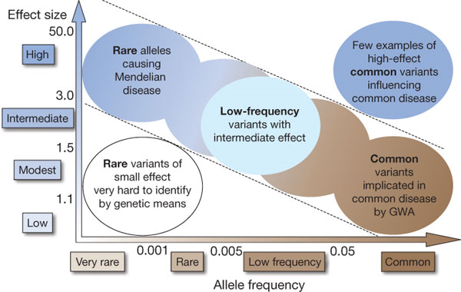

Figure 37: Relationship between effect size and allele frequency. It is expected that rare variants with large effect size were actively selected against in the population and therefore should be rare.

Currently, most of the focus in scz was directed to genetic variation yet it is possible that the heritability of scz is also transmitted in the form of epigenetic changes such as methylation. It was observed that the risk for individual born from a schizophrenic mother is larger than that from a schizophrenic father. This suggests that maternal specific elements, such as maternal imprinting and mitochondria might account for part of the risk of scz. Epigenetic studies in scz [?, ?] has identified genes with differential DNA methylation patterns associated with scz, suggesting the importance of epigenetics in the etiology of scz.

As a highly heritable, most of the research of scz has been focusing on the genetic factors. Although the genetic variation accounted for majority of the variations in scz, the environmental factors, especially prenatal infection is also an important factor to consider. It was estimated that prenatal infection accounts for roughly 33% of all scz cases [?]. The mia rodent model has provide vital information on the possible interaction between the immune and neuronal system in the etiology of scz [?]. For example, il6, a pro-inflammatory cytokine has been found to be an important mediator in generating the schizophrenia-like behaviour in rodent model [?]. More importantly, there are evidence of the interaction between prenatal infection and genetic variation, supporting a mechanism of gene-environment interaction in the causation of scz [?]. As the SNP-heritability estimation does not take into account of the gene environmental interactions, it is possible that the “missing” heritability can be due to gene-environmental interactions. Efforts is now made by the European network of national scz networks studying Gene-Environmental Interaction (EUGEI) to identify possible genetic and environmental interaction that contributes to the disease etiology of scz.

With the sophistication of technologies, we can now perform whole genome sequencing with the HiSeq 10 Ten system costing less than $1,000. Therefore, the largest challenge now resides in how to make sense of the data instead of data generation. For example, the alignment of sequence read to low complexity sequence or low-degeneracy repeats remains challenging and might be error prone, thus have a negative impact to the quality of the results[?]. New sequencing technology such as Oxford Nanopore which can provide extra long-reads, might help to make alignment easier due to the extra information for each individual reads. However, the Oxford Nanopore is still under development and has a relatively high error rate [?]. Only until the error rate is dramatically decreased can the use of Oxford Nanopore system become feasible.

Even if the reads can perfectly aligned to the genome, the functional annotation of variants remains challenging. When it comes to complex disease such as scz, there can be a lot of causal variants observed throughout the genome yet currently one can only provide estimates of the functional impact of variants on the exomic regions. The development of ENCODE project [?] and Genotype-Tissue Expression (GTEx) project [?] have helped provide reference point for the annotation of genetic variations in the intergenic regions yet there are still many genetic variation in the genome where their function remains unknown. Only through the tireless effort of the molecular biologist can we gain sufficient information required to make sense of the sequencing data obtained.

In conclusion, we have only catch a glimpse of the etiology of scz and there are still a lot of questions left unanswered. It is expected that only by combining the study of epigenetic, genomic variation, gene expressions, and gene environmental interaction can provide a deeper understanding of the complex disease mechanism of scz be obtained.

[heading=bibintoc,title=Bibliography]